By Emily Jill Lynch, J.D.
Professor at southwestern college
Business Law
An open educational resource

Dedication
To my daughter, Isabelle. I write this book now to make college more affordable for students, and hope that you will be able to go college affordably when you’re eighteen.

Table of Contents
Chapter on Agency and Employment 3
I. Introduction to Agency and Employment 3
II. How is a Principal-Agent Relationship Formed? 6
III. The Authority Vested in the Agent 10
A. The First Type of Potential Authority: Actual Authority 10
B. The Second Type of Potential Authority: Apparent Authority 10
C. The Third Type of Potential Authority: Ratified Authority 11
D. Estoppel 12
IV. Duties Between Principals and Agents 13
A. Duties of the Agent 13
B. Duties of the Principal 14
V. Liability to Third Parties 16
VI. Termination of Agency 17
VII. How to Form an Employer-Employee Relationship 17
VIII. Duties of Employers 17
IX. Employment-at-Will 18
X. Employment Agreements 18
XI. Independent Contractors 4
Key Terms 6
Review Questions 7
Exercise 8
Chapter on Sole Proprietorships 10
I. Introduction to Sole Proprietorships 10
Full Case Name 10
Short Case Name 10
Reporter 11
Forming a Sole Proprietorship 14
II. Management of a Sole Proprietorships 15
III. Liability of a Sole Proprietorship 15
IV. Continued Existence of Business and Transferability 16
V. Profits and Losses of Sole Proprietorships 16
VI. Taxation of the Sole proprietorship 16
VII. Termination of the Sole Proprietorship 21
Key Terms 21
Review Questions 21
Web Exercise 21
Chapter on General Partnerships 22
I. Introduction to General Partnerships 22
II. Formation and Financing of General Partnerships 23
III. Public Document for a General Partnership 28
IV. Private Document for General Partnership 29
A. Management of the Partnership 31
B. Liability of the Partnership 34
C. Continuance of the Partnership Business 35
D. Profits and Losses of the Partnership 35
E. Taxation of the Partnership 36
F. Termination of the Partnerships 38
Key Terms 39
Review Questions 39
Web Exercise 40
Chapter on Limited Liability Partnerships 41
I. Introduction to Limited Liability Partnerships 41
II. Formation of the Limited Liability Partnership 41
III. Management of the Limited Liability Partnership. 46
IV. Liability of the Limited Liability Partnership 46
V. Continued Existence of the Limited Liability Partnership 61
VI. Profits and Losses of Limited Liability Partnerships 61
VII. Taxation of the Limited Liability Partnership 61
VIII. Termination 62
Key Terms 62
Review Questions 62
Web Exercise 62
Introduction to Limited Partnerships 64
I. Introduction to Limited Partnerships 64
II. Formation of Limited Partnerships 65
III. Management of the Limited Partnership 79
IV. Liability of the Limited Partnership 79
V. Continued Existence of the Limited Partnership 80
VI. Profits and Losses of the Limited Partnership 80
VII. Taxation of Limited Partnership 81
VIII. Termination of the Limited Partnership 81
IX. How are General Partnerships and Limited Partnerships Different? 82
Key Terms 82
Review Questions 83
Chapter on Limited Liability Companies 85
I. Introduction to Limited Liability Companies 85
II. Laws of LLCs 86
III. Formation and Financing of the LLCs 86
A. Public Document: Articles of Organization 86
B. Private Document for LLCs: Operating Agreement 89
IV. Financing of the LLC 90
V. One-Person LLCs 90
VI. Management of the LLC 90
A. Flexible Management 90
B. Member-Managed or Manager Managed LLCs 91
VII. Liability of the LLC 91
VIII. Continued Existence of the LLC and Transferability of the LLC 109
IX. Profits and Losses of the LLC 109
X. Taxation 110
XI. Termination of the LLC 110
Key Terms 110
Review Questions 111
Chapter on Corporations 113
I. Introduction to For-Profit Corporations 113
II. Pre-incorporation 113
A. Liability of Promoters in a For-Profit Corporation 114
B. Where Should a For-Profit Corporation Incorporate? 114
1. Incorporating in Delaware. 114
III. Formation and Financing of the For-Profit Corporation 115
A. Name Availability of the For Profit Corporation 115
B. Public Document for For-Profit Corporation: Articles of Incorporation 117
1. Preemptive rights 119
C. Organizational meeting and Incorporators of the For-Profit Corporation 119
D. Close Corporations 119
E. Private Document for a For-Profit Corporation: Bylaws 120
F. Capitalization 121
G. Debt Financing in a For-Profit Corporation 124
H. Benefits of Using Equity Capital Instead of Debt Capital 124
Key Terms 125
Review Questions 125
Assignment 126
Chapter on Directors and Officers 127
I. Introduction to Directors and Officers 127
II. Role of Directors and Officers in a For-Profit Corporation 127
III. Election and Appointment of Director and Officers for a For-Profit Corporation. 128
A. Term of Directors and Officers in a For-Profit Corporation 128
B. Vacancies of Directors and Officers in a For-Profit Corporation 128
C. Removal of Directors and Officers of a For-Profit Company 128
D. Board of Directors Meetings in a For-Profit Corporation 128
E. Duties of Directors and Officers of a For-Profit Corporation 129
F. Compensation and Indemnification of Directors and Officers of For-Profit Corporations 130
G. Liability of Directors and Officers in a For-Profit Corporation 134
Key Terms 134
Review Questions 135
Chapter on Shareholders 136
I. Introduction to Shareholders 136
II. Shareholder Rights in a For-Profit Corporation 136
A. Shareholder Inspection Rights in a For-Profit Corporation 136
B. Shareholder Voting Rights in a For-Profit Corporation 137
C. Shareholder Actions in a For-Profit Corporation: Direct and Derivative 137
III. Liability of Shareholders in a For-Profit Corporation 146
IV. Shareholder Meetings in a For-Profit Corporation 147
Key Terms 149
Review Questions 150
Chapter on Other For-Profit Corporation Issues 151
I. Taxation 151
A. S Corporations 152
II. Nonprofit Corporations 153
III. Amending the Articles of Incorporation for a For-Profit Corporation 154
IV. Corporate Combinations in For-Profit Corporations 154
A. Merger in a For-Profit Corporation 155
B. Share Exchanges in a For-Profit Corporation 155
C. Purchase of Assets in a For-Profit Corporation 156
D. Purchase of Stock in a For-Profit Corporation 156
E. Hostile Takeovers 156
V. Termination of a For-Profit Corporation 158
A. Voluntary Dissolution of a For-Profit Corporation 158
B. Administrative Dissolution of a For-Profit Corporation 159
C. Involuntary Dissolution of a For-Profit Corporation 159
D. Articles of Dissolution in a For-Profit Corporation 159
E. Liquidation 159
F. Qualification in Foreign Jurisdictions for For-Profit Corporations 160
Key Terms 161
Review Questions 161
Web Exercise 162

Chapter on Agency and Employment

Student Learning Outcomes
- Be able to define what a principal-agent relationship is.
- Compare and contrast the different types of agent authority.
- Understand the duties of both principals and agents.
- Explain the liability of principals for agents in regards to third parties.
- Appreciate how an employer-employee relationship comes about.
- Review an employment agreement.

Introduction to Agency and Employment
This chapter will start on a more global perspective of agency law and then move into more specific examples of business entity principal-agent relationships in later chapters. This is because agency law is like a building block of business law, and so it needs to be discussed first. Almost everyone working for another person can be categorized as an agent for another. The actor is the agent and the person receiving the action is the principal.

Agent: the actor in a principal-agent relationship
Principal: the person receiving the action in a principal-agent relationship

The caveat is for there to be the relationship, both the agent and the principal must consent to the relationship. For example, if someone wanted to use another person’s credit card without their permission, even if to buy things on behalf of the principal, there would not be a principal-agent relationship. Both parties must agree or consent to the relationship. This does not have to be an express oral or written agreement. Using the example above (and ignoring credit card companies’ rules about unauthorized users), one person handing another person their credit card, could be considered implied consent through behavior (one person handed the card and the other person took it). It is usually better to have express oral or written consent though. For the consent to be valid, both parties must have the capacity to consent. The capacity to consent refers to a variety of different types of capacity, such as age and mental capacity.
There are two major types of agents:
- general and
- specific.
A general agent has the authority to perform all different types of business for the principal, which the principal could have performed for himself. The specific agent has authority to perform specific types of business for the principal. Going back to the credit card example, a specific agent would only have the authority to make purchases on that credit card. A specific agent can only do the things that the principal has specifically requested. Any actions that are outside the scope of the agency would not be authorized.
Even though someone can act as an agent for someone else without being paid, an agent may be controlled, to some extent, by the principal. This, in turn, subjects the principal to some liability for the agent’s actions. This is since the agent did not act for himself, but for the principal. Since the agent did not commit the action for himself, why should he be held liable for any results of that action? Going back to the authorization that an agent may have there are three major types:
- actual authority;
- apparent authority; and
- ratified authority.
These three types, as well as estoppel, will be discussed later in the chapter.
Principal-agent relationships do not have to be paid, so an employer-employee relationship can be a type of principal-agent relationship, but principal-agent relationship is broader. Look at the following graphic that illustrates this concept.

Graphic of Principal-Agency Relationship in Relation to Employer-Employee Relationship

Principal-Agent
Relationship

Employer-Employee
Relationship

If you have aging parents, then you may have agreed to perform services as an agent of your parent. You may have agreed to make medical decisions for them, should they be unable. You may have agreed to act as a trustee of their trust, if they have any assets, when they die. You may have agreed to do this for them paid or unpaid. What are some other unpaid principal-agent relationships you can think about?
After discussing agency, the chapter will move on to discuss employment more. The chapter will cover how an employer-employee relationship is formed, additional duties employers owe employees, employment-at-will v. employment agreements, and how independent contractors are dissimilar to employees.

How is a Principal-Agent Relationship Formed?
As mentioned in the introduction, people entering a principal-agent relationship must have capacity to consent to the relationship. Sometimes people lack mental capacity and need an agent but are not legally able to appoint one for themselves. A court can appoint someone to be their agent. Please either look at the form “Petition for Appointment of Conservator” or go to the form through the weblink below. Please note that some of the times a court may be able to appoint a conservator (or agent) are when the principal has a mental illness, physical illness or disability, chronic use of drugs, and/or chronic intoxication.

Petition for Appointment of Conservator
Form is Also Available at: https://courts.michigan.gov/Administration/SCAO/Forms/courtforms/pc639.pdf
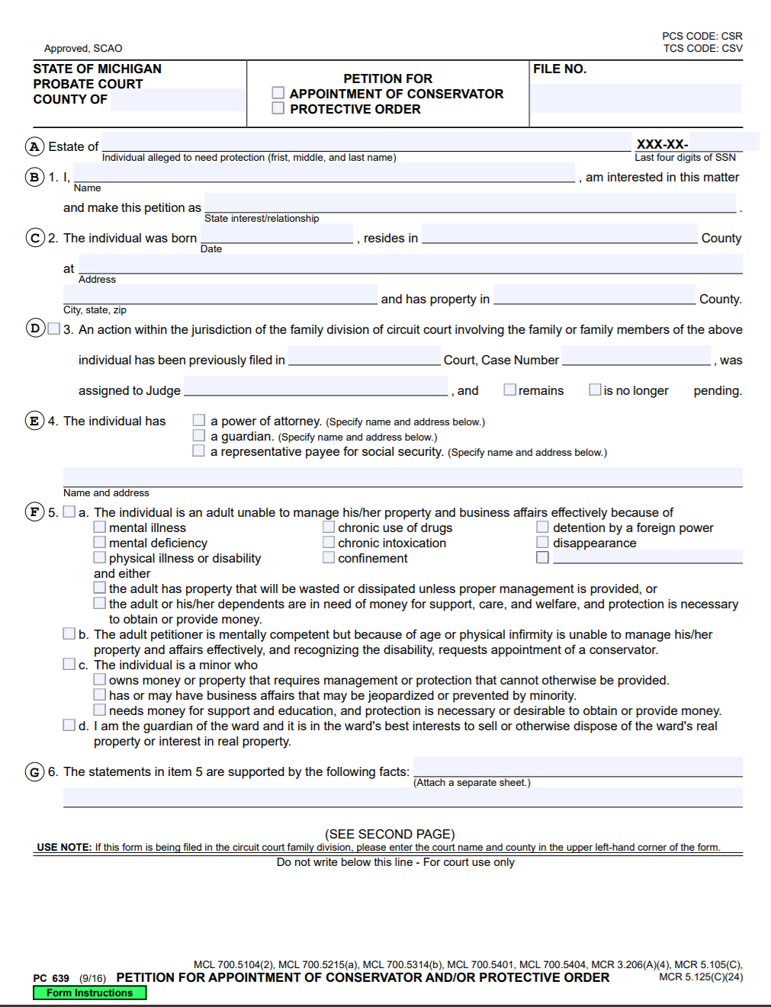
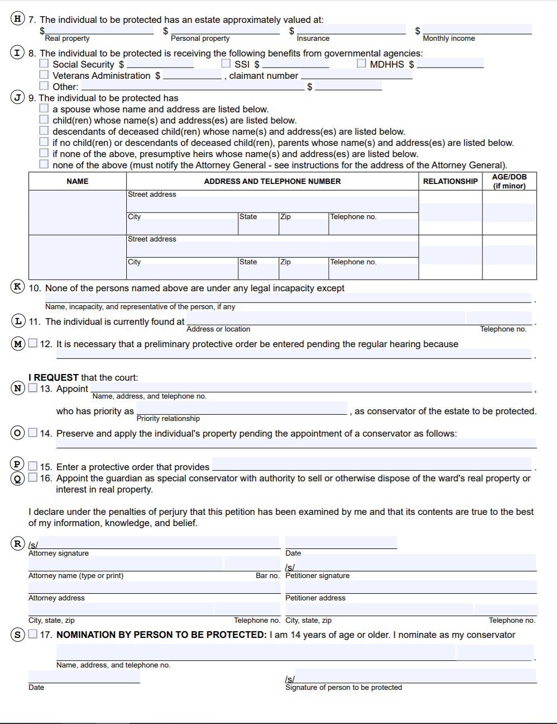
The principal does need to have legal capacity to consent; an agent does not! An agent could be under the age of eighteen (18), for example, if they understand what they are consenting to.
Principal-agent relationships also may not be formed for the purpose of carrying on an illegal activity. The news has made a big deal out of murder for hire contracts. It is ironic that someone wanting to murder another would be concerned about a contract. If this were true though, the contract would be invalid as would the principal-agent relationship, as murder is not a legal act.

Web Activity
Take a look at the Murder for Hire Act at https://www.justice.gov/archives/jm/criminal-resource-manual-1107-murder-hire-offense What is the travel requirement?

The Authority Vested in the Agent

The First Type of Potential Authority: Actual Authority
There are two types of actual authority: express and implied. Express occurs when the principal agent state or write down the principal-agent relationship. Some principal-agent relationships must be written, such as one regarding real-property purchases or sales. Implied authority is conduct from which a principal-agent relationship can be inferred. The example of one person handing another person a credit card for use on behalf of the first person is an example of affirmative conduct that implies actual authority to use the credit card.

The Second Type of Potential Authority: Apparent Authority
Apparent authority can be difficult to understand as it is very similar to estoppel (discussed later). In apparent authority, look at what a third party was reasonable in believing about the agent’s status versus what the agent and principal believed. If Abdi goes to a dog grooming shop and sees someone in an apron, holding an electric shaver, he is reasonable in believing that the person wearing the apron is acting on behalf of the owners of the dog grooming shop. The fact that someone might have walked in off the street, put on the employee apron and grabbed an electronic shaver does not matter (the owner of the shop should prevent people from doing this), and Abdi has a reasonable belief. The owner of the shop made it look like someone who walked in off the street had authority by not preventing that person from grabbing an employee apron and electric shaver.
There are three factors to apparent authority:
- conduct of the principal, implying that a person is acting as his agent;
- a third party relies on that implication; and
- the third party acted to his detriment by his reliance on that implication.
Another way to think about actual authority, whether express or implied and apparent authority is this illustration. Think of actual authority, express or implied as the line between the principal and the agent. Imagine a dotted line going from the principal straight to the third party. This is apparent authority.

Figure Illustrating Apparent Authority
Principal

Agent Third Party

The Third Type of Potential Authority: Ratified Authority
A person may not initially have permission to act for another, but then they are given permission after the fact. As an employee, you may have gone above and beyond for your employer and performed work in addition to what you were required to do. If your employer sees that additional work and states: “good job,” then the employer has arguably ratified the additional work after the fact. This does not however give license to an employee to work overtime without express authorization ahead of performing overtime.
The elements of ratified authority are:
- The agent acted on behalf of the principal, and the principal then ratifies the act;
- The principal must know all of the important, or material facts, in the act;
- The act must be ratified in its entirety;
- The principal must have authority to authorize and ratify the act; and
- The ratification must occur before a third party voids the act.

Estoppel
Estoppel is a fourth way a principal-agent relationship can be found. It is handled differently than the first three ways above. It is based upon a public policy argument that it would be unfair if a principal-agent relationship were not found. The court will determine whether there was one or not. Estoppel is found when it is reasonable for a third party to think that someone is acting as an agent, and in this way, estoppel is very similar to apparent authority. How estoppel differs from apparent authority, is estoppel also depends upon the actions of the alleged agent, and not just the principal.
Using the same example from above of the dog grooming salon owner who did not secure employee aprons or electric shavers, what if the dog grooming salon owner had secured the employee aprons? What if the agent went into the employee break room to get an employee apron, and then picked up an electric shaver that was not secured an anyway? The owner did not secure the electric shaver. The agent went into an employee break room. Both acted to make a third party think that the person off the street was an employee of the dog grooming salon.
An estoppel argument also has the added arguments about the size and bargaining position of the parties. If the dog grooming salon is a bigger salon, like a national chain, it is much more likely a court will find the national chain helped create a principal-agent relationship expectation. If the dog grooming salon is a smaller salon, like a mom and pop operation, it is much less likely a court will find the smaller salon helped create a principal-agent relationship expectation.
In summary, while estoppel is like apparent authority, estoppel is different in that there is an unfairness argument and the agent’s actions, in addition to the principal’s actions, are looked at.

Duties Between Principals and Agents

Duties of the Agent
An agent has a fiduciary duty to the principal. A fiduciary relationship is a legal and ethical relationship. The principal should be able to trust the agent as the agent works on behalf of the principal. This means the agent should act in good faith and with due care of the principal and the principal’s interests. The agent must be responsible with the principal’s money and other interests involved in the principal-agent relationship. This generally means that the agent should treat the principal’s money and interests as if they were his own (so long as the agent acts with care with his own money and interests). A duty of care imposes upon the agent the duty to act as a reasonably prudent agent would under similar circumstances.

The Agent Should Perform the Agreed Upon Tasks
Once an agent, the agent is performing the agreed upon tasks for the principal. The agent has the obligation to perform these tasks as soon as is reasonably practicable and performing these tasks well. This is also known as due diligence.
Due diligence: performing tasks as soon as is reasonably practicable and performing these tasks well.

The tasks should be done thoroughly and properly. This means that the agent does not act with negligence in performing these tasks. If a paid agent does not perform the agreed upon tasks, the agent can be found to be in breach of the contract created by the principal-agent relationship.

The Agent Should Provide Notification to the Principal
Material information must be provided to the principal, so the principal has the important information necessary to make a decision about the principal’s rights and actions. Notification should take place in a timely manner so that the principal has the necessary information when called upon to make decisions.

The Agent Should Be Loyal to the Principal
When working as an agent, the agent should not compete with the principal or help others compete against the principal. The agent should treat the principal’s interests as his own, or even above his own, at least those interests within the principal-agent relationship. If there are prospective business advantages that the agent becomes aware of while in the relationship, the agent should let his principal know so that the principal can take those advantages, if desired.
The duty of loyalty also requires that the agent not have a conflict of interest. The agent cannot work for another principal whose interests are converse to the first. If an agent represents more than one principal, this is known as dual agency and typically all parties must agree to the dual agency.

The Agent Should Account to the Principal
An agent may need to spend money in the course and scope of principal-agent relationship. All money spent on behalf of the principal needs to be accounted for. If the agent collects money for the principal, then the agent needs to account for the monies received as well.

Duties of the Principal

Compensation
If an agency is not a free agency, then the principal does have an obligation to pay the agent. If payment is not pre-negotiated, then it may become whatever is the industry standard or reasonable payment.

Reimbursement
Corresponding with the agent’s duty to account to the principal, if the agent accounts for expenditures made on behalf of the principal, then the principal is to reimburse the agent. The expenses must be authorized by the principal and part of the principal-agent relationship. If the expenses are authorized and part of the relationship, then they are, the principal’s expenses.
The accounting can be something simple like below, or the principal might require additional information when the agent accounts.

Figure on Simple Accounting for Principal
Expenditure for: | Amount paid to: | Amount: | Paid from which account: | Date:

Indemnification
Depending upon the type of behavior by the agent, the principal is responsible for holding harmless (indemnifying) the agent. Usually an agent’s misbehavior is categorized as one of three types of misbehavior:
- negligent;
- reckless and willful; and/or
- intentional.
With negligent, or careless misbehavior, the principal must indemnify the agent. With intentional misbehavior, the principal does not have to indemnify the agent. With reckless and willful misbehavior, the principal may have to indemnify, but usually does not. Drunk driving is often considered reckless and willful misbehavior, as most people do not realize how little alcohol it takes to drive impaired, although they are aware alcohol can impair driving ability (look at the Figure on Blood Alcohol Content infra). If the principal did nothing to encourage the agent to drink and drive, then typically the principal would not be liable for the agent’s behavior while drinking and driving.
The below figure, also found at https://www.dmv.ca.gov/portal/dmv/detail/pubs/hdbk/actions_aps_court
shows that the only safe driving limit is a .00 blood alcohol limit (shown in green). It shows that driving skills are impaired between .02 and .07 blood alcohol content (shown in yellow). It shows that people are legally intoxicated (at least in the state of California) with a blood alcohol content of .08 or higher (shown in red).

Figure on Blood Alcohol Content
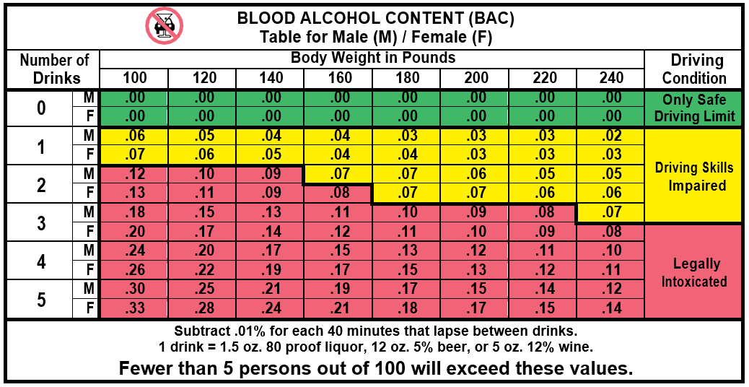

Cooperation
The principal must cooperate with the agent so that the agent is able to perform his duties. This may require that the principal provide a credit card, an office, tools, etc.

Liability to Third Parties
A principal can be held vicariously liable for the actions his agent, which means he must indemnify his agent and pay for lawsuits against the agent, when the agent was negligently acting on his behalf. For there to be vicarious liability, the agent must be acting within the course and scope of the principal-agent relationship when he acted. Typically, the principal-agent relationship must be an employer-employee relationship rather than an independent contractor relationship for vicarious liability to apply.

Termination of Agency
A principal-agent relationship may be terminated in one of four ways:
- Mutual agreement;
- The end of the agreed upon duration of the relationship;
- Accomplishment of the purpose of the principal-agent relationship; or
- When a specific (previously agreed upon) event occurs.
If the termination does not happen in one of these four ways, then there has been a breach of the relationship.

How to Form an Employer-Employee Relationship
There are many different types of employment, including full and part-time employees. With employment though, the employer is most definitely in control of the employee’s work and must pay the employee. There are payroll taxes. Employers pay into Social Security, Medicare, income taxes, and unemployment taxes.

Duties of Employers
Employers have all the duties of principals in a principal-agency relationship. Additionally, the employer must pay at least minimum wage, overtime (if applicable), may pay a pension, is subject to the Family and Medical Leave Act, is subject to workers’ compensation, is subject to the Occupational Health and Safety Act, and is subject to immigration laws.

Web
Go to the following webpage: https://www.dol.gov/agencies/whd/minimum-wage/state There is a clickable map of the United States. Select the state that you are currently living in. Determine what the minimum wage is in your state.

Employment-at-Will
Sometimes employees do work under a contract. A lot of employees do work under what is known as employment-at-will. This means that the employer can fire an employee at almost any time for almost any reason. It also means that the employee can terminate at almost any time for almost any reason and does not usually even have an obligation to provide two (2) weeks’ notice. There are exceptions to being able to fire someone at any time, for any reason. Wrongful discharge is such an exception. If a worker is exercising certain rights, then if the employer fires them for exercising those certain rights, the employee may have a legal right he can sue over against the employer. What are those three rights?
- An employee cannot be forced to violate the law.
- An employee must be allowed to use his legal rights.
- An employee should be allowed to perform legal duties.
An example of an employee being forced to violate the law would be if an employer asked someone to deliver a package of illegal drugs for him. An example of an employee being allowed to use his legal rights would be allowing an employee to whistle blow on his employer and not get in trouble for doing so. An example of an employee being allowed to perform legal duties is allowing an employee time to go vote.

Employment Agreements
Some employees do have employment agreements, such as employees who work with secret information, such as a secret process. This is known as proprietary information. The information is considered property to the employer and worth money, so they want to protect that information. There might also be an implied contract if there is not a specific, written employment contract, such as an employee handbook might grant some additional rights to employees above an at-will employment.

Web Exercise
Take a look at what was recommended to be in an employee handbook in 2010, but reading the article at https://www.inc.com/guides/2010/06/what-to-include-in-employee-handbook.html. What additional things do you think should now also be included in an employee handbook due to events in the last ten years?

An employment agreement is a contract and must have an offer, an acceptance, and consideration. The names of the employee and employer should be specified. The contract may include the location where the work will be performed. The contract should cover payment and benefits. It should indicate at time that the contract is good for. The contract should indicate which law will govern the interpretation of any ambiguity in the contract. It should be at least dated and signed.

Sample Employment Agreement:
Employment Agreement
THIS AGREEMENT made as of the day of , 20 , between Employer having its principal place of business at ; and Employee in the State of Arizona.
WHEREAS the Employer desires to obtain the benefit of the services of the Employee, and the Employee desires to render such services on the terms and conditions set forth.
IN CONSIDERATION of the promises and other good and valuable consideration (the sufficiency and receipt of which are hereby acknowledged) the parties agree as follows:
- Employment
The Employee agrees that he will at all times faithfully, and to the best of his skill, perform all of the duties required of his position. In carrying out these duties, the Employee shall comply with all Employer rules and regulations.
- Position Title
As a , the Employee is required to perform the following duties in a professional manner.
(a)__________________________________
  - _________________________________
  - Other duties as may arise from time to time.
- Compensation
- As full compensation for all services provided the employee shall be paid at the rate of . Such payments shall be subject to such normal statutory deductions by the Employer.
- The salary mentioned in paragraph (l)(a) shall be reviewed on annually.
- All reasonable expenses arising out of employment shall be reimbursed assuming same have been authorized prior to being incurred and with appropriate receipts.

- Vacation
The Employee shall be entitled to vacations in the amount of weeks per annum.
- Benefits
The Employer shall at its expense provide the Employee with the Health Plan.
- Probation Period
It is understood and agreed that the first ninety (90) days of employment shall constitute a probationary period. The Employer may, in its absolute discretion, terminate the Employee's employment, for any reason during this time.
- Performance Reviews
The Employee will be provided with a written performance appraisal annually.
- Termination
- The Employee may at any time terminate this agreement and his employment by giving not less than two weeks written notice to the Employer.
- The Employer may terminate this Agreement and the Employee’s employment at any time for sufficient cause.
- The employee agrees to return any Employer property at the time of termination.
- Non- Competition
It is agreed that following termination of the employee’s employment with Employer for any reason the employee shall not hire or attempt to hire any current employees of Employer or solicit business from Employer’s clients for six (6) months.
- Laws
This agreement shall be governed by the laws of the State of Arizona.
- Entire Agreement
This agreement contains the entire agreement between the parties and shall be amended or modified only by written instrument signed by both of the parties hereto.
- Severability
The parties hereto agree that in the event any article or part thereof of this agreement is held to be unenforceable or invalid then said article or part shall be struck and all remaining provision shall remain in full force and effect.
Signatures and date

Independent Contractors
Independent contractors are treated differently than employees, and so need to be discussed to understand the differences between them and employees. An intendent contract is typically hired to do a specific task(s). The independent contract mainly is different from an employee because the independent contractor is in control over how he performs the task(s). Employees typically have their work controlled by their employer.
There are additional factors that can be used to help determine whether someone is an independent contractor or an employee:
- If the person who is doing the work owns his own business, it is more likely he will be considered an independent contractor.
- If the jobs are typically jobs performed by employees, it is more likely the job will be considered one done by employees.
- If the person who is doing the work provides his own tools, it is more likely he is an independent contractor.
- The longer the length of the work, the more likely it is that the person is an employee.
- If the work is billed, it is more likely the work is independent contractor work.
- What the parties understand their relationship to be also helps determine whether the person is an independent contractor or employee.
Now that we have discussed the differences, we will look at why this is important. Employers are frequently held liable for the negligence of the employees, but not that of independent contractors. Thus, sometimes an employer will try to assert that an employee is an independent contractor, to avoid liability, and the above tests are used to see if the employer can avoid liability or not.
An independent contractor is their own boss and should be held responsible for their own acts. This does affect a person’s right to obtain workers’ compensation insurance through the alleged employer though, as the independent contractor can have their own liability insurance.
There are a couple of exceptions to the rule that if someone is an independent contractor, an alleged employer will not have to pay for the negligence of the independent contractor:
- Inherently dangerous activities and
- If the alleged employer negligently hired the independent contractor.
For inherently dangerous activities, it makes common sense that the employer should not be allowed to delegate dangerous tasks to others, and then get out of paying for liability as a result of injuries from the inherently dangerous activity. Even if hiring an independent contractor, a hirer needs to not negligently hire an independent contractor.
Please review the 1099 form from the Internal Revenue Service below. You can see that this is intended to account for things that might not normally be accounted for, such as rent, royalty, other income, fishing boat proceeds, medical and health care payments, payments to attorneys, etc.

Internal Revenue Service Form 1099 for an Independent Contractor
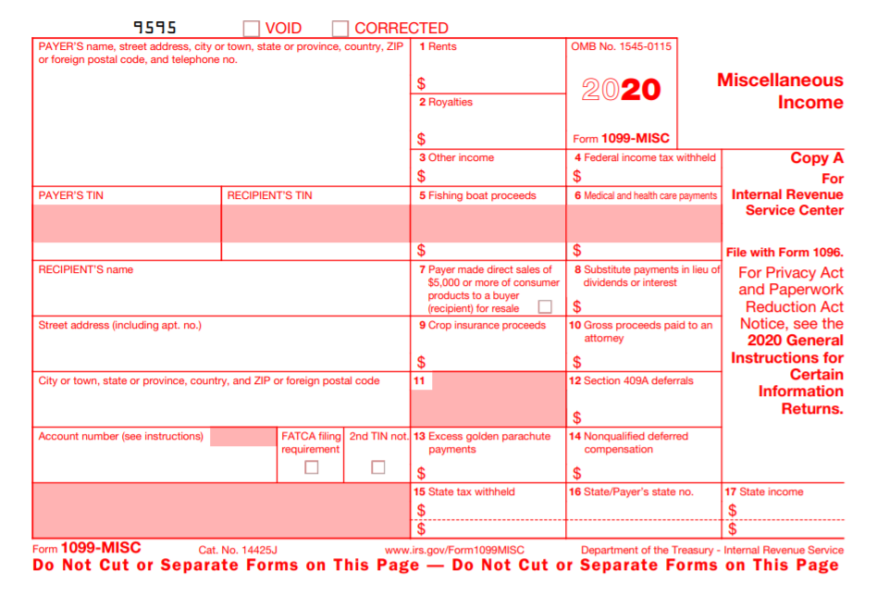
The form is a red and white form for Miscellaneous Income. It requires a payor to provide its address, its taxpayer identification number, the payee’s taxpayer identification number, the payee’s name, the payee’s address, rent/royalties/other income, taxes withheld, and medical and health care payments.

Key Terms
- Actual authority
- Agency
- Agent
- Apparent agency
- Duty of care
- Duty of loyalty
- Employee
- Employer-employee relationship
- Estoppel
- Indemnification
- Principal
- Principal-agent relationship
- Respondeat superior
- Vicarious liability

Review Questions

- Identify who the parties are in an agency relationship.
- Explain the differences between agency by estoppel and apparent authority.
- Is money required for a principal-agent relationship to be found? What about an employer-employee relationship?
- What duties does a principal owe to an agent?
- How can a principal and agency relationship be ended?
- Have you ever acted as an agent for someone else? If so, how?
- How is principal-agency different from an employer-employer relationship?
- When are employers responsible for the actions of their employees?

Web Links
We will be using the California Secretary of State’s website for business entities in the State of California quite a bit in this book. Please go to the forms website (located at: https://www.sos.ca.gov/business-programs/business-entities/forms/) and familiarize yourself with this website.

Exercise
Start preparing timesheets for the work you do in this class, so you can get used to preparing timesheets in a law firm.
Time should be keep in increments of 6 minutes. This means that the hour is divided into 10 segments. Most attorney-client fee agreements (which also cover paralegals, state that if we work 8 minutes, for example, we round UP to the nearest increment, which would be a .2). Once we get to over an hour, we put time in the following format: 1.2 for an hour and twelve minutes.
0-6 minutes= .1
7-12 minutes= .2
13-18 minutes= .3
19-24 minutes= .4
25-30 minutes= .5
31-36 minutes= .6
37-42 minutes= .7
43-48 minutes= .8
49-54 minutes= .9
55-60 minutes= 1.0

You also need to learn how to phrase your time so that your supervising attorney will approve it. Instead of writing: “Read Chapter 1,” write “Review and Analyze Chapter 1.” Review and Analyze is what you should write whenever you read something in law.
When you write something for a homework assignment, you should call it “Draft,” so for example, you “Draft Removal Pleading.” If you edit your pleading, then you could separately bill for that as: “Finalized Removal Pleading.”
For timekeeper, you put down two initials. Thus, Arabella Jimenez would be aj (lowercase for paralegals).
The date should always be the date you performed the task.
Typical format:
Date | Assignment | Description | Timekeeper | Time

Chapter on Sole Proprietorships

Student Learning Objectives
- Learn how to define a sole proprietorship.
- Be able to outline the documents necessary to start a sole proprietorship.
- Explain how liability works in a sole proprietorship.

Introduction to Sole Proprietorships
When one person owns a business, it can be a sole proprietorship. A sole proprietor is not incorporated and has unlimited personal liability for the sole proprietorship, which is just treated as an extension of the sole proprietor. It is easy to form a sole proprietorship and may only require a business license. There are a lot of sole proprietorships in the United States as a result.
The following case indicates that sole proprietorships are considered extensions of the individual as discussed in this section and that sole proprietorship business interests are personal property. Reading cases is a major way in which legal professionals learn the law.

Full Case Name
The full case name of the case below is:
Carol K. Munstermann, Personal Representative of the Estate of Jodi Sue Rowe, Deceased, appellee, v. Alegent Health - Immanuel Medical Center, a not-for-profit corporation, and Hudson Hsieh, M.D., appellants.

Short Case Name
The short case name for the Mustermann case is: Mustermann v. Alegent Health.

The formula for deriving the short case name is to take the last names of the first plaintiff and defendant
or
Short case name = first plaintiff's last name [here Mustermann]+ first defendant's last name [here is a business, so a shortened business name, Alegent Health]

Cases are traditionally found in books called Case Reporters. Case Reporters are bound volumes of cases. In the example below, there are three.

Reporter
271 Neb. 834 *; 716 N.W.2d 73 **; 2006 Neb. LEXIS 92 ***
The first two are physical volumes of cases. The third one is an electronic version. Let's look at each one separately.

1. 271 Neb. 834. This is the 271th volume of the Neb. reporter. The page the case starts on is 834. Thus, 271 Neb. 834 is an 'address' of where to physically find that case.
2. 716 N.W.2d 73. This is the 716th volume of the N.W.2d [second] reporter. The case starts on page 73. Thus, 716 N.W.2d 73 is an address of where to physically find that case.
3. 2006 Neb. LEXIS 92. If there are other addresses, this one is ignored as it is 'only' an online publication.

Case: England v. Simmons
England v. Simmons
295 Ga. 1; 757 S.E.2d 111 (2014).
Robert Carl Haege died in December 2006. Three months earlier, Haege had made a will, in which he left his “personal assets” to his brother and sister, and in which he left his “business interests, both tangible and intangible, real or personal, connected to the business known as Traditional Fine Art, Ltd.” to his brother, sister, and two longtime employees. After Haege died, questions arose about the disposition of property associated with Traditional Fine Art, Ltd., insofar as Traditional Fine Art was a sole proprietorship and, therefore, had no legal existence separate and apart from Haege himself. [emphasis added] The will was admitted to probate, and Sharon Haege England — Haege's sister — was appointed as executrix of his estate. England failed to distribute any property to James S. Simmons and Elery Stinson — the two longtime employees — and they filed this lawsuit against England, seeking a declaratory judgment as to the meaning of the will with respect to the property associated with Traditional Fine Art. The trial court entered a final judgment for England, concluding that, because Traditional Fine Art was only a sole proprietorship, the property associated with the business was merely the personal property of Haege, and there was, therefore, nothing to pass under the “business interests” provision of the will.
Simmons and Stinson appealed, and in a split decision, the Court of Appeals reversed. Simmons v. England, 323 Ga. App. 251 (746 SE2d 862) (2013). The majority of the Court of Appeals looked to the intention of the testator as evidenced by the plain terms of his will, and it concluded that Haege evidently meant to differentiate between his personal property “connected with the business known as Traditional Fine Art, Ltd.” and his other “personal assets.” Id. at 253-254. Noting that “the intention of the testator must prevail,” and noting as well that “operation is to be given to every part of [the will] if this can be done without violating its terms or the intention of the testator,” the Court of Appeals concluded that Simmons and Stinson were entitled — along with England and her brother — to share in any “business interests, both tangible and intangible, real or personal, connected to the business known as Traditional Fine Art, Ltd.,” and the existence and identity of such property were “simply issues for the factfinder, which must identify the business interests.” Id. (citations and punctuation omitted). Two judges dissented, reasoning as the trial court did that a sole proprietorship has no legal existence and that all property connected with the business was merely the personal property of Haege. Id. at 254-255 (Boggs, J., dissenting). On the petition of England, we issued a writ of certiorari to review the decision of the Court of Appeals, and we now affirm.
In this Court, England does not dispute the fundamental premise of the decision of the Court of Appeals — that a sole proprietor may separately dispose in his will of personal property connected with his sole proprietorship and his other personal property — and she is right not to dispute it…. Instead, England argues that Haege did not actually intend to separately dispose of any property associated with his sole proprietorship. In support of this argument, England points to the sentence of the will that immediately follows the provision leaving “business interests … connected with the business known as Traditional Fine Art, Ltd.”:
It is specifically the intent of this provision that [James] S. Simmons enjoy, after this bequest, thirty[-]four (34%) percent of the outstanding member certificates, that Elery Stinson enjoy seventeen (17%) percent of the outstanding member certificates, [and] that James E. Haege and Sharon Haege England each enjoy twenty[-]four[-]and[-]one[-]half (24.5%) percent of the outstanding member certificates.
This sentence, England says, limits the “business interests” referenced in the preceding sentence to membership certificates evidencing ownership of Traditional Fine Art, and since it remained a sole proprietorship when Haege died, she concludes, there are no such membership certificates. The provision concerning “business interests,” England argues, was meant to apply only in the event that Haege organized his sole proprietorship as a separate legal entity, which he never did.
The problem is, if Haege meant only to direct the disposition of nonexistent membership certificates, he could have done so quite simply with the sentence upon which England relies, and he could have omitted nearly all of the preceding sentence about “business interests.” Moreover, that preceding sentence must refer to something more than membership certificates, insofar as the ownership interest represented by such certificates is indisputably intangible personal property, but in the preceding sentence, Haege referred to “all of my business interests, both tangible and intangible, real or personal, connected to the business known as Traditional Fine Art, Ltd.” If such “business interests” only meant membership certificates, the references to tangible and real property would have no meaning and would, in fact, be nonsensical.
(1) Taking the will as a whole, the most natural and reasonable understanding of these provisions is that Haege left his personal property that amounted to “business interests … connected to the business known as Traditional Fine Art, Ltd.” — specifically including, but not limited to, membership certificates that he owned, if any — to Simmons, Stinson, and his brother and sister, and he left all of his other personal property to his brother and sister alone…. That is how the majority of the Court of Appeals understood the will, and it was correct to do so. We also find no error in the conclusion of the Court of Appeals that the precise identification of the property amounting to “business interests … connected to the business known as Traditional Fine Art, Ltd.” “are simply issues for the factfinder.” Simmons, 323 Ga. App. at 254 (citation omitted). Accordingly, we affirm the judgment of the Court of Appeals.

II. Forming a Sole Proprietorship
A sole proprietor can start a sole proprietorship by starting to transact business. There are usually not documents a sole proprietor must prepare at a state or federal governmental level. Even with taxes, the taxes for the sole proprietorship can be just additional forms for the sole proprietor’s regular taxes. Schedule C is Profits and Losses of the Business and gets added to a 1040, for example. It is a good idea to have a business license, which is often done at a county or city level, to make sure businesses are legitimate in the area.
If a sole proprietor does have employees, she will need to obtain a Federal Employer Identification number (https://www.irs-ein-tax-id.com/?gclid=Cj0KCQjwm9D0BRCMARIsAIfvfIbWZ2RoK9HhHJ9X6EKJzbZPgAqHoWoIFCT7mZBgFYAzX1Q3-q4yizMaAjquEALw_wcB). If the sole proprietor does not have employees, she can use his Social Security number on her taxes. If the sole proprietor uses their legal name for the business, then they do not have to do the paperwork for a fictitious business name. If the name is at all different from the person’s legal name, then the sole proprietor should file a fictitious business name for their sole proprietorship.
For a business license, the main purpose of it as indicated above, is that cities and counties want to make sure that businesses within their borders are conducting legitimate business, including salespeople. There is a legal “fiction” that a sole proprietor has an agreement with herself on how to conduct the business, but legally it is not possible to have agreement without two people.
One of the hard parts of starting a sole proprietorship is that one person has limited ability to raise money. To start a business the sole proprietor must often go into debt. An individual can only borrow so much money, based on her credit history and assets. One of the businesses with the least success rate percentages is restaurants. Restaurants are expensive businesses to start. They need a large amount of highly specialized equipment. Raising this amount of money or going into this amount of debt as a sole proprietor is difficult. The sole proprietor could use money she has, if she has any. She could borrow against a house or retirement funds.

Management of a Sole Proprietorships
A sole proprietor can manage the business by herself or pay someone to manage the business for her. If she manages the business herself, she must handle any employees herself. Oftentimes, this can be an issue. A person might want to start a small business, doing something that was formerly a hobby of hers, such as a cake pop business. If the cake pop store owner has good business management skills, this works well. If the cake pop store owner has poor business management skills, this does not work well. Again, the cake pop store owner could hire a business manager, but this does add to the cost of running the business. There are numerous other business decisions to be made, such as vacations and pursuing new business.

Liability of a Sole Proprietorship
A sole proprietor is essentially the same as the sole proprietorship and the business runs as an extension of her. She is therefore fully liable for all the business’s liabilities. If the business is sued, the sole proprietor responsible for paying the lawsuit settlement (unless there is insurance). If the sole proprietor’s employees are negligent, the sole proprietor may have to pay for that negligence. The sole proprietor’s personal assets can be used to pay these business liabilities, if the liabilities are greater than the business assets. Money in a personal account, a car, a home, etc. can be used to pay these business liabilities.
This liability can be reduced by having business liability insurance. The liability could be reduced by the amount of the insurance policy. Another way to limit some of this liability is through contracts. There can be liability contracts signed when agreeing to perform work for a client.

Continued Existence of Business and Transferability
It can be difficult to sell a sole proprietorship, in particularly if the business sells services, such as tax preparation. When people hire a tax preparer, they are often hiring a specific person that they want, rather than any tax preparer. Thus, if the business owner changes, the business may not be successful. The ownership could change through a sale or through a being willed to someone. It may be better, in some instances, to shut down the old business and start a new one, rather than try to take over for the first business owner.

Profits and Losses of Sole Proprietorships
Since the sole proprietor owns the business by herself, she gets to have all the profits and the losses of the business. Profits can come from selling goods or from selling services. All the losses of the business belong to the sole proprietor and she can deduct as many of them as she is able to off her individual taxes.

Taxation of the Sole proprietorship
There are taxation benefits to operating as a sole proprietor. One is the ease of filing taxes comparatively to some other business entities. The sole proprietor may use their current federal tax form and add a Schedule C. Schedule C looks at the profits and losses from the business. Losses can be used to offset some profits, so that the sole proprietor may have to pay less in taxes.
Schedule C also allows for business deductions, some of which are listed: advertising, car expenses for business purposes, liability insurance, interest payments, professional services (i.e. tax preparation), rent, supplies, business license, business entertainment, travel, and wages. An individual’s tax rate is normally less than a corporate tax rate, so the sole proprietorship is often taxed less than a corporation.
The sole proprietor may have to pay self-employment tax and Federal Insurance Contribution Act (more commonly known as FICA). FICA is a combination of Social Security and Medicare. This is paid for the sole proprietor and any employees. Retirement is an additional consideration and may provide additional tax benefits.

Schedule C: Profit or Loss from Business

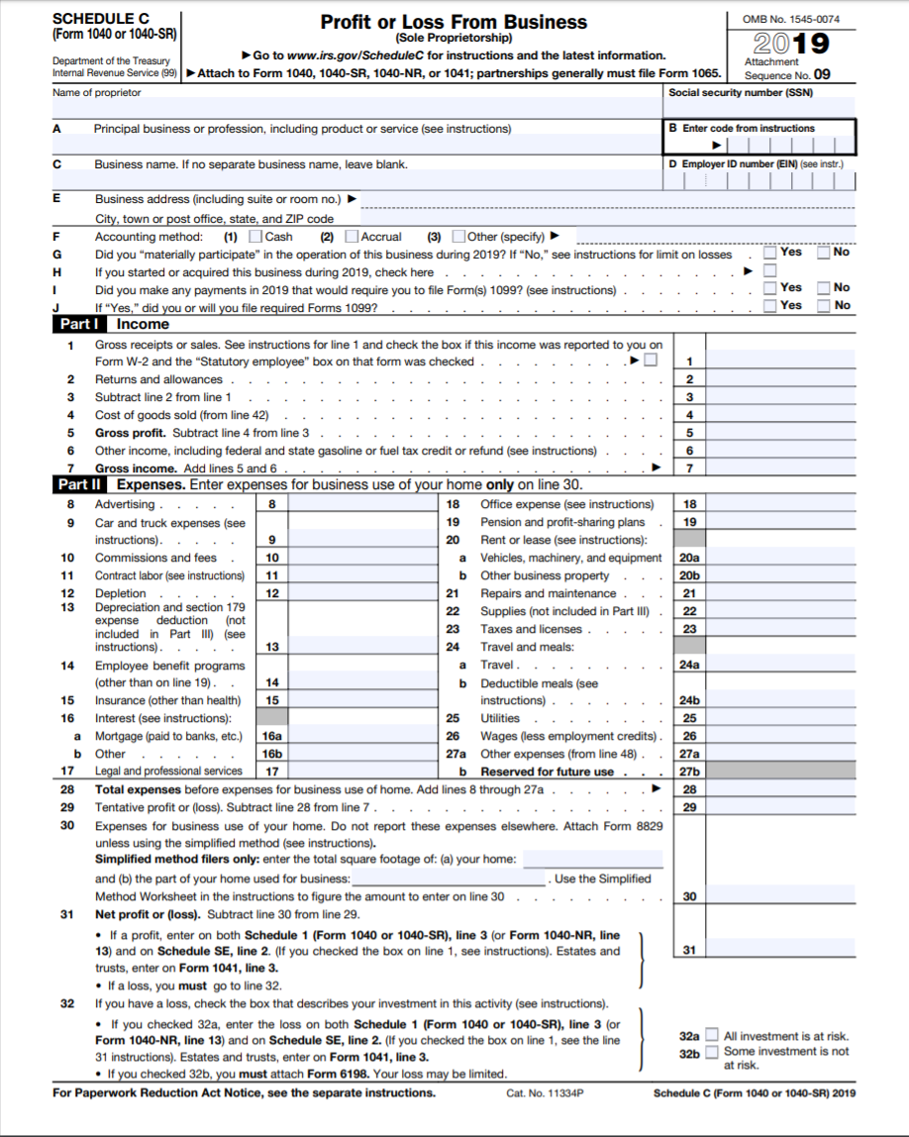

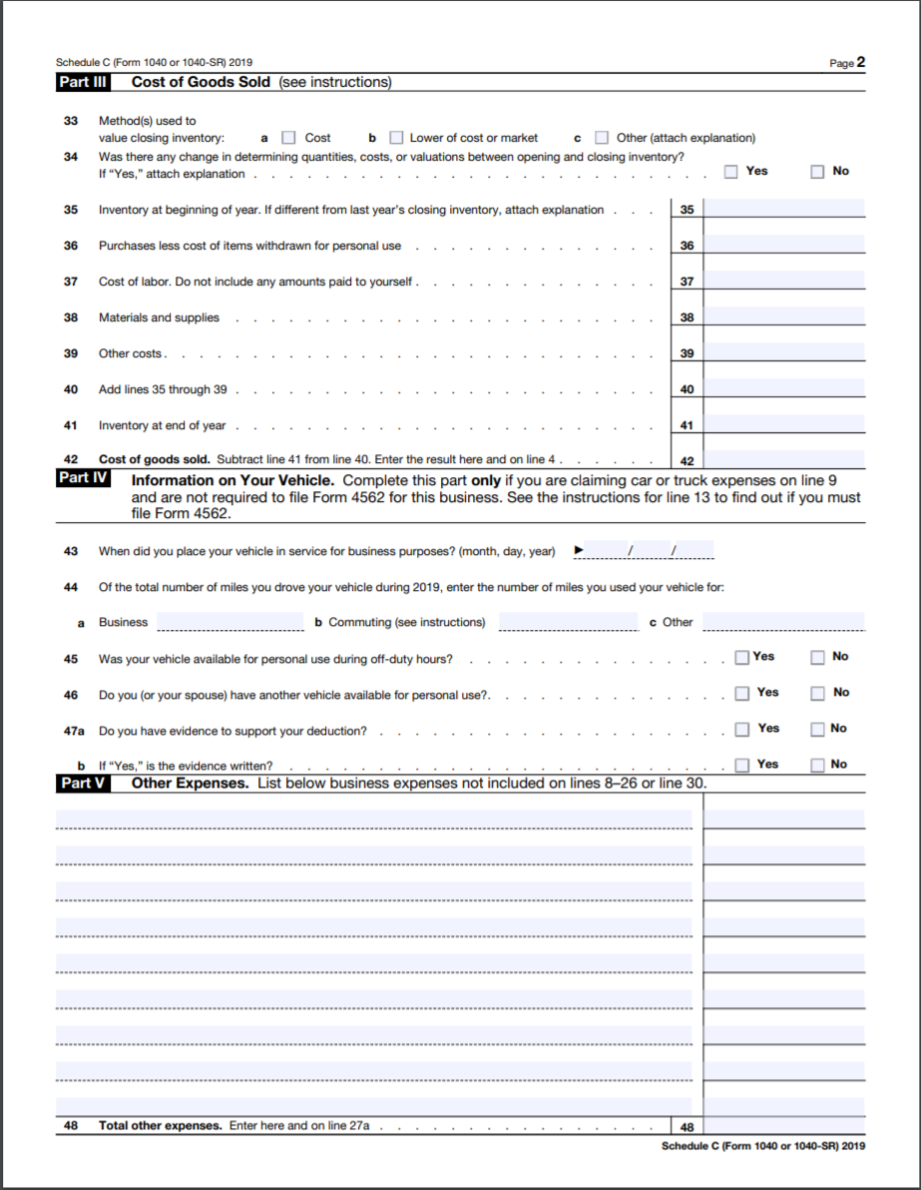
The Schedule C, which is a black and white form, attached to the Form 1040 goes into more detail. Sales, returns, and costs of goods are looked at first. Then, several more business deductions are discussed such as: advertising, automobile expenses, commissions, contract labor, depreciation, employee benefit, insurance, interest, mortgage, legal and professional services, office expenses, pensions, rent, business property, repairs, supplies, taxes/licenses, travel and meals (both for entertaining and not), utilities, and wages.

Termination of the Sole Proprietorship
Since there is so little business formation required for a sole proprietorship, there is very little that needs to be done to end the sole proprietorship. The sole proprietor can just decide to terminate. She should file a final Schedule C, Profits and Losses of the business with the Internal Revenue Service. She could also notify the city/county that issued the business license that she is ending the business.
The sole proprietor could close the business entirely or try to sell it. When selling, she is selling the business assets and the goodwill (the thing that makes someone chose that business over others). If the goodwill is wrapped up in the sole proprietor, again, it can be difficult to sell that portion. The sole proprietorship can terminate when the sole proprietor passes away.

Key Terms
- Fictitious business name statement
- Insurance
- Personal liability
- Sole proprietor
- Vicarious liability

Review Questions
- Fully discuss flexible management in a sole proprietorship.
- How can the unlimited personal liability be limited somewhat in a sole proprietorship?
- How is a sole proprietorship taxed?
- When might it be difficult to buy and sell a sole proprietorship?

Web Exercise
In general, this website is a great free resource for researching a variety of legal issue. http://www.law.cornel.edu (Links to an external site.). Go to the website. Determine where the United States Code, Federal Rules of Civil Procedure, and US Supreme Court opinions are.

Chapter on General Partnerships

Student Learning Outcomes
- Discuss how a general partnership is formed.
- Determine why management in a general partnership can be problematic.
- Compare and contrast the liability in a general partnership with a sole proprietorship.
- Be able to explain the sharing of profits and losses among partners.
- Appreciate the difference in taxation from a sole proprietorship.

Introduction to General Partnerships
A partnership is a business entity with at least two people who act as co-owners of a business, in order to make money. The business entity must be voluntary, meaning that the partners are part of the general partnership of their own free will. Each partner in a general partnership starts out on an equal footing, though that can change through a contract, here known as the partnership agreement.
There always must be at least two people in a partnership for it to stay a partnership. An interesting note is that in law, people also include corporations. So, there could be two corporations joining to make a partnership. However, if two corporations do not form a partnership, and the partners are people, the individual partners are liable for the acts of their partners and not just their own acts (like in a sole proprietorship). This is greater liability than in a sole proprietorship.
The partners must be working or acting for an active business. That means the partnership is seeking new business, not trying to retire or end the business. Unless there is a writing to the contrary, the partners share the profits, losses, and management of the general partnership. The partnerships goal is to make a profit. This may not be economically feasible while the business is getting up and running.
Nationally, there are two general acts that states usually adapt and make their own for governing general partnerships. These two acts are the Revised Uniform Partnership Act (RUPA) and the Uniform Partnership Act (UPA).
Almost all states follow the Revised Uniform Partnership Act, which is based off the Uniform Partnership Act. In addition to the version of RUPA or UPA that a state adopts and modifies as law, partnerships are governed by the partnership agreement and common, or case, law. Under RUPA, a partnership is separate from the partners. Note that in this regard, a partnership is different than a sole proprietorship, which is an extension of the sole proprietor. The partnership can own property in the partnership’s name, the partnership can contract, and the partnership can be sued.

Formation and Financing of General Partnerships
Sometimes people form a general partnership without conscious thought to doing so. If people act as general partners to third parties, then the law will probably uphold that they are a general partnership. This can happen in industries where people work closely together, such as real estate agents. One realtor might be selling the home, but having another person show it. The first realtor should have a written contract in place clarifying the relationship, as to third parties coming to view the house, it might look like the two realtors are partners. Sharing profits can also create a de facto partnership.
It is easier and cheaper to form a general partnership than a corporation. General Partnerships do not have a minimum capital contribution to start, so the partners do not have to have a lot of money to form a general partnership. So, while cheaper to start, general partnership may become much more expensive in the long run, do to unlimited personal liability for the acts of partners.
It is easier to get start-up loans as a general partnership than a sole proprietor as there is more credit history and assets to draw from with two or more people than one person normally. However, it is more difficult to raise money than in a corporation, where a corporation can sell shares to earn money.
The name of a general partnership could be a combination of the partners’ last names or it can be a fictitious name (the partnership would need to file a fictitious business name statement). There can be state filing fees in forming a general partnership, which is usually minimal. The expense in formation comes from drafting a legally adequate partnership agreement. The partnership should pay for a well drafted partnership agreement though as this can prevent lawsuits and costly issues from arising later. While not required to have a partnership agreement, it is highly recommended.
The following case is about one company attempting to argue that there is an implied partnership. While the company did not win, this case is helping to read to determine what a court looks at when determining whether an implied general partnership will be found. Pay particular attention to the court finding that there was not profit sharing, not sharing of assets, and not sharing of losses.

Case: Big Easy Cajun Corp. v. Dallas Galleria Ltd.
Big Easy Cajun Corp. v. Dallas Galleria Ltd.
293 S.W.3d 345 (2009).
Dallas Galleria Limited sued appellants on two imputed liability theories: limited partnership and single business enterprise. The trial court granted appellants a directed verdict on the limited partnership theory, but Dallas Galleria Limited obtained a jury verdict--and the trial court signed a judgment--on the single business enterprise theory. Both parties appealed the judgment on multiple grounds. For the reasons discussed below, we reverse the trial court's judgment and render judgment that Dallas Galleria Limited take nothing by its suit against appellants.
BACKGROUND
In 1999, Dallas Galleria Limited ("Galleria") entered into a lease with Big Easy Cajun - Dallas, Inc. ("BEC Dallas"), whereby BEC Dallas would operate a food-court restaurant in the Galleria mall for ten years. In 2002, BEC Dallas defaulted on the lease and abandoned the premises. Galleria sued BEC Dallas for breach of the lease. When BEC Dallas failed to answer, Galleria obtained a default judgment in the amount of $ 459,732.17, plus attorney's fees, costs, and interest (the "Default Judgment"). The Default Judgment was not satisfied.
In 2003, Galleria brought a new suit against appellants seeking to enforce the Default Judgment against them under the single business enterprise theory. Appellants include other food-court restaurants, an operating company, and a management company; all are organized as independent corporations. Subsequently, Galleria amended its petition to allege an implied partnership among appellants and BEC Dallas as another reason why they should be required to satisfy the Default Judgment. The case was tried to a jury, but after Galleria's case in chief, the trial court directed a verdict against Galleria on its implied partnership claim. The jury returned a verdict in favor of Galleria on the single business enterprise claim and assessed Galleria's damages at $ 283,112.38. The trial court's judgment included those damages, plus attorney's fees, costs, and interest.
Both parties appealed, raising multiple issues. However, during the pendency of the appeal, the Texas Supreme Court issued an opinion on the theory of single business enterprise that controls this appeal. See SSP Partners v. Gladstrong Investments (USA) Corp., 275 S.W.3d 444 (Tex. 2008). We address appellants' first issue on the viability of the theory of single business enterprise in light of SSP Partners. And because we conclude SSP Partners requires us to reverse the trial court's judgment on the single business enterprise theory of liability [removed], we review Galleria's conditional cross-point concerning the viability of its implied partnership theory of liability….
IMPLIED PARTNERSHIP
Galleria filed its own notice of appeal and included a conditional cross-point. Galleria urged that--if we reversed the jury's verdict on single business enterprise--it was entitled to a new trial on the issue of implied partnership. Galleria argues the trial court erroneously granted a directed verdict on the implied partnership issue because it produced more than a scintilla of evidence on that theory. A directed verdict is proper if there is no probative evidence raising a material fact dispute on a claim. Prudential Ins. Co. of Am. v. Fin. Review Servs., Inc., 29 S.W.3d 74, 77 (Tex. 2000). In reviewing a directed verdict, we consider all of the evidence in a light most favorable to the party against whom the verdict was directed and disregard all contrary evidence and inferences; we give the losing party the benefit of all reasonable inferences created by the evidence. Coastal Transp. Co., Inc. v. Crown Cent. Petroleum Corp., 136 S.W.3d 227, 234 (Tex. 2004).
A partnership is "an association of two or more persons to carry on a business for profit as owners." TEX. REV. CIV. STAT. ANN. art 6132b-2.02 (a) (Vernon Supp. 2008). We look to the following factors to determine whether persons have created a partnership:
(1) receipt or right to receive a share of profits of the business;
(2) expression of an intent to be partners in the business;
(3) participation or right to participate in control of the business;
(4) sharing or agreeing to share:
(A) losses of the business; or
(B) liability for claims by third parties against the business; and
(5) contributing or agreeing to contribute money or property to the business.
Id. art.6132b-2.03(a). The most important of these factors are sharing profits and participating in the control of the business. Id. Comment of Bar Comm. - 1993 ("Traditionally, sharing of profits and of control have been regarded as the most important. They will probably continue to be the most important under this section.").
As to sharing of profits, Galleria argues profits of individual restaurants were "siphoned into" Big Easy Cajun - Management Corporation and Florida Operations Corporation under the guise of management fees and license fees, or royalties. Then, according to Galleria, the siphoned funds were paid out as dividends to the two men who were major shareholders of the various corporations. Even when we consider this evidence in a light most favorable to Galleria and disregard all contrary evidence and inferences, see Coastal Transport, 136 S.W.3d at 234, there is no probative evidence of profit sharing. Undisputed testimony in the record established the individual restaurants, including BEC Dallas, received specific administrative services in return for their management fees. These payments were compensation for services rendered and are, therefore, unrelated to the restaurant's profits. See Schlumberger Tech. Corp. v. Swanson, 959 S.W.2d 171, 176 (Tex. 1997). And as to the royalties, which individual restaurants paid for use of the corporate marks, the Texas Supreme Court has asserted that entitlement to a royalty based on gross receipts is not profit sharing. See id. Our review of the record does not yield a scintilla of evidence that any of the appellants agreed to share profits.
We next address Galleria's argument based upon participation in the control of the business. Galleria argues the Florida Operations Corporation retains control of the Big Easy Cajun intellectual property. It charges that the operations corporation "controls" the amount of license fees to be paid, and the management corporation "controls" the amount of management fees to be paid. These matters represent part of the agreement between operators of an individual restaurant and the other corporate entities. The entity that owns intellectual property safeguards its value, and the entity performing administrative tasks for one business receives payment for those services. Galleria asserts that performing those administrative tasks also represents the corporations' participation in the control of the business. Again, even when we consider this argument in a light most favorable to Galleria and disregard all contrary evidence and inferences, see Coastal Transport, 136 S.W.3d at 234, the record shows no evidence of a sharing of control in the various businesses.
Nor does the record contain evidence of the remaining partnership factors. The appellant entities did not share losses. The undisputed evidence at trial was that, once BEC Dallas was operating, individual shareholders made capital contributions to keep it running; none of the other corporate entities made such contributions. Finally, one of the majority shareholders of the corporations was asked why he organized his businesses as separate corporations. He responded that he did not want a problem at one restaurant to endanger all of his different ventures. This statement is clearly contrary to any implied agreement to share liabilities for claims by third parties against the business.
We conclude there is no probative evidence raising a material fact dispute on Galleria's claim of implied partnership. Prudential Ins., 29 S.W.3d at 77. The trial court correctly granted the directed verdict on that claim….

Public Document for a General Partnership
Most states require a general partnership to file a public document that can be researched at that state’s Secretary of State Website. One of the reasons the Secretary of State maintains this information is to make it easier for those injured by a business entity to sue. Typically, when forming a business entity, the business entity will have to name an agent for service of process (someone who accepts lawsuits on behalf of the business entity). There are a variety of different names for this public document, such as a “Statement of Partnership Authority.” Other information that may be required on the form is: the partnership’s name, the employer identification number, the address of the principal place of business for the general partnership, names and addresses of the partners, and those partners who can legally bind the partnership.

Web Exercise
Go to the website below, read through the instructions and the form on how to prepare a Statement of Partnership Authority in the state of California.
https://bpd.cdn.sos.ca.gov/gp/forms/gp-1.pdf

Private Document for General Partnership
If there is no private document, a partnership agreement, for the general partnership, then the partnership will be governed by state statutes on partnerships (adapted from either RUPA or UPA discussed supra). This may not be as favorable to the partnership or partners as a well-drafted partnership agreement. A partnership can be formed through oral agreement, though this is not recommended. The better practice is to have the agreement in writing, even though oral agreement or even actions can be used to form or find a partnership exists. There are many different things that a well-drafted partnership agreement should cover. For instance, the partnership agreement should have the legal name of the partnership (i.e. the one from the fictitious business name statement, if any), the names and addresses of the individual partners (this would be their personal addresses; this is a private document), the purpose of the partnership, the address where the main business of the partnership takes place, how long the partnership is supposed to go on for, what each partner is contributing to the partnership, how to go about getting additional financial contributions (if needed), an accounting of partnership assets, discussion of handling profits and losses, liability for individual partners, how changes to partners may be made, how the partnership may be dissolved, the law that should apply to the partnership (i.e. a specific state), the date, and signatures of all the partners.
When delineating the purpose, it should be broadly draft. For example, if the initial goal of a general partnership is to sell cashmere sweaters, it should be drafted more broadly: “To sell wearable apparel.” This lets the client’s business grow without having to constantly be modifying the partnership purpose.
The principal place of business is an important part of the agreement. This address is where the business records are to be kept. They need to be at a known location so that partners can verify how much they are owed, etc. by checking the books. In the partnership agreement, the contributions each partner makes should be spelled out, along with the percentage of profits each partner is entitled to as a result. Otherwise, in a general partnership agreement, each general partner will receive an equal amount to all other partners of the partnership’s profits. A discussion of any additional, future contributions needs to be discussed too. A partner does not have to always contribute in dollars to the partnership. Different people have different assets. A partner could contribute or borrow again real property to help fund the partnership. Another partner might not have any cash or real property assets but may have ideas that are marketable or worth money, known as intellectual property.
Intellectual property: ideas that are marketable or worth money.
If there is partnership property, the property should be referred to in the partnership agreement, along with partners’ interest in that property. If the partners’ interests in that property are not discussed, then the property is solely the partnerships. Partners do not automatically draw a monthly salary, so pay for partners should be covered in the partnership agreement.
Management, if not discussed in the partnership agreement, is then shared equally. If the partners desire another arrangement, they should specify the arrangement in the partnership agreement. It can be a problem when, for example, there are two partners and they do not specify. If they do not specify, then each of the two partners would have fifty percent (50%). If they did not agree, neither one would be able to break the stalemate, as neither one has more than 50% of the vote.
New partners typically require all partners to agree, unless the partnership agreement states otherwise. If there are a lot of partners, it may be just about impossible to get them all to agree. Therefore, in particularly with more partners, the partnership agreement should change the unanimous agreement, to perhaps a simple majority agreement to add a new partner.
Even when starting the partnership by drafting a partnership agreement, the end of the partnership should be envisioned. The partnership agreement could state a specific date on which the partnership should end. The partnership agreement could state that the partnership continues at the will of the partners. If at will, the partnership agreement could further identify whether all partners must agree to stop and wind up the partnership, or whether only some of the partners must withdraw from the partnership for it to be terminated.
There are many more additional provisions that can be placed into a partnership agreement, which is a contract. These are the bare minimum that should be discussed in the agreement. Since it is a contract, it should be dated and include signatures of the partners.

Management of the Partnership
As indicated above, if the partnership agreement does not state, then all partners share management equally. This means if there are two partners, they each get a 50% say. If there are four partners, they each get a 25% say. The success of any business depends in large part on the management of that business. There may be times where it is not in the best interest of the business or making a profit to have all partners equally managing. It may even be best to have one managing partner. Oftentimes, partnerships will have someone more experienced in management handle the management and the other partners handle more the purpose of the partnership, whether that be services or selling goods.
Agency law applies to partnerships. This is part of the reason agency law was discussed early in this text. The partners owe each other a duty of loyalty and fiduciary duties as they are agents of each other. Partners are supposed to act in the best interest of the partnership, and not in their own personal best interest. Partners need to act with due care towards each other and the partnership. The individual partners should not act negligently. If a partner did act with negligence, then that partner will be liable to the partnership. If a partner acts negligently to a third party, this is affecting his other partners, who are also liable, under a general partnership, for his actions (unless the partnership agreement has made other arrangements).
As agents of each other, one partner can usually bind all the partnership (and thus the other partners) to a contract that the one partner signed. There is a document called a “Statement of Partnership Authority.” This is a public document, signed with the Secretary of State for the state that the partnership has its principal place of business. This statement gives the public, if they know about it, notice of which partners in a partnership have the authority to legally bind the partnership to contracts. There is another document, called a “Statement of Denial” or similar, which states that certain partners do not have the authority to bind the partnership. If a third party knows about a statement of denial and still signs a contract with a partner without legal authority to bind the partnership, the contract would be not be legally binding on the partnership. The general public does not know about statements of authority or statements of denial, so these documents have limited effectiveness.
Statement of Denial
The Statement of Denial is a simpler form. It requires the name of the partnership; the fact denied, which can include denial of authority or status as a partner; and being signed under penalty of perjury. For full instructions, go to: https://bpd.cdn.sos.ca.gov/gp/forms/gp-2.pdf
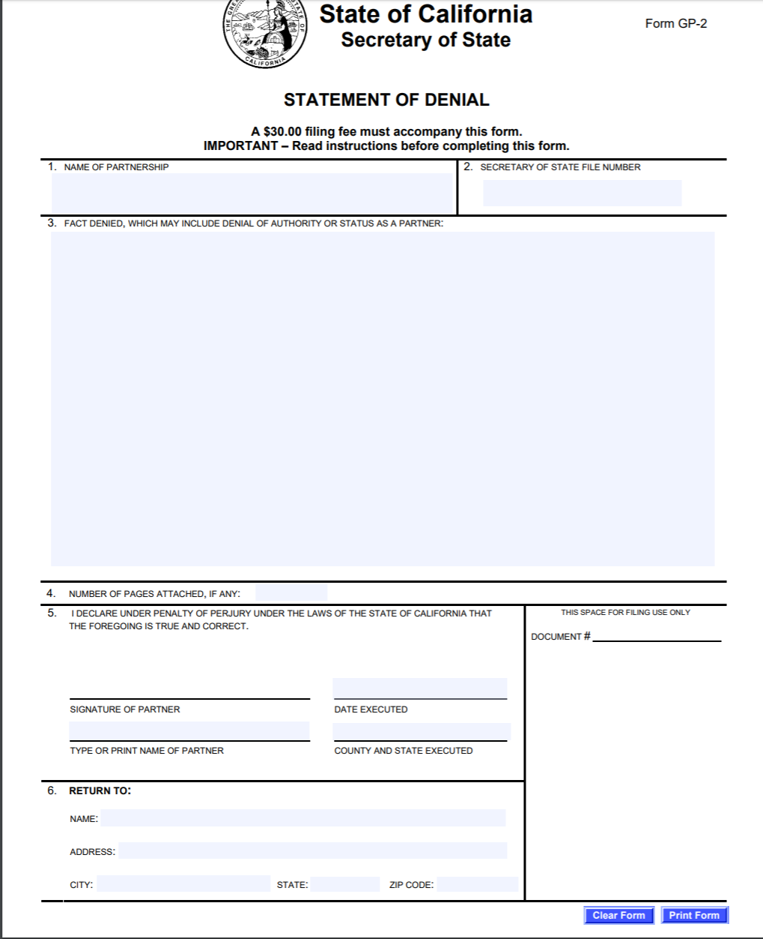

The law holds there are some things that all partners must unanimously consent to. Such things include giving property to creditors, getting rid of the goodwill of the business, waiving the partnership’s right to a jury trial, and acts that are outside of the partnership agreement. Other things are often voted upon and pass by a majority vote.

Liability of the Partnership
The liability in a general partnership is perhaps the worst of any business entity. It is worse than in a sole proprietorship. In a sole proprietorship, the sole proprietor is only responsible for her own negligence. In a general partnership, each partner is responsible for his own negligence and the negligence of his other partners.
To understand what a bad deal a partnership can be for the individual partners, we need to understand the concept of joint and several liability. The idea is beneficial to plaintiffs; joint and several liability makes it easier for plaintiffs to successfully sue someone when first filing the complaint. Oftentimes, a third party going to a storefront, for example, will not know all the owners or partners of that storefront. If the plaintiff had to know all the names of the partners from the beginning to not have her complaint kicked out of court, this would be very difficult. Once a complaint is filed, discovery to find out who the other partners can take place, and the plaintiff can amend her complaint to include the partners, if necessary. The law is under joint and several liability that the plaintiff can put down one partner or any other combinations of partners, if there are not zero partners. Whomever the plaintiff names at the beginning of the lawsuit should answer the complaint. The plaintiff can choose to amend or not amend the complaint, after discovery, to include more or all of the partners. If the plaintiff does not choose to amend the complaint and sticks to only having some of the partners’ names, then those partners would be initially responsible for paying for up to one hundred percent (100%) of the lawsuit. The partners named on the lawsuit, after paying, could then turn around and seek reimbursement from the other partners. During the lawsuit, the partners could also join the other partners into the lawsuit but may not desire to as it often costs more money. Reimbursement may just be the cheaper way to go.
Another concept important to understanding partnership is the concept of marshalling of assets. If there is a settlement award against the partnership, all partnership assets necessary to pay that award must be used first. If there is still money needed to pay for the award, only once all the business assets are depleted may the personal assets of the partners be used. When discussing liability, please remember that the liability discussed here is if the partnership agreement does not change the liability. How a lot of partners get around all this liability is to carry high amounts of liability insurance.

Continuance of the Partnership Business
The partnership will most likely stay in business so long as it is making a profit and continues to have partners. If a partner wants out of the partnership, this may create issues. Without a writing otherwise, the partners must all agree unanimously to sell a partner’s interest and rights to proof. A partnership is voluntary and not allowing everyone to vote on changing a partner is not considered voluntary. Voting also allows the partnership to figure out what to do if they are losing a partner’s contribution and need to replace it. If all partners agree, the one partner sells his interest and the partnership continues.

D. Profits and Losses of the Partnership
A partner has an interest in the partnership and a right to partnership profits. The partnership may have its own property. The partner’s interest would be in that property, which is separate from the partner’s individual property. This can become confusing when the partner contributes of property to the partnership; if nothing is in writing, that property does become the property of the partnership. An interest in the partnership property may not be sold without the agreement of the partners.
Profits of the partnership are owned by each partner, according to their interest in the partnership agreement, and if none, in equal share to each other. Another reason why people do not, on purpose, frequently chose a partnership, is that no matter how much one partner contributes, he gets an equal share to a partner that put in every little (unless the partnership agreement states otherwise). Thus, if partner A puts in ninety percent (90%) of the partnership property and partner B puts in ten percent (10%) of the partnership property, and there is not partnership agreement, then both partner A and B receive fifty percent (50%) of the partnership profits. To share in the profits, the partnership agreement should discuss how often the partnership profits will be distributed.
Partnership property is the combination of all the individual partners’ contributions, which frequently become partnership property and causes each partner to lose her individual rights to the property. The partners do have interests in the partnership property but cannot sell or use the partnership property as if it were just her own. The interest in the partnership property depends upon the partnership agreement, and if not discussed there, then the interest will be in equal proportion to all the other partners. If there are five (5) partners, then each partner would have a twenty percent (20 percent) interest in the partnership property.
The partnership agreement should discuss contribution to partnership losses, if any. If it does not, then each contribution should be in proportion to the ownership interest in the partnership. If there are ten (10) partners in the partnership, then each should contribute ten percent (10%) to the partnership’s losses.

Taxation of the Partnership
Taxation of a general partnership is a benefit. The partnership itself does not pay taxes. The partnership must file its own tax return, or Form 1065 each year. The partnership does not pay any tax though, as the tax flows through to the individual partners. The individual partners file a 1040 and then add a Schedule K-1. The Schedule K-1 covers the partners’ portion of the partnership profits or losses. The individuals pay at their tax rates for their portion of profits from the partnership. This is also called pass through taxation, as it passes through the general partnership to the partners. The individual tax rate of the partners is frequently better than corporate taxation, so the tax rate is a benefit.

Schedule K-1: Partner’s of Current Year Income, Deductions, Credits, and other Items
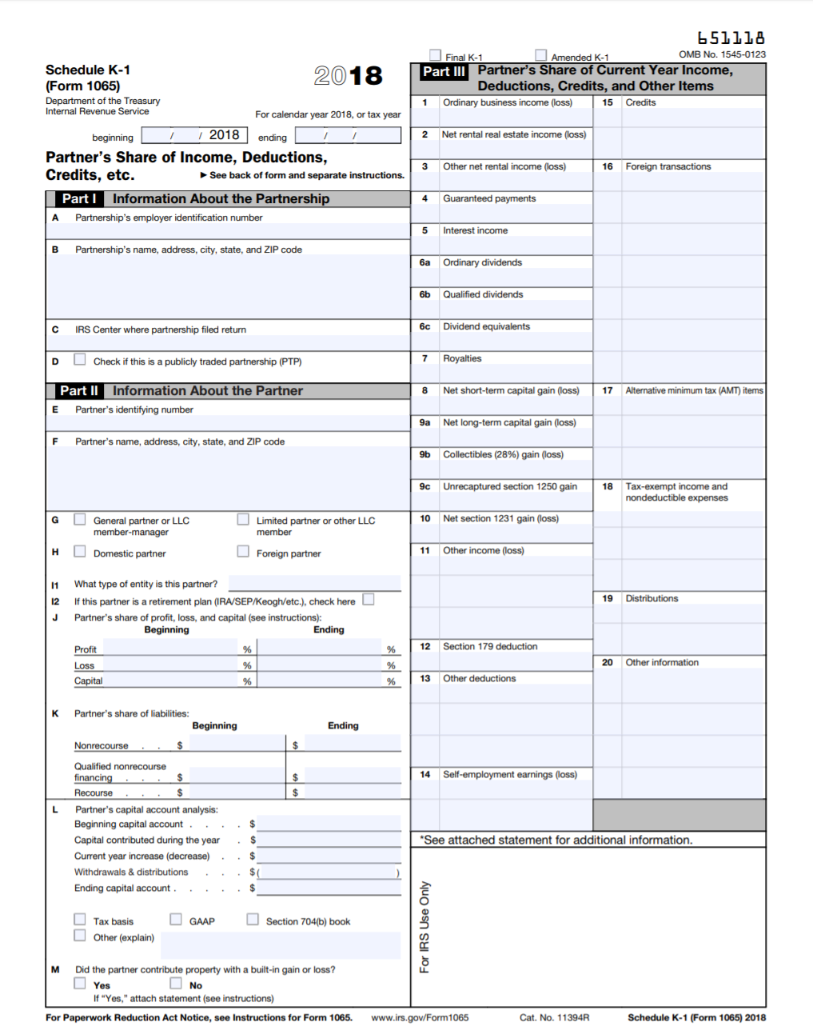
Schedule K-1 is a black and white Internal Revenue Form divided into three major parts. The first part is short and is about the partnership. Not a lot of information is needed about the partnership here as this is the partners accounting of their individual taxes and the partnership files its own tax form. The second section asks for details about the partner and the partner’s beginning and ending profits, losses, and capital. The third and final part asks for the partner’s current year income, deductions, and credits.

Termination of the Partnerships
The older Uniform Partnership Act, or UPA, does not deal with the termination of the general partnership as well as the Revised Uniform Partnership Act, or RUPA. With UPA, if a partnership leaves the partnership, then the partnership will dissolve/terminate. The partnership needs to finish or close out all its current business so it can terminate. The partnership will need to liquidate assets into cash and pay of all debts it can. Any money left after paying off all debts would be paid to the partners in a percentage equally to their ownership interest. Dissolution under UPA happens by either actions of the partners or by a court degree. Actions of partners include the partnership term coming to an end, one partner wishing to leave, if all partners agree that the partnership should terminate, if one partner is forced out of the partnership by the other partners, if the partnership cannot legally continue, if a partner dies, or if a partner files bankruptcy. These are a lot of different reasons a partnership can terminate if there is not a writing to the contrary. The partnership agreement should cover these different instances so that if it is not desired that the partnership end in these circumstances, then the partnership can instead continue. If there is not a discussion of these issues in the partnership agreement, then under UPA, the partnership must dissolve under these events.
A court can also rule that the partnership must dissolve. A court can find a partner to be mentally incompetent, which absent a partnership agreement to the contrary, would mean that the partnership must dissolve. A court can decree that a partner is incapable of performing his job duties. If a court does, absent a partnership agreement to the contrary, then the partnership must dissolve. A court could determine that a partner is not honoring his duties to the partnership. If a court does, absent a partnership agreement to the contrary, then the partnership must dissolve. A court could find that the partnership cannot make a profit or that it is equitable to dissolve the partnership.
Dissociation refers to one partner leaving the partners. Under RUPA, and unlike with UPA, one partner dissociation does not mean that the partnership must dissolve. The rule under RUPA is that so long as the partnership buys out the dissociating partner, the partnership continues. A Statement of Dissociation should be filed in the state where the partnership has its principal place of business. The Statement of Dissociation is important for the dissociating partner because it helps to limit the potential liability of the dissociating partner.

Key Terms
- Dissociation
- Dissolution
- General partner
- Joint and several liability
- Marshaling of assets
- Partnership
- Revised Uniform Partnership Agreement

Review Questions
- What uniform partnership act does your state follow?
- What are the documents necessary in forming a general partnership agreement?
- If there is not a written partnership agreement, then how are profits shared among the partners?
- Why is the unlimited personal liability worse in a general partnership than in a sole proprietorship?
- If the partnership forms without a partnership agreement, then how are profits and losses shared?

Web Exercise
While the tax forms were provided to you, more are available at the Internal Revenue Services’ website, http://www.irs.gov. Go to this website and determine where the tax forms for a general partnership are located.

Chapter on Limited Liability Partnerships

Student Learning Outcomes
- Compare and contrast a limited liability partnership to a limited partnership.
- Determine what the liability is for a limited liability partnership in your state.

Introduction to Limited Liability Partnerships
Limited Liability Partnerships are discussed next because they often utilize laws or statutes based off the Revised Uniform Partnership Act, which is one of the uniform partnership acts that applies to General Partnerships. Pay attention to the similarities and differences between limited liability partnerships and general partnerships. Limited liability partnerships are often made up of professionals, who provide services. Some states even restrict limited liability partnerships to professionals, such as accountants, architects, and lawyers. The limited liability partnership allows for partners to share knowledge and management, but somewhat manage their liability. A limited liability partnership is also easier to form than a corporation. How limited liability partnership are different than general partnerships is that the partners do have limited liability for the acts of the other partners in a limited liability partnership.

Formation of the Limited Liability Partnership
Recall from the chapter on general partnerships that the law that applies in a state regarding a general partnership is the state’s adaptation of either the Uniform Partnership Act or Revised Uniform Partnership Act. With Limited Liability Partnerships, it is the same. Therefore, general partnerships and limited liability partnerships are formed very similarly. The public document for a limited liability partnership is the Registered Limited Liability Partnership Registration or some version of that name. This public document has the name of the limited liability partnership, along with the LLP designation. The designation LLP is enough and Limited Liability Partnership does not need to be written out. The designation requirement is to put the public on notice that the business is a limited liability partnership. Whether this does put the public on notice about the limited liability is questionable. The principal place of business of the limited liability partnership is public information. The agent for service of process for the llp is public information. The document will include a statement, that helps notify the public, that a limited liability partnership has limited liability. The number of partners within the limited liability partnership will be designated. The starting date of the limited liability partnership will be delineated and there will be at least one partner’s signature on the document.
The registration should be filled in correctly and filed in a timely manner, especially since until it is, the partners do not have limited liability protection. The registration may also require, depending upon the state, a brief description of the nature of the business being conducted.
The private document for all partnerships is a partnership agreement. A limited liability partnership agreement is like a general partnership agreement. However, there is information about the limited liability in a limited liability partnership agreement. The agreement should at the very least cover the contributions of the partners, who receives and how much of both profits and losses, when new partners are admitted to the partnership, and the dissolution of the partnership. For further discussion of what should generally be covered in a partnership agreement, please look back to the chapter on general partnerships. If the partnership agreement does not discuss these matters, then the profits, losses, and management of the limited liability partnership will all be equal, no matter what individual partners contributed to the partnership. Thus, if there are twenty (20) partners, then each partner would receive five percent (5%) no matter how much money or how little money each individual partner put into the partnership.
It is not easy to obtain enough capital to start a limited liability partnership business. It is to garner financing than with a sole proprietorship or general partnership even, as there is limited liability that allows incoming partners to feel more secure in putting their money into the business.

LLP-1: Application to Register a Limited Liability Partnership
The form and instructions are available at: https://bpd.cdn.sos.ca.gov/llp/forms/llp-1.pdf
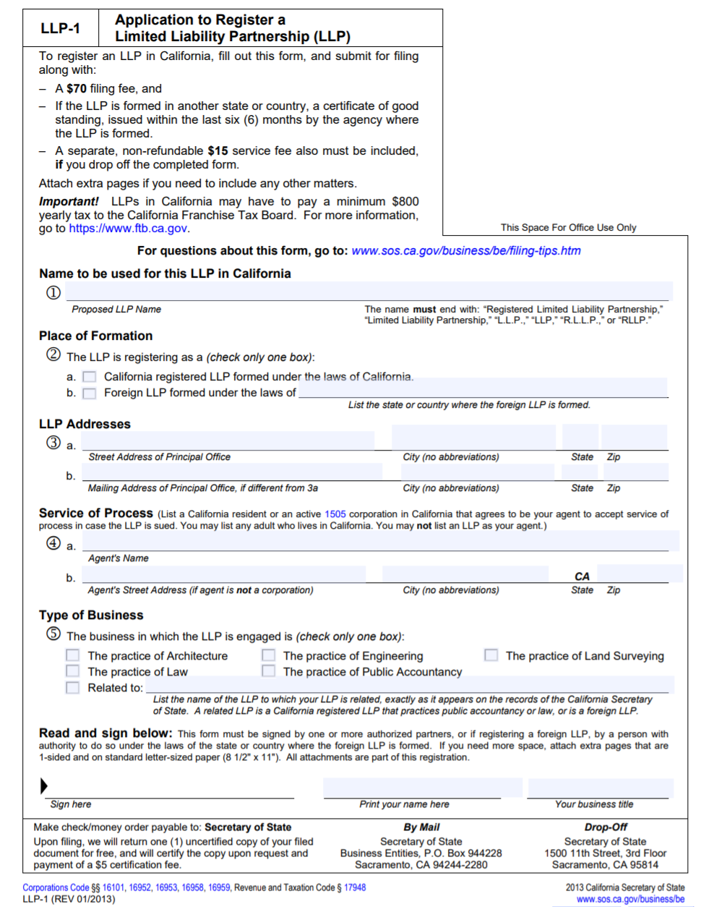
The LLP-1 form with the California Secretary of State is a black and white form to register Limited Liability Partnerships within California. The form requires a registered agent for service of process and is mainly for the following businesses: architecture, law, engineering, accounting, and land surveying. There is also an alternative security provision for, see infra.

LLP-3 Alternative Security Provision of a Limited Liability Partnership (LLP)
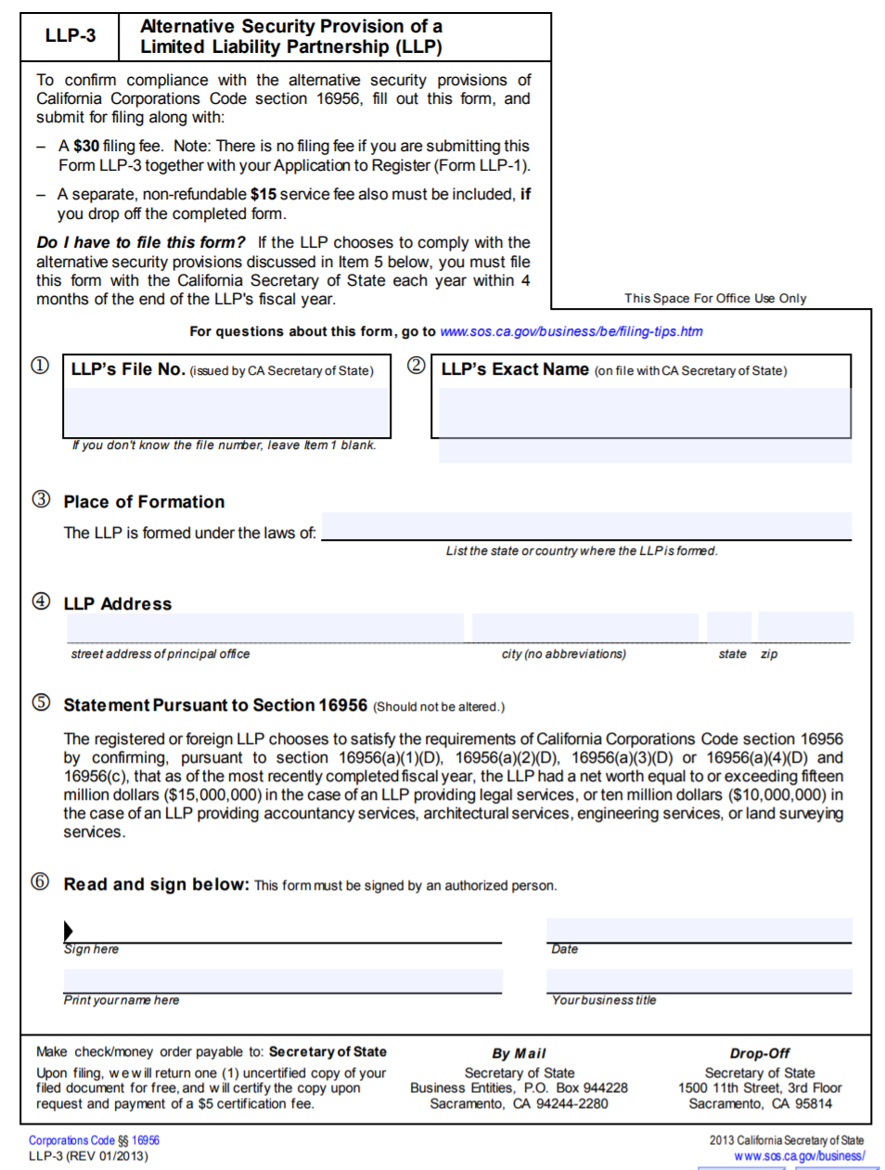
The alternate security provision has a llps, for the last fiscal year, have at least a net worth of fifteen million dollars ($15,000,000) if a legal llp, and at least a net worth of ten million dollars ($10,000,000) if another type of allowed llp in California.

Management of the Limited Liability Partnership.
General partnerships and limited liability partnerships are managed similarly. The benefit to operating as a limited liability partnership is that the partners do have some limited liability for the actions of their partners. Management will be shared equally unless specified otherwise in the partnership agreement. Architects can often operate as LLPs but may not be good managers. One architect or some of the architects could be designated the managing partner or the LLP could hire a manager to manage the LLP. Limited liability partners are agents of one another and have the duties an agent dos, such as fiduciary duties, duty of care and duty of loyalty. It is possible for one partner to sign on behalf of the partnership and the partnership will be bound to a contract.

Liability of the Limited Liability Partnership
With the liability in a limited liability partnership, the laws are different from state to state. The best thing to do is to look up the liability for the state you work in. By way of a sample, we will look at Alaska Statutes Section 32.06.306(c) on liability in a limited liability partnership:
“An Obligation of a partnership incurred while the partnership is a limited liability partnership, whether arising in contract, in tort, or otherwise, is solely the obligation of the partnership. A partner is not personally liable, direct or indirectly, by way of contribution or otherwise, for the obligation solely by reason of being or acting as a partner. This subsection applies even if inconsistent with partnership agreement provision that exists immediately before the vote required to become a limited liability partnership under AS 42.06.911(b).”
You will note from this section that partners are not responsible for either negligent (tort) or contract errors their co-partners make. The partnership is liable for these acts. This is what is known as a full shield state, that it fully shields partners from the torts and contractual errors made by their partners. If the statute did not shield co-partners from both the tort and contracts errors their partners made, then the state would be a partial shield state.
Perhaps more importantly, since most LLPs are partnerships of professionals, is whether a state requires the LLP to carry malpractice insurance or not. Read the following case on whether a legal llp does not have malpractice insurance, which might revoke its llp status and render the partners individually liable.

While most of us may currently be located in the state of California, it is helpful to learn how to research law. Pick five states and go to the laws referenced for them below. How does each of those five statutes apply liability in a limited liability partnership?
- Code of Alabama Section 10-8A-3.06(c)
- Alaska Statutes Section 32.06.306(c)
- Arizona Revised Statutes Section 29-1026(C)
- Arkansas Code Annotated Section 4-46-306(c)
- California Corporations Code Section 16306(c)
- Colorado Revised Statutes Section 7-64-306(3)
- Connecticut General Statutes Section 34-327(c)
- 6 Delaware Code, Section 15-306
- Florida Statute Section 620.8306(3)
- Official Code Georgia Annotated Section 14-8-15(b)
- Hawaii Revised Statute Section 425.117(c)
- Idaho Code Section 53-3-306(c)
- Illinois, 805 Illinois Compiled Statutes Section 206/306
- Indiana Code Annotated Sections 23-4-1-44 to 23-4-1-53
- Iowa Code Section 486A.306(3)
- Kansas Statute Annotated Section 56a-306
- Kentucky Revised Statute Section 363.220
- Louisiana Revised Statute 9:3431(A)
- 31 Maine Revised Statute Section 1034
- Maryland corporations and Associations Code Annotated Section 9A-306(c)
- Annotated Laws of Massachusetts General Laws, Chapter 108A, Section 15(2)
- Michigan Compiled Laws Sections 449.44-449.48
- Minnesota Staute Annotated Section 323A.0306(c)
- Missisippi Code Annotated Section 79-13-306(c)
- Section 358.150 Missouri Revised Statutes
- Montana Code Annotated Section 35-120-807
- Revised Statutes of Nebraska Annotated Section 67-418(3)
- New Hampshire Revised Statutes Annotated Section 304-A:15
- New Jersey Statute Section 42:1A-18(c)
- New Mexico Statute Annotated Section 54-1A-306
- New York Consolidated Law Service Partnership Section 26
- North Carolina General Statutes Section 59-45(a1)
- North Dakota Century Code Section 45-22-08.1
- Ohio Revised Code Annotated Section 1776.36(c)
- 54 Oklahoma Statutes Section 1-306(c)
- Oregon Revised Statute Section 67.105
- 15 Pennsylvania Consolidated Statutes Section 8204
- Rhode Island General Laws 1956, Section 7-12-26
- South Carolina Code Annotated Section 33-41-370
- South Dakota Codified Laws Section 48-7A-306(c)
- Tennessee Code Annotated Sections 61-1-306
- Texas Business Organizations Code Section 152.801(a)
- Utah Code Annotated Section 48-1d-306(3)
- 11 Vermont Statutes Annotated Section 3226(c)
- Virginia Code Annotated Section 50-73.96
- Revised Code Washington Section 25.05.125
- West Virginia Code Section 47B-3-6(c)
- Wisconsin Statutes Section 178.12

Case: Mortgage Grader, Inc. v. Ward & Olivio, L.L.P

Mortgage Grader, Inc. v. Ward & Olivo, L.L.P.

225 N.J. 423; 139 A.3d 30 (2016).
In this case, the Court must determine whether a law firm practicing as a limited liability partnership ("LLP") failed to maintain professional malpractice insurance to cover claims against it, and, if so, whether that failure may cause the revocation of the firm's LLP status, rendering innocent partners personally liable. To inform that determination, we also consider when a law-firm LLP incurs its obligation to a client under the Uniform Partnership Act ("UPA"). N.J.S.A. 42:1A-18.
For the reasons that follow, we conclude that the requirement in Rule 1:21-1C(a)(3) that law firms organized as LLPs maintain malpractice insurance does not extend to the firm's windup period and does not require purchase of tail insurance coverage. Moreover, Rule 1:21-1C(a)(3) is a disciplinary rule and this Court is solely responsible for attorney discipline. Consequently, violation of that Rule does not result in automatic conversion of a law firm organized as an LLP into a general partnership ("GP") and Mortgage Grader had no vicarious liability claim against Ward….
In July 2009, Mortgage Grader hired Olivo of Ward & Olivo ("W & O") to pursue claims of patent infringement against other entities. Mortgage Grader entered into settlement agreements in those matters. In exchange for one-time settlement payments, Mortgage Grader granted those defendant-entities licenses under the patents, including perpetual rights to any patents Mortgage Grader received or obtained through assignment, regardless of their relationship to the patents at issue in the litigation. It is those provisions of the settlement agreement that allegedly gave rise to legal malpractice.
On June 30, 2011, W & O dissolved and entered into its windup period. It is undisputed that W & O continued to exist as a partnership for the sole purpose of collecting outstanding legal fees and paying taxes. The next day, Ward formed a new LLP and began to practice with a new partner. W & O's claims-made malpractice insurance policy ran through August 8, 2011. W & O did not purchase a "tail policy." Olivo sent Mortgage Grader a letter on May 10, 2012 on behalf of both Olivo Law Group, LLC and W & O, informing Mortgage Grader of the termination of legal services.
Mortgage Grader filed a complaint against W & O, Olivo, and Ward in October 2012. The complaint alleged legal malpractice by Olivo, claiming that the settlement agreements resulting from Olivo's representation harmed Mortgage Grader's patent rights. Specifically, the complaint alleged that the settlement agreements limited damages to past damages, failed to provide for royalty rates or licensing fees for future use of the patents, and failed to limit the licensing fee provision in the settlements to only the patents in the suit. Mortgage Grader thereafter filed an affidavit of merit ("AOM") pursuant to N.J.S.A. 2A:53A-27 to support its malpractice claims and served the AOM on Olivo and W & O, but failed to serve it on Ward.
Ward filed an answer and subsequently moved to dismiss for failure to state a claim. Ward argued that the requirement in Rule 1:21-1C, which provides that a law firm organized as an LLP must purchase malpractice insurance, is silent as to tail coverage following its dissolution. Ward also argued that, in any event, W & O had satisfied the Rule's requirement because W & O had insurance while it practiced law. Ward maintained that, as a result, W & O's liability shield remained intact and therefore he could not be held vicariously liable for Olivo's alleged negligence. Ward also claimed that Mortgage Grader never served him with an AOM as required by N.J.S.A. 2A:53A-27.
Mortgage Grader countered that W & O was still in operation and practicing law during its windup period, and that it was therefore required to maintain malpractice insurance pursuant to Rule 1:21-1C(a)(3) during that time. Mortgage Grader contended that W & O's failure to maintain insurance stripped the LLP of its liability shield and converted it to a GP. Mortgage Grader also claimed that it had substantially complied with the Affidavit of Merit Statute….
Mortgage Grader argues that law firms organized as LLPs in the windup period continue to exist as viable entities, and must therefore maintain professional liability insurance as required by Rule 1:21-1C(a)(3). Because malpractice insurance is a prerequisite to the formation of a law-firm LLP, Mortgage Grader contends that the natural consequence for non-compliance is the conversion of the LLP into a GP. Mortgage Grader maintains that is made possible by the open-ended provision in Rule 1:21-1C(a)(2) stating that the Court may "otherwise discipline" LLPs that fail to comply with the Rule that authorizes attorneys to operate as an LLP. Further, Mortgage Grader points to Olivo's termination of the attorney-client relationship in May 2012, nine months after W & O's malpractice insurance lapsed. Based on that, Mortgage Grader claims that no distinction exists between the windup period and pre-dissolution practice that would support an interpretation that the Rule does not require the purchase of tail coverage. Consequently, Mortgage Grader maintains that service of an AOM on Ward was not required because the basis of the claim against him was vicarious liability as a member of a GP….
Ward counters that W & O complied with the Rule's insurance mandate because W & O maintained professional liability insurance during the entire time it was actively engaged in the practice of law, and after its policy lapsed, W & O existed solely to collect outstanding fees and pay taxes in an effort to wind up the partnership. According to Ward, neither Rule 1:21-1C(a)(3) nor the UPA mandates the purchase of tail coverage, and any determination to the contrary would constitute a dramatic change that should result only from this Court's rule-making function or from the State Legislature rather than as a result of motion practice in a trial court. Ward asserts that a mandate to purchase tail coverage would essentially require coverage perpetually into the future because the six-year statute of limitations for a professional malpractice claim would not apply to claims arising from representation on behalf of a minor or the drafting of a will.
Ward also argues that even if this Court determines that failure to obtain tail coverage violates Rule 1:21-1C(a)(3), neither the rule nor the UPA authorize a remedy of converting a law-firm LLP into a GP for failure to maintain malpractice insurance. In Ward's view, the failure of the Legislature and the Supreme Court to provide for such a remedy demonstrates that such a remedy was never contemplated. Finally, Ward contends that Mortgage Grader failed to serve him with an AOM, and failed to substantially comply with the Affidavit of Merit Statute….
Amicus curiae the New Jersey State Bar Association ("NJSBA"), also urges this Court to affirm the Appellate Division's determination that neither the UPA nor Rule 1:21-1C(a)(3) permits a court to convert a law-firm LLP to a GP for failure to maintain malpractice insurance. According to the NJSBA, the Legislature has been aware of the Rule since its enactment in 1996, yet has never sought to amend the UPA to allow for the conversion of an LLP to a GP.
In addition, the NJSBA points out that Rule 1:21-1C(a)(2) permits only this Court, not a trial court, to impose sanctions on an LLP that fails to comply with the mandate to maintain malpractice insurance. Even if this Court were to find policy reasons in favor of removal of LLP status as a sanction for non-compliance with the insurance mandate during the windup period, the NJSBA maintains that this Court should consider the imposition of such a sanction through its rule-making process rather than the present appeal. Finally, the NJSBA points out that mandating tail coverage would affect law-firm LLPs of all sizes, and could disproportionately affect small LLPs and those that practice in particular areas of the law….
An appellate court interprets both statutes and court rules de novo…. No deference is owed to "interpretation[s] of the law and the legal consequences that flow from established facts….”
We first determine whether the malpractice insurance mandate of Rule 1:21-1C(a)(3) applies to the windup period. The New Jersey Constitution grants this Court "jurisdiction over the admission to the practice of law and the discipline of persons admitted." N.J. Const. art. VI, § 2, ¶ 3. Effective January 1, 1997, we added Rule 1:21-1C to permit attorneys to organize as LLPs. The LLP structure establishes a shield from personal liability for LLP partners. See R. 1:21-1C(a)(1) (incorporating UPA by reference); N.J.S.A. 42:1A-18(a) & (c).
Rule 1:21-1C conditions practice by law-firm LLPs on compliance with partnership law, adherence to the rules of professional responsibility, and maintenance of malpractice insurance. Specifically, section (a) provides that "[a]ttorneys may engage in the practice of law as limited liability partnerships" provided that
[t]he limited liability partnership shall obtain and maintain in good standing one or more policies of lawyers' professional liability insurance which shall insure the limited liability partnership against liability imposed upon it by law for damages resulting from any claim made against the limited liability partnership by its clients arising out of the performance of professional services by attorneys employed by the limited liability partnership in their capacity as attorneys.
[R. 1:21-1C(a)(3) (emphasis added).]
The plain language of Rule 1:21-1C ties the mandate to carry malpractice insurance to damages from the performance of "professional services." We find no indication that the administrative activities characterizing a windup are included within that term. Cf. Cal. Corp. Code § 16956(a)(2)(A) (stating that "[u]pon the dissolution and winding up of the partnership, the partnership shall, with respect to any insurance policy or policies then maintained pursuant to this subparagraph, maintain or obtain an extended reporting period endorsement or equivalent provision in the maximum total aggregate limit of liability required to comply with this subparagraph for a minimum of three years if reasonably available from the insurer").
In addition to the plain language of the insurance mandate, subsection (a)(1) of Rule 1:21-1C instructs that "[a]ll provisions of the Uniform Partnership Act, N.J.S.A. 42:1A-1 through 56, shall be complied with, except where inconsistent with these rules." R. 1:21-1C(a)(1). Because Rule 1:21-1C incorporates the UPA by reference, we next examine the language of the UPA and related legal authority.
A partnership's existence continues during the windup period and "is terminated when the winding up of its business is completed." N.J.S.A. 42:1A-40(a). Under the UPA, "the express will of all of the partners to wind up the partnership business" causes dissolution and commences the winding up of a partnership. N.J.S.A. 42:1A-39(b)(2). At any time prior to the completion of the winding up of a partnership, all of the partners "may waive the right to have the partnership's business wound up and the partnership terminated." N.J.S.A. 42:1A-40(b). In that event, "the partnership resumes carrying on its business as if dissolution had never occurred, and any liability incurred by the partnership or a partner after the dissolution and before the waiver is determined as if dissolution had never occurred." N.J.S.A. 42:1A-40(b)(1) (emphasis added). The windup period is temporally indeterminate under the UPA due to the partners' ability to waive dissolution and because winding up is limited in terms of activity.
During the windup period, the LLP continues to exist, but only to wind up the partnership's affairs. "On dissolution the partnership is not terminated, but continues until the winding up of partnership affairs is completed, and for that purpose alone…." "A dissolved corporation exists solely to prosecute and defend suits, and not for the purpose of continuing the business for which it was established…." Our Appellate Division in addressing this issue has previously held that "dissolution is distinguished from termination of the partnership business; despite dissolution, the partnership continues for the purpose of winding up partnership affairs…." "[D]issolution designates the point in time when the partners cease to carry on the business together; termination is the point in time when all the partnership affairs are wound up; winding up, the process of settling partnership affairs after dissolution…." Similarly, N.J.S.A. 14:12-9 would bar professional corporations from practicing law during the windup period. See N.J.S.A. 14A:12-9 (stating that a dissolved corporation "shall carry on no business except for the purpose of winding up its affairs"). The UPA sets forth activities that do not constitute "transacting business": "collecting debts or foreclosing mortgages or other security interests in property securing the debts, and holding, protecting, and maintaining property so acquired." N.J.S.A. 42:1A-53(a)(8). In sum, the important distinction pertaining to LLP liability is the point in time at which an LLP enters dissolution, commences winding up its affairs, and thus ceases to engage in the business for which it was created.
We consider the UPA and the case law interpreting it to be dispositive on this issue. The administrative activities conducted during the windup period are not the transacting of business for which a law-firm LLP was established. Accordingly, we conclude that under the circumstances here, where a law-firm LLP has entered the windup period and has ceased to provide any legal services, the windup period does not constitute practicing law and therefore no acts of malpractice could be committed during this period. Such a law firm is not required to maintain professional liability insurance under Rule 1:21-1C(a)(3). Therefore, W & O fully complied with the Rule's insurance mandate by maintaining malpractice insurance the entire time it was engaged in the practice of law.
Similarly, the date on which W & O incurred its alleged obligation to Mortgage Grader is also dispositive. The National Conference of Commissioners on Uniform State Laws (the "National Conference"), in its comment to the Revised Uniform Partnership Act ("RUPA"), the proposed legislation New Jersey adopted and codified as the UPA, provides in part that "partnership obligations under or relating to a note, contract, or other agreement generally are incurred when the note, contract, or other agreement is made." RUPA (1997), Comment 3 to Section 306, at 51. "Partnership obligations under or relating to a tort generally are incurred when the tort conduct occurs rather than at the time of the actual injury or harm." Ibid. Therefore, we hold that a law-firm LLP incurs its obligation to a client on the date the alleged malpractice occurred. Here, W & O was a valid LLP with professional liability insurance coverage at the time of Olivo's alleged malpractice.
Our holding precludes Mortgage Grader from maintaining a vicarious liability claim against Ward. Our analysis does not end there, however, because we next address the trial court's conversion of W & O from an LLP into a GP.
In addition to erroneously determining that W & O was still practicing law during its windup period, the trial court improperly relied on Rule 1:21-1C to convert W & O from an LLP to a GP. The Rule provides that "any violation of this rule by the limited liability partnership shall be grounds for the Supreme Court to terminate or suspend the limited liability partnership's right to practice law or otherwise to discipline it." R. 1:21-1C(a)(2) (emphasis added). Therefore, only this Court has the authority to discipline a law firm organized as an LLP. Here, the trial court erred by relying on a disciplinary rule that only this Court may use.
Moreover, the phrase "or otherwise discipline it" is circumscribed by a variety of sanctions imposed through the court rules. See, e.g., R. 1:20-15A (listing disbarment, indeterminate suspension, term of suspension, censure, reprimand, and admonition as categories of discipline)…. Because only this Court may use Rule 1:21-1C to discipline a law firm organized as an LLP, and the Court Rules do not list conversion of business organizational form as a type of sanction, we conclude that conversion of W & O from an LLP to a GP was improper under the Rule.
Our analysis does not end with Rule 1:21-1C because we must also determine if the UPA provides authority to convert an LLP to a GP. The UPA defines a partnership as "an association of two or more persons to carry on as co-owners of a business for profit formed under [N.J.S.A. 42:1A-10], predecessor law, or comparable law of another jurisdiction." N.J.S.A. 42:1A-2. With certain exceptions, "all partners are liable jointly and severally for all obligations of the partnership." N.J.S.A. 42:1A-18(a). By contrast,
[a]n obligation of a partnership incurred while the partnership is a limited liability partnership, whether arising in contract, tort, or otherwise, is solely the obligation of the partnership. A partner is not personally liable, directly or indirectly, by way of contribution or otherwise, for such an obligation solely by reason of being or so acting as a partner.
[N.J.S.A. 42:1A-18(c) (emphasis added).]
The UPA further provides that the status of an LLP "remains effective, regardless of changes in the partnership” until the LLP cancels its status under N.J.S.A. 42:1A-6(d) or the State Treasurer revokes its status under N.J.S.A. 42:1A-49(c) for failure to file an annual report when due or pay the required filing fee under N.J.S.A. 42:1A-49. N.J.S.A. 42:1A-47(e).
The UPA's provisions that govern revocation of LLP status reflect a tendency to preserve the liability shield. In the event that the State Treasurer seeks to revoke an LLP's status for failure to file an annual report or pay the filing fee, the UPA requires that the LLP receive sixty days' notice of the impending revocation. N.J.S.A. 42:1A-49(c). During this time period, the LLP has an opportunity to cure the deficiency before the effective date of the revocation. Ibid. If the LLP cures, the revocation does not take effect. Ibid. The UPA also permits an LLP to apply for reinstatement within two years after the effective date of revocation. N.J.S.A. 42:1A-49(e). If the LLP applies and reinstatement is granted, the reinstatement relates back to and takes effect as of the effective date of the revocation, and the LLP's status continues as if the revocation never occurred. N.J.S.A. 42:1A-49(f). The National Conference explains that "[t]he relation back doctrine protects gaps in the reinstated partnership's liability shield." RUPA (1997), comment to Section 1003, at 147.
In sum, the UPA offers many mechanisms to preserve LLP status once obtained, and those mechanisms apply retroactively to sustain the partnership's liability shield even during gaps in LLP status. Those provisions, combined with the lack of any language in this statutory scheme giving authority to the judiciary to convert a properly recognized LLP into a GP, lead us to conclude that the UPA provides no support for the trial court's conversion of W & O from an LLP to a GP….
We now address whether the mandate in Rule 1:21-1C(a)(3) to obtain malpractice insurance should carry into the future by requiring law-firm LLPs to maintain insurance after dissolution. Practical considerations and public policy concerns lead us to hold that tail coverage is not required.
Because a claims-made policy provides coverage only for claims made while the policy is in effect, we cannot impose a requirement for an LLP to purchase tail coverage without deciding how long the tail coverage must last. Even if such a requirement were tailored to meet the six-year statute of limitations for malpractice actions, it would fail to ensure coverage for all possible claims. For example, a malpractice claim involving an attorney who handled a claim on behalf of a minor could result in the tolling of the statute of limitations until the minor reached adulthood, meaning the minor could file a timely claim more than six years after the malpractice. Similarly, a dispute regarding a will an attorney drafted in all likelihood would not arise until after the client's death, which may occur much longer than six years after the drafting of the will.
In addition, competing public policy concerns play a role in our analysis. "On the one hand, Rule 1:21-1C provides attorneys the opportunity to practice in a chosen entity that includes limited liability for its members. On the other, it seeks to protect consumers of legal services from attorney malpractice by requiring such entities to maintain adequate insurance." First Am. Title Ins. Co. v. Lawson, 177 N.J. 125, 139, 827 A.2d 230 (2003). Ultimately, we determined, "the rule helps to limit the public's exposure to uninsured risks arising from the receipt of legal services in this State." Ibid.
This insurance requirement for law-firm LLPs marks a departure from the general rule that malpractice insurance is not required for attorneys in New Jersey. Our rules do not require tail coverage for professional corporations or GPs, nor do they require single practitioners to carry any insurance, including tail coverage.
We decline to impose a tail requirement on attorneys who choose to practice as LLPs, particularly because a mandate to purchase tail coverage still would not fully protect the public from uninsured risks due to the types of scenarios outlined above.⁴ We hold that the mandate in Rule 1:21-1C for LLPs to purchase professional liability insurance does not include any requirement to purchase tail coverage….
For the reasons set forth above, we hold that the mandate in Rule 1:21-1C that a law-firm LLP purchase professional liability insurance does not extend to the windup period when the law firm has ceased performing legal services. In addition, we hold that Rule 1:21-1C does not require law-firm LLPs to purchase tail coverage to maintain malpractice insurance beyond dissolution. Further, we affirm the Appellate Division's conclusion that a trial court does not have the authority to convert a law-firm LLP into a GP….
Partners in an LLP are not liable for torts that their partners commit. This is very different than a general partnership. Remember that with a general partnership, even the personal assets of the partners could be affected. The limited liability is granted by many states because of a state-imposed requirement to have liability insurance, like illustrated in the above case.
To go further into full and partial shield states, most states are full or what we will call limited shield states now. In a traditional partial shield state, a partner does have liability for contractual mistakes her partner makes. This is personal liability, so personal assets are on the hook. Full shield states have partners not be personally liable for the tortious or contractual mistakes other partners make. Limited shield states are in between, and are often moving towards being full shield states. Being in a full shield state is best for partners.

Continued Existence of the Limited Liability Partnership
Similar to a general partnership, it is not easy to keep an LLP continuing if one partner wants to leave. All partners would have to agree on adding a new partner. A partner in an LLP can only, without permission, give away rights to profits. If the partner wants to get rid of her interest and management responsibilities in an LLP, it requires consent of all remaining partners.

Profits and Losses of Limited Liability Partnerships
Similar to a general partnership, when there are profits or losses in an LLP, then the partners will get those profits and losses typically. There should be a partnership agreement specifying when the partners get paid and in what percentage. If there is not then, like the general partnership, each limited liability partner will get a share in the profits and losses that is equal to all other limited liability partners. For example, if there are eight (8) partners, then the partners will each receive twelve and one-half (12 ½) percent of the profits and losses.

Taxation of the Limited Liability Partnership
The llp does not pay taxes itself, though it does file a partnership tax form known as Form 1065. The tax is passed through to the individual partners. The individuals will pay taxes in accordance with their personal tax rate or take losses against other profits. The partner files a schedule K-1 along with the rest of their taxes. The IRS matches up the Form 1065 for the partnership and all the K-1s for the individual partners to make sure each partner is being accurate in their taxes.

Termination
Again, llps terminate similar to how general partnerships terminate. If any of the partners withdraws, because each partner has management responsibilities to the llp (absent an agreement to the contrary), the partner’s withdrawal can cause the llp to terminate. The remaining partners would need to decide whether they wanted to try to continue the business of the limited liability partnership. If they do not, then there will be a dissolution of the limited liability partnership. Under RUPA, the partners have ninety days to decide to continue the partnership after a withdrawal. The best practice is to discuss the eventual dissolution of the partnership in the partnership agreement.

Key Terms
- Limited liability partnership
- Revised Uniform Partnership Act

Review Questions
- If there are differences between general partnerships and limited liability partnerships, what are they?
- What types of professions are usually llps?
- Who are the managers of a limited liability partnership?
- What types of financial guarantees does an llp have to have?

Web Exercise
Take a few minutes to familiarize yourself with the American Bar Association website: American Bar Association.
- Where is the practice area on business and corporate located?
- What are some of the subtopics under the practice area on business and corporate?
The American Bar Association does have its own suggested rules on professional responsibility. It applies to attorneys and paralegals in California if the California Rules of Professional Responsibility do not cover a certain issue that the ABA ones do. Find the ABA guidelines on professional responsibilities.

Introduction to Limited Partnerships

Student Learning Objectives
- Compare and contrast a limited partnership to a general partnership and a limited liability partnership.
- Discuss, in detail, the financing and taxes in a limited partnership.

Introduction to Limited Partnerships
Of the three partnerships discussed in this text, limited partnerships are discussed last as they are the most dissimilar from the other two: general partnerships and limited liability partnerships. In a limited partnership, there are both general and limited partners. Only the limited partners have limited liability. The general partners in the limited partnership do not have limited liability. The primary purpose of a limited partnership is to help raise funds on behalf of the general partners by providing limited liability to the limited partners so that they are in fact, more willing to invest. High risk projects are often the projects that limited partnerships are formed to undergo, such as movies, high risk real estate ventures, speculating for oil, etc. In essence, the limited partner gets to “gamble” on a high-risk venture, while only losing up to the amount of his investment.
Since limited partnerships are usually entered into with intent and can deal with large amounts of money, they are much more heavily regulated than general partnerships. It makes sense that if someone wealthy is going to invest into a business that probably will not make a profit, then the wealthy person would want the rest of their assets protected. The chapter will go into much more detail on why a wealthy person would be willing to risk even the amount of their investment, but it has to do with taxes. General partners in a limited partnership are similar to the general partners in a general partnership. Thus, the general partners in a limited partnership do not need to be discussed as much as the limited partners in the limited partnership.
The law that applies to limited partners is very different than the law that applies to general partnerships and limited liability partnerships. Whereas with general and limited liability partnerships, if the partnership agreement is silent on splitting of partnership profits, profits will be shared equally, this is not the case with a limited partnership. If the partnership agreement in a limited partnership does not specify how profits are to be divided, then they will be divided in proportion to their ownership percentage or percentage that they have contributed to the limited partnership. The law that applies to limited partnerships is either the Uniform Limited Partnership Act (ULPA) or the Revised Uniform Limited Partnership Act (RULPA).

Formation of Limited Partnerships
There must be, similar to all partnerships, at least two partners. The difference with a limited partnership is that at least one of these two partners must be a general partner and the other must be a limited partner. The general partner is supposed to manage the limited partnership. The general partner frequently has the idea, but not the money to execute that idea. He needs limited partners to invest in his idea. If a general partner has an idea of where he would like to try to drill for oil, then he seeks people to invest so he has the money to carry out his idea.
The public document for a limited partnership is called a certificate of limited partnership or something similar. The document is filed with the secretary of state in the state where the limited partnership has its principal place of business. The information on the form will include the name of the limited partnership, the name and address for the agent of service of process to accept lawsuits for the limited partnership, and the name and addresses of any and all general partners (this is not private), along with when the limited partnership will dissolve.
Usually, a limited partner’s name cannot be part of the name of the limited partnership. This can be confusing to the general public as to who is managing the limited partnership. If a general partner does have the same name as a limited partner, then the general partner can keep his name on the limited partnership.
The addresses of the general partners are included and not considered public; some states allow for the addresses of the limited partners, but the limited partners addresses could just be within the private document, the partnership agreement as well. The end date of the partnership is important to the limited partners so that they know when they will get their contributions back, if any are left, for example.
If there are major changes to the certificate of limited partnership, then the certificate should be amended. The partners have to approve the changes to the certificate for it to be amended. The certificate has to be filed correctly for the limited partners to have limited liability.
The private document for this partnership is also a partnership agreement. A limited partnership agreement will be costly as it will have to satisfy often wealthy investors that their personal assets are protected. For the private document, again the limited partnership’s name should be included. All the addresses of all the partners should be included so that the partners have the information necessary to reach out to each other. If the addresses change, they should be updated. Changing addresses in the partnership agreement is typically less costly than changing them in the public document.
The purpose of the limited partnership should be discussed. It should be broad so that the partnership can grow without the need to immediately revise the purpose. The agreement should discuss where the principal place of business is as well, so investors know where the financial records are kept. The limited partners are not usually involved in the day to day business of the limited partnership, so they need to be able to verify what profits and losses they are entitled to receive from the limited partnership.
Limited partners will often require the limited partnership to have an absolute end date so that the limited partners know when they might get any contributions (if any are left) back from the partnership. Whatever the contribution of the partner is, that is the percent of what the partner receives of profits and losses. For example, if a limited partner contributes five percent (5%) of the total contributions for the limited partnership, then that limited partner will receive 5% of the profits and losses.
Limited partners are not supposed to help manage the partnership. Since what limited partners contribute is supposed to be “just” money, it should be written into the partnership agreement that the limited partners can buy and sell their interests in the partnership without having to get all partners approval. If this is not in the partnership agreement, then unfortunately, the partners will have to get all partners’ approvals to buy and sell their limited partners’ interests.
Financiering a limited partnership is easier than a general partnership, a limited liability partnership, or even a sole proprietorship. The limited partners targeted to invest are often wealthy or have money that they can afford to lose. They receive limited liability that makes them more willing to invest. Why the limited partner wants to invest is that the general partner has something of value in addition to the high risk activity that could hit it big and earn a lot of money—the general partner has tax deductions he can sell to the limited partners. The general partner is usually happy to do this as he does not have a lot of profits to take these tax deductions against. The limited partners are happy to be able to negotiate for tax deduction as they have a lot of profits to try to offset with tax deductions.

Certificate of Limited Partnership
The full form and instructions may be found at: https://bpd.cdn.sos.ca.gov/lp/forms/lp-1.pdf
Below, please find a sample Limited Partnership Agreement.

Limited Partnership Agreement
LIMITED PARTNERSHIP AGREEMENT
This Agreement of Limited Partnership is made effective as of , by and between General Partner), and Limited Partners.
IT IS HEREBY AGREED:

ARTICLE I THE PARTNERSHIP
  - Name of Partnership. The name of the Partnership shall be " , a Limited Partnership."
  - Purpose of Partnership. The Partnership shall engage in the business of and such activities as are related.
  - Principal Place of Business. The principal executive office of the Partnership shall be at _________________________.
  - Certificate of Limited Partnership. The General Partner shall immediately execute a Certificate of Limited Partnership and cause that Certificate to be filed in the office of the Secretary of State. Thereafter, the General Partner shall execute and cause to be filed certificates of amendment of the Certificate of Limited Partnership whenever required.
ARTICLE II MEMBERS OF PARTNERSHIP
  - Original General Partners. The name of the General Partner is .
  - Original Limited Partners. The names of each original Limited Partner are as follows:

  - Admission of Additional General Partners. Subject to any other provision of this Agreement, and the Acquisition and Loan Documents, a person may be admitted as a General Partner after the Certificate of Limited Partnership is filed only with the written consent of each General Partner and the vote or written consent of fifty-one percent (51%) of all Partners.
  - Admission of Additional Limited Partners. Subject to the provisions of Article IX of this Agreement, governing transfers of Partnership interests, a person may acquire an interest
in the Partnership directly from the Partnership and be admitted as an Additional Limited Partner only with the approval of the General Partner and fifty-one percent (51%) of all Partners. Each Partner's interest will be proportionally reduced to admit the new Limited Partner.
ARTICLE III FINANCING
  - Capitalization. The Partnership shall have a total initial capitalization of up to ______________________________________. Each Partner shall contribute the sum of _______________________________ for each ________________________ interest in the Partnership. The General Partner and Limited Partners shall initially contribute the amounts set forth opposite their respective names on Exhibit A.
  - Additional Capital Contributions.
    - The General Partner may determine the amount of additional capital required by the Partnership and may require each Partner, General and Limited,1 to contribute a proportionate share of additional capital to the Partnership. The General Partner's determination will be binding on all Partners, unless fifty-one percent (51%) of all Partners vote otherwise. Each Partner's proportionate share of additional capital shall be defined as the product of the total amount of additional capital required by the Partnership multiplied by that Partner's "percentage interest in profits and losses" as set forth in Exhibit A. Additional capital contributions shall be made in cash by each Partner to the Partnership within ten (10) days after written notice of the amount of additional capital contributions has been delivered to each Partner.
In the event that any Partner fails to contribute any additional capital contribution required hereunder within ten (10) days after the Call Notice, then that Partner shall be in default under this Agreement. Any Partner who is in default under this Agreement for failing to contribute the additional capital contributions required hereunder shall have ninety (90) days from the date of delivery the Call Notice in which to cure that default by contributing his share of the required additional capital contribution.
So long as a Partner is in default hereunder, he shall have no voting rights but shall receive notice of any meetings.
    - If any Partner is in default under Subsection 3.2B hereunder and fails to cure the default within ninety (90) days of the Call Notice by contributing the additional required capital then such Partner shall be in breach of this Agreement.
    - If any Partner is in breach of this Agreement pursuant to Subsection 3.2(c), then at the option of the Partnership, his interest in the Partnership shall be terminated and he shall become an unsecured creditor for an amount equal to his original capital contribution decreased by the sum of:
      - his proportionate share of all losses previously incurred by the Partnership (excluding depreciation);
      - by any distributions previously made to said defaulting Partner.

  - Interest in Contributions. No interest shall be paid on a Partner's capital contributions.
  - Withdrawal and Return of Capital.
    - No Partner may withdraw any portion of the capital of the Partnership and no Partner shall be entitled to the return of that Partner's contribution to the capital of the Partnership except upon dissolution of the Partnership.
    - No Partner shall be entitled to demand the distribution of Partnership property other than cash as part of the return of that Partner's capital account on dissolution.
    - No Partner shall have a priority over any other Partner as to the return of his capital account upon the dissolution of the Partnership.

ARTICLE IV
ALLOCATION AND DISTRIBUTION OF PROFITS AND LOSSES
  - Allocation of Profits and Losses. The net income of the Partnership shall be allocated to, and any net losses suffered by the Partnership shall be borne by, the Partners in the proportions set forth in Exhibit A attached hereto and incorporated herein by this reference.
  - Distribution of Cash Available for Distribution. The General Partner shall determine the amount of any distribution to the Partners and the timing of all such distributions. The General Partner's determination shall be binding upon all Partners.
  - Priorities Among Partners. No Partner shall be entitled to any priority or preference over any other Partner as to any distribution from the Partnership.
ARTICLE V
MANAGEMENT OF PARTNERSHIP AFFAIRS AND VOTING RIGHTS
  - Control and Management. Except as otherwise set forth in this Agreement, the General Partner shall have sole and exclusive control of the Limited Partnership.
5.2 Voting Rights of Limited Partners.
    - Except as provided in Subsection 5.2(b), the Limited Partners shall not have either the obligation or the right to take part, directly or indirectly, in the active management or control of the business of the Partnership.
    - The following Partnership actions may only be taken after approval by vote of the Partners:
- Veto of a call for additional capital;
- Admission of an additional General Partner;
- Admission of an additional Limited Partner;
- Admission of a Substituted General Partner;
- Amendment of the Partnership Agreement
- The sale or transfer of the Project;
- Consent to dissolution; and
- Election of a new general partner.
    - Except where otherwise expressly set forth in this Agreement, all of the acts listed in Section 5.2(b)(i) through 5.2(b)(ix) shall be approved by fifty-one percent (51%) vote of the interests of the Partners, each Partner having one vote for each one percent (1%) interest in profits and losses owned by that Partner with the General Partner having the same voting rights as a Limited Partner.
ARTICLE VI

PARTNERSHIP MEETINGS

  - Call and Place of Meetings. Meetings of the Partners at the Principal Executive Office of the Partnership may be called pursuant to the written request of any Partner.
6.2 Notice of Meeting. Immediately upon receipt of a written request stating that the Partner or Partners request a meeting on a specific date (which date shall not be less than ten (10) nor more than sixty (60) days after the receipt of the request by the General Partner), the General Partner shall immediately give notice to all Partners. Valid notice may not be given less than ten (10) nor more than sixty (60) days prior to the date of the meeting, and shall state the place, date, and hour of the meeting and the general nature of the business to be transacted. No business other than the business stated in the notice of the meeting may be transacted at the meeting. Notice shall be given by mail, addressed to each Partner entitled to vote at the meeting at the address appearing in the books of the Partnership for the Partner.
  - Quorum. At any duly held or called meeting of Partners, Partners holding at least fifty-one percent (51%) of the voting power who are represented in person or by proxy shall constitute a quorum for all purposes other than amending this Agreement in which case seventy- five percent (75%) of the interests of all Partners shall be required. The Partners present at a duly called or held meeting at which a quorum is present may continue to transact business until adjournment, notwithstanding the withdrawal of enough Partners to leave less than a quorum, if any action taken, other than adjournment, is approved by the requisite percentage of interests of Partners.
  - Meetings Not Duly Called, Noticed, or Held. The transaction of business at any meeting of Partners, however called and noticed, and wherever held, shall be as valid as though consummated at a meeting duly held after regular call and notice, if a quorum is present at that meeting, either in person or by proxy, and if, either before or after the meeting, each of the
persons entitled to vote, not present in person or by proxy, signs either a written waiver of notice, a consent to the holding of the meeting, or an approval of the minutes of the meeting.
  - Waiver of Notice. Attendance of a Partner at a meeting shall constitute waiver of notice, except when that Partner objects, at the beginning of the meeting, to the transaction of any business on the ground that the meeting was not lawfully called or convened. Attendance at a meeting is not a waiver of any right to object to the consideration of matters required to be described in the notice of the meeting and not so included, if the objection is expressly made at the meeting. Any Partner approval at a meeting shall be valid only if the general nature of the proposal is stated in any written waiver of notice.
  - Proxies.
    - Every Partner entitled to vote may authorize another person or persons to act by proxy with respect to that Partner's interest in the Partnership.
    - Any proxy purporting to have been executed in accordance with this Section shall be presumptively valid.
    - No proxy shall be valid after the expiration of eleven (11) months from the date thereof unless otherwise provided in the proxy. Subject to Subsections (f) and (g) of this Section, every proxy continues in full force and effect until revoked by the person executing it.
The dates contained on the proxy forms presumptively determine the order of execution, regardless of the postmark dates on the envelopes in which they are mailed.
    - A proxy is not revoked by the death or incapacitation of the person executing it, unless (except as provided in Subsection (f) of this Section), before the vote is counted, written notice of the death or incapacity of the maker is received by the Partnership.
    - Revocation of a proxy is effective by a writing delivered to the Partnership stating that the proxy is revoked or by a subsequent proxy executed by the Partner who executed the proxy or, as to any meeting, by the attendance and exercise of the right to vote at that meeting by the Partner who executed the proxy.
ARTICLE VII
ASSIGNMENT AND/OR TRANSFER OF PARTNERSHIP INTEREST

  - Prohibition Against Assignment, Sale, or Other Transfer. Notwithstanding any other provision of this Agreement, during the nine (9) month period after execution hereof, no Partner or his heirs, personal representative, successors, or assigns, shall have the right to assign, sell or otherwise transfer, for consideration or gratuitously, all or any portion of his interest in this Partnership, except to a bona fide resident of the State.
  - Assignments. A Partner may assign all or part of his interest in the profits and losses of the Partnership to any other person upon such terms and conditions as he may deem fit. The Assignee shall not be admitted as a Substituted Partner without the approval of the General Partner or, if the General Partner is the Assigning Partner, without the approval of fifty-one percent (51%) of the Limited Partners. Any assignment made to anyone, not admitted as a Substituted Partner, shall be effective only to give the Assignee the right to receive the share of profits to which the Assigning Partner would otherwise be entitled, shall not relieve the Assigning Partner from any liability under any agreement to make additional capital contributions, shall not relieve the Assigning Partner from liability under the provisions of this Agreement, and shall not give the Assignee the right to become a Substituted Partner. Neither the General Partner nor the Partnership shall be required to determine the tax consequences to any Assignee arising from the assignment of a Partnership interest. The Partnership shall continue with the same basis and capital accounts for the Assignee as was attributable to the Assigning Partner.
  - Transfer on Death of a Partner.
    - If any Partner dies, then his personal representative, heirs, devisees, or successors shall have an option, exercisable within sixty (60) days after the date of death to either:
      - elect to become Substituted Partners; or
      - offer to sell all but not less than all of the deceased Partner's interest to the remaining Partners.
ARTICLE VIII DISSOLUTION OF THE PARTNERSHIP
  - Dissolution and Winding Up. The Partnership shall be dissolved, and its affairs shall be wound up upon expiration of the term provided for the existence of the Partnership; or when all of the assets of the Partnership have been sold or distributed by the Partnership.
ARTICLE IX MISCELLANEOUS PROVISIONS
  - Entire Agreement. This Agreement contains the entire understanding among the Partners and supersedes any prior written or oral agreements between them respecting the subject matter contained herein. There are no representations, agreements, arrangements, or understandings, oral or written, between and among the Partners relating to the subject matter of this Agreement that are not fully expressed herein.
  - Attorneys' Fees and Costs. If any action at law or in equity, including an action for declaratory or injunctive relief, is brought to enforce or interpret the provisions of this Agreement, the prevailing party shall be entitled to reasonable attorney's fees and costs.
  - Governing Law. All questions with respect to the construction of this Agreement and the rights and liabilities of the parties hereto shall be governed by the laws of the State of California.
  - Notices. All notices shall be in writing and sent by regular United States mails. All notices to the Partners shall be sent to them at the addresses shown for them in the records of the Partnership. All notices to the Partnership shall be sent to it at its principal executive office. Notices shall be deemed to have been delivered when deposited in the United States mails.
  - Successors. Subject to the restrictions against assignment of partnership interests contained herein, this Agreement shall inure to the benefit of and shall be binding upon the assigns, successors in interest, personal representatives, estates, heirs, and legatees of each of the parties hereto.
  - Severability. If any provisions of this Agreement shall be declared by a court of competent jurisdiction to be invalid, void, or unenforceable, the remaining provisions shall continue in full force and effect.
  - Counterparts. This Agreement may be executed in several counterparts and all counterparts so executed shall constitute one agreement which shall be binding on all of the parties hereto, notwithstanding that all of the parties are not signatory to the original or the same counterpart.
Effective , 20 , at .

GENERAL PARTNER:

LIMITED PARTNER:

Management of the Limited Partnership
Limited partners are not supposed to help manage the limited partnership. If the limited partner does, then he is at risk of losing his limited liability status. There are several things that the limited partners can still do without it being consider managing the limited partnership. The limited partner is allowed to be an employee or independent contractor of the limited partnership. The limited partner is also allowed to co-sign or guarantee a loan for the limited partnership so that the general partner can get the funding necessary to fund the high-risk activities.
Limited partners are welcome to attend partnership meetings and are always allowed to view the financial records. The limited liability partner can do make suggestions. He cannot enforce these suggestions. The limited partner can consult but cannot dictate. The limited partner can propose something, but not require it. If the limited partner starts to boss and order things to be done, then the limited partner has lost his limited liability status. Only the general partner is supposed to manage the limited partnership.

Liability of the Limited Partnership
There is still unlimited liability for general partners. The general partner(s) is on the hook for the debts of the limited partnership. The general partner in a limited partnership has similar liability to the general partners in a general partnership. The general partner should be on the hook as the general partner is choosing a high-risk activity to conduct through the limited partnership. The general partner can limit liability by purchasing insurance.
The limited liability is only for limited partners. The limited partner is only supposed to contribute capital and not management. His liability is limited to the amount he invested in the partnership. If the limited partners invested fifty thousand dollars ($50,000) in the limited partnership, the partner would lose up to $50,000. If the limited partners invested thirty thousand dollars ($30,000) in the limited partnership, the partner would lose up to $30,000.

Continued Existence of the Limited Partnership
General partners have to be agreed upon in order to be added or replaced and have to be agreed upon by all the partners in writing. The limited partnership certificate should be amended to reflect this as well.
When a general partner does withdraw, this can trigger the partnership’s entire dissolution. This should be anticipated when drafting the limited partnership agreement, so that instead, the limited partnership could continue afterward so long as there is still one general partner left.
When limited partnerships leave a limited partnership, it does not impact the limited partnership in the same way. The limited partners are supposed to be only contributing money, and as long as another limited partner, with money, can be found, then it does not impact the limited partnership very much. Since it may impact the limited partnership if there is not a lot of money, limited partners often are required to provide at least six (6) months’ notice that they are withdrawing. The length is to give the general partner time to find other people to be limited partners and fund the limited partnership. At the end of the 6 months’ notice, the leaving limited partner is allowed to take his money from the partnership. If the only limited partner withdraws, it will impact the limited partnership, as all the money will be gone.

Profits and Losses of the Limited Partnership
The limited partnership agreement is the best way to discuss how profits and losses will be divided among the limited and general partnerships. If the limited partnership agreement does not discuss this, then RULPA indicates that profits and losses are based upon each partner’s contribution to the partnership. If there are four partners and Partner Judy puts in fifteen percent (15%), Partner Micajah puts in twenty percent (20%), Partner Annette puts in thirty-five percent (35%), and Partner Xiomara puts in thirty percent (30%), then Partner Judy gets 15% of the profits or losses, Partner Micajah gets 20% of the profits or losses, Partner Annette gets 35% of the profits or losses, and Partner Xiomara gets 30% of the profits or losses.

Taxation of Limited Partnership
There is pass-through taxation in a limited partnership. The tax passes through the partnership (which does not pay taxes), to the individual partners (who pay at their individual tax rate). The partnership does still file a Form 1065. The individual partners add a Schedule K-1 to their normal tax returns and report their share of the partnership profits and losses.
Partners take profits or losses to report on their taxes in proportion to the amount they originally put in. If a partner contributes seventeen percent (17%) to the partnership, then the partner receives 17% of the profits or losses to declare on his taxes.
Limited partners often invest in a limited partnership to get more tax benefits against profits from other businesses on his taxes. The partner may want a loss to offset profits so he will have to pay less taxes. The partner may also be ‘purchasing’ a tax deduction owed to the general partner from the general partner to deduct against his other profits. This allows the limited partner to pay less in taxes. Limited partnerships are often in huge areas of risk, so they often have huge losses, at least for several years. The general partners may have ‘sellable’ tax deductions from interest payments on a mortgage for a building used by the limited partnership, operating expenses for the limited partnerships, or depreciation of business assets for the limited partnership.

Termination of the Limited Partnership
Limited partnerships can dissolve in several ways. The limited partnership often will be for a specified period so that the limited partners know for certain when they will be able to get contributions back from the limited partnership. If the limited partnership is for two (2) years, then it will be expired after 2 years, unless the partners vote to continue the partnership. The limited partnership agreement could instead state that the limited partnership will dissolve after the limited partnership is no longer making profits or losses. All partners can agree in writing to dissolve the partnership.
One partner withdrawing from the limited partnership can cause the entire limited partner to dissolve. Withdrawal of a partner can occur when a partner retires, dies, goes bankrupt, or goes mentally insane. A partnership can be dissolved by order of the court. One general partner leaving the limited partnership does not usually cause the limited partnership to dissolve, so long as there is at least one general partner left. If other partners, within ninety (90) days, agree in writing to continue the partnership and there is at least one general and limited partner left, the limited partnership can carry on.
To dissolve the limited partnership, there needs to be a Cancellation of the Certificate of Limited Partnership that is filed in the state that is the principal place of business for the limited partnership. The assets of the limited partnership should be liquidated or changed into cash. All creditors have to be paid, including the state’s tax board. If there is any money left over after all the creditors are paid, then the money goes to the partners in their ownership percentage. This entire process is called winding up.
Certificate of Cancellation of California Limited Partnership
Please find the instructions and form at: https://bpd.cdn.sos.ca.gov/lp/forms/lp-4-7.pdf

How are General Partnerships and Limited Partnerships Different?
In a general partnership, all the partners are general partners. This is not the case in a limited partnership, wherein there may only be one general partner and a lot of limited partners. In a general partnership, without a partnership agreement stating otherwise, then there will be unlimited personal liability for all of the partners for the other partners’ actions. In the limited partnership, the limited partners have limited liability, but the general partners have unlimited personal liability. In a general partnership, all the partners manage equally unless the partnership agreement states otherwise. In a limited partnership, the limited partners are not supposed to manage at all. General partnerships do not normally require paperwork to be filed with the appropriate secretary of state. Limited partnerships do require paperwork to be filed with the appropriate secretary of state.

Key Terms
- General partner
- Limited partner
- Limited partnership
- Pass-through taxation
- Revised Uniform Limited Partnership Act

Review Questions
- What types of businesses are usually limited partnerships?
- Should a lot of information be detailed in the limited partnership agreement? Why or why not?
- Why are limited partnership agreements more common than general partnership agreements?
- Explain how limited partnerships attract investors through tax deductions.

Exercise
Model Rules of Professional Conduct Rule 6.1

One of the most understressed obligations of legal professionals is to provide free or cheap legal services to those who cannot afford legal services. Read the Model Rule below and then research how you could volunteer in the area of business law, for example, the Small Business Association. Even if you’re not personally interested in volunteering, it is a great way to give some experience in law.
"Public Service
Every lawyer has a professional responsibility to provide legal services to those unable to pay. A lawyer should aspire to render at least (50) hours of pro bono publico legal services per year. In fulfilling this responsibility, the lawyer should:
(a) provide a substantial majority of the (50) hours of legal services without fee or expectation of fee to:
(1) persons of limited means or
(2) charitable, religious, civic, community, governmental and educational organizations in matters that are designed primarily to address the needs of persons of limited means; and
(b) provide any additional services through:
(1) delivery of legal services at no fee or substantially reduced fee to individuals, groups or organizations seeking to secure or protect civil rights, civil liberties or public rights, or charitable, religious, civic, community, governmental and educational organizations in matters in furtherance of their organizational purposes, where the payment of standard legal fees would significantly deplete the organization's economic resources or would be otherwise inappropriate;
(2) delivery of legal services at a substantially reduced fee to persons of limited means; or
(3) participation in activities for improving the law, the legal system or the legal profession.
In addition, a lawyer should voluntarily contribute financial support to organizations that provide legal services to persons of limited means."

Chapter on Limited Liability Companies

Student Learning Outcomes
- Figure out what laws apply to limited liability companies.
- Describe the formation documents necessary for an llc.
- Discuss who manages a limited liability company.
- Compare and contrast a llc’s taxation to that of the three partnerships we studied.

Introduction to Limited Liability Companies
A limited liability company is the best of both partnerships and corporations. It has members which can act like partners, if the partners manage the llc together. The members of an llc do not have to manage together though, they could delegate the management. An llc is also similar to a partnership as it is also pass-through taxation. This means that each member pays taxes at his individual tax rate, rather than like a corporation, which pays at a corporate tax rate. Corporate tax rates are often high, higher than individual tax rates. The limited liability corporation, like it sounds, has limited liability.
While there are major benefits to an llc, it is not the entity to pick if the client want their business to be national or eventually go national. The laws about llcs change from state to state significantly. There are uniform acts, called the Uniform Limited Liability Company Act (ULLCA) and Revised Uniform Limited Liability Company Act (RULLCA), but most states use their own acts. The llc is popular in the United States due to both having tax benefits and having limited liability.
An llc is a business entity separate from the members that make it up and an llc has its own legal rights. The llc is considered able to sue and be sued on its own, able to purchase and sell property, able to enter into debt instruments on its own, able to lend money, able to make investments, etc. An llc is an artificial person and has a many of the same rights as a natural person. The members of an llc do not have to be natural persons, but could be corporations or other business entities.

Laws of LLCs
While llcs are often regulated by state law, sometimes the securities laws will apply to LLCs. These laws are known as the Securities Act of 1933 and the Securities and Exchange Act of 1934. These acts protect inactive investors, meaning investors that are not involved in the day to day operation of the business. If the members do not participate in the business, then these Securities Acts may apply.
Securities Acts apply when an investment is in a common enterprise and the person investing is making money off of someone else’s work not his own. A common enterprise is a business that is a common one and widely known. Target would be a common enterprise.
If an LLC does decide to go public by selling stocks, then it is subject for securities laws and does not get the benefit of pass-through taxation. The LLC would be taxed like a corporation.

Formation and Financing of the LLCs
Many states prevent professionals from being LLCs due to the limited liability. LLCs often do not have to have a lot of capital to start up with. An llc may not have to have liability insurance.

Public Document: Articles of Organization
The public document for an llc will be a charter or articles of organization, or something similar. An LLC has to be meet the state’s reporting requirements for the states it is in, with the secretary of state in those states. This means that at the least, the llc has an agent for service of process and managers of the llc are both updated. If these minimum requirements are not kept current, then the state may dissolve the llc.
Articles of organization will require the name of the llc, the address, the agent for service of process, the name and addresses of the organizer(s), length of the llc, and information about the personal liability of the members of the llc. The name has to have an indication that it is an llc. The llc designation should be consistently used to help notify the public of the limited liability of the company. Prior to filing the articles, organizers should make sure that the name is available at the secretary of state by performing name searches.
The principal place of business of the LLC allows the members to visit and see the financial records of the company. Members do this to make sure that they are being correctly paid. If the llc is manager-managed, the managers’ names and addresses should be in the articles as well.

California Articles of Organization
The full instructions and form for California Articles of Organization can be found at: https://bpd.cdn.sos.ca.gov/llc/forms/llc-1.pdf
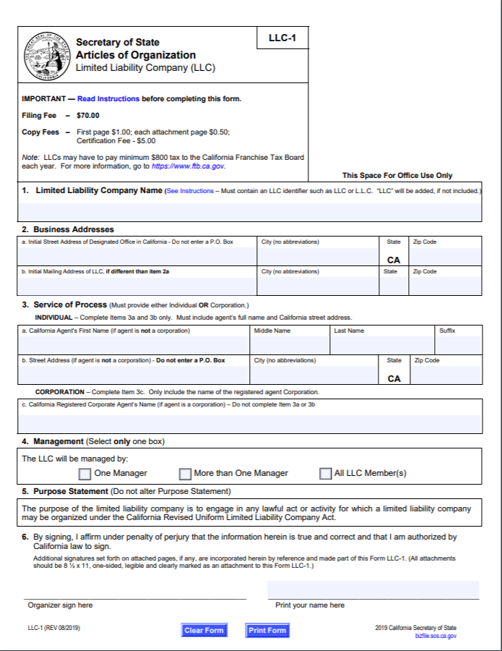Like most California business entity forms, it requires an agent for service of process. Something different about this form is the indication whether the llc will be managed by one manager, more than one manage, or all the llc members.

Private Document for LLCs: Operating Agreement
The operating agreement is a private agreement, like a partnership agreement was the private agreement for partnerships. The operating agreement covers how the members are to act towards each other. While some states do not require a written operating agreement, it is a good idea to have a written one. There should be a lot of detail about llc management. The agreement should have the name of the llc, names and addresses of all of the members, llc purpose, the principal place of business, llc terms, actions the llc can perform, how the llc will be managed, llc meetings, how llc members will vote, how to admit new members to the llc, how members leave an llc, and how to dissolve the llc.
The llc purpose should be written broadly so it does not need to constantly be re-written. LLCs are artificial people and have legal rights; the operating agreement should discuss which legal rights the members want the llc to have. This can include the llc suing in its own name, the llc being able to buy and/or sell property, and the llc taking a loan or giving a loan.
The operating agreement should include each member and the amount of contributions each member has made to the llc. The contributions should be delineated as either cash, property, or services. If cash is not provided, it may be necessary to appraise the item for its value. The operating agreement should state when distributions will be made, including, but not limited to final distributions. This all can help reduce the likelihood of potential conflicts.
An LLC can be managed by its members or its members can hire a manager to manage the llc. If an llc is member managed, then the members who manage can still have limited liability. Member-managed llcs usually work better with fewer members. Larger llcs with more members do better hiring a few managers. In a manager-managed llc, certain members could be managers or outsiders could be managers. If an LLC is manager-managed, only the managers have the rights to bind the managers.
LLC meetings are not usually required by statute, so the operating agreement needs to discuss them, as well as how members can join or leave, along with dissolving the whole llc.

Financing of the LLC
LLC members make contributions to the LLC. The contributions can be cash, property, or services. Property can be real property and it can be intellectual property. If the operating agreement does not discuss contributions, most state statutes require members to contribute equally. An llc has more benefits over S Corporations. An LLC also has the great tax status and an LLC allows for foreign investors (unlike an S Corporation).

One-Person LLCs
Some state statutes allows for one person to form an llc. The llc is preferred to a sole proprietorship, if one’s profession allows them to become an llc, due to the limited liability. It is a bit more to set up than a sole proprietorship, but the limited liability protection can well make it worth it.

Management of the LLC
All members could manage, some managers could manage, or outside manager(s) could manage. An llc does not require that there be shareholder meetings, like a publicly traded corporation does.

Flexible Management
No matter how an llc is managed, some things require unanimous consent of all of the llc members. Even these things may be addressed in the operating agreement and no longer require unanimous consent. If they are not addressed in the operating agreement, the following usually require unanimous consent: amending public documents, merging, and disposing of llc property. If distributions above what was discussed in the operating agreement are to be made, this will require unanimous agreement. Adding members requires unanimous agreement. Dissolution has to be unanimously agreed to.

Member-Managed or Manager Managed LLCs
Member-managed llcs require all llc members to have an equal say in managing the llc. In this instance, it does not matter what each member financially contributed to the llc. Each member is an agent of the llc. Agents can bind the llc. Agents are fiduciaries and have to act with due care.
Manager-managed llcs might have some of the members be managers or outside people will manage. Only the managers are agents. The managers are fiduciaries and have to act with due care. Managers are chosen and removed by a majority vote of members. These managers are usually paid for their service.

Liability of the LLC
Members and managers of llcs do not have unlimited personal liability, above and beyond what they contributed to the llc, for the actions of the llc. If a member of manager personal commits an error, then she can still be held personally liable. The limited liability of an llc is what makes it a popular business entity. This makes an llc similar to a corporation and the liability that shareholders have.
To start the company though, personal signatures may be required. These personal signatures may bind individuals to be personally liable for debt.
The llc can be sued, so if an llc causes injuries, then the llc can be sued. If the llc was started with little-to-no money, there might not be a lot of money to pay those lawsuits. The llc may not have insurance to help pay for those lawsuits either.
The following case discusses llc members not being liable for tortious acts of the llc. It even holds that members of an llc who personally sign a hotel franchise agreement along with the LLC are not liable for the tortious acts of the LLC. Finally, it even holds that an llc member who was a hotel manager might have personal liability for his own actions, but is not liable just as a member of the llc.

Braucher v. Swagat Group, LLC

Braucher v. Swagat Group, L.L.C.
702 F. Supp. 2d 1032 (2010).
…In the winter of 2006, Georgia Braucher and Bonnie Leiser stayed at the Comfort Inn in Lincoln, Illinois (Hotel), owned by the Defendant LLC and operated under a Franchise Agreement (Agreement) with Choice Hotels. The other Swagat Defendants were members of the LLC. Georgia Braucher and Bonnie Leiser became ill shortly after their stays at the Hotel, and both were diagnosed with Legionnaires Disease. Legionnaires Disease is a respiratory disease that presents symptoms similar to pneumonia…. On March 10, 2006, the Illinois Health Department closed the Hotel when Legionella bacteria, the bacteria that cause Legionnaires Disease, was found in the Hotel's pool and spa. Georgia Braucher died on March 19, 2006.
Bonnie Leiser and Georgia Braucher's daughter Marjorie Braucher then brought these cases against the Defendants. Choice Hotels brought cross-claims against the Swagat Defendants for indemnification. The Defendants now seek summary judgment on the Plaintiffs' claims. The Swagat Defendants also seek partial summary judgment on Choice Hotels' cross-claims for indemnification. For the reasons set forth below, the Motions to Bar are allowed, the Choice Summary Judgment Motions are allowed, and the Swagat Summary Judgment Motions and the Partial Summary Judgment Motions are allowed in part and denied in part.
STATEMENT OF FACTS
On February 15, 2001, Choice Hotels and the Swagat Defendants entered into the Agreement.... All of the Swagat Defendants were parties to the Agreement, not just the LLC. The Agreement granted the Swagat Defendants a franchise to operate the Hotel as a Comfort Inn. The Agreement gave the Swagat Defendants a license to use Choice Hotels' Comfort Inn marks, its system for operating hotels, and its reservation system. Agreement, § 2. The Agreement required the Swagat Defendants to pay various fees to Choice Hotels and to comply with all of the Choice Hotels' Rules and Regulations for operating the Hotel as a Comfort Inn. Id., §§ 4, 6. The Agreement further authorized Choice Hotels to inspect the Hotel periodically to insure that the Swagat Defendants complied with the terms of the Agreement and Choice Hotels' Rules and Regulations. Id., § 6.g.
The Agreement contained a provision entitled "Indemnification" (Indemnification Clause)….
The Agreement also contained a provision entitled "Business Relationship", which stated, in part:
You are an independent contractor. Nothing in this Agreement makes, or is intended to make, either party an agent, legal representative, subsidiary, joint venturer, partner, employee, independent contractor or servant of the other (except that we are acting as your agent when making reservations for your Hotel) . . ..
The Choice Hotels' Rules and Regulations stated that Choice Hotels would perform periodic inspections. The Rules and Regulations referred to such an inspection as a "Quality Assurance Review" (QAR)…. The Rules and Regulations stated that the QAR:
[I]s designed to assist you and Choice by identifying areas in which your Hotel does not meet the minimum standards of the Comfort Inn brand, as set forth in these Rules & Regulations. This review is not intended to determine whether your Hotel is in compliance with federal, state and local laws and regulations, which is your sole responsibility.
Id. A failing grade in a QAR could, at Choice Hotels' discretion, result in a notice of default and, ultimately, termination of the Agreement if the defaults were not cured within thirty days of the notice. Id.
The Rules and Regulations also required the Swagat Defendants to place a plaque in the lobby visible from the front desk that stated that the Hotel was independently owned and operated by the LLC. Id., § 828.1. The Choice Hotels provided advertising, a toll-free 800 number telephone reservation system, and a website which included an internet reservation system. The Choice Hotels' reservation system was tied directly into the Hotel's computerized reservation system. The Choice Hotels' website contained a statement on the home page that each Choice Hotel was independently owned and operated….
The Swagat Defendants began operating the Hotel as a Comfort Inn in 2001. The Swagat Defendants placed the required plaque in the lobby, stating that the Hotel was independently owned and operated. The plaque was on display in 2006 when the Plaintiffs stayed at the Hotel. The Swagat Defendants also kept copies of the current Choice Hotels' Worldwide Hotel Directory (Directory) available in the lobby. The 2006 Directory contained a statement that each hotel was owned and operated….
The Hotel participated in Choice Hotels' program that allowed guests to accumulate points toward a free stay at Choice Hotels. If a guest redeemed points for a free stay, Choice Hotels reimbursed the participating hotel for the cost of the night's stay.
The Hotel had an indoor swimming pool and spa. The Rules and Regulations required the Swagat Defendants to have either a swimming pool or a pre-approved exercise room at the Hotel…. The Rules and Regulations further stated, "Swimming pool, recreation areas and all filtration and chemical feed systems must meet all applicable local, state and federal codes…." The pool and spa area was enclosed in a separate room. The pool and spa area had a ventilation system that was separate from the rest of the Hotel, and had two exterior windows and a door that opened into an interior hallway of the Hotel….
The Hotel retained an employee of the former owner. The employee was named Wayne Filmore. Filmore handled the maintenance of the pool and spa at the Hotel until he left in 2003. Filmore showed Vasant Patel how to maintain the pool and spa…. The Illinois Department of Public Health (Department) inspector, Chad Curless, also showed Patel how to use pool test kits…. After Filmore left the Hotel, Vasant Patel maintained the pool and spa. Vasant Patel had no other training or experience in pool and spa maintenance. Choice Hotels did not provide him with any training in pool and spa maintenance.
Choice Hotels' Franchise Service Director Mark Schimmel conducted the QARs at the Hotel. He tried to conduct these reviews every seven months, usually twice a year. He said that he did not make that schedule sometimes…. The QAR included a visual inspection of the pool and spa. Schimmel would check to see that the water was clear. He would check pool records for chemical checks to determine if the franchisee was doing a minimum of maintenance on a daily basis and to determine if there were any problems. Schimmel, however, did not test the pool or spa water during the inspection. Schimmel would visually inspect the pool equipment. He would also note any chlorine smell in the pool area. Schimmel had the authority to shut down a pool if the water was cloudy. Cloudy water was a safety hazard because a person drowning at the bottom of the pool could not be seen if the water was cloudy…. If Schimmel could not see the floor drain at the bottom of the pool, he would close the pool immediately and require the franchisee to remedy the situation.
Schimmel conducted a QAR of the Hotel on November 11, 2004. This was the last QAR before the Plaintiffs' stays at the Hotel in 2006. Schimmel used a score sheet for the QAR. The sheet listed two general categories, Cleanliness (CL) and Maintenance and Capital Improvement (MCI). The Hotel started with 1000 points in each category. Schimmel assigned points for any deficiency in any listed category. These points were deducted from the initial 1000 points in one of the two categories. The Hotel received a final score in each category. A score of 750 points in each of the two general categories was passing….
In the November 11, 2004, QAR, Schimmel deducted points for deficiencies in the following aspects of the pool and spa area on the QAR checklist:
. pool area/deck dirty, furniture soiled
. algae/mildew in pool, water unclear, milky, dirty
. furniture damage/needs paint and adequate lounge furniture
. safety equipment not accessible/missing
. depth not adequately marked
. lighting inadequate/damaged/missing
. signs damage/need paint/inadequate
. fences/gates damages/inoperative/inadequate
. walls/floor/deck/ceiling damaged
. damage/needs paint, dated/aged….
The Hotel, overall, received a passing grade on this QAR….
The Department conducted periodic inspections of the pool and spa area. The Department's regulations required the Hotel to check the chlorine and pH levels in the pool and spa twice a day. The free chlorine level was supposed to be 1 to 4 parts per million (ppm) in water below 85[degree]s Fahrenheit, and between 2 to 4 ppm for water 86[degree]s and above…. The pH level was supposed to be between 7.2 and 7.6…. The Hotel was required to keep a log documenting the daily checks. The Log listed the chlorine, pH level, and water temperature determined each check….
The Department's Inspector Chad Curless conducted the inspections at the Hotel. On October 17, 2005, Curless shut down the pool and spa because the chlorine level was below 1 ppm and the pH level was greater than 8 in both the pool and spa. Curless Deposition, at 61-62. Curless noted on his report:
Operational reports have been filled in for the rest of the year through 2005. This is false documentation….
Curless said that the chlorine and pH levels were all filled out for the rest of the year on the Log….
Curless discussed the proper use of pool testing kits with Vasant Patel at this time. Vasant Patel had a Taylor brand kit, but used testing chemicals that were designed to be used with a Rainbow brand testing kit. The use of the wrong chemicals could result in incorrect readings. Curless told Vasant Patel to use only the Taylor brand chemicals with the Taylor brand testing kit….
Vasant Patel called Curless on October 21, 2005, to tell him that the chlorine and pH levels were corrected in the pool and spa. Curless authorized him to reopen the pool and spa. Curless made a surprise inspection of the pool and spa on October 22, 2005. The chlorine and pH levels were within appropriate limits at that time….
Curless inspected the pool and spa again on February 8, 2006. This time he found that the chlorine level in the pool was too high at 6 ppm, there was no chlorine level in the spa, and the pH level in the spa was greater than 8. Curless closed the spa…. Curless allowed Vasant Patel to reopen the spa on February 14, 2006….
The Log stated that on February 8, 2006, the chlorine level was 3.1 and the pH level was 7.1 in both the pool and the spa. Log. Curless said that there was a big difference between 7.1 and 8. Curless Deposition, at 80. In fact, the Log stated that the free chlorine level was always between 3.1 and 3.4, and the pH level was always between 7.1 and 7.4 from January 1, 2006, until the pool and spa were closed on March 10, 2006. Log. Curless stated that in his experience, chlorine levels and pH levels usually would vary more than this from day to day….
On March 6, 2006, the Department received a notice of a possible outbreak of Legionnaires Disease at the Hotel. Id., at 86. Curless inspected the pool and spa the next day, on March 7, 2006. This time, he found no chlorine in either the pool or spa and pH levels in excess of 8 in both the pool and spa. Id., at 88. He shut both the pool and spa down and took water samples for testing. Those samples tested positive for Legionella bacteria. The Department immediately sent the Hotel notice to shut the pool and spa down….
The Log showed chlorine levels of 3.1 and pH levels of 7.3 and 7.8, respectively, on March 6, 2006, the day before Curless' inspections. Curless stated in his deposition, that in his experience, the chlorine levels would not have gone from 3.1 to 0 in one day, and pH levels would not have gone from 7.3 to more than 8 in one day….
Plaintiff Bonnie Leiser stayed at the Hotel from January 14, 2006, to January 16, 2006. She and her brother Brian Leiser stayed together in the same room. They were attending a funeral of a family member. Her brother made the reservation. Bonnie Leiser had stayed at the Hotel before. Bonnie Leiser went into the spa during her stay at the Hotel. After her stay, she became ill. She was diagnosed with Legionnaires Disease. Bonnie Leiser smoked cigarettes at the time she contracted Legionnaires Disease.
Bonnie Leiser was familiar with the Comfort Inn brand. She had seen Choice Hotels' commercials on television…. She was not aware of the fact that the LLC owned the Hotel. She testified that, at the time of her deposition, she understood that the Swagat Defendants owned the Hotel and operated it as a subsidiary of Choice Hotels. She testified at her deposition that she assumed that Choice Hotels and the Swagat Defendants were partners. Id., at 155.
Marjorie Braucher and her mother Georgia Braucher stayed at the Hotel from February 11 to February 13, 2006. Marjorie made the reservation. Georgia and Marjorie had stayed at Choice Hotels before elsewhere. Georgia Braucher did not go into the pool and spa area of the Hotel during her stay. Georgia walked down the hallway by the pool and spa area about four times during her stay, but she did not go into the area. After their stay, Georgia Braucher became ill. She was diagnosed with Legionnaires Disease and died on March 19, 2006. Georgia was 90 years old at the time….
The Department investigated the occurrence of Legionella bacteria at the Hotel pool and spa. The Department report stated that there were 160 cases of respiratory illnesses reported by people who stayed at the Hotel in early 2006…. There were five confirmed cases of Legionnaires Disease including Bonnie Leiser and Georgia Braucher…. The level of Legionella bacteria found in the water from the pool and spa was 2000 times higher than the level that would normally be found in municipal tap water…. The Department also tested water from the faucets and showers in some of the Hotel rooms…. This water had no Legionella bacteria….
The Plaintiffs' expert Dr. David Smith opined that the Hotel did not maintain the pool and spa properly. Dr. Smith is a retired United States Coast Guard Commander with extensive experience in water safety and water rescue procedures. He also has training and experience in the proper maintenance procedures for swimming pools…. He opined that Vasant Patel falsified the Log. He based his opinion on Curless' notation on the October 2005 inspection form that the records were falsified and the fact that the chlorine level and pH level on the Log stayed so uniform. He opined that the levels would have varied more widely from day to day. He noted that the Log showed that the pool and spa were regularly subjected to shock treatments designed to increase the amount of free chlorine in the pool and spa… He said that the chlorine levels should have increased immediately after the treatments, but the Log consistently showed no change in the levels. He opined that this indicated that the Log was fabricated. Curless agreed that it was unusual for the chlorine and pH levels to stay so uniform from day to day….
The Plaintiffs' expert Dr. Carl Fliermans opined to a reasonable degree of medical certainty that Bonnie Leiser and Georgia Braucher contracted Legionnaires Disease from the bacteria in the pool and spa area of the Hotel…. Dr. Fliermans is a microbial ecologist and an expert on Legionnaires Disease…. Dr. Fliermans based his opinion on the fact that others who stayed at the Hotel contracted the disease; Bonnie Leiser and Georgia Braucher both were infected with the specific type of Legionella bacteria that was found in the pool and spa; the levels of Legionella bacteria found in the spa on March 7, 2006, were so high that the level would have been elevated when Leiser and Braucher stayed at the Hotel; the pool and spa records indicated that the pool and spa were not maintained properly; and no other cases of Legionnaires Disease were reported to the Centers for Disease Control from the Lincoln, Illinois, area generally…. He opined that under these circumstances, the source of Bonnie Leiser and Georgia Braucher's infection was the Hotel's pool and spa.
Dr. Fliermans stated that Legionnaires Disease is contracted by taking an aerosol form of contaminated water into the person's lungs. He opined that Bonnie Leiser could have breathed in the mist from the pool and spa when she used the spa. He opined that Georgia Braucher could have breathed in the mist from the pool and spa area when she walked down the Hotel hallway. He opined that the mist from the pool and spa area came into the Hotel hallway when the door to the spa and pool area was opened and closed….
Choice Hotels filed cross-claims against the Swagat Defendants…. Choice Hotels alleged cross-claims for express indemnity under the Indemnification Clause, implied indemnity, and contribution against each Swagat Defendant. The express indemnity claims asked for a judgment against each Swagat Defendant for any amount that Choice Hotels is liable to the Plaintiffs, plus attorneys fees and costs for defense of the suit…. The implied indemnity claims alleged that the Swagat Defendants were obligated to indemnify Choice Hotels if Choice Hotels was found vicariously liable for the acts of the Swagat Defendants….
ANALYSIS
The Defendants now seek summary judgment. Choice Hotels and the Swagat Defendants seek summary judgment on all of Plaintiffs' claims. The Swagat Defendants also seek partial summary judgment on Choice Hotels' Cross-Claims for express and implied indemnification….
II. CHOICE HOTELS' SUMMARY JUDGMENT MOTIONS
Choice Hotels moves for summary judgment on three bases. First, Choice Hotels seeks summary judgment on the Negligence Counts, the Wrongful Death Counts, the Survival Act Counts, and the Funeral Expense Counts (collectively the Duty Counts) on the grounds that it did not owe a duty to either Bonnie Leiser or Georgia Braucher to maintain the pool and spa at the Hotel. Second, Choice Hotels moves for summary judgment on the Leiser and Braucher Res Ipsa Counts (collectively the Res Ipsa Counts) on the grounds that it was not in exclusive control of the pool and spa at the Hotel. Third, Choice Hotels moves for summary judgment on the Leiser and Braucher Agency Counts (collectively the Agency Counts) on the grounds that there is no evidence that circumstances existed under which it would be responsible to either Bonnie Leiser or Georgia Braucher for the actions of any Swagat Defendant under an apparent agency theory.
At summary judgment, the movant, Choice Hotels, must present evidence that demonstrates the absence of a genuine issue of material fact…. The Court must consider the evidence presented in the light most favorable to the opponent of the motion, the Plaintiffs. Any doubt as to the existence of a genuine issue for trial must be resolved against Choice Hotels…. Once Choice Hotels has met its burden, each Plaintiff must present evidence to show that issues of fact remain with respect to an issue essential to her case, and on which she will bear the burden of proof at trial…
The Duty Counts are all based on a theory of negligence and require evidence that Choice Hotels owed a duty to Bonnie Leiser and Georgia Braucher to maintain the pool and spa at the Hotel…. It is clear that the Agreement did not create a duty on the part of Choice Hotels toward the patrons of the Hotel, including Bonnie Leiser and Georgia Braucher. The LLC owned the Hotel. Choice Hotels provided a franchise to the Swagat Defendants pursuant to the Agreement. Under the terms of the Agreement, Choice Hotels neither owned nor operated the Hotel. The Agreement specifically provided that the Swagat Defendants were independent contractors and no agency relationship existed between them and Choice Hotels.
The face of the Agreement, however, is not controlling on the issue of duty. A franchisor may assert sufficient control of a hotel to be responsible for the operation of the pool and spa…. A franchisor, however, must make sure that the franchisee maintains the required level of quality associated with the franchised brand in order to protect trademarks…. This monitoring may include setting standards for the operation of the franchise, retaining the right to inspect the franchise operation periodically, and retaining the right to withdraw the franchise or to close an aspect of the franchise operation for failure to comply with the franchisor's standards. A franchisor will not be responsible for the operation of the franchisee hotel unless it asserts more direct control than these limited rights associated with maintaining the quality of its brand….
The Plaintiffs present no evidence that Choice Hotels went beyond these limited steps to maintain the required level of quality associated with the franchised brand. Choice Hotels made visual inspections of the pool and spa area twice a year at most, and retained the right to close the pool and spa if the water was cloudy. Choice Hotels retained the right to close cloudy pools because of the risk of drowning, not because of the risk of toxic bacteria build-up. Choice Hotels also required, in the Rules and Regulations, that the Hotel comply with the law. The Swagat Defendants had to meet these requirements anyway. Choice Hotels did not impose any additional requirements for controlling bacteria levels in the pool or spa. Choice Hotels never took any action to test the water quality in the pool and spa area. Based on the evidence presented, Choice Hotels did not exercise sufficient control over the Hotel to be considered an operator of the Hotel.
The Plaintiffs rely on Greil v. Travelodge International, Inc., as authority that a franchisor may be responsible for the operation of a hotel if it only takes the limited steps that Choice Hotels did to maintain the quality of its brand…. The Greil decision applied California law, not Illinois law. The California cases on which the Greil court relied indicate that a franchisor may be deemed responsible for the franchisee's operations even when the franchisor only engages in limited monitoring of the franchise…. California law is inconsistent with Illinois law on this point, and Illinois law controls. The Greil decision, therefore, is not persuasive.
The Plaintiffs argue that Choice Hotels is liable because it voluntarily assumed the duty to maintain the pool and spa at the Hotel. Whether a party voluntarily assumed a duty is a question of law. Castro, 732 N.E.2d at 42. If a party voluntarily undertakes a duty, the duty is limited to the extent of the undertaking…. Here, Choice Hotels never voluntarily took on the task of maintaining the water to avoid the risk of infection. Again, Choice Hotels made visual inspections of the pool and spa area twice a year at most, and retained the right to close the pool and spa if the water was cloudy because of the risk of drowning, not because of the risk of toxic bacteria build-up. None of the evidence presented indicates that Choice Hotels assumed that duty. Choice Hotels is entitled to summary judgment on the Duty Counts alleged against it.
Choice Hotels is also entitled to summary judgment on the Res Ipsa Counts. To establish a res ipsa loquitur claim, a party must present evidence that: (1) the occurrence ordinarily does not happen in the absence of negligence, and (2) the exposure to Legionella bacteria was caused by an agency or instrumentality within the Defendants' exclusive control…. As explained above, Choice Hotels did not exert exclusive control over the pool and spa at the Hotel. Choice Hotels, at best, made limited visual inspections of the pool and spa twice a year and required the Swagat Defendants to comply with the law regulating aquatic facilities in hotels. The LLC owned the Hotel, and Vasant Patel managed the Hotel, including the pool and spa. Choice Hotels did not exert exclusive control. Choice Hotels is entitled to summary judgment on the Res Ipsa Counts.
Choice Hotels is also entitled to summary judgment on the Agency Counts. To establish an apparent agency, the Plaintiffs must present evidence that: (1) Choice Hotels held out one or more of the Swagat Defendants as having authority to act as its agent, or Choice Hotels knowingly acquiesced in one or more of the Swagat Defendants exercising the authority as Choice Hotels' agent; (2) the Plaintiffs, acting reasonably under the circumstances, assumed that an agency existed; and (3) the Plaintiffs relied on the apparent agency to their detriment….
The Plaintiffs fail to present evidence that Choice Hotels held the Swagat Defendants out as its agents. The Plaintiffs present evidence that Leiser believed that Choice Hotels operated the Hotel. She testified that she believed this based on the Choice Hotels commercial she saw on television. The Plaintiffs also present evidence that Choice Hotels operated a reservation system that used an 800 telephone number and an internet web site. Choice Hotels also operated a frequent traveler program in which customers could accumulate points that would entitle them to a free night's stay at a participating Choice Hotels.
None of this evidence demonstrates that Choice Hotels held out the Swagat Defendants as its agent. The use of the brand name shows a franchise relationship, but the existence of a franchise does not create an agency…. Bonnie Leiser does not present evidence of the content of the Choice Hotels commercials which gave her the impression that Choice Hotels operated its franchisees' hotels. In fact, the only evidence of representations regarding the relationship between Choice Hotels and the Swagat Defendants were the parties' repeated disclaimers of any agency: the plaque in the lobby of the Hotel that declared that the Hotel was independently owned and operated, the disclaimer on the Choice Hotels' website which stated that all Choice Hotels are independently owned and operated, and the disclaimer in the 2006 Directory which stated that all Choice Hotels are independently owned and operated. The Plaintiffs fail to present evidence that Choice Hotels held the Swagat Defendants out as its agents. Choice Hotels is entitled to summary judgment on the Agency Counts as well.
The Plaintiffs rely on Greil and Crinkley v. Holiday Inns, Inc., to support their claim of apparent agency…. Neither of these cases apply Illinois law. In addition, the Greil court denied summary judgment on the apparent agency theory because the franchisee hotel did not contain a disclaimer that the hotel was independently owned and operated… The Greil court noted that even under California law a franchisor could avoid a claim of apparent agency by placing a disclaimer in the lobby of the franchisee hotel…. Here, the LLC displayed the disclaimer in the lobby where patrons could see it before they checked in. There is no evidence of an apparent agency. Choice Hotels is entitled to summary judgment.
III. PARTIAL SUMMARY JUDGMENT MOTIONS
The Swagat Defendants ask for partial summary judgment on Choice Hotels express indemnity and implied indemnity counts in the Cross-Claims. The Swagat Defendants are entitled to partial summary judgment on the implied indemnity claims, but issues of fact exist with respect to the express indemnity claims.
Indemnity clauses in contracts are enforceable in Illinois and are governed by principles of contract interpretation…. In this case, the Indemnification Clause is clear: the Swagat Defendants are obligated to indemnify Choice Hotels for all costs, including attorney fees and costs of suit, if: (1) Choice Hotels is subject to a claim for damages allegedly arising from the operation of the Hotel; (2) Choice Hotels is not at fault for the alleged damages; and (3) one or more of the Swagat Defendants is found to be at fault for the alleged injuries. The first two elements have been established: the Plaintiffs brought claims against Choice Hotels for damages allegedly arising from the operation of the Hotel, and Choice Hotels is not at fault. As discussed below, issues of fact remain with respect to whether any of the Swagat Defendants were at fault in this case. The Swagat Defendants may be obligated to indemnify Choice Hotels, and so pay its attorney fees and expenses, if one or more of the Swagat Defendants is found to be at fault for the injuries to Bonnie Leiser and the injuries and death of Georgia Braucher.
The Swagat Defendants argue that the Indemnification Clause is really a contribution clause. The Court disagrees in this situation. The clause obligated the Swagat Defendants to indemnify Choice Hotels in the limited situation in which Choice Hotels was subject to a claim, but was not at fault. If Choice Hotels had been partially at fault, then the Swagat Defendants would be correct; the clause would have imposed a contribution obligation on joint tort feasors, not an indemnification obligation. But, that did not occur here because Choice Hotels was not at fault. Thus, the Swagat Defendants are not entitled to summary judgment on the express indemnity cross-claim.
The Swagat Defendants are entitled to summary judgment on the implied indemnity claim. Choice Hotels alleged that the Swagat Defendants were impliedly obligated to indemnify it if Choice Hotels was vicariously liable for their acts. Choice Hotels is not vicariously liable for the acts of the Swagat Defendants, so there is no implied indemnity. The Swagat Defendants are entitled to partial summary judgment on this cross-claim.
IV. SWAGAT SUMMARY JUDGMENT MOTIONS
All of the Swagat Defendants ask for summary judgment on all of Plaintiffs' claims, both the Duty Counts and the Res Ipsa Counts. In addition, Vijay C. Patel, Himanshu M. Desai, and Vaidik International, Inc., seek summary judgment on the grounds that the LLC owned and operated the Hotel and that they, as members of the LLC, have no personal liability. Defendant Vasant Patel also seeks partial summary judgment to the extent that the Plaintiffs seek to hold him liable as a member of the LLC. The Court will address these portions of the Motions separately.
A. The Members of the LLC
Defendants Vijay C. Patel, Himanshu M. Desai, and Vaidik International, Inc., seek summary judgment on the grounds that they are not liable for the acts of the LLC, the owner of the Hotel. Vijay C. Patel, Himanshu M. Desai, Vasant Patel and Vaidik International, Inc., were members of the LLC. The LLC owned the Hotel. Only Vasant Patel worked at the Hotel. Defendants Vijay C. Patel, Desai, and Vaidik International, Inc. were only members. Members of limited liability companies, such as the LLC, are not liable for the tortious acts of the limited liability company…. Defendants Vijay C. Patel, Desai, and Vaidik International, Inc. are entitled to summary judgment.
The Plaintiffs argue that these Defendants are personally liable because they signed the Agreement in their personal capacities. This is clearly wrong. A member of a limited liability company who signs a contract in a personal capacity is liable on the contract, but is not thereby liable for any other obligation of the limited liability company…. These Defendants are entitled to summary judgment.
Similarly, Vasant Patel is entitled to partial summary judgment to the extent that the Plaintiffs seek to hold him liable as a member of the LLC. Vasant Patel managed the Hotel and maintained the pool and spa, and as explained below, may or may not have some personal liability for his own actions, but he is not liable simply as a member of the LLC.
B. Res Ipsa Counts
The LLC and Vasant Patel, personally, seek summary judgment on the Plaintiffs' Res Ipsa Counts on the grounds that the Plaintiffs failed to present evidence to establish that the pool and spa were the source of the Plaintiffs' Legionnaires Disease. To establish a res ipsa loquitur claim, a party must present evidence that: (1) the occurrence ordinarily does not happen in the absence of negligence, and (2) the exposure to Legionella bacteria was caused by an agency or instrumentality within the Defendants' exclusive control…. The Plaintiffs have presented evidence on each of these elements. The Plaintiffs' expert, Dr. Fliermans, opined that the source of the Legionella bacteria that caused Bonnie Leiser and Georgia Braucher's Legionnaires Disease was the pool and spa at the Hotel.... The pool and spa area was in the exclusive control of the LLC and Vasant Patel, as the Hotel manager and the individual who personally maintained the pool and spa. Dr. Smith opined that the Legionella bacteria were in the pool and spa because the pool and spa were not properly maintained. Curless' inspections, when read favorably to the Plaintiffs, also support the inference the pool and spa were not properly maintained: the records were falsified at the October 2005 inspection; there was no chlorine in the spa at the February 2006 inspection; and there was no chlorine in either the pool or spa at the March 8, 2006, inspection. This evidence is sufficient to establish that issues of fact exist on the Res Ipsa Counts.
The Defendants argue that Plaintiffs failed to produce evidence that the pool and spa were the exclusive source of the Legionella bacteria because Dr. Fliermans agreed that: (1) Legionella bacteria existed in low levels in the Lincoln, Illinois, public water supply; (2) the bacteria could have theoretically multiplied in the Hotel's hot water heater; and so, (3) the Plaintiffs could have come in contact with the Legionella bacteria while taking a shower at the Hotel rather than from the pool or spa…. Dr. Fliermans, however, excluded the Lincoln, Illinois, water supply and the showers at the Hotel as possible sources of the Legionella bacteria because: (1) no cases of Legionnaires Disease from the Lincoln, Illinois, area generally were reported to the Centers for Disease Control; (2) the pool and spa were not maintained properly; and (3) the level of Legionella bacteria found in the spa area was so high on March 7, 2006, that it must have been at elevated levels at the time that Bonnie Leiser and Georgia Braucher stayed at the Hotel…. These reasons are sufficient to support the validity of his opinions for purposes of summary judgment. The Defendants may cross-examine Dr. Fliermans on these matters to point out the weakness in his opinions at trial. His opinions are sufficient to create an issue of fact.
The Defendants also ask for summary judgment on the Duty Counts. To establish the Duty Counts, the Plaintiffs must present evidence of a duty, breach of duty, injury and proximate cause…. The Plaintiffs have presented evidence on these elements. The Defendant LLC owned and operated the Hotel, and so, owed a duty to the Plaintiffs as guests. Vasant Patel, as manager and the person responsible for maintaining the pool and spa, had a duty to the Plaintiffs as guests. Dr. Smith opined that these Defendants breached their duty by failing to maintain the pool and spa properly, thereby allowing the Legionella bacteria to grow to dangerous levels. The inspections by Curless supported Dr. Smith's opinions. On the issue of proximate cause, Dr. Fliermans opined that the Legionella bacteria in the pool and spa were the source of the bacteria that caused Bonnie Leiser and Georgia Braucher to contract Legionnaires Disease. Last, Bonnie Leiser suffered injuries from her illness, and Georgia Braucher died from her illness. The Plaintiffs have presented evidence on each element.
The Defendants argue that Dr. Fliermans' opinions on causation are mere conjecture. As explained above, the Court disagrees. Dr. Fliermans had a valid basis for his conclusions that the pool and spa were the source of Legionella bacteria that caused Bonnie Leiser and Georgia Braucher's illnesses. The Defendants may attack those opinions on cross-examination at trial, but those opinions are sufficient for purposes of summary judgment….

Continued Existence of the LLC and Transferability of the LLC
An llc can continue as long as the members desire. If the articles of organization do not spell out the llc term, then the llc is an at-will llc. If the articles of organization do spell out the llc term, then the llc is known as a term llc. There only needs to be one member to continue the llc (so long as the state allows for llcs with one member). If other members do dissociate, they may be required under state statutes to provide six-months notice.
Members can give away rights to profit without other members’ approval but cannot give away management rights without other members’ approval. Replacing members requires a majority (if in the partnership agreement) and unanimous approval (if not in the partnership agreement).

Profits and Losses of the LLC
If it is not discussed in the operating agreement, then the state statute on llcs will govern what percentage each member receives of the LLC’s profits/losses. If the state statute is based upon ULLCA, then the profits will be divided equally, no matter what the members initially contributed. Losses are also shared equally.

Taxation
The llc has pass-through taxation, which means taxation passes through the llc to its members and members pay taxes at their individual tax rates. The LLC files a form 1065. Members add a Schedule K-1 to their 1040 (or other tax forms). An llc can elect to be taxed as a corporation rather than similar to a partnership. If the llc members have high tax brackets, they might want to check the box to be taxed like a corporation.

Termination of the LLC
The llc will want to buy out the dissociating member’s interest so that it does not wind up the llc. Dissociation can happen by the member stating he wants to leave, a pre-agreed upon event occurs, a member is asked to leave, a member goes bankrupt, or a member can die.
An llc can dissolve in several different ways. The documents of the llc may state when the llc is supposed to be terminated. If members do not want the llc to be terminated at the end of a term, they could renew the articles of organization. All members could agree to dissolve the llc. This is common when the llc is not making money. A court can dissolve the llc. The secretary of state can dissolve an llc. This can occur when the llc does not file its annual reports for two or more years. If the llc is being dissolved, then articles of termination or articles of dissolution should be filed. Any final distributions to the members can only be made after all llc debts are paid.
If the llc commits fraud, it may be possible to pierce the corporate veil of the llc to end it. This allows members of the public to get to the personal assets of the managers/members of an llc if they have been abusing the llc. Piercing the corporate veil is also a remedy with corporations.

Key Terms
- Articles of organization
- Limited liability company
- Manager-managed
- Member-managed
- Operating agreement
- Uniform Limited Liability Company Act

Review Questions
- Compare and contrast llcs to the three different types of partnerships we studied in this text.
- Describe the operating agreement provisions that should be in the operating agreement.
- Who manages an llcc?
- What is the personal liability like in an llc?
- Is the taxation beneficial in an llc? Why or why not?

Ethics Exercise
Read the following section of the Business and Professions code and discuss with your classmates what is and is not unauthorized practice of law. California Business and Professions Code 6450 addresses what a paralegal cannot do or it will be considered unauthorized practice of law:
"(a) “Paralegal” means a person who holds himself or herself out to be a paralegal, who is qualified by education, training, or work experience, who either contracts with or is employed by an attorney, law firm, corporation, governmental agency, or other entity, and who performs substantial legal work under the direction and supervision of an active member of the State Bar of California, as defined in Section 6060, or an attorney practicing law in the federal courts of this state, that has been specifically delegated by the attorney to him or her. Tasks performed by a paralegal include, but are not limited to, case planning, development, and management; legal research; interviewing clients; fact gathering and retrieving information; drafting and analyzing legal documents; collecting, compiling, and utilizing technical information to make an independent decision and recommendation to the supervising attorney; and representing clients before a state or federal administrative agency if that representation is permitted by statute, court rule, or administrative rule or regulation.
(b) Notwithstanding subdivision (a), a paralegal shall not do the following:
(1) Provide legal advice.
(2) Represent a client in court.
(3) Select, explain, draft, or recommend the use of any legal document to or for any person other than the attorney who directs and supervises the paralegal.
(4) Act as a runner or capper, as defined in Sections 6151 and 6152.
(5) Engage in conduct that constitutes the unlawful practice of law.
(6) Contract with, or be employed by, a natural person other than an attorney to perform paralegal services.
(7) In connection with providing paralegal services, induce a person to make an investment, purchase a financial product or service, or enter a transaction from which income or profit, or both, purportedly may be derived.
(8) Establish the fees to charge a client for the services the paralegal performs, which shall be established by the attorney who supervises the paralegal’s work. This paragraph does not apply to fees charged by a paralegal in a contract to provide paralegal services to an attorney, law firm, corporation, governmental agency, or other entity as provided in subdivision (a)."

Chapter on Corporations

Student Learning Objectives
- Establish who promoters are in a corporation.
- Appreciate the benefits to incorporating in Delaware.
- Cover the pre-incorporation activities necessary prior to filing articles of incorporation and drafting bylaws.
- Review and analyze how to prepare bylaws.
- Discuss debt financing and equity financing.

Introduction to For-Profit Corporations
Corporations make more money than any other business entity. Corporations are a completely separate legal entity from the shareholders. A corporation is an artificial person. Artificial people still have the rights to sue and be sued, own property, make charitable donations, have a corporate seal, make property, go into debt, sign contracts, lend money, pursue business, elect directors and officer, and pay into retirement for employees. While artificial people have rights, it is harder to punish an artificial person than a natural person. A natural person can be put in jail. Directors cause corporations to take actions. The corporation can block some of the liability a director might have for making the corporation do some things.
Corporations are subject to the laws of the state that the corporation is incorporated in. Most states have adopted the Model Business Corporation Act (MBCA), or a version of the MBCA. If the state’s statutes adopting the MBCA do not speak to an issue, then the case law or common law of a state will govern on that issue. There is also a Revised Multiple Business Corporation Act (RMBCA) that has been widely adopted now.

Pre-incorporation
The people who start corporations are known as promoters. Promoters raise money to start the corporation, they find shareholders, they find directors, they find officers, they find employees, they find attorneys for the corporation, they find certified public accountants for the corporation, they come up with a business plan, and they figure out where the corporation should be located. There are some states that are much more pro-corporation than others, notably Delaware and Nevada.

A. Liability of Promoters in a For-Profit Corporation
In getting the corporation started, the promoter may sign contracts for the corporation. These are pre-incorporation contracts. If signed before the corporation is formed, then who is liable for those contracts and for how long? Promoters are typically liable for these contracts until the corporation ratifies these contracts. A promoter might have a contract stating that they are acting on behalf of the company, and not themselves, in order to try to negate some of this liability. Promoters can also limited their liability as ratification of a contract relates all the way back to the date that the contract was sign. So if a promoter signs a mortgage for a corporation he is forming on August 21, and then the corporation forms on December 6 and the corporation signs, ratifying the mortgage, then the corporation is liable on the mortgage all the way back to August 21, and not just December 6.

B. Where Should a For-Profit Corporation Incorporate?

1. Incorporating in Delaware.
Delaware is a very pro-corporation state. Corporations often pick states that are pro-corporation to form in. Corporate fees are a big business in the state of Delaware. Delaware protects corporations against hostile takeover. Delaware gives directors limited liability. Delaware does not make corporation have minimum capital contributions. Delaware does not have corporate state income tax for corporations that do not conduct business in the state. Corporations incorporated in Delaware can be owned anonymously. Filing can be performed until midnight Delaware time. Delaware has pro-corporation case law. This is the number one reason why so many corporations incorporate in Delaware. Most corporate issues have been litigated in Delaware and the court holdings are favorable to corporations. Delaware has a special court just for corporate law cases. Judges have practice corporate law. Delaware does not require director meetings to be held in person. Shareholders can a meeting by written vote though a majority must agree in that meeting to pass anything.
Delaware incorporation usually works well if the corporation conducts business in several states. The internal affairs of the corporation can be governed by Delaware state law. If the corporation only does business in one state (other than Delaware), then it does not make as much sense to incorporate in Delaware. It would probably be better to incorporate within the home state.

Web Exercise
Go to Delaware’s Division of Corporations website, located at: https://corp.delaware.gov/. Compare and contrast this site to the California Secretary of State’s website located at: https://www.sos.ca.gov/

Formation and Financing of the For-Profit Corporation
A corporation can be made up of only one person (depending on the state) or can be made up of thousands and thousands of people. The corporation is an artificial person. It has most of the same rights as a natural person. It is easier to raise money as a corporation or go into debt to start the business. Corporations can an option to issue stock or take on debt to get the money to start up.

A. Name Availability of the For Profit Corporation
Commonly recognized names sell products. The corporation will need to reserve its name in all fifty states, if the name is available in all of those states. The name cannot be fraudulent and imply a relationship with the United States government, for instance, that does not exist. The name will also have corporation in it.
It is possible to check the name availability in each state. This check is available at each Secretary of State’s websites. There should be an attempt to keep corporate names from being too similar to one another. Name reservation is possible if the name is available. Name reservation often only lasts for one hundred and twenty days. A shell company, just started to “save” the name, could be formed instead if name reservation needs to be for longer.
In the State of California, the name can be reserved using the form below.

Name Reservation Request Form
N
The form is a black and white form that allows for three choices for names to be reserved. The person requesting the name reservation should have checked if the name is available. Finally, fees are discussed.

B. Public Document for For-Profit Corporation: Articles of Incorporation
The name may be slightly different from state to state for the articles of incorporation. There is a lot more uniformity among states as to how corporations are run versus limited liability corporations. Most states are following their version of the Revised Model Business Corporation Act or Model Business Corporation Act. Delaware has its own very pro-corporation state statues.
The corporation only exists after the articles of incorporation are properly filed. There has to be the correct information in the articles, along with signatures of the incorporator(s), and filing of them with the proper filing fee at the secretary of state. Information to be included in the articles of incorporation include the name, address, agent, purpose, description of corporate stock and number of authorized shares, names and addresses of the incorporators, director information, corporate management, director and shareholder liability, and director indemnification. Other information can be put into the corporate bylaws. The agent for service of process is in the articles and will accept documents from the public and from the secretary of state for the corporation. The corporate purpose will either be in the articles or the bylaws. It should be broad and legally valid. Shares have to be discussed in some detail in the articles, i.e. how many, what class, common, or preferred. The corporation, even after it gets its articles and bylaws completed, has to file annual reports and comply with securities laws. The corporation does file its own tax returns and does pay taxes.

Articles of Incorporation for California General Stock Corporation
The form for a general stock corporation in California is located at: https://bpd.cdn.sos.ca.gov/corp/pdf/articles/arts-gs.pdf
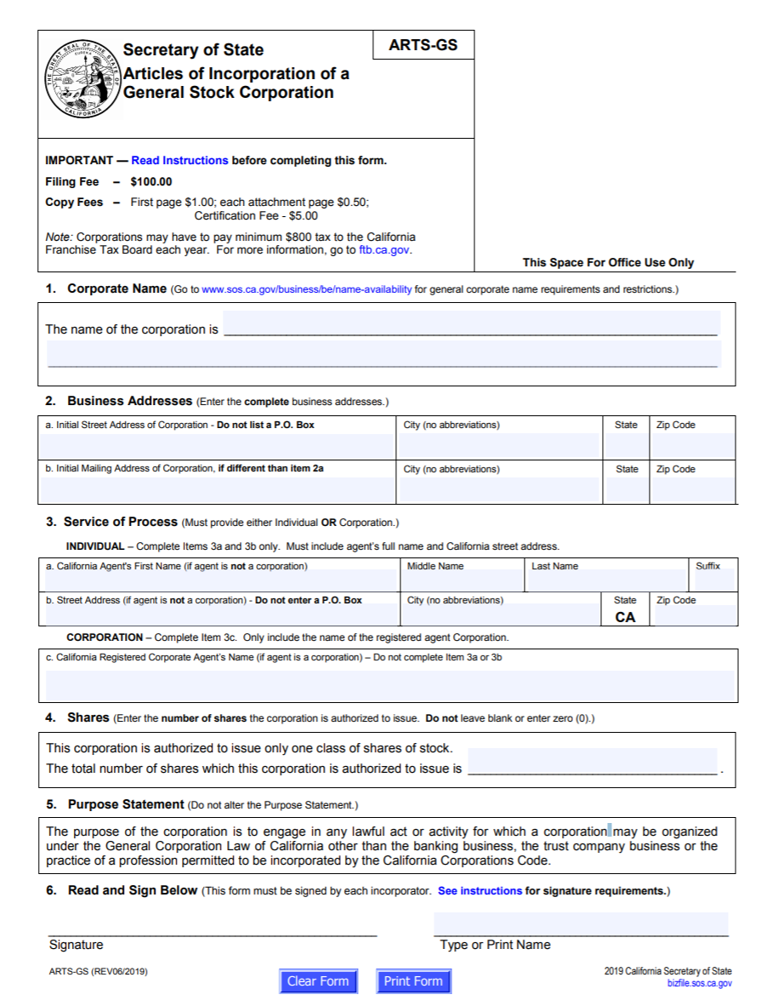

1. Preemptive rights
Preemptive rights have to be discussed in the articles of incorporation. When shareholders have a lot of shares, they do not want the percent ownership that they have in a corporation due to that large amount of shares to get diluted by issuing a lot more shares. The shareholder has to have preemptive rights so that any time new shares are issued, the shareholder has a right to buy as many of the new shares as needed to keep his ownership interest. For example, if a shareholder has ten percent ownership in the corporation and one hundred thousand (100,000) more shares are issue, the shareholder who has preemptive rights would have the right to buy ten thousand (10,000) of those new shares. The shareholder does not have to buy 10,000 shares if she does not want to. She just has the option to.

Organizational meeting and Incorporators of the For-Profit Corporation
The first meeting of the corporation is called the organizational meeting. The organizational meeting helps finalize all the preliminary things a corporation has to have done so it can operate. The articles of incorporation have to be approved. Contracts entered into by promoters have to be ratified. Directors of the corporation have to be elected. Officers have to be appointed by directors to carry out the day to day operations of the corporation. The bylaws have to be adopted. Pre-incorporation stock subscriptions have to be accepted and issued. The corporate seal is approved. The stock certificate look and format is approved. The corporation decides where to bank. The accounting method for the corporation is decided. The corporation’s fiscal year is decided. Stock is issued, if any. The names of shareholders are recorded. The amount of shares are recorded. The amount paid by each shareholder for their shares is recorded.

Close Corporations
A close corporation is dissimilar to a for profit corporation. A corporation has a lot of corporate formalities to observe. A close corporation is much less formal. A close corporation is often a family run corporation. A close corporation is not publicly traded. A close corporation is privately owned. A close corporation may have stock but that stock can only be sold to family and/or friends, and not the public. The stock has to state on it that it is a close corporation stock. Members of the close corporation often participate in the running of the close corporation. A close corporation is not required to have a board of directors, or bylaws, or formal shareholder meetings. A close corporation does not need to take minutes. A close corporation does still get to keep its limited liability even if it does not have to maintain all these corporate formalities.
The close corporation is limited to family and/or friends. It has a cap of fifty (50) people. There are bars to transferring shares outside the family/friends. The shareholder has to offer his shares to people within the close corporation first.
A close corporation does have to do articles of incorporation and indicated on there that they are a close corporation. In a close corporation, most of the shareholders are partaking in the management of the corporation and therefore, they do not need to have board of directors or formal shareholder meetings. Members can act like directors and officers. Shareholders make their living from the corporation often.
California Close Corporation Articles of Incorporation
The form for a California close corporation is located, with instructions, at: https://bpd.cdn.sos.ca.gov/corp/pdf/articles/arts-cl.pdf

Private Document for a For-Profit Corporation: Bylaws
The private document for a for-profit corporation is known as bylaws. A lot more information goes into the bylaws than goes into the articles of incorporation. The bylaws are easier to change to as they do not need to be refiled with the secretary of state. Articles require shareholders to consent to them being changed. Bylaws may only require directors to consent to them being changed. Articles go to the secretary of state. Bylaws stay with the corporation. Bylaws include the name, address, shareholder information, board of director information, officer information, information about stock, tax year, and inspecting fiscal records. Thus, there is some duplication of information between the articles of incorporation and bylaws. Bylaws should discuss shareholder meetings in a lot of breadth and depth, along with how to notice those meetings. If the notice is not proper notice, then the shareholders’ meeting will be in valid. There should be an explicit stating of the date, time, and place of both regular and special shareholder meetings. Quorum needs to be discussed in detail, so people know how many people have to vote on issues. Shareholder voting rights and inspection of financial documents are to be in the bylaws too.
Directors are discussed in the bylaws, such as how many, how long their terms are, and what their qualifications are required to be. Directors, in the bylaws, are told what work/decisions they can delegate to officers. Appointing officers by the directors should be discussed. Directors are supposed to know when they have their meetings, so not as much detail is needed about director meetings. Directors are often paid to attend meetings and shareholders are not, so the standards are different. The bylaws should consider allowances for whether directors have to be in person or if they can attend virtually.
Liability for directors should be addressed. How directors will be paid should be address. How to remove directors should be addressed. Directors may be insured for liability. Directors may be indemnified for liability.
Officers are discussed in bylaws. The titles will be indicated. Responsibilities will be indicated and compensation will be indicated.
Dividends are discussed in bylaws. Share issuance and transferring of shares is discussed. Stock certificates are discussed in the bylaws. Corporate seals and amending of bylaws are commonly in bylaws.

Capitalization
A for-profit corporation’s obvious goal is to make a profit. To start the corporation, the corporation can either issue stock or go into debt to obtain the money need to pay for the starting costs. With debt, the debtors are the first to be paid back. The shareholders are the last to be paid back. To attract shareholders, it is often important to have a stock that can be bought and sold easily.
The corporation needs to have enough capital that it can pay for debts and lawsuits. The shareholders do not want to have to worry about potential liability outside of what they paid for their stock.

1. Issuance of Stock in the For-Profit Corporation
Authorized stock is stock that has been discussed in the articles of incorporation. Outstanding stock is stock that has been sold by the corporation. The articles of incorporation do go into some detail about stock. The articles should discuss the classes, number, and rights of the stock. Other issues about stock that are often addressed in the bylaws included, but are not limited to: dividends, liquidation, voting, conversion, and redemption. Dividends will be discussed more later. Liquidation rights are a shareholder’s rights, if any, to be paid after creditors are paid. The shareholder would potentially be able to get a percent of what is left in assets equal to the percent that the shareholder invested in the corporation. Voting rights allow for shareholders to vote for directors. Shareholders may also be asked to vote on corporate changes, stock issues, etc. Conversion rights, if any, allow for a shareholder to take their stock and convert it into another security with the corporation. Redemption rights, if any, let the shareholder force the corporation to buy back the shareholder’s shares.
Once a corporation issues all of its authorized shares, it should amend its articles of incorporation so that it can authorize more shares. This is one of those changes that shareholders need to vote upon.

2. Consideration for Stock in the For-Profit Corporation
Whatever a corporation will accept can essentially be used to buy stock in a corporation. Things that might be accepted include money, personal property, real property, intellectual property, a debt instrument, work, other stocks, etc. Sometimes employees of a corporation receive stocks as partial compensation or additional compensation to their salaries.

Stock Certificates in the For-Profit Corporation
Almost all stock records are electronic today. Sometimes, people still do want a paper stock certificate, i.e. a Disney stock certificate, because it looks cool. Stock certificates have to have the corporate name, state of incorporation, person(s) issuing the stock, and the number and type of shares. This information should be part of the electronic records.

Transferring of For-Profit Stock
If a stock is not a close corporation stock, it should be easy to buy and sell, assign, or gift.

Classes of For-Profit Corporation Stock
There may be many different classes of stock in a for-profit corporation and even within those classes of stock, there may be series of stock. Within the same series though each stockholder must be treated the same as other stockholders within that series. The rights to dividends, voting, liquidation, preemptive, conversion, and redemption must all be the same for the same series stockholders.

Types of Stock in a For-Profit Corporation Stock
There are three major types of stock, one of which we have already discussed, close corporation stock. The other types of stock are common stock and preferred stock. An easy way to remember preferred stock is that preferred stock, in general, receives preferential treatment regarding dividends. With common stock, the stockholder receives an ownership percentage in the corporation based upon how much stock he purchased. If the shareholder bought seventeen percent (17%) stock in the corporation, then the shareholder would own 17% of the corporation. Common shareholders are paid very last. First the debtholders are paid. Then, the preferred shareholders are paid. Finally, the common shareholders are paid if there is any money left over. Realize that employees are essentially considered debtholders too—if a for-profit corporation is not doing well, it still needs to pay salaries before it pays dividends. Common shareholders have a right to participate in dividends if dividends are in fact issued.
Preferred shareholders are paid their stock dividends before common shareholders and receive assets if the corporation dissolves before common shareholders. This is a dividend right and a liquidation right. Preferred stock is a combination of debt and equity because they are paid before common. Preferred stockholders do not have to be given a right to vote though. Preferred stock often does not rise in value as much as common stock does either. Preferred stock dividends may be cumulative though. If a stock dividend cannot be paid one year, preferred shareholders may be able to get two years of stock dividends the following year.

Debt Financing in a For-Profit Corporation
A corporation is not required to go into debt to finance itself. However, most corporations need to go into some debt to obtain enough money to start running the corporation. Debt financing is when the corporation does borrow start up or continuing monies to run. The corporation usually has to pay interest on this kind of financing. It may have to pay back the debt within a set amount of time. The debt information should be in writing. It should have the amount of debt, when repayment is due, the interest rate, and any property securing the debt. Corporations often do like debt financing to some extent as the interest is tax deductible. Also, debt holders do not help manage the corporation. They are paid first before shareholders.

1. Unsecured Debt and Secured Debt in a For-Profit Corporation
Unsecured debt is like an I owe you without anything attached to it. If I do not pay, you could take me to court about the written document, but it would be harder to get paid than if the debt was secured by property. Secured debt has the promise to repay but also a piece of property that can be taken if the promise to repay is not honored. Mortgages are an example of this. People get mortgages and if they do not repay the mortgage, then the house can be taken back.

Benefits of Using Equity Capital Instead of Debt Capital
The corporation may not want to go into debt and choose to sell stock, to have equity capital, to finance the corporation. Shareholders themselves though often want the corporation to go into debt. This is because when the corporation issues more shares, the additional shares can dilute the original shareholders’ ownership percentage in the corporation unless they have and if they use preemptive rights. Since most shareholders do not have preemptive rights and their ownership in the corporation would go down with the issuance of more shares, these shareholders encourage the corporation to go into debt rather than issue more shares. The government also provides a benefit to debt financing by allowing for the interest on the debt to be tax deductible.

Key Terms
- Articles of incorporation
- Board of directors
- Bylaws
- Common stock
- Corporation
- Debt security
- Dividends
- Officers
- Organizational meeting
- Preemptive rights
- Promoter
- Quorum
- Revised Model Business Corporation Act
- Shareholder

Review Questions
- What are the benefits to incorporating in Delaware?
- What do promoters do to start the corporation?
- How are close corporations, S Corporations, and nonprofits different from for-profit corporations?
- How do preemptive rights work?
- How are common and preferred stock different?
- When is debt financing preferred to equity financing?

Assignment
Find and put together a package of the following forms (hint: use the California Secretary of State website http://www.sos.ca.gov/business-programs/business-entities/forms/ (Links to an external site.)) to upload as part of this assignment. The upload should be a pdf document that combines all the forms without any of the instructions.
a. A California State of Partnership Authority form.
b. A California Certificate of Limited Partnership form.
c. A California registered Limited Liability Partnership Registration
d. A California Articles of Organization form for an LLC
e. A California Articles of Incorporation from for a Corporation.

Chapter on Directors and Officers

Student Learning Objectives
- Digest what directors do in a corporation.
- Apply how long directors are elected, how they are elected, and how they are removed in bylaws.
- Compare and contrast the duties of officers with that of directors.
- Compare and contrast insurance with the concept of indemnification.
- Differentiate between the business judgement rule and reliance upon others.

I. Introduction to Directors and Officers
Directors oversee a corporation. The directors are given this responsibility through the articles of incorporation, bylaws, and from state law. Shareholders vote the directors in and out of the corporation. Officers serve at the whim of the directors. They are appointed and can be removed by the directors. The officers handle the day-to-day business of the corporation. Duties apply to both directors and officers.

II. Role of Directors and Officers in a For-Profit Corporation
Directors are supposed to act together for the corporate good. In a small or even medium size company, you may find that the director has several roles, including that of an officer and shareholder. In larger companies, these roles will normally all be separate. The directors make corporate decisions and manage the corporation. They do need guidance and support from the shareholders to amend the corporate governing documents, issue stock, dissolve, merge, or sell major corporate assets. Directors declare dividends and pay dividends to shareholders. Directors approve major corporate decisions too. The directors appoint, manage, and remove officers. Directors work towards authorizing more shares or obtaining bonds.
Officers of a corporation prepare minutes. They keep corporate records. Officers do the work delegated to them by the directors. Officers can include but are not limited to president, vice president, secretary, and treasurer. Presidents typically run shareholder meetings. They act as the leader of the officers. The Vice President fills in when the President is not able. The secretary, in particular, keeps the minutes. The secretary prepares notices of meetings. The treasurer oversees the finances for the corporation, though there will be outside auditors too.

III. Election and Appointment of Director and Officers for a For-Profit Corporation.
Directors are elected by the shareholders of the for-profit corporation. The number of directors will be delineated in the bylaws. The first board of directors are appointed by incorporators at the organizational meeting. These board of directors serve until the first shareholder’s meeting. The shareholders then vote for directors. How many shareholders have to vote yes for directors will be discussed in the bylaws. Directors can be voted upon through the use of either straight voting (1 vote per share), or cumulative voting (shares owned multiplied by the total number of open positions on the board).

A. Term of Directors and Officers in a For-Profit Corporation
Terms for directors are most frequently one (1) year. How many times a director can be reelected should be spelled out in the bylaws. Officers are voted upon or appointed by the board of directors. They can be removed at any time.

B. Vacancies of Directors and Officers in a For-Profit Corporation
Vacancies arise in both directors and officer positions, perhaps due to resignation or death. With directors, the remaining directors may appoint a new director to serve until there is another election. Otherwise, there may be a special election to elect a director to replace the one no longer in office. Vacancies in officers are usually made by a majority of the directors.

C. Removal of Directors and Officers of a For-Profit Company
Directors can be voted out at the next election by the shareholders. Directors can be removed for cause in the interim. This process should be discussed in the bylaws. Breach of duty is sufficient cause to remove a director. Officers can be removed at any time, for any reason by the board of directors.

D. Board of Directors Meetings in a For-Profit Corporation
Meetings of the board of directors should take place at least annually. The meetings will at least have voting on the directors and a review of the actions of the officers for the year. Dividends may be discussed. Annual reports need to be made. There may be additional meetings to the annual meetings, such as quarterly meetings. Annual reports made by the directors to the shareholders will normally cover financial statements, business conducted summary, information on corporate products, director and officer information, and stock information.
The notice requirements are not as stringent for directors as they are for shareholders. Directors work for the corporation, are often paid, and should at the very least know when the annual meetings are to be held. Special meetings of directors are more stringent in notice requirements. Notice can be made in a variety of different ways, but should be explained in the bylaws, and may be allowed through writing, email, and/or phone. If the notice is not properly given, the unnoticed or improperly noticed director(s) could waive notice.
A quorum is the least amount of people needed to legitimately transact business. Quorum ranges from state-to-state from thirty-three percent (33%) to fifty-one percent (51%). If there is not a quorum of directors at a meeting, then the meeting should not be held as business at the meeting will not be considered legitimate.
Minutes need to be accurate. The secretary should sign and file the minutes in the corporation’s minutes book, which may be electronic. There should be notices of meetings too that are kept.

E. Duties of Directors and Officers of a For-Profit Corporation
The three major duties that apply to both directors and officers are fiduciary duty, duty of care, and duty of loyalty. These should sound familiar to you as they were discussed with agency law. Fiduciary duty is a duty owed to someone because of being a position of trust and confidence. Duty of care is shown by managing the corporation diligently. What would an ordinarily prudent director (or officer) do under the same circumstances? Due care requires the exercising of good faith in performing management or tasks for the corporation. A director therefore needs to attend meetings. Directors and officers should research decisions before making them. While at meetings, directors and officers should participate. If there appears to be fraud of some sort, directors and officers should investigate. Neither directors nor officers should commit illegal acts.
The duty of loyalty means that directors and officers have to act in the corporation’s best interests, not in their own best interests. This includes not competing with the corporation, having a conflict of interest with the corporation, or insider trading. Taking a corporate opportunity as a director or office and not letting the corporation take it or at least have the right of first refusing is self-dealing. The corporation needs to have the right of first refusal and if it refuses, then all the disinterested members of the board must approve the director taking the opportunity.

F. Compensation and Indemnification of Directors and Officers of For-Profit Corporations
Unless otherwise stated in the corporation’s incorporation documents (bylaws and articles), then directors set their own compensation. It has to be reasonable. It may include stock.
Directors are frequently indemnified from liability so that the corporation can obtain directors. Otherwise, directors would be potentially liable for extremely large amounts of money, depending upon the corporation. Indemnification means that the corporation will pay if a lawsuit is settled against the director. This is not an unlimited indemnification though. If the director breaches a duty, commits fraud, or benefits himself, then he probably will not be indemnified by the corporation for this behavior. In addition, the corporation will also probably have insurance to insure the director as well.
How much officers are compensated is decided by the directors.
Review the sample indemnification agreement of a corporation for a director below.

Sample Indemnity Agreement
SAMPLE INDEMNITY AGREEMENT
This Indemnity Agreement, effective as of , is made by and between corporation with executive offices located and the Director (the “Indemnitee”).
RECITALS
A. The Company is aware that competent and experienced persons are increasingly reluctant to serve as directors or officers of corporations unless they are protected by comprehensive liability insurance or indemnification, due to increased exposure to litigation costs and risks resulting from their service to such corporations, and due to the fact that the exposure frequently bears no reasonable relationship to the compensation of such directors and officers;
B. The Company believes that it is unfair for its directors and officers and the directors and officers of its subsidiaries to assume the risk of large judgments and other expense that may be incurred in cases in which the director or officer received no personal profit and in cases where the director or officer was not culpable;
C. It is necessary for the Company to contractually indemnify its officers and directors and the officers and directors;
D. Section 145 of the General Corporation Law of Delaware, under which the Company is organized (“Section 145”), empowers the Company to indemnify by agreement its officers, directors, employees and agents,;
E. The Company, has determined that the liability insurance coverage available to the Company and its subsidiaries as of the date hereof is unreasonably expensive. The Company believes, therefore, that the interest of the Company’s stockholders would best be served by a combination of such insurance as the Company may obtain, and the indemnification by the Company of the directors and officers of the Company and its subsidiaries;
AGREEMENT
NOW, THEREFORE, the parties hereto, intending to be legally bound, hereby agree as follows:
1. Agreement to Serve. The Indemnitee agrees to serve and/or continue to serve as an agent of the Company, at its will (or under separate agreement, if such agreement exists), in the capacity the Indemnitee currently serves as an agent of the Company, so long as he or she is duly appointed or elected and qualified or until such time as he or she tenders his resignation in writing or he or she is removed from such position.
2. Mandatory Indemnification. The Company shall indemnify the Indemnitee from:
(a) Third Party Actions. If the Indemnitee is a person who was or is a party or is threatened to be made a party to any proceeding (other than an action by or in the right of the Company) by reason of the fact that he or she is or was an agent of the Company, or by reason of anything done or not done by him or her in any such capacity, against any and all expenses and liabilities of any type whatsoever actually and reasonably incurred by him or her in connection with the investigation, defense, settlement or appeal of such proceeding if he or she acted in good faith and in a manner he or she reasonably believed to be in or not opposed to the best interests of the Company; and
(b) Derivative Actions. If the Indemnitee is a person who was or is a party or is threatened to be made a party to any proceeding by or in the right of the Company to procure a judgment in its favor by reason of the fact that he or she is or was an agent of the Company, or by reason of anything done or not done by him or her in any such capacity, against any amounts paid in settlement of any such proceeding and all expenses actually and reasonably incurred by him or her in connection with the investigation, defense, settlement, or appeal of such proceeding if he or she acted in good faith and in a manner he or she reasonably believed to be in or not opposed to the best interests of the Company; and
3. Partial Indemnification. If the Indemnitee is entitled under any provision of this Agreement to indemnification by the Company for some or a portion of any expenses or liabilities of any type whatsoever incurred by him or her in the investigation, defense, settlement or appeal of a proceeding but not entitled, however, to indemnification for all of the total amount thereof, the Company shall nevertheless indemnify the Indemnitee for such total amount except as to the portion thereof to which the Indemnitee is not entitled.
4. Interpretation of Agreement. It is understood that the parties hereto intend this Agreement to be interpreted and enforced so as to provide indemnification to the Indemnitee to the fullest extent now or hereafter permitted by law.
5. Severability. If any provision or provisions of this Agreement shall be held to be invalid, illegal or unenforceable for any reason whatsoever, (i) the validity, legality and enforceability of the remaining provisions of the Agreement (including, without limitation, all portions of any paragraphs of this Agreement containing any such provision held to be invalid, illegal or unenforceable, that are not themselves invalid, illegal or unenforceable) shall not in any way be affected or impaired thereby, and (ii) to the fullest extent possible, the provisions of this Agreement (including, without limitation, all portions of any paragraphs of this Agreement containing any such provision held to be invalid, illegal or unenforceable, that are not themselves invalid, illegal or unenforceable) shall be construed so as to give effect to the intent manifested by the provision held invalid, illegal or unenforceable.
6. Modification and Waiver. No supplement, modification or amendment of this Agreement shall be binding unless executed in writing by both of the parties hereto. No waiver of any of the provisions of this Agreement shall be deemed or shall constitute a waiver of any other provision hereof (whether or not similar) nor shall such waiver constitute a continuing waiver.
7. Governing Law. This Agreement shall be governed exclusively by and construed according to the laws of the State of _______________, as applied to contracts between ____________ residents entered into and to be performed entirely within _____________.
The parties hereto have entered into this Indemnity Agreement effective as of the date first above written.
CORPORATION
By: |  | ________________________
Its: |  | ________________________
INDEMNITEE:
______________________________

G. Liability of Directors and Officers in a For-Profit Corporation
Directors and officers can be held liable for tortious or criminal misconduct they are those that they supervise commit. Directors can also be sued for a derivative lawsuit.
The business judgement rule also helps protect directors and officers from liability. If the director or officer made a decision in good faith, then the business judgment rule holds that the director or officer cannot be held personally liable. Another rule that limits director and officer liability is reliance upon others. Directors and officers, through the reliance and others rule, can rely upon reasonable information given to them by attorneys, certified public accountants, and other professionals working for the corporation. These professionals often carry their own liability insurance.

Key Terms
- Annual meeting
- Board of directors
- Business judgment rule
- Directors
- Duty of care
- Duty of loyalty
- Minutes
- Proxy
- Officers
- Quorum
- Reliance on others

Review Questions
- How are director tasks different from officer tasks?
- What is a quorum?
- Explain the business judgment rule and reliance on others.
- Are directors or officers allowed to have conflicts of interest in relation to the corporation?
- Discuss the fine point difference between insurance and indemnification.

Chapter on Shareholders

Student Learning Objectives
- Discuss how shareholders should act with voting and any shareholder driven lawsuits.
- Describe how financial reports are important to shareholder rights.
- Assess the differences between derivative and direct lawsuits.
- Detail the corporate formalities corporations must abide by.

I. Introduction to Shareholders
One of the biggest duties of shareholders is to elect directors. Shareholders vote on major corporate changes and changes to bylaws. While the shareholders own the corporation, they do not typically manage the corporation. Again, it is the board of directors that manage the corporation and the officers that carry out the directors’ directions. Shareholders have to do one thing for the corporation and that is that shareholders have to pay for their stock. Shareholder liability is typically limited to the amount that they paid for their stock.

II. Shareholder Rights in a For-Profit Corporation
Shareholders have a right to vote, to liquidation, and to sell their shares. Shareholders may be given an additional right, known as preemptive rights. This is the right to purchase the same ownership percentage in newly issued shares, so that the shareholder’s ownership percentage does not go down with the issuance of new shares. Liquidation rights are rights to leftover proceeds that the corporation still has, if any, after dissolving and paying creditors. The liquidation right is the same as the shareholder’s percentage ownership in the corporation.

Shareholder Inspection Rights in a For-Profit Corporation
Shareholders have rights to see financial records of corporation, including but not limited to annual reports, balance sheets, and income statements. This allows the shareholder to vary that he is getting paid what he should be in dividends. Shareholders also have rights to look at corporate records, such as minutes and shareholder records, including but not limited to articles of incorporation, bylaws, and lists of the different shareholders. Shareholders sometimes like to view lists of other shareholders to determine whether they could possibly get other shareholders to vote the same way as them on different corporate issues, including but not limited to, voting for certain directors.

Shareholder Voting Rights in a For-Profit Corporation
Shareholders should research the directors that they are voting for before voting for them. However, this does not always happen, and sometimes a director is elected that commits fraud. Shareholders are having more and more lawsuits to fix issues caused by directors. Shareholders can remove directors before their term is up and also when their term is up. However, to remove a director when his term is not up, is expensive, as a special meeting will have to be noticed and held.
Shareholders are also given the chance to vote on other corporate issues, not just voting on directors. The shareholders might vote on changing the corporation, changing the articles of incorporation, a sale of a large amount of assets, or even the voluntary dissolution of the corporation. Shareholders can ask for still more items to call for them to vote upon.
Usually, one share equals one vote. This is straight voting. There is also cumulative voting. This is only utilized for voting for directors. A shareholder’s shares are multiplied by the open positions on the board of directors.

C. Shareholder Actions in a For-Profit Corporation: Direct and Derivative
A direct action is when shareholder(s) sue the company for something the company did to the shareholder(s). The shareholders were directly harmed. The corporation may have prevented these shareholders from voting, inspecting the financial records, or failed to provide them with a dividend that was owed to them. A derivative action is often compared to a class action as there are some similarities. A representative shareholder sues so that the corporation gets a right that is owed to it. The directors of the company are not obtaining that right for the company, so the shareholder has to do it for them. The right is owed to the corporation. The shareholder is just acting on behalf of the corporation. The shareholder, if the derivative action is won, will be paid expenses and attorney’s fees. The shareholder may also get a benefit from the right that was enforced, similar to what the other shareholders would receive.
Derivative rights come into play, in particular, when the board of directors are doing something and are unlikely to sue themselves. There may also be a corporate right against a third party that could be the topic of a derivative action. In the first instance, the shareholder might sue the director of a corporation if the director used corporate assets for themselves illegally or if the director severely mismanaged the corporation. Again, the director would be unlikely to sue himself in this situation, hence the allowance for derivative actions.
There are three things that must be met in order for a derivative action to be brought: a shareholder has to have been a shareholder when the injury occurred, the shareholder has to represent the interests of the corporation, and the shareholder has to make a written demand on the company asking the company to take action, and the company must have not taken action after the demand for a minimum of ninety (90) days.
See the language below for the requirement that a shareholder must bring certain lawsuits derivatively.

Requirement that a shareholder must bring certain lawsuits derivatively
A shareholder may not enforce a corporate right by means of a lawsuit brought in an individual capacity – all such actions must be brought derivatively. Whenever a cause of action exists primarily in behalf of the corporation against directors, officers, and others, for wrongful dealing with corporate property, or wrongful exercise of corporate franchises, so that the remedy should regularly be obtained through a suit by and in the name of the corporation, and the corporation either actually or virtually refuses to institute or prosecute such a suit, then, in order to prevent a failure of justice, an action may be brought and maintained by a stockholder, or stockholders, either individually or suing on behalf of themselves and all others similarly situated, against the wrongdoing directors, officers, and other persons; but it is absolutely indispensable that the corporation, itself, should be joined as a party, usually as a co-defendant. That the plaintiff should allege and prove that application was made to the directors or managing body, and a reasonable notice, request, or demand that they institute proceedings on the part of the corporation against the wrongdoers, and their refusal to do so after such reasonable request or demand, is but a statement of a general rule. Wills v. Nehalem Coal Co., 52 Or 70, 87, 96 P 528, 534 (1908).

Successful derivative lawsuits are somewhat rare, but read the successful one below.

Perlman v. Feldman

Perlman v. Feldmann
219 F.2d 173 (1955)
This is a derivative action brought by minority stockholders of Newport Steel Corporation to compel accounting for, and restitution of, allegedly illegal gains which accrued to defendants as a result of the sale in August, 1950, of their controlling interest in the corporation. The principal defendant, C. Russell Feldmann, who represented and acted for the others, members of his family, was at that time not only the dominant stockholder, but also the chairman of the board of directors and the president of the corporation. Newport, an Indiana corporation, operated mills for the production of steel sheets for sale to manufacturers of steel products, first at Newport, Kentucky, and later also at other places in Kentucky and Ohio. The buyers, a syndicate organized as Wilport Company, a Delaware corporation, consisted of end-users of steel who were interested in securing a source of supply in a market becoming ever tighter in the Korean War. Plaintiffs contend that the consideration paid for the stock included compensation for the sale of a corporate asset, a power held in trust for the corporation by Feldmann as its fiduciary. This power was the ability to control the allocation of the corporate product in a time of short supply, through control of the board of directors; and it was effectively transferred in this sale by having Feldmann procure the resignation of his own board and the election of Wilport's nominees immediately upon consummation of the sale.
The present action represents the consolidation of three pending stockholders' actions in which yet another stockholder has been permitted to intervene. Jurisdiction below was based upon the diverse citizenship of the parties. Plaintiffs argue here, as they did in the court below, that in the situation here disclosed the vendors must account to the non-participating minority stockholders for that share of their profit which is attributable to the sale of the corporate power. Judge Hincks denied the validity of the premise, holding that the rights involved in the sale were only those normally incident to the possession of a controlling block of shares, with which a dominant stockholder, in the absence of fraud or foreseeable looting, was entitled to deal according to his own best interests. Furthermore, he held that plaintiffs had failed to satisfy their burden of proving that the sales price was not a fair price for the stock per se. Plaintiffs appeal from these rulings of law which resulted in the dismissal of their complaint.
The essential facts found by the trial judge are not in dispute. Newport was a relative newcomer in the steel industry with predominantly old installations which were in the process of being supplemented by more modern facilities. Except in times of extreme shortage Newport was not in a position to compete profitably with other steel mills for customers not in its immediate geographical area. Wilport, the purchasing syndicate, consisted of geographically remote end-users of steel who were interested in buying more steel from Newport than they had been able to obtain during recent periods of tight supply. The price of $ 20 per share was found by Judge Hincks to be a fair one for a control block of stock, although the over-the-counter market price had not exceeded $ 12 and the book value per share was $ 17.03. But this finding was limited by Judge Hincks' statement that 'what value the block would have had if shorn of its appurtenant power to control distribution of the corporate product, the evidence does not show.' It was also conditioned by his earlier ruling that the burden was on plaintiffs to prove a lesser value for the stock
Both as director and as dominant stockholder, Feldmann stood in a fiduciary relationship to the corporation and to the minority stockholders as beneficiaries thereof…. His fiduciary obligation must in the first instance be measured by the law of Indiana, the state of incorporation of Newport…. Although there is no Indiana case directly in point, the most closely analogous one emphasizes the close scrutiny to which Indiana subjects the conduct of fiduciaries when personal benefit may stand in the way of fulfillment of trust obligations. In Schemmel v. Hill, 91 Ind.App. 373, 169 N.E. 678, 682, 683, McMahan, J., said: 'Directors of a business corporation act in a strictly fiduciary capacity. Their office is a trust…. Directors of a corporation are its agents, and they are governed by the rules of law applicable to other agents, and, as between themselves and their principal, the rules relating to honesty and fair dealing in the management of the affairs of their principal are applicable. They must not, in any degree, allow their official conduct to be swayed by their private interest, which must yield to official duty. In a transaction between a director and his corporation, where he acts for himself and his principal at the same time in a matter connected with the relation between them, it is presumed, where he is thus potential on both sides of the contract, that self-interest will overcome his fidelity to his principal, to his own benefit and to his principal's hurt.' And the judge added: 'Absolute and most scrupulous good faith is the very essence of a director's obligation to his corporation. The first principal duty arising from his official relation is to act in all things of trust wholly for the benefit of his corporation.'
In Indiana, then, as elsewhere, the responsibility of the fiduciary is not limited to a proper regard for the tangible balance sheet assets of the corporation, but includes the dedication of his uncorrupted business judgment for the sole benefit of the corporation, in any dealings which may adversely affect it…. Although the Indiana case is particularly relevant to Feldmann as a director, the same rule should apply to his fiduciary duties as majority stockholder, for in that capacity he chooses and controls the directors, and thus is held to have assumed their liability…. This, therefore, is the standard to which Feldmann was by law required to conform in his activities here under scrutiny.
It is true, as defendants have been at pains to point out, that this is not the ordinary case of breach of fiduciary duty. We have here no fraud, no misuse of confidential information, no outright looting of a helpless corporation. But on the other hand, we do not find compliance with that high standard which we have just stated and which we and other courts have come to expect and demand of corporate fiduciaries. In the often-quoted words of Judge Cardozo: 'Many forms of conduct permissible in a workaday world for those acting at arm's length, are forbidden to those bound by fiduciary ties…. A trustee is held to something stricter than the morals of the market place. Not honesty alone, but the punctilio of an honor the most sensitive, is then the standard of behavior. As to this there has developed a tradition that is unbending and inveterate. Uncompromising rigidity has been the attitude of courts of equity when petitioned to undermine the rule of undivided loyalty by the 'disintegrating erosion' of particular exceptions….' The actions of defendants in siphoning off for personal gain corporate advantages to be derived from a favorable market situation do not betoken the necessary undivided loyalty owed by the fiduciary to his principal.
The corporate opportunities of whose misappropriation the minority stockholders complain need not have been an absolute certainty in order to support this action against Feldmann. If there was possibility of corporate gain, they are entitled to recover. In Young v. Higbee Co., supra, 324 U.S. 204, 65 S.Ct. 594, two stockholders appealing the confirmation of a plan of bankruptcy reorganization were held liable for profits received for the sale of their stock pending determination of the validity of the appeal. They were held accountable for the excess of the price of their stock over its normal price, even though there was no indication that the appeal could have succeeded on substantive grounds. And in Irving Trust Co. v. Deutsch, supra, 2 Cir., 73 F.2d 121, 124, an accounting was required of corporate directors who bought stock for themselves for corporate use, even though there was an affirmative showing that the corporation did not have the finances itself to acquire the stock. Judge Swan speaking for the court pointed out that 'The defendants' argument, contrary to Wing v. Dillingham (5 Cir., 239 F. 54), that the equitable rule that fiduciaries should not be permitted to assume a position in which their individual interests might be in conflict with those of the corporation can have no application where the corporation is unable to undertake the venture, is not convincing. If directors are permitted to justify their conduct on such a theory, there will be a temptation to refrain from exerting their strongest efforts on behalf of the corporation since, if it does not meet the obligations, an opportunity of profit will be open to them personally.'
This rationale is equally appropriate to a consideration of the benefits which Newport might have derived from the steel shortage. In the past Newport had used and profited by its market leverage by operation of what the industry had come to call the 'Feldmann Plan.' This consisted of securing interest-free advances from prospective purchasers of steel in return for firm commitments to them from future production. The funds thus acquired were used to finance improvements in existing plants and to acquire new installations. In the summer of 1950 Newport had been negotiating for cold-rolling facilities which it needed for a more fully integrated operation and a more marketable product, and Feldmann plan funds might well have been used toward this end.
Further, as plaintiffs alternatively suggest, Newport might have used the period of short supply to build up patronage in the geographical area in which it could compete profitably even when steel was more abundant. Either of these opportunities was Newport's, to be used to its advantage only. Only if defendants had been able to negate completely any possibility of gain by Newport could they have prevailed. It is true that a trial court finding states: 'Whether or not, in August, 1950, Newport's position was such that it could have entered into 'Feldmann Plan' type transactions to procure funds and financing for the further expansion and integration of its steel facilities and whether such expansion would have been desirable for Newport, the evidence does not show.' This, however, cannot avail the defendants, who -- contrary to the ruling below -- had the burden of proof on this issue, since fiduciaries always have the burden of proof in establishing the fairness of their dealings with trust property….
Defendants seek to categorize the corporate opportunities which might have accrued to Newport as too unethical to warrant further consideration. It is true that reputable steel producers were not participating in the gray market brought about by the Korean War and were refraining from advancing their prices, although to do so would not have been illegal. But Feldmann plan transactions were not considered within this self-imposed interdiction; the trial court found that around the time of the Feldmann sale Jones & Laughlin Steel Corporation, Republic Steel Company, and Pittsburgh Steel Corporation were all participating in such arrangements. In any event, it ill becomes the defendants to disparage as unethical the market advantages from which they themselves reaped rich benefits.
We do not mean to suggest that a majority stockholder cannot dispose of his controlling block of stock to outsiders without having to account to his corporation for profits or even never do this with impunity when the buyer is an interested customer, actual or potential, for the corporation's product. But when the sale necessarily results in a sacrifice of this element of corporate good will and consequent unusual profit to the fiduciary who has caused the sacrifice, he should account for his gains. So in a time of market shortage, where a call on a corporation's product commands an unusually large premium, in one form or another, we think it sound law that a fiduciary may not appropriate to himself the value of this premium. Such personal gain at the expense of his coventurers seems particularly reprehensible when made by the trusted president and director of his company. In this case the violation of duty seems to be all the clearer because of this triple role in which Feldmann appears, though we are unwilling to say, and are not to be understood as saying, that we should accept a lesser obligation for any one of his roles alone.
Hence to the extent that the price received by Feldmann and his codefendants included such a bonus, he is accountable to the minority stockholders who sue here…. And plaintiffs, as they contend, are entitled to a recovery in their own right, instead of in right of the corporation (as in the usual derivative actions), since neither Wilport nor their successors in interest should share in any judgment which may be rendered…. Defendants cannot well object to this form of recovery, since the only alternative, recovery for the corporation as a whole, would subject them to a greater total liability.
The case will therefore be remanded to the district court for a determination of the question expressly left open below, namely, the value of defendants' stock without the appurtenant control over the corporation's output of steel. We reiterate that on this issue, as on all others relating to a breach of fiduciary duty, the burden of proof must rest on the defendants…. Judgment should go to these plaintiffs and those whom they represent for any premium value so shown to the extent of their respective stock interests.
The judgment is therefore reversed and the action remanded for further proceedings pursuant to this opinion.

III. Liability of Shareholders in a For-Profit Corporation
Shareholders are usually only able to lose the amount of money that they paid for their stock. That means that the shareholders personal assets are protected. Piercing the corporate veil is an exception to this rule. Think of the corporation as a veil of protection between third party creditors and the shareholders. This veil can be pierced in certain instances, including if the shareholder is treating the corporate bank accounts as his own (commingling of assets), no holding meetings (lack of corporate formalities), and not adequately funding the corporation (inadequate capitalization). To avoid allegations of comingling of assets, a shareholder’s bank account should be separate from the corporation’s bank account. A shareholder should not use the corporation’s bank accounts to pay the shareholder’s bills. To avoid allegations of lack of corporate formalities, the corporation should have shareholder meetings, board of directors’ meetings, and maintain corporate financial records and minutes.

Shareholder Meetings in a For-Profit Corporation
Shareholders can have annual and special meetings. The annual meetings have to be discussed in detail in the bylaws. The location of the meetings may be at the corporation’s principal place of business. At annual meetings, directors are elected, independent auditors are voted in, and any other remaining issues. Many shareholders cannot afford to attend shareholder meetings or do not have sufficient shares to make it worth their while to go to the shareholder meetings, so they will vote via proxy. The proxy votes and all votes are counted.
For the meeting to be valid, a quorum of shareholders is required. A quorum of shareholders is the least number of shareholders needed to legitimately transact business at that meeting. Depending upon the state, a quorum can be one-third (1/3) to fifty-one percent (51%). Then, out of the quorum, usually a majority have to vote yes for something to pass.
Special meetings are often held for emergent issues that cannot wait until the next annual meeting. Since it is expensive to have an additional, special meeting, it usually is an important issue that cannot wait.
Notice with shareholder meetings is important. Who is entitled to notice of meetings is who is a shareholder on the record date. Since there are people buying and selling their shares at all times, record date is an arbitrary date, usually one month before the meeting. Whomever owns stock in the corporation on that date usually gets notice.
There are strict requirements about what must be in a notice. A notice must have the place, the time, and the date of the meeting. It is a good practice to include the time zone, especially if the corporation is a national corporation. The notice may allow for additional issues to be brought up at the meeting. The notice will have the record date spelled out in it. The notice will be signed by the secretary of the corporation. If a shareholder does not receive valid notice, then they can waive notice or simply show up at the meeting and not object.
A proxy is a way for a shareholder to vote without attending the meeting. The proxy gives another person authorization to vote for certain shareholders. The proxy statement has to indicate who has the authority to vote on behalf of certain shareholder(s). The proxy is normally good for one shareholders’ meeting. The proxy must vote the shareholders’ shares as directed.
Proxy materials are provided along with annual reports and disclosure statements. The proxy, per the Securities and Exchange Commission must state what the shareholders are voting upon. If the vote is for a board of directors, the proxy must allow shareholders the ability to not vote for one or more of the board of directors. In addition, a proxy statement is required to have the date, time, and location; revocation of the proxy rules; listing of the directors and officers; and the procedure for voting.
Minutes of meetings have to be accurately kept along with any waivers of invalid notice of meetings. The secretary of the corporation, an officer, prepares and signs the minutes. The notice, along with how it was sent to shareholders, should also be kept.
If the shareholders give written consent, then the shareholders could take action without a meeting. The number of shareholders that have to agree has to be a majority or unanimous, depending upon the state requirement.
Introduction to, Taxation, Amending Articles of Incorporation, Corporate Combinations, Termination, Qualification in Foreign Jurisdictions, and Bankruptcy in For-Profit Corporations
Corporate profit are often taxes two to three times. Trying to minimize tax liability is thus a big issue with corporations.
Corporations can change their structure through one of many ways, including but not limited to: mergers, share exchanges, consolidations, the sale of assets/share, and hostile takeovers. Corporations can also terminate, either voluntarily or involuntarily.
States that the corporation does not have its principal place of business are foreign states for the corporation. To legitimately transact business in foreign states, the corporation needs to qualify to do so in those states.

Key Terms
- Shareholders’ meeting
- Bylaws
- Commingling of assets
- Direct action
- Directors
- Dividends
- Minutes
- Piercing the corporate veil
- Preemptive rights
- Record date
- Shareholder
- Stock certificates

Review Questions
- Who is the owner of a corporation? Explain your answer.
- What records may a shareholder inspect?
- How is a derivative lawsuit different from a direct lawsuit?
- How are board of directors elected?
- When can the corporate veil be pierced?

Chapter on Other For-Profit Corporation Issues

Student Learning Objectives
- Detail double taxation within a corporation.
- Discuss different types of corporations.
- Delineate why articles of incorporation are amended.
- Outline requirements for qualifying in foreign jurisdictions.

I. Taxation
Corporations have to indicate their earnings on IRS Form 1120. The corporate tax rate is usually much higher than for a normal person. However, corporation can often take additional or different tax deductions than regular people. The corporation may get a tax deduction for contributions to makes to employees’ retirement funds, for example.
Corporation profits are retained or distributed to shareholders as dividends. If retained, the corporation often reinvests the profits into the business and has the potential to make still higher profits. This may, in turn, drive up the price of shareholder’s stock, so that they benefit even if they did not receive a dividend one year. When the corporation does not provide dividends though, the Internal Revenue Service does not get to tax those dividends. The IRS does not like this and has the accumulated earnings tax to encourage corporations to issue profits as dividends. If a corporation has earnings above what is reasonable and the purpose is to avoid taxation on dividends, then the IRS can impose the accumulated earnings tax. This tax is fifteen percent (15%) or more based on the year of amounts accumulated above two hundred and fifty thousand dollars ($250,000).
Double taxation works in that when a corporation makes a profit, it pays taxes on that first profit. The second, or double taxation, takes place when the corporation gives shareholders dividends and then the shareholders have to pay taxes on those dividends. If the corporation is a subsidiary of a parent corporation, the subsidiary pays taxes when it makes a profit. The parent pays taxes when it makes a profit (using some of the same profits of the subsidiary). The shareholders pay taxes when they sell their dividends (the third tax). However, all this taxation is reduced by the fact that many corporations receive large tax deductions and/or tax breaks.
In addition to federal taxes, a corporation may have to pay state taxes. These state taxes may be based upon the corporation’s revenue or may be a flat tax. There is also often what is referred to as “the pleasure of doing business tax/free.” This is a tax or fee that helps a state recover some of the costs of having corporation’s use its roads and emergency system, for example. There can be property and/or sales tax.

A. S Corporations
An S Corporation is taxed differently than a regular corporation. The S Corporation still gets to have limited liability too. The profits and losses are passed through to the individual shareholders. The shareholders pay taxes at their individual tax rate, so that there is not double taxation like with a regular for-profit corporation. There are several rules that have to be followed though to have and keep S status. Per the Internal Revenue Service website, accessed December 4, 2019:
“To qualify for S corporation status, the corporation must meet the following requirements:
- Be a domestic corporation
- Have only allowable shareholders
  - May be individuals, certain trusts, and estates and
  - May not be partnerships, corporations or non-resident alien shareholders
- Have no more than 100 shareholders
- Have only one class of stock
- Not be an ineligible corporation (i.e. certain financial institutions, insurance companies, and domestic international sales corporations).” https://www.irs.gov/businesses/small-businesses-self-employed/s-corporations
If the S Corporation does not adhere to these requirements, then it will not stay an S Corporation and will go to being taxed like a regular for-profit corporation. Usually, today, the preferred entity is an llc as an llc has beneficial taxes, limited liability, and does not have these restrictions.
S Corporations are formed like a regular corporation and then have to do an election to S status. This election needs to be done fifteen (15) days before the third month in the corporation’s self-defined annual year. If the election is revoked, then the corporation cannot reapply for five (5) years. The S Corporation reports to the IRS the profits and losses of the business and each shareholder’s percent of those. The shareholders report too on their percent and then pay taxes on their percent.

II. Nonprofit Corporations
Nonprofits do not want to be taxed and to avoid taxation, the nonprofit has to adhere to several rules. First, the nonprofit must provide a public, mutual, or religious benefit. Public benefit would include the American Cancer Society, which performs cancer research for the public benefit. Mutual benefit is for the mutual benefit of its members, so a sorority would qualify. Religious benefit might include religions that you are unfamiliar with.
The nonprofit needs to decide which of these three major types of nonprofits it will be. Public benefit is often in the areas of medicine or teaching. States regulate nonprofit formation. Even though a nonprofit, it is still a corporation, so will still have to file articles of incorporation. There might have to be special permission sought from a state attorney general to form.
Incorporation alone does not mean that a corporation can just decide to not pay taxes. The IRS requires an application for tax exempt status under the Internal Revenue Code Section 501(c). The IRS will provide a ruling through letter. The nonprofit has to file yearly paperwork to maintain nonprofit status. The nonprofit will probably not have to pay state taxes such as income or property taxes.
Nonprofit corporations do have boards of directors and bylaws. Profits may not be issued as dividends and must be reinvested back into the purpose of the nonprofit. There are not shares or shareholders in a nonprofit corporation.

III. Amending the Articles of Incorporation for a For-Profit Corporation
Important changes should be noted by amending the articles of incorporation. If an amendment affects shareholder rights, then the shareholders should vote on the amendment. Otherwise, the board of directors may be able to just vote on the amendment. When shareholders are required to vote, then a majority would frequently needed to pass the amendment. Articles of amendment include the corporation name, the amendments, information regarding what will happen if there is a share exchange, the date, and who voted on the amendment.
If there are changes to stock, then the articles of incorporation must be amended. Changes to stock could include adding preemptive rights or adding new classes of stock. Authorizing more shares to be issued is another change to stock that would require amendment.

IV. Corporate Combinations in For-Profit Corporations
There are a variety of different corporate combinations, including but not limited to mergers, share exchanges, purchase of assets, purchase of stock, and hostile takeovers. Shareholder rights may be affected during these combinations, so usually both shareholders and directors have to agree to a corporate combination, though there are exceptions. Articles of amendment to the articles of incorporation may then need to be filed. A majority vote or more may need to take place for approval. If shareholders do not agree with the corporate combination, the shareholder may be able to have their shares bought back at fair market price.

Merger in a For-Profit Corporation
Merger occurs when two companies combine and only one company survives. The surviving corporation is known as that. The merging corporation is known as the merging corporation. The surviving corporation receives all the assets and liabilities of the merging corporation. Mergers also take place between parent and subsidiary corporations. When a subsidiary merges back into the parent corporation, then it is known as an upstream merger. When a parent corporation moves into a subsidiary corporation, it is known as a downstream merger.
Mergers start with letters of intent. Then, there is a plan of merger with a date, information about the surviving and merging corporations’ stock, and information about the surviving corporation such as the location of it and its directors. There must be a plan for how shares will be converted. The merging corporation has to disclose all of its assets and debts and has to plan for how it will be dissolved. The plan of merger is often approved by both the directors and the shareholders for both the surviving and merging corporations.

B. Share Exchanges in a For-Profit Corporation
The buying corporation in a share exchange will buy shares in the target. The target corporation’s shareholders might get stock in the corporation buying, in a third corporation, or just be bought out. There must be a plan of exchange. Usually both directors and shareholders will be vote on the exchange.

C. Purchase of Assets in a For-Profit Corporation
One company buying up the assets of another is known as purchase of assets. There will be negotiations and then a letter of intent, followed by an agreement. The agreement should contain the name of the corporations, a description of the assets, the money to be paid for the assets, whether liabilities will be assumed, the date of the agreement and when the transfer will take place, and signatures. Shareholder approval may only be required by the corporation selling the assets. The buying corporation often will pick the best assets and not take over any debts. If a shareholder in the selling corporation does not agree, that shareholder may be able to get the fair market price of their shares.

D. Purchase of Stock in a For-Profit Corporation
The buyer of this stock purchases all the rights and responsibilities. The agreement has to state what the buying price is for the stock and when and how that will be paid.

E. Hostile Takeovers
A hostile takeover occurs when one company takes over another, without consent, and goes over the management of the nonconsenting corporation to take it over. The directors do not approve. The two major ways a hostile takeover starts is either through a tender offer or a proxy contents. A proxy contest happens when the taking over corporation seeks the shareholders of the target to vote for the aggressor’s management team. The aggressor corporation makes promises that its management team will do a better job for shareholders, to try to get the target’s shareholders to vote for the aggressor’s management teams.
Another way a hostile takeover can start is through a tender offer. The aggressor corporation starts buying up stocks quietly, up to four point nine percent (4.9%) in the target. At five percent (5%), the aggressor has to disclose the tender offer per the Securities and Exchange Commission. Then, after disclosing, the aggressor attempts to buy fifty-one percent (51%) of the target’s shares.
There are several ways in which a target can try to avoid being hostilely taken over, and they include but are not limited to courting a white knight, buying another company, poison pills, golden parachutes, suicide pacts, Pac-Man, and crown jewel defenses. With the courting a white knight defense, the target company seeks out a different company than the aggressor that the target would prefer to merge with over the aggressor. With a buy another company defense, the target wants to buy another company to help make itself stronger to be able to avoid a hostile takeover. With the poison pill defense, the board of directors grants additional rights to common shareholders and this is triggered during a tender offer. This would give shareholders more rights and make it more difficult for an aggressor to buy the target. Golden parachutes are a large amount of money that an aggressor would have to pay for managers to buy them out and make the hostile takeover that much more expensive. Suicide pacts are when one manager of a target is fired, they all resign. It might make it more difficult for consistent management if all managers resign, or it might just be what the aggressor corporation is hoping for. Pac-Man is when a target corporation turns around and attempts a tender offer on the aggressor. Finally, there is the crown jewels defense. If a target has assets the aggressor wants, the target may attempt to sell off some of the assets or crown jewels to make itself less attractive to the target.
Read the following example of a hostile takeover.

Example of Hostile Takeover
In 2009, Kraft Foods tried a hostile takeover of Cadbury. It was so contentious that the United Kingdom changed is hostile takeover rules as a result. At the time Kraft attempted the hostile takeover, it was the second largest food conglomerate world-wide. Cadbury fought the hostile takeover for months and then made an agreement with Kraft. Cadbury was not for sale at the time of the hostile takeover. Cadbury told its shareholders the deal was not a good one. Cadbury tried to convince its shareholders that the business model of Kraft, being a conglomerate, was against Cadbury’s more personal business model.
Cadbury also told shareholders that being bought out by another candy company, any candy company, would be better than to become part of Kraft. Cadbury also had the government state that it would oppose a hostile takeover that did not respect the company. However, Cadbury eventually agreed that the majority of its shareholders would sell. This agreement was approved by over seventy percent (70%) of the shareholders. Investors were given cash and shares in Kraft. In 2012, Kraft split in Kraft Food Groups and Mondelez. In 2015, Heinz gave shareholders shares and cash in Heinz Kraft.

Termination of a For-Profit Corporation
Dissolution happens when a corporation formally ends its legal existence. The corporation converts all assets to cash, pays off its debts, and provides remaining assets to shareholders to wind up and liquidate the business for dissolution. The corporation should seek to pay as many unknown claims as possible and retain funds to pay any that it cannot determine prior to dissolution. If the corporation does not, then it can be possible for an unknown claimant to potential go against former shareholders.

Voluntary Dissolution of a For-Profit Corporation
Voluntary dissolution requires approval by both directors and shareholders. This might happen when the corporation is not making money, is merging, or is selling the majority of its assets or stock. The majority of shareholders should approve the dissolution, and for those who do not, those shareholders may be able to receive the fair market value of their shares. After dissolution has been approved, then the corporation needs to file articles of dissolution.

Administrative Dissolution of a For-Profit Corporation
Administrative dissolution happens by a secretary of state dissolving a corporation. This might happen due to the corporation not paying any required state income taxes, not filing its annual reports, not maintaining its registered agents for service of process, or the time period for the corporation’s existence (if any was given in the articles) being expired.

Involuntary Dissolution of a For-Profit Corporation
Creditors, secretaries of state, and shareholders of corporations can ask a judge to involuntarily dissolve a corporation. If the dissolution is involuntary, the judge can ask a liquidator to oversee the dissolution as there is a lack of trust that the corporation will ethically dissolve. Shareholders have to typically agree by majority. There might have been directors committing fraud and the corporation might be going bankrupt. A creditor can seek involuntary dissolution if the corporation is not able to get debts paid.

Articles of Dissolution in a For-Profit Corporation
Once the corporation is liquidated, it has to file articles of dissolution. These articles include the name, address, dissolution date, the shareholder agreement, discussion of who creditors will be paid, and indications about whether there was any money left over and paid to shareholders.

Liquidation
If liquidation is voluntary then a court does not need to oversee it, though a shareholder could still ask for a court to oversee the liquidation. The corporation should try to let all known creditors know about the dissolution. Notice should be mailed to all last known addresses and let the creditor known that it has one hundred and twenty days to make a claim. There may also be unknown claims against the corporation and the corporation can take out advertisements to provide notice. If the corporation does not notice people, then those unknown claimants might get up to three years to file.

Qualification in Foreign Jurisdictions for For-Profit Corporations
A corporation lives where it is primarily domiciled/incorporated. If it wants to work in more than one state, then it is known as a foreign corporation. If the corporation does not qualify to do business in another state, then the corporation can be fined, not be able to use that state’s courts, and directors and officers can have greater liability. Corporation struggle with this because if they are considered doing business in another state they have to pay additional filing fees and taxes.
To figure out if a corporation should qualify in a foreign jurisdiction or not, it needs to be determine how much and how long the corporation plans to do business in that state. A corporation can be part of a lawsuit in a foreign state and that is not considered business sufficient to have to qualify. Meetings and bank accounts in foreign states are not constituting transacting business. Mail orders do not constitute doing business. Selling through independent contractors does not constitute doing business. Owning property in a foreign state does not constitute doing business. Conducing regular and continuous business of a similar nature in a foreign state for over thirty days does constitute doing business and a corporation will have to qualify in that foreign jurisdiction. The corporation will have to file annual reports, pay fees, and pay taxes. If it does not, then the corporation’s qualification can be revoked in that foreign state. It will be much more difficult to defense itself in a lawsuit in the foreign state. The corporation can be penalized financially, its contracts might not be upheld, and its directors and officers may be held more liable.

Key Terms
- Accumulated earnings tax
- Consolidation
- Crown jewls
- Double taxation
- Golden parachute
- Hostile takeover
- Liquidation
- Merger
- Pac-man
- Poison pill
- Proxy contest
- Purchase of assets
- Share exchange
- Suicide pact
- Target corporation
- Tender offer
- To court a white knight
- Unknown claim

Review Questions
- What is double taxation of corporations?
- Describe each of the major corporate changes in the chapter.
- Write a short essay on how a hostile takeover can potentially be defeated?
- Is it possible that a creditor can force the dissolution of a corporation? Why or why not?

Web Exercise
The Securities and Exchange Commission has regulations on corporate changes located at http://www.sec.gov. Go and look up the regulations on one of the corporate changes discussed in the chapter.

