**Still needs links to further resources at the end.**

**ASCCC OERI Attribution Guide**

One of the great advantages of using OER is the freedom to choose high-quality materials and recombine them for your own instructional purposes. So long as you properly attribute sources licensed to share and edit, you can publish and distribute these remixes to your students.

But wait. How do you properly attribute sources that have been remixed, mingled, and mashed up?

This guide will help you attribute remixed materials following attribution standards established by [Creative Commons](https://creativecommons.org/), while maintaining readability and usability for your students. It will also consider accessibility issues for students who require screen readers.

# Creative Commons Licenses

Since a solid understanding of Creative Commons licensing is important when using and remixing OER, let’s look at little at the licenses you may find on source content. Creative Commons licenses are based on four conditions.**[[1]](#endnote-1)**

**Table 1: Conditions of Creative Commons LIcenses[[2]](#endnote-2)**

| **Icon** | **Right** | **Description** |
| --- | --- | --- |
| [Attribution](https://en.wikipedia.org/wiki/File:Cc-by_new.svg) | [Attribution](https://en.wikipedia.org/wiki/Attribution_(copyright)" \o "Attribution (copyright))  (BY) | Licensees may copy, distribute, display and perform the work and make derivative works and remixes based on it only if they give the author or licensor the credits ([attribution](https://en.wikipedia.org/wiki/Attribution_(copyright)" \o "Attribution (copyright))) in the manner specified by these. Since version 2.0, all Creative Commons licenses require attribution to the creator and include the BY element. |
| [Share-alike](https://en.wikipedia.org/wiki/File:Cc-sa.svg) | [Share-alike](https://en.wikipedia.org/wiki/Share-alike" \o ")  (SA) | Licensees may distribute derivative works only under a license identical ("not more restrictive") to the license that governs the original work. (See also [copyleft](https://en.wikipedia.org/wiki/Copyleft" \o "Copyleft).) Without share-alike, derivative works might be sublicensed with compatible but more restrictive license clauses, e.g. CC BY to CC BY-NC.) |
| [Non-commercial](https://en.wikipedia.org/wiki/File:Cc-nc.svg) | [Non-commercial](https://en.wikipedia.org/wiki/Creative_Commons_NonCommercial_license" \o "Creative Commons NonCommercial license)  (NC) | Licensees may copy, distribute, display, and perform the work and make derivative works and remixes based on it only for [non-commercial](https://en.wikipedia.org/wiki/Non-commercial" \o "Non-commercial) purposes. |
| [Non-derivative](https://en.wikipedia.org/wiki/File:Cc-nd.svg) | No Derivative Works (ND) | Licensees may copy, distribute, display and perform only verbatim copies of the work, not [derivative works](https://en.wikipedia.org/wiki/Derivative_work" \o "Derivative work) and [remixes](https://en.wikipedia.org/wiki/Remix_culture" \o "Remix culture) based on it. Since version 4.0, derivative works are allowed but must not be shared. |

Those conditions are used in combination to create six regularly used licenses and the CC0 public domain waiver.**[[3]](#endnote-3)**

**Table 2: Seven Regularly Used Creative Commons Licenses[[4]](#endnote-4)**

| **Icon** | **Description** | **Shortening** | **Attribtion Required** | **Allows**  **Remixing** | **Allows commercial use** |
| --- | --- | --- | --- | --- | --- |
| [CC0 icon](https://en.wikipedia.org/wiki/File:CC0_button.svg) | Freeing content globally without restrictions | CCO | No | Yes | Yes |
| [CC-BY icon](https://en.wikipedia.org/wiki/File:CC-BY_icon.svg) | Attribution alone | BY | Yes | Yes | Yes |
| [CC-BY-SA icon](https://en.wikipedia.org/wiki/File:CC-BY-SA_icon.svg) | Attribution + ShareAlike | BY-SA | Yes | Yes | Yes |
| [CC-by-NC icon](https://en.wikipedia.org/wiki/File:Cc-by-nc_icon.svg) | Attribution + Noncommercial | BY-NC | Yes | Yes | N0 |
| [CC-BY-NC-SA icon](https://en.wikipedia.org/wiki/File:Cc-by-nc-sa_icon.svg) | Attribution + Noncommercial + ShareAlike | BY-NC-SA | Yes | Yes | No |
| [CC-BY-ND icon](https://en.wikipedia.org/wiki/File:Cc-by-nd_icon.svg) | Attribution + NoDerivatives | BY-ND | Yes | No | Yes |
| [CC-BY-NC-ND icon](https://en.wikipedia.org/wiki/File:Cc-by-nc-nd_icon.svg) | Attribution + Noncommercial + NoDerivatives | BY-NC-ND | Yes | No | No |



# Considerations for Remixing OER

Creating new OER by taking relevant pieces of content from several openly licensed sources and remixing them into a coherent whole is a great way to make affordable learning tools available to your students that resemble more closely your own pedagogy, as opposed to using a single OER source, or a traditional textbook where publishers make these pedagogical decisions for you and overcharge your students for it. However, the task of remixing relevant OER resources into a single teaching material is complicated by the fact that OER sources can have different types of open licenses. Therefore, it is very important to keep track of the different Creative Commons licenses your original sources use in order to simplify the process of creating attribution statements for your remixed learning tools. One tool for doing this is the [Course Content Catalog](https://docs.google.com/spreadsheets/d/16qeBYqePy4U7J8GBIfVqsPvvLlSQNXLHIauLwnI-8iE/edit" \l "gid=0). You can make a copy of this for yourself and use it track your source content. This was developed by Quill West who also created a [video tutorial](https://www.youtube.com/watch?v=BD7NCewDxdA&feature=youtu.be) for it.[[5]](#endnote-6)

It’s important that you respect the licenses of your source content. See the chart below for which combinations of licenses are compatible.

**Table 3: Compatibility of Creative Commons LIcenses[[6]](#endnote-7)**

|  | **If the final product is** | | | | | | | |
| --- | --- | --- | --- | --- | --- | --- | --- | --- |
| **Can I use** |  | [CC0 icon](https://en.wikipedia.org/wiki/File:CC0_button.svg) | [CC-BY icon](https://en.wikipedia.org/wiki/File:CC-BY_icon.svg) | [CC-BY-SA icon](https://en.wikipedia.org/wiki/File:CC-BY-SA_icon.svg) | [CC-by-NC icon](https://en.wikipedia.org/wiki/File:Cc-by-nc_icon.svg) | [CC-BY-NC-SA icon](https://en.wikipedia.org/wiki/File:Cc-by-nc-sa_icon.svg) | [CC-BY-ND icon](https://en.wikipedia.org/wiki/File:Cc-by-nd_icon.svg) | [CC-BY-NC-ND icon](https://en.wikipedia.org/wiki/File:Cc-by-nc-nd_icon.svg) |
| [CC0 icon](https://en.wikipedia.org/wiki/File:CC0_button.svg) | **Y** | **Y** | **Y** | **Y** | **Y** | **Y** | **Y** |
| [CC-BY icon](https://en.wikipedia.org/wiki/File:CC-BY_icon.svg) | **N** | **Y** | **Y** | **Y** | **Y** | **Y** | **Y** |
| [CC-BY-SA icon](https://en.wikipedia.org/wiki/File:CC-BY-SA_icon.svg) | **N** | **N** | **Y** | **N** | **Y** | **N** | **Y** |
| [CC-by-NC icon](https://en.wikipedia.org/wiki/File:Cc-by-nc_icon.svg) | **N** | **N** | **N** | **Y** | **N** | **N** | **N** |
| [CC-BY-NC-SA icon](https://en.wikipedia.org/wiki/File:Cc-by-nc-sa_icon.svg) | **N** | **N** | **N** | **N** | **Y** | **N** | **N** |
| [CC-BY-ND icon](https://en.wikipedia.org/wiki/File:Cc-by-nd_icon.svg) | **N** | **N** | **N** | **N** | **N** | **N** | **N** |
| [CC-BY-NC-ND icon](https://en.wikipedia.org/wiki/File:Cc-by-nc-nd_icon.svg) | **N** | **N** | **N** | **N** | **N** | **N** | **N** |

Besides accounting for and abiding by all the different licenses used for your remixed learning tool, one has to keep in mind accessibility issues, specifically, how the placement of attributions within your remixed learning tool can affect the students’ experience using it. The presence of hyperlinks, non-friendly URL’s, and other non-syntactic text within your teaching materials’ content can affect the overall user experience, especially when the student uses accessibility tools like screen readers. It is for this reason that we are recommending listing attribution statements in places other than within the body of your learning tool’s content. Attribution statements can be included at the end of the document, as an MLA or APA-style works cited or bibliography, or as footnotes or endnotes. Following the recommendations in this guide will ensure your students will have an accessible and affordable learning tool that properly attributes and credits each of the sources contributing to your remixed OER. [[7]](#endnote-8)

# Basic Attribution Statements

The first step is to create proper *attribution statements* for the individual items you are going to remix. I is important to note that using[[8]](#endnote-9) There is no one right way; just make sure your attribution is reasonable and suited to the medium you're working with. That being said, you still have to include attribution requirements somehow, even if it's just a link to an About page that has that info.[[9]](#endnote-10)

A good rule of thumb is to use the acronym **TASL**, which stands for **T**itle, **A**uthor, **S**ource, **L**icense.

**Title** - What is the name of the material?

* If a title was provided for the material, include it. Sometimes a title is not provided; in that case, don't worry about it.

**Author** - Who owns the material?

* Name the author or authors of the material in question. Sometimes, the licensor may want you to give credit to some other entity, like a company or pseudonym. In rare cases, the licensor may not want to be attributed at all. In all of these cases, just do what they request.

**Source** - Where can I find it?

* Provide the source of the material so others can find it. Since we live in the age of the Internet, this is usually a URL or hyperlink where the material resides.

**License** - How can I use it?

* You are obviously using the material for free thanks to the CC license, so make note of it. Don't just say the material is Creative Commons, because that says nothing about how the material can actually be used. Remember that there are six different CC licenses; which one is the material under? Name and provide a link to it, eg. [http://creativecommons.org/licenses/by/4.0/](https://creativecommons.org/licenses/by/4.0/) for CC BY.
* If the licensor included a license notice with more information, include that as well.

**Lastly, is there anything else I should know before I use it?**

* When you accessed the material originally did it come with any copyright notices; a notice that refers to the disclaimer of warranties; or a notice of previous modifications? (That was a mouthful!) Because that kind of legal mumbo jumbo is actually pretty important to potential users of the material. So best practice is to just retain all of that stuff by copying and pasting such notices into your attribution. Don't make it anymore complicated than it is -- just pass on any info you think is important.
* Regarding modifications: Don't forget to note if you modified the work yourself ([example](https://wiki.creativecommons.org/wiki/Best_practices_for_attribution" \l "This_is_a_good_attribution_for_material_you_modified_slightly" \o "Best practices for attribution)). If you are at the point where you are creating and licensing derivative works ([example](https://wiki.creativecommons.org/wiki/Best_practices_for_attribution" \l "This_is_a_good_attribution_for_material_from_which_you_created_a_derivative_work" \o "Best practices for attribution)), see [Marking your work with a CC license](https://wiki.creativecommons.org/wiki/Marking_your_work_with_a_CC_license" \o "Marking your work with a CC license).

These best practices are based on actual CC license requirements. Noting the title is a requirement of all CC licenses version 3.0 or earlier, optional for 4.0. Noting the author, source, license, and retaining any extra notices is a requirement of all CC licenses.

If you have any doubts or questions, you can read the complete attribution requirements which are spelled out in detail in the legal code of every CC license, eg. [http://creativecommons.org/licenses/by/4.0/legalcode#s3a](https://creativecommons.org/licenses/by/4.0/legalcode" \l "s3a). This [chart compares the detailed requirements across all versions of CC licenses.](https://wiki.creativecommons.org/wiki/License_Versions" \l "Detailed_attribution_comparison_chart" \o "License Versions)[[10]](#endnote-11)

The easiest way to do this is with the very handy [Open Attribution Builder](http://www.openwa.org/open-attrib-builder/" \t "_blank) created by the great folks at [Open Washington](http://www.openwa.org/" \t "_blank).

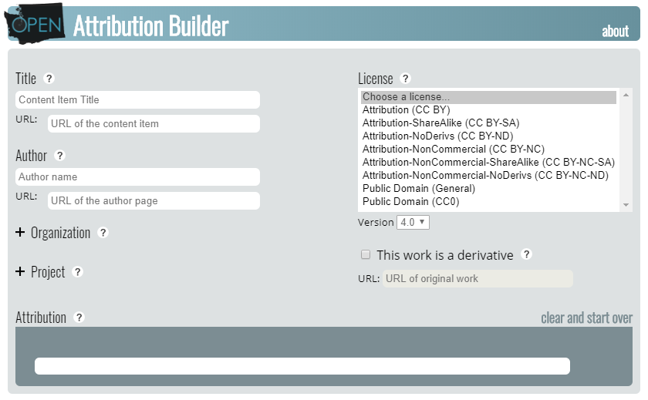

Figure 2: A screen capture of the Open Attribution Builder[[11]](#endnote-12)

For more detail on writing attributions, consult the [Attributions tab](http://libguides.mhcc.edu/oer/attributions" \t "_blank) of the [Mt. Hood Community College Textbook Affordability Libguide](http://libguides.mhcc.edu/oer/mhcc" \t "_blank) or [Creative Commons Best practices for attribution](https://wiki.creativecommons.org/wiki/Best_practices_for_attribution" \t "_blank). [[12]](#endnote-13)

How you attribute your source depends on what format your OER is. Let’s look at the soruces of content that would likely be included in a funded proposal.

# Digital Formats of Text-Based OER

This includes web sites, web pages, PDFs, online tools, videos, etc. As such, the attribution for a digital OER is the most common type of attribution you will find and makes a good introduction to creating attributions. It contains four essential elements: *title of the work, author/creator statement, source or link to the original work,* and *license*.

Here is an example of an attribution for the main source of content used to create this attribution guide.

["Attribution Statements for Remixed OER Content"](https://openoregon.org/attribution-statements-for-remixed-oer-content/" \t "_blank) by [Kevin Moore](http://openwa.org/" \t "_blank), [Open Oregon Education Resources](https://openoregon.org/" \t "_blank) is licensed under [CC BY 4.0](http://creativecommons.org/licenses/by/4.0" \t "_blank)

Note that the title, author/creator and license included links to their respective sites. Most OER appears on the Web or in digital formats with hyperlinking functions, so most likely you will share these resources with your students in the same way.[[13]](#endnote-14)

## Attributions for Multiple Sources

Once you start combining OER, properly attributing multiple sources can raise questions. There are few different ways to do this. Below you will find information on and examples of using footnotes and endotes (which is what this document uses), compiled lists of sources, and standard citation formats.

### Using Footnotes (or Endnotes)

One of the simplest and clearest ways to incorporate attribution statements in remixed OER may be citing sources with footnotes (or endnotes, if you prefer). For example, this paragraph earlier in this document remixes two CC-BY sources of content:

The first step is to create proper *attribution statements* for the individual items you are going to remix. It is important to note that using OER in academia is still in its infancy, and so far official, standardized guidelines have not been established to handle attributions for remixed content.1 There is no one right way; just make sure your attribution is reasonable and suited to the medium you're working with. That being said, you still have to include attribution requirements somehow, even if it's just a link to an About page that has that info.2

And the endnotes at the end of this document have attributions that correspond to each portion of adtopated text:

1 Adapted from ["Attribution Statements for Remixed OER Content"](https://openoregon.org/attribution-statements-for-remixed-oer-content/" \t "_blank) by [Kevin Moore](http://openwa.org/" \t "_blank), [Open Oregon Education Resources](https://openoregon.org/" \t "_blank) is licensed under [CC BY 4.0](http://creativecommons.org/licenses/by/4.0" \t "_blank)

2 Adapted from ["Best practices for attribution"](https://wiki.creativecommons.org/wiki/Best_practices_for_attribution" \t "_blank) by [Creative Commons](https://creativecommons.org/" \t "_blank) is licensed under [CC BY 4.0](http://creativecommons.org/licenses/by/4.0" \t "_blank)

### Compiled Lists of Sources

If the platform doesn’t allow for footnotes or endnotes, users can list links to each source in an attribution section at the bottom of the page that the content appears on.

Here is an example modified from Dave Dillon’s OER Textbook *Blueprint for Success in College and Career*[[14]](#endnote-15). This list appeared at the end of Chapter 7: Speaking The Language of College.

*Licenses and Attributions:*

CC licensed content, Shared previously:

A Different Road To College: A Guide For Transitioning To College For Non-traditional Students.

Authored by: Alise Lamoreaux.

Located at: <https://openoregon.pressbooks.pub/collegetransition/chapter/chapter-4/>

License: [CC BY 4.0](https://creativecommons.org/licenses/by/4.0/)

Adaptions: Reformatted. Added learning objectives. Modified reasons for going to college. Updated sources.

Time Ferriss: Smash Fear, Learn Anything.

Authored by TED.com.

Located at:  [https://www.ted.com/talks/tim\_ferriss\_smash\_fear\_learn\_anything#t-19570](https://www.ted.com/talks/tim_ferriss_smash_fear_learn_anything" \l "t-19570)

License: [CC BY-NC-ND 4.0](https://creativecommons.org/licenses/by-nc-nd/4.0/)

If you were to input these into the Open Attribution Builder, you would get the following attributions:

["A Different Road To College: A Guide For Transitioning To College For Non-traditional Students."](https://openoregon.pressbooks.pub/collegetransition/chapter/chapter-4/" \t "_blank) by Alise Lamoreaux. is licensed under [CC BY 4.0](http://creativecommons.org/licenses/by/4.0" \t "_blank)

["Time Ferriss: Smash Fear, Learn Anything."](https://www.ted.com/talks/tim_ferriss_smash_fear_learn_anything" \l "t-19570" \t "_blank) by [TED.com](https://www.ted.com/" \t "_blank) is licensed under [CC BY-NC-ND 4.0](http://creativecommons.org/licenses/by-nc-nd/4.0" \t "_blank)

### Using Standard Citation Formats

Scholars make attribution statements through standard citation formats such as Modern Language Association (MLA 8) and American Psychological Association (APA) styles. Adapting this method to remixed OER can simplify the attribution process. By using the signal phrases used in scholarly citation, you can indicate a fuller attribution on a separate list of attributed works (traditionally known as a bibliography or reference page.)

For example :

Socrates (ca. 469 – 399 B.C.E.) (Greek Σωκράτης Sōkrátēs) was an ancient Greek philosopher and one of the pillars of the Western tradition. Having left behind no writings of his own, he is known mainly through Plato, one of his students. Plato used the life of his teacher and the Socratic method of inquiry to advance a philosophy of idealism that would come to influence later Christian thought and the development of Western civilization. (“Socrates”)

The signal phrase links to the original web page of the source. On the bibliography page, where you would find

“[Socrates](http://www.newworldencyclopedia.org/entry/Socrates).” New World Encyclopedia, New World Encyclopedia, 8 Oct. 2015. Accessed 16 Mar. 2017. Licensed under [CC BY-SA 4.0](http://creativecommons.org/licenses/by-sa/4.0" \t "_blank)[[15]](#endnote-16)

## Images

Captions remain a reliable way to provide the creators or owners of an image proper credit, while also using CC license attributions. Some word-processing and web design software will enable you to create a caption that is attached to the metadata for the image, which helps users of screen readers. The caption on the image below provides an example.[[16]](#endnote-17)

[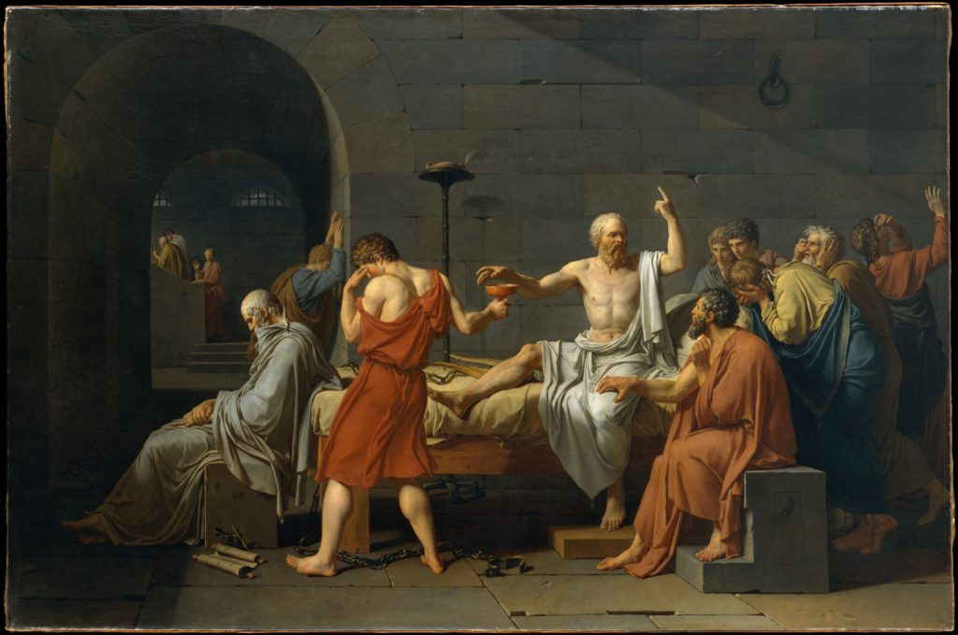](https://openoregon.org/attribution-statements-for-remixed-oer-content/dt40/)

Figure 3: “[The Death of Socrates](http://www.metmuseum.org/art/collection/search/436105)” by Jacques Louis David is in the [Public Domain](https://wiki.creativecommons.org/Public_domain)[[17]](#endnote-18)

## Slide Presentations

Presentation software such as PowerPoint provides instructors with creative ways to remix open resources and attribute those sources. Below see two slides using the Socrates example. In the first slide, the caption provides the attribution for the image, much as it would in a text-based document. On the second slide, essential information from the New World Encyclopedia entry is shared in bullet points with an attribution statement created with the Open Washington attribution builder.[[18]](#endnote-19)

*[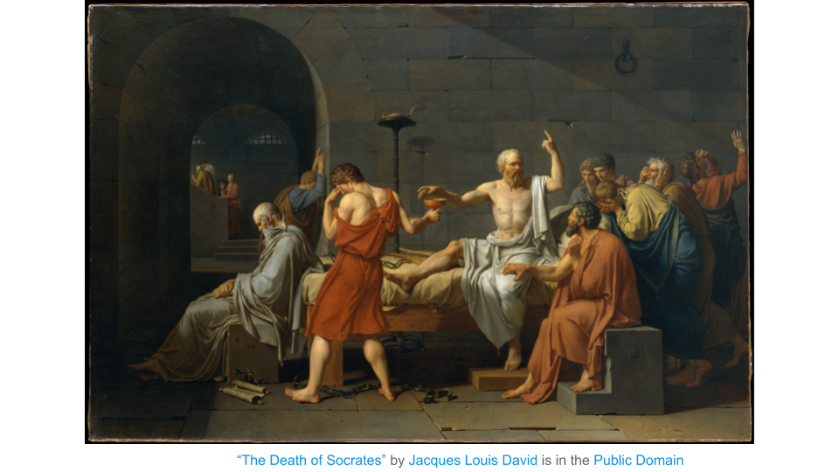](https://openoregon.org/attribution-statements-for-remixed-oer-content/untitled-presentation-2/)*

Figure 4: Slide with image and attribution statement as caption. [[19]](#endnote-20)

*[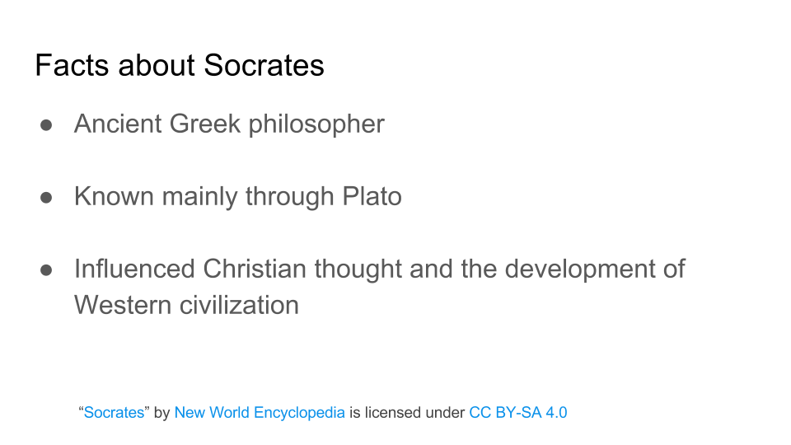](https://openoregon.org/?attachment_id=970)*

Figure 5: Slide with bullet-point summary from attributed source. [[20]](#endnote-21)

## Online Videos

Videos are a great way to share content with students. If your video content features remixed OER, the attributions may already be provided in that source content. For example, if the Socrates slide presentation above were to be turned into a video, the attribution statements are already included.

Another method is to put the attribution statement at the end of the video. In the video [Science Commons by Creative Commons](https://www.youtube.com/watch?v=hZAcTNFzF-s&feature=youtu.be&t=1m52s" \t "_blank), at the 1:52 mark a slide states that “All images and music used to create this work were licensed under Creative Commons licenses.” Credit slides then list the originators alphabetically.

When you upload a video to YouTube, you have the option of selecting the license type, one of which is a Creative Commons license. For good examples of this practice, take a look at the videos on the [Open Oregon channel on YouTube](https://www.youtube.com/channel/UC56yG1-TKXz5ij1Ge6YrVQQ). You can find the license statement in the “about” box under the video.[[21]](#endnote-22)

# What About Using Content that is Fully Copyrighted?

What happens when you want to use content in your remixed OER that does not have a Creative Commons (or other open) license? This is a tricky topic that likely falls back to Fair Use.

If there are public domain or openly licensed alternatives, those should be used. Users can also contact the creators of the copyrighted content for permission to use the content or to ask them to consider adopting a Creative Commons license.

If no such sources of content are freely available, users should carefully evaluate whether their use of copyrighted content would qualify under Fair Use. If you are working on a project funded by the OERI and are encountering this issue, please reach out to your project lead.

## Information About Fair Use

Copyright in the U.S. is intended to promote the creation of new works by providing an incentive for creators. However, recognizing that new works often build on or incorporate existing works, the law strikes a balance between the rights of creators and the rights of users via exceptions to the exclusive rights of the creator.[[22]](#endnote-23)

The fair use exception is detailed in Section 107 of the U.S. Copyright Act. Unlike other copyright exceptions, fair use is flexible and can apply to a broad array of uses. It is designed to be adaptable to new uses and technologies so that Congress doesn’t have to create new exceptions before a new technology can be utilized.[[23]](#endnote-24)

Under the “fair use” rule of copyright law, an author may make limited use of another author’s work without asking permission. However, “fair use” is open to interpretation. Fair use is intended to support teaching, research, and scholarship, but educational purpose alone does not make every use of a work fair.

Instead of specifying an exact type of user, type of material or amount that qualifies for this exception, the fair use statute provides a framework for the analysis and application of four factors that determine whether or not a particular use may qualify as fair use.

The four factors of fair use are:

* Purpose & character of use, including whether commercial (i.e. publishing a book) or non-commercial (i.e. using in a classroom assignment)
* Nature of the original material (i.e., is the work published or unpublished? Fact or fiction? Highly creative?)
* Amount and substantiality of the original work (are you using the entire work or just a portion?)
* Effect on the marketplace or on the work’s value (will your use have a financial impact on the creator?)

When considering whether a proposed use of a copyrighted work may qualify as fair use, you must weigh all four factors together. Each factor is equally important.[[24]](#endnote-25)

A [Fair Use Checklist](http://hsl.osu.edu/copyright/fair-use-checklist) can be very helpful for conducting a fair use analysis. The checklist indicates various criteria for each factor which have been found in a court of law to favor or oppose a finding of fair use. It is highly recommended that you use a fair use checklist to evaluate the strength of your argument for fair use.

Below are a few tips to consider when relying on the fair use exception in order to use copyrighted works in your endeavors.

* Use only lawfully acquired copyrighted works – To be able to claim fair use you must have used a legal copy of the original work.
* Acknowledge all of your sources with a bibliographic citation – Giving proper credit to the original creator demonstrates good faith and may help strengthen your fair use case.
* Use only the amount of the original work that you need to accomplish your goal – Since the amount of the original work that is used is one of the fair use factors, it is always important to only use what you need and not add extra material.[[25]](#endnote-26)

# Further Resources

INSERT LINKS TO OUR WEBINARS and WHAT ELSE HERE

1. Adapted from ["Creative Commons license"](https://en.wikipedia.org/wiki/Creative_Commons_license" \t "_blank) by [Wikipedia](https://en.wikipedia.org/wiki/Main_Page) is licensed under [CC BY 4.0](http://creativecommons.org/licenses/by/4.0" \t "_blank) [↑](#endnote-ref-1)
2. Adapted from ["Creative Commons license"](https://en.wikipedia.org/wiki/Creative_Commons_license" \t "_blank) by [Wikipedia](https://en.wikipedia.org/wiki/Main_Page) is licensed under [CC BY 4.0](http://creativecommons.org/licenses/by/4.0" \t "_blank) [↑](#endnote-ref-2)
3. Adapted from ["Creative Commons license"](https://en.wikipedia.org/wiki/Creative_Commons_license" \t "_blank) by [Wikipedia](https://en.wikipedia.org/wiki/Main_Page) is licensed under [CC BY 4.0](http://creativecommons.org/licenses/by/4.0" \t "_blank) [↑](#endnote-ref-3)
4. Adapted from ["Creative Commons license"](https://en.wikipedia.org/wiki/Creative_Commons_license" \t "_blank) by [Wikipedia](https://en.wikipedia.org/wiki/Main_Page) is licensed under [CC BY 4.0](http://creativecommons.org/licenses/by/4.0" \t "_blank) [↑](#endnote-ref-4)
5. ["Getting Started: A Content Catalog"](https://canvas.instructure.com/courses/1208502/pages/getting-started-a-content-catalog?module_item_id=14203837) by Quill West, [CCCOER](https://www.cccoer.org/" \t "_blank) is licensed under [CC BY 4.0](http://creativecommons.org/licenses/by/4.0" \t "_blank) [↑](#endnote-ref-6)
6. Adapted from Combining licenses by Suzanne Wakim licensed [CC-BY 4.0](https://creativecommons.org/licenses/by/4.0/) [↑](#endnote-ref-7)
7. Adaped from ["Attribution Statements for Remixed OER Content"](https://openoregon.org/attribution-statements-for-remixed-oer-content/" \t "_blank) by [Kevin Moore](http://openwa.org/" \t "_blank), [Open Oregon Education Resources](https://openoregon.org/" \t "_blank) is licensed under [CC BY 4.0](http://creativecommons.org/licenses/by/4.0" \t "_blank) [↑](#endnote-ref-8)
8. Adapted from ["Attribution Statements for Remixed OER Content"](https://openoregon.org/attribution-statements-for-remixed-oer-content/" \t "_blank) by [Kevin Moore](http://openwa.org/" \t "_blank), [Open Oregon Education Resources](https://openoregon.org/" \t "_blank) is licensed under [CC BY 4.0](http://creativecommons.org/licenses/by/4.0" \t "_blank) [↑](#endnote-ref-9)
9. Adapted from ["Best practices for attribution"](https://wiki.creativecommons.org/wiki/Best_practices_for_attribution" \t "_blank) by [Creative Commons](https://creativecommons.org/" \t "_blank) is licensed under [CC BY 4.0](http://creativecommons.org/licenses/by/4.0" \t "_blank) [↑](#endnote-ref-10)
10. Adapted from ["Best practices for attribution"](https://wiki.creativecommons.org/wiki/Best_practices_for_attribution" \t "_blank) by [Creative Commons](https://creativecommons.org/" \t "_blank) is licensed under [CC BY 4.0](http://creativecommons.org/licenses/by/4.0" \t "_blank) [↑](#endnote-ref-11)
11. ["Open Attribution Builder"](http://www.openwa.org/open-attrib-builder/" \t "_blank) by [Open Washington](http://openwa.org/" \t "_blank) is licensed under [CC BY 4.0](http://creativecommons.org/licenses/by/4.0" \t "_blank) [↑](#endnote-ref-12)
12. “[Open Attribution Builder](http://www.openwa.org/attrib-builder/" \t "_blank)” by [Open Washington](http://www.openwa.org/" \t "_blank) is licensed under [CC BY 4.0](http://creativecommons.org/licenses/by/4.0" \t "_blank) [↑](#endnote-ref-13)
13. Adatped from ["Attribution Statements for Remixed OER Content"](https://openoregon.org/attribution-statements-for-remixed-oer-content/" \t "_blank) by [Kevin Moore](http://openwa.org/" \t "_blank), [Open Oregon Education Resources](https://openoregon.org/" \t "_blank) is licensed under [CC BY 4.0](http://creativecommons.org/licenses/by/4.0" \t "_blank) [↑](#endnote-ref-14)
14. Adapted rom ["Blueprint for Success in College and Career"](https://press.rebus.community/blueprint2/" \t "_blank) by Dave Dillon is licensed under [CC BY 4.0](http://creativecommons.org/licenses/by/4.0" \t "_blank) [↑](#endnote-ref-15)
15. ["Attribution Statements for Remixed OER Content"](https://openoregon.org/attribution-statements-for-remixed-oer-content/" \t "_blank) by [Kevin Moore](http://openwa.org/" \t "_blank), [Open Oregon Education Resources](https://openoregon.org/" \t "_blank) is licensed under [CC BY 4.0](http://creativecommons.org/licenses/by/4.0" \t "_blank) [↑](#endnote-ref-16)
16. Adatped from ["Attribution Statements for Remixed OER Content"](https://openoregon.org/attribution-statements-for-remixed-oer-content/" \t "_blank) by [Kevin Moore](http://openwa.org/" \t "_blank), [Open Oregon Education Resources](https://openoregon.org/" \t "_blank) is licensed under [CC BY 4.0](http://creativecommons.org/licenses/by/4.0" \t "_blank) [↑](#endnote-ref-17)
17. Adatped from ["Attribution Statements for Remixed OER Content"](https://openoregon.org/attribution-statements-for-remixed-oer-content/" \t "_blank) by [Kevin Moore](http://openwa.org/" \t "_blank), [Open Oregon Education Resources](https://openoregon.org/" \t "_blank) is licensed under [CC BY 4.0](http://creativecommons.org/licenses/by/4.0" \t "_blank) [↑](#endnote-ref-18)
18. Adatpted from ["Attribution Statements for Remixed OER Content"](https://openoregon.org/attribution-statements-for-remixed-oer-content/" \t "_blank) by [Kevin Moore](http://openwa.org/" \t "_blank), [Open Oregon Education Resources](https://openoregon.org/" \t "_blank) is licensed under [CC BY 4.0](http://creativecommons.org/licenses/by/4.0" \t "_blank) [↑](#endnote-ref-19)
19. ["Attribution Statements for Remixed OER Content"](https://openoregon.org/attribution-statements-for-remixed-oer-content/" \t "_blank) by [Kevin Moore](http://openwa.org/" \t "_blank), [Open Oregon Education Resources](https://openoregon.org/" \t "_blank) is licensed under [CC BY 4.0](http://creativecommons.org/licenses/by/4.0" \t "_blank) [↑](#endnote-ref-20)
20. ["Attribution Statements for Remixed OER Content"](https://openoregon.org/attribution-statements-for-remixed-oer-content/" \t "_blank) by [Kevin Moore](http://openwa.org/" \t "_blank), [Open Oregon Education Resources](https://openoregon.org/" \t "_blank) is licensed under [CC BY 4.0](http://creativecommons.org/licenses/by/4.0" \t "_blank) [↑](#endnote-ref-21)
21. Adatpted from ["Attribution Statements for Remixed OER Content"](https://openoregon.org/attribution-statements-for-remixed-oer-content/" \t "_blank) by [Kevin Moore](http://openwa.org/" \t "_blank), [Open Oregon Education Resources](https://openoregon.org/" \t "_blank) is licensed under [CC BY 4.0](http://creativecommons.org/licenses/by/4.0" \t "_blank) [↑](#endnote-ref-22)
22. ["Citing Sources: Fair Use"](https://guides.library.ucla.edu/citing/fairuse" \t "_blank) by [UCLA Library](https://www.library.ucla.edu/" \t "_blank) is licensed under [CC BY 4.0](http://creativecommons.org/licenses/by/4.0" \t "_blank) [↑](#endnote-ref-23)
23. ["Choosing and Using Sources: A Guide to Academic Research - What Is Fair Use?"](https://ohiostate.pressbooks.pub/choosingsources/chapter/what-is-fair-use/" \t "_blank) by [Teaching & Learning, University Libraries](https://library.osu.edu/teaching" \t "_blank), [University of Ohio](https://www.osu.edu/" \t "_blank) is licensed under [CC BY 4.0](http://creativecommons.org/licenses/by/4.0" \t "_blank) [↑](#endnote-ref-24)
24. ["Choosing and Using Sources: A Guide to Academic Research - The Four Factors"](https://ohiostate.pressbooks.pub/choosingsources/chapter/four-factors/" \t "_blank) by [Teaching & Learning, University Libraries](https://library.osu.edu/teaching" \t "_blank), [University of Ohio](https://www.osu.edu/" \t "_blank) is licensed under [CC BY 4.0](http://creativecommons.org/licenses/by/4.0" \t "_blank) [↑](#endnote-ref-25)
25. ["Choosing and Using Sources: A Guide to Academic Research - Evaluating Your Case for Fair Use"](https://ohiostate.pressbooks.pub/choosingsources/chapter/evaluating-your-case-for-fair-use/" \t "_blank) by [Teaching & Learning, University Libraries](https://library.osu.edu/teaching" \t "_blank), [University of Ohio](https://www.osu.edu/" \t "_blank) is licensed under [CC BY 4.0](http://creativecommons.org/licenses/by/4.0" \t "_blank) [↑](#endnote-ref-26)