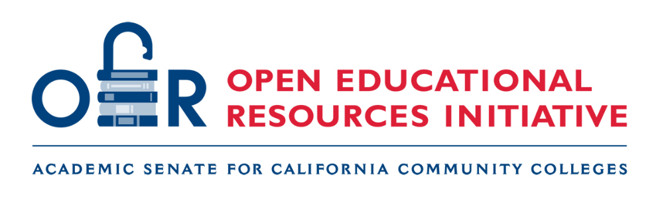

• OER Liaison Newsletter – December 2020 •

Greetings OER Liaisons! It’s hard to believe it – but this is our final newsletter of 2020. We hope your term is winding down smoothly and that you are looking forward to a much-deserved break. We wish you and yours a safe, happy, and healthy holiday season.

As is now our practice, this newsletter begins with information designed for you and then transitions into the more general information that will be in the OERI Newsletter that is intended for you to share with your colleagues.

Please note that if any of the OERL events appear appropriate for others at your college, feel free to share the information. We welcome all to join us.

• OER Liaison Tracking •
Please be sure to update your Fall 2020 OERL activities in the Fall 2020 Liaison Tracking Spreadsheet (tinyurl.com/Fall2020OERL) before December 11. This information is necessary in order for you to be cleared to receive your Fall 2020 stipend.

• December 2020 OERL Conversations and Webinars •

Wednesday, December 2, 10:00 AM – 11:00 AM
OERL Conversation: OER New Year's Resolutions
New year, new opportunities to learn and grow your OER initiative. Come to this conversation with ideas about tangible goals for 2021 and brainstorm with your OER colleagues on strategies to achieve those goals. What will your resolution be?
Register for OERL Conversation: OER New Year’s Resolutions

Tuesday, December 8, 2:00 PM – 3:00 PM
OERL Webinar: Open Educational Practices
Open educational practices provide a framework for making learning more transparent, participatory, and collaborative. How do you create an environment that empowers your students to facilitate their learning? How do you incorporate giving students’ ownership of various aspects of the course into your teaching? How do you work with your students to replace “disposable” assignments with experiences that are more meaningful? Join us to learn about both large and small changes that can help you implement an adaptive course design.
Register for OERL Webinar: Open Educational Practices

• OER-Related Resolutions •

At the 2020 Fall ASCCC Fall Plenary, three resolutions related to our work were adopted by the delegates. Two are related to SB 1359 and one is more general. It is our hope that all three will help you in your local advocacy work.

Recommendations for the Implementation of a Zero Textbook Cost* (ZTC) Designation in Course Schedules (Fall 2020, 09.01)
Whereas, Resolution 13.01 S19 asked that the “Academic Senate for California Community Colleges develop suggested guidelines, policies, and practices for implementation of SB 1359 (Block, 2016) no later than Spring of 2020”;
Whereas, Most California community colleges have overcome the technical challenges associated with implementing a “no-cost” designation in their online course schedules and are now seeking to perfect this implementation by ensuring consistency in the criteria used to determine which sections are marked with this designation and establishing procedures to ensure that no qualifying sections are missed;
Whereas, The details of the legislation—i.e., the requirement that sections marked with the no-cost designation be those “that exclusively use digital course materials”—are inconsistent with how “zero textbook cost” had been defined by the California Community Colleges Chancellor’s Office and is silent with respect to whether the designation can be used when a student is required to purchase tangible supplies (e.g. goggles, a calculator, or paint; and
Whereas, Consistency and transparency across colleges is beneficial to students, faculty, and anyone with an interest in assessing the impact of efforts to reduce textbook costs;
Resolved, That the Academic Senate for California Community Colleges recommend that the no-cost designation be used to recognize those sections that use digital resources, as consistent with SB 1359 (Block, 2016), and those sections that require a text yet are “no- cost” due to something other than a digital alternative;
Resolved, That the Academic Senate for California Community Colleges encourage local academic senates to interpret the SB 1359 (Block, 2016) requirements as in alignment with those established by the California Community Colleges Chancellor’s Office for courses that are zero textbook cost (ZTC);
Resolved, That the Academic Senate for California Community Colleges recommend integration of identification of a course section as being no-cost into the existing textbook selection process; and
Resolved, That the Academic Senate for California Community Colleges provide additional guidance and resources related to SB 1359 (Block, 2016) no later than the Fall 2021 Plenary.
This resolution is intended to address some of the lingering questions regarding which sections can be given the ZTC marking – which we can now refer to as “ZTC” as we are taking that position that what SB 1359 is referring to – and ZTC – are one and the same. In the guidance from the Chancellor’s Office regarding ZTC, it was made explicit that sections that required the purchase of supplies, such as goggles, calculators, and paint, could be ZTC and those that required students to purchase access to digital resources or homework system were not. As it is critical that our messaging to students be accurate, a companion resolution was developed and adopted that emphasizes the import of ensuring that students are aware of such non-textbook costs.

Ensure Course Cost Transparency for Students (Fall 2020, 20.02)

Whereas, Faculty have both the freedom to select the course materials they deem most appropriate and the responsibility to consider the cost burden as they do so;

Whereas, Provisions of the Higher Education Opportunity Act that went into effect in July, 2010 required each institution of higher education receiving federal financial assistance to “disclose, on the institution's Internet course schedule and in a manner of the institution's choosing, the International Standard Book Number and retail price information of required and recommended college textbooks and supplemental materials for each course listed in the institution's course schedule used for preregistration and registration purposes”;

Whereas, Ensuring the transparency of textbook, supplemental material, supply, and other course-related costs is of critical importance when unpredictable costs associated with course-taking may exceed the fees students pay to take courses, placing additional financial burdens on students; and

Whereas, Some disciplines and colleges have well-established and clearly visible processes for informing students of costs and fees prior to registration while others do not;

Resolved, That the Academic Senate for California Community Colleges encourage local academic senates to advocate for the implementation of a process for consistent, clear, and transparent messaging to students prior to registration regarding all material and supply costs in appropriate locations including the schedule of classes and the bookstore.

The third resolution was a more general one – regarding accepting ASCCC activities as filling “flex” requirements [Include Academic Senate for California Community Colleges (ASCCC) Events, Courses, and Service as Pre-Approved Activities to Satisfy Flex Requirements]. We hope this will help you to entice your colleagues to attend our events.

• Sample Cover Message •
Greetings college community! As the Open Educational Resources Liaison, it is my role to share communications from the ASCCC Open Educational Resources Initiative (OERI) with you. Please read on to learn about upcoming events that are open to all and an opportunity for faculty to play a role in increasing OER consideration and adoption by others in their discipline.

If I can assist you in your considering OER– or answer any OER-related questions, please let me know.

• ASCCC OERI Wants You •

The ASCCC OERI is still seeking faculty for various roles. While faculty with OER experience are preferred, we are prepared to support faculty who are new to OER and interested in playing a leadership role.

Discipline Leads (December 2020 – January 2021)

The OERI is recruiting discipline leads for the following disciplines. Applications will be reviewed as they are received. Discipline leads are initially tasked with identifying the OER available for their discipline. If you have any questions about this opportunity, please contact the ASCCC OERI Faculty Coordinator, Michelle Pilati.
- Addiction Studies (courses in programs designed to train students to become alcohol and other drug counselors, see C-ID ADS descriptors)
- Business Office Technologies (find the C-ID BSOT descriptors under Office Technology/Business Information Worker)
- Geology
- Information Technology Information Services
- Nursing
- Physics
- Public Health Science

ASCCC OERI-Facilitated Work

The ASCCC OERI is recruiting faculty in the disciplines below for OER work to be initiated before the end of the term and continuing into the new year. If you are interested, please submit an application as soon as possible. A planning meeting will be scheduled with interested faculty to discuss the scope of the work and the timeline.

Communication Studies (C-ID COMM 130, Interpersonal Communication)

English as a Second Language (focus TBD)

Nursing (focus TBD)

Psychology (C-ID PSY 150, Introduction to Biological Psychology)

Applications will be reviewed as they are received.

OER Reviewers and Disciplines Leads for Spring 2021

In addition, we are currently seeking faculty to review OER in a long list of disciplines and Discipline Leads for Spring 2021. If you are interested in any of these opportunities – or in OER work more generally – please submit an application. If your discipline is one that we are not currently focusing on, your application lets us know not only that you are interested, but that faculty in your discipline are interested.

Additional information about the Discipline Lead role is available on the application page.

• OERI Weekly Webinars – December 2020 •

During the fall 2020 term, our OERI Weekly Webinars are scheduled for Fridays at 3:00 pm.

OERI Webinars are intended for a diverse audience. We hope you will all join us! Please share with your colleagues.

Friday, December 4, 3:00 PM – 4:30 PM
OER and Anthropology
Which OER are available for anthropology courses and in use at California community colleges and other colleges/universities? Join us for a panel discussion with the editors of new OER textbooks for cultural anthropology, biological anthropology (lecture and lab), archaeology, gender, and magic/witchcraft/religion. In this presentation, you will learn about the available resources and share your anthropology OER feedback and needs.
Register for OER and Anthropology

Friday, December 11, 3:00 PM – 4:00 PM
When Open Meets Online
Merging the principles of open pedagogy and effective online course design increases the efficacy of each. The principles of online course design can be used to embed Open Educational Resources (OER) seamlessly into your classes and open teaching practices provide a framework for developing enduring and engaging course assignments. Join us to learn how to take your teaching to the next level by blending open and online.
Register for When Open Meets Online

