H5P Content Authoring Accessibility Guide
November 2020

Summary
ASCCC uses the revised Section 508 standards as the minimum accessibility standards for instructional content like H5P activities. ASCCC identified accessibility barriers with H5P activities in April 2020 and provided detailed feedback to H5P developers. For example, ASCCC identified significant accessibility failures with the Mark the Words activity type.
After meeting with H5P developers, ASCCC determined that it could provide training to content authors to make some H5P activities more accessible. Other accessibility barriers identified still need to be addressed by H5P.
ASCCC reports the following results for the activity types it evaluated:
- Drag the Words, not recommended
- Fill in the Blanks, recommended with workarounds
- Mark the Words, not recommended
- Multiple Choice, recommended with workarounds.
All the H5P activities evaluated have accessibility barriers affecting users who are blind and users with learning disabilities who use assistive technology to read the content aloud. These include but are not limited to:
- No option to set the correct language for the activity
- No option to set the correct language for content
- No title for the activity iframe.
In addition to reporting accessibility barriers with specific H5P activity types, this document includes a guide designed to help H5P content authors avoid creating accessibility barriers for users. The purpose is to ensure the H5P activities are as accessible as currently possible. Content authors should also follow all accessibility techniques for digital content. For additional information, review ASCCC Quick Guides Accessibility Overview and Accessibility Resources.

Contents
Summary 1
Reporting Accessibility Barriers 3
Accessibility Standards 3
H5P Accessibility Standards 3
Accessibility Conformance Testing 4
Evaluation Methodology 4
H5P Testing Results 5
ASCCC Testing Results 5
Drag the Words, Not Recommended 5
Fill in the Blanks, Recommended with Workarounds 6
Mark the Words, Not Recommended 7
Multiple Choice, Recommended with Workarounds 7
H5P Activity Workarounds 8
General Workarounds 8
Fill in the Blanks Workarounds 10
Multiple Choice Workarounds 14

Reporting Accessibility Barriers
ASCCC identified accessibility barriers with H5P activities in April 2020 and provided detailed feedback to H5P developers. ASCCC met with H5P developers in May 2020 to review the concerns.
After meeting with H5P developers, ASCCC determined that some of the accessibility failures were the result of content author error. ASCCC provided training to content authors to make some H5P activities more accessible. For additional information about the training, review the following section H5P Activity Workarounds.
Other accessibility barriers identified need to be addressed by H5P. ASCCC proposed fixes, but even with content author training and temporary workarounds some H5P activity types are not currently accessible.
For example, ASCCC identified significant accessibility failures with the Mark the Words activity type. In response, H5P updated the Content types recommendations page to include the accessibility barriers. However, H5P has not yet implemented other fixes.

Accessibility Standards
ASCCC uses the revised Section 508 standards as the minimum accessibility standards for instructional content like H5P activities. The Section 508 standards include WCAG 2.0 level A and AA. Since H5P activities and the H5P content authoring user interface are web content, the WCAG 2.0 success criteria are directly applicable.

H5P Accessibility Standards
The Content types recommendations page maintained by H5P lists several activity types that appear to support WCAG 2.1 level A and AA accessibility standards.
WCAG 2.1 includes all WCAG 2.0 accessibility standards. However, WCAG 2.1 does not include all the additional Section 508 applicable standards.

The additional Section 508 standards that apply to H5P activities include Chapter 6: Support Documentation and Services. The additional Section 508 standards that apply to the H5P content authoring user interface include Chapter 5: Software and Chapter 6: Support Documentation and Services.
Please note, Chapter 3: Functional Performance Criteria may apply where the requirements in Chapter 5: Software do not address one or more functions of the H5P activity types or content authoring user interface. Also, if the H5P activity types or content authoring user interface provides equivalent facilitation through alternative design or technology that results in substantially equivalent or greater access, it should be documented in Chapter 3: Functional Performance Criteria.

Accessibility Conformance Testing
ASCCC evaluated the following H5P activity types for accessibility conformance:
- Drag the Words
- Fill in the Blanks
- Mark the Words
- Multiple Choice.
ASCCC did not conduct accessibility testing for the H5P content authoring user interface.

Evaluation Methodology
The accessibility testing included:
- the Trusted Tester Version 5 Web on Windows process by a certified Trusted Tester
- manual testing with JAWS and NVDA in Chrome and Firefox on Windows by an experienced user of screen reading software.

H5P Testing Results
H5P defines accessible to mean, “either there are no known accessibility issues that [they] are aware of for the end user view of the content type, or that any known issues are about to be fixed.”
H5P reports the following results for the activity types ASCCC evaluated:
- Drag the Words is accessible
- Fill in the Blanks is accessible
- Mark the Words, “There are known problems that will not be solved immediately. We aim to solve them when the H5P Hub is done.”
- Multiple Choice is accessible.

ASCCC Testing Results
ASCCC recommends using content that conforms with the Section 508 standards, including WCAG 2.0 level A and AA. This means that various users with disabilities can read, understand, and interact with content and activities with about as much effort as users without disabilities.
ASCCC reports the following results for the activity types ASCCC evaluated:
- Drag the Words, not recommended
- Fill in the Blanks, recommended with workarounds
- Mark the Words, not recommended
- Multiple Choice, recommended with workarounds.

Drag the Words, Not Recommended
This activity is not accessible with screen reading software like JAWS and NVDA. The drag and drop functionality works fairly well with keyboard navigation if screen reading software is not running. The main accessibility failures occur when the activity is attempted with screen reading software.
H5P developers reported the bug creating the accessibility barrier with the Drag the Words and screen reading software was identified in October 2019. Until this major accessibility failure is corrected and the activity type reevaluated for accessibility conformance, the Drag the Words H5P activity type is not recommended for use.

Fill in the Blanks, Recommended with Workarounds
This activity can be made mostly accessible. Content authors need to correctly use content formatting and H5P activity type specific options to ensure each Fill in the Blanks activity is as accessible as currently possible.
Accessibility barriers include, but may not be limited to:
- No option to set the correct language for the activity
  - This means that the text, in a language other than English, of any activity is not pronounced correctly by assistive technology that reads the text aloud.
  - If the text of an entire activity is in Spanish, the text of the entire activity is not pronounced correctly by assistive technology.
  - This barrier affects users who are blind and users with learning disabilities who use assistive technology to read text aloud.
- No option to set the correct language for content
  - This means that text, in a language other than English, in any activity is not pronounced correctly by assistive technology that reads the content aloud.
  - If an activity has instructions in English and questions in Spanish, the questions will not be pronounced correctly by assistive technology.
  - This barrier affects users who are blind and users with learning disabilities who use assistive technology to read the content aloud.
- No title for the activity iframe
  - This means that when the activity is embedded on a web page, it does not have a meaningful title that can be identified by assistive technology.
  - A user who cannot see the activity on the web page
  - Uses of assistive technology, such as screen reading software, may not be able determine the purpose of the iframe content and choose whether or not to interact with that content.

Mark the Words, Not Recommended
This activity is not accessible with screen reading software like JAWS and NVDA. The reading order is not logical and can be very confusing for users. H5P added a “text only” version of the question text, not visible on screen. This requires a user of screen reading software to read the text of all the questions in the activity first, then read the questions again and attempt to find the words to mark.
The structure of the activity is another significant accessibility barrier. While the activity may visually appear to have sentences, and a beginning and end, it is programmed as a list of words. When a user gets to the end of the list, the list cycles back to the beginning. There is no indication, other than the visual structure of the activity, that the user is reading repeated content.
The Mark the Words activity type is not recommended for use until H5P implements recommended fixes these and other accessibility barriers that have been reported.

Multiple Choice, Recommended with Workarounds
This activity can be made mostly accessible. Content authors need to correctly use content formatting and H5P activity type specific options to ensure each Multiple Choice activity is as accessible as currently possible.
Accessibility barriers include, but may not be limited to all the barriers identified in Fill in the Blanks, Recommended with Workarounds (see above for details):
- No option to set the correct language for the activity
- No option to set the correct language for content
- No title for the activity iframe.

H5P Activity Workarounds
The following guide is organized by H5P activity type content authoring fields and options. Not all H5P activity types have the same fields or options.
These recommendations are designed to help content authors avoid creating accessibility barriers for users and ensure the H5P activities are as accessible as currently possible. Content authors should also follow all accessibility techniques for digital content. For additional information, review ASCCC Quick Guides Accessibility Overview and Accessibility Resources.
In the following sections, activity types and activity elements are in bold.

General Workarounds

Activity Title
Example activity title:
Activity 1.1.2 (on the web page the text is coded as a heading 3 or other appropriate heading level)
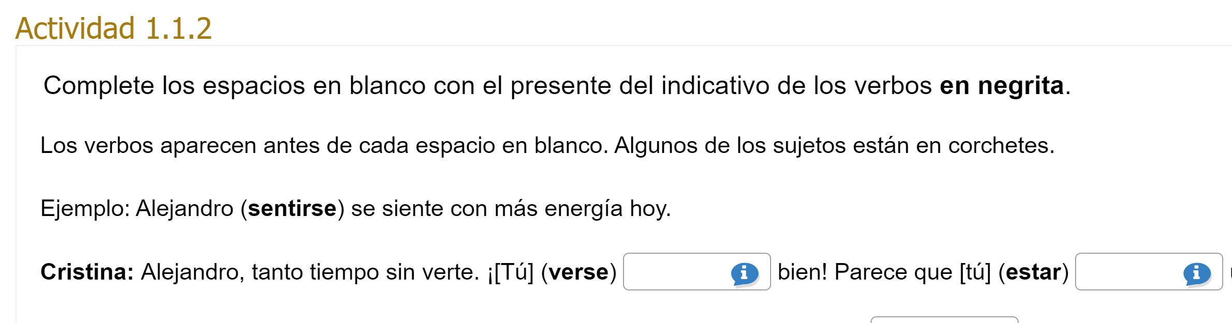
H5P activities do not have accessible titles when embedded on a web page (the title for the iframe is missing). To provide a more accessible title, include a heading with the activity name or number as the activity title before each activity.

Bold Text
Example use of bold text:
In the following exercises, verbs are in bold.
Include brief instructions for users that explain the use of bold text in H5P activities. The instruction should let users know that bold text will be used and the meaning of the bold text. By providing the instructions, users of assistive technology can decide if they want to turn on the software feature to identify changes in text formatting. The instructions also make the meaning of the bold text clear to all users.

Fill in the Blanks Workarounds

Task Description
Example Task description:
Complete the blanks with the present tense of the verbs in bold.
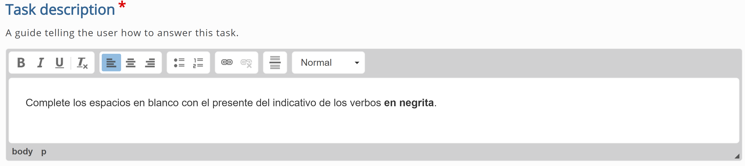
The Task description field is intended to provide instructions for the activity. However, the Task description field also acts as the label for each Line of text. These labels are used by assistive technology. While visually, the Task description only appears once, in an activity with multiple Lines of text, users of assistive technology encounter the Task description repeated as many times as there are Lines of text in the activity.
The Task description should be short because it is also the label used by assistive technology for each Line of text. While the Task description field includes text formatting options, the text formatting is not part of the label used by assistive technology.
Do not use italics, links, lists, headings, or any other text formatting options in the Task description field if the text formatting conveys structure or meaning.

Text Blocks and Lines of Text
Example Line of text:
Every day, I (to wake up, to put on) early because (to study, to attend) classes at the university in the morning.
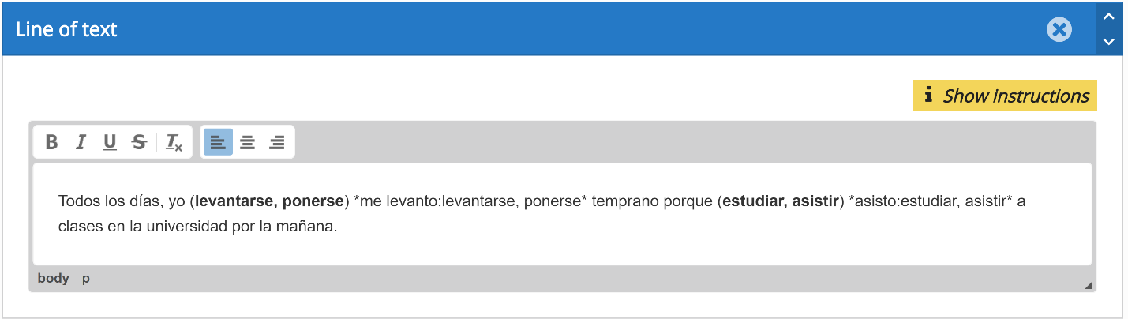
Fill in the Blanks activities are organized by Text blocks called Lines of text. Each Line of text has limited content formatting options.
Content authors can use Lines of text to separate activity questions. However, Text blocks do not support numbered or bulleted lists or headings within each Line of text.
The text formatting in Lines of text should be limited to normal text as much as possible. Bold text can be used when the use and meaning are described in the activity Task description.

Activity Instructions
Example activity instructions:
The verbs appear before each blank space. Some of the subjects are in brackets.
Example: Dr. Pérez (to work) works in the Los Angeles clinic.
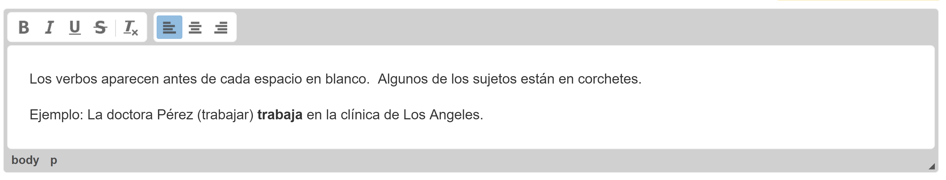
The Fill in the Blank activity does not provide an accessible option to include detailed instructions for the activity and correctly label activity elements for assistive technology. Detailed instructions should be added in the first Line of text instead of the Task description.

Blanks
Example Blanks:
Every day, I (to wake up, to put on) early because (to study, to attend) classes at the university in the morning.
The Blanks in the Fill in the Blanks activities are edit fields. The information associated with each Blank should always appear before the Blank. This way the information associated with each Blank can serve as a text label.
When the text labels for Blanks have multiple options, use a comma instead of a slash to separate the options. Commas are easier to read with assistive technology than slashes.

Textual Tips
Example Textual tip:
(to wake up, to put on) to wake up, to put on
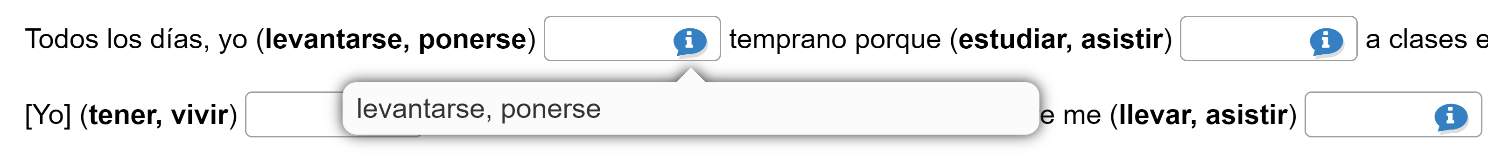
Blanks are automatically labeled for assistive technology as “blank number of total blanks.” “Blank number” is the order of the Blank and “total blanks” is the total number of Blanks in the entire activity. If an activity has 16 Blanks as answers, then the first Blank is labeled “blank 1 of 16.”
To be accessible, the label for the Blanks should provide users of assistive technology with enough information to understand how to interact with the edit field. The information related to each Blank appears in parenthesis before the Blank but is not associated with the label for the Blank.
Since “blank 1 of 16” is not descriptive enough, a workaround is to include the information related to each Blank as a Textual tip.

The Textual tip should include the answer options in the text label. These will usually be the options in parenthesis. The Textual tip should also include any additional text related to the Blank. For example, if the subject of the verb is in brackets, [she], it should also be in the Textual tip.
Please note, the Text Override for the tip label should be updated to better describe the text label. In this example, the tip label should be changed to “Verb to conjugate”. Similarly, the label for the tip icon should be updated. Instead of “Tip”, the label should be “Verb”.

Behavioral Settings for Fill in the Blanks
The following is a list of Behavioral Settings options with suggestions to make the content accessible:
- Automatically check answers after input
  - Do not check
- Put input fields on separate lines
  - Do not check
- Show confirmation dialog on "Check"
  - Do not check
- Show confirmation dialog on "Retry"
  - Do not check

Text Overrides and Translations for Fill in the Blanks
In this example, the answers are verbs that need to be conjugated to match the context of the sentence. The following is a list of Text Overrides and Translations options with suggestions to make the content accessible:
- Text for "Show solutions" button
  - Show solution for Activity 1
- Text for "Retry" button
  - Retry Activity 1
- Text for "Check" button
  - Check Activity 1
- Assistive technology label for saying an input has a tip tied to it
  - Verb to conjugate
- Tip icon label
  - Verb

Multiple Choice Workarounds

Question
Example Question:
Select the correct that identifies the type of comparison.
Stanford University is the most expensive of the four options mentioned in the article.
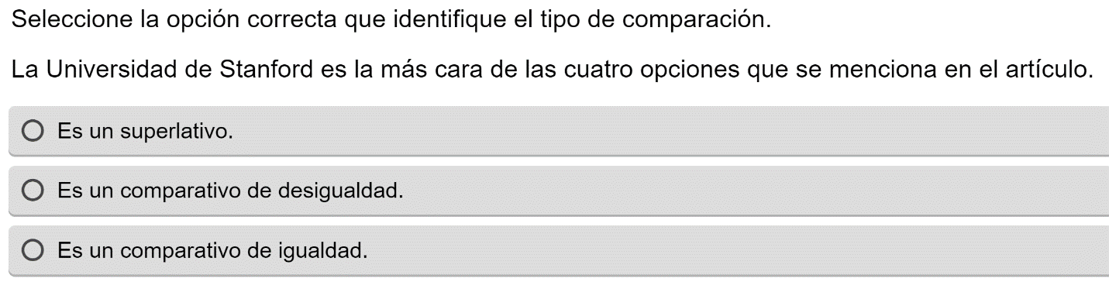
The Question field is intended to provide instructions for the activity and the question related to the Available options. However, the Question field also acts as the label for each Available option. These labels are used by assistive technology. While visually, the Question only appears once, users of assistive technology encounter the Question repeated as many times as there are Available options in the activity.
The Question should be short because it is also the label used by assistive technology for each Available option. While the Question field includes text formatting options, the text formatting is not part of the label used by assistive technology.
Do not use italics, superscripts, subscripts, headings, or any other text formatting options in the Question field if the text formatting conveys structure or meaning.

Available Options
Example Available options:
- It is a superlative.
- It is a comparison of inequality.
- It is a comparison of equality.
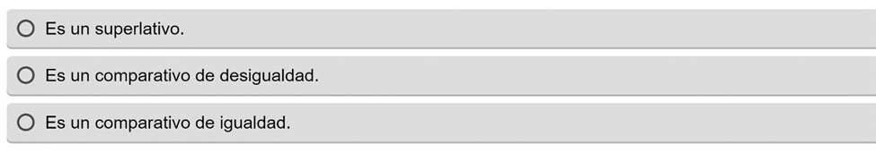
Multiple Choice activity answers are organized as Available options. Each Available option has limited content formatting options.
The text formatting in Available options should be limited to normal text as much as possible. Bold text can be used when the use and meaning are described in the activity Question.

Tips and Feedback
Each Available option can include Tips and feedback. The H5P options were not tested for accessibility conformance.

Behavioral Settings for Multiple Choice
The following is a list of Behavioral Settings options with suggestions to make the content accessible:
- Randomize answers
  - Do not check
- Show confirmation dialog on "Check"
  - Do not check
- Show confirmation dialog on "Retry"
  - Do not check
- Automatically check answers
  - Do not check

Text Overrides and Translations for Multiple Choice
The following is a list of Text Overrides and Translations options with suggestions to make the content accessible:
- Check answer button label
  - Show solution for Activity 1
- Show solution button label
  - Show solutions for Activity 1
- Retry button label
  - Retry Activity 1

