MyOpenMath: Accessible Content Authoring Guide
It is important to consider accessibility when creating content in MyOpenMath, regardless of whether that content is a link item, text page, assessment instructions, a question, a forum post, or any other way of sharing content. Accessible content ensures that all students can access and use the content you create, regardless of any barriers they may face.
This guide includes the basic accessibility approaches needed in all disciplines, as well as the unique concerns in mathematics. In mathematics we face a few challenges:
- Mathematical formulas: Unlike standard text, screen reading software used by students without vision or with limited vision can only read mathematical formulas if they are displayed in a way that the screen reading software can understand.
- Graphs: Screen reading software cannot read a graph, so a text-based alternative must be provided. The appropriate alternative often depends on the context.
- Diagrams: Likewise, screen reading software cannot read a diagram, so a text-based alternative must be provided.
- Data tables: Mathematics often involves tables of values for a function and statistics often involves tabular representations of data. Without proper formatting, it is hard for a student without vision or a student with limited vision to navigate a data table and understand the relationship between the table cells and the headers.
- Drawing and Graphing: In math we often ask students to draw graphs of a function. For students without vision, with limited vision, or with limited manipulation, doing so with a mouse on the screen can be impossible.
- Videos: We commonly use videos to guide students through example problems. For students without hearing, with limited hearing, or with limited language, cognitive, and learning abilities, when trying to watch the video in a noisy room, and lots of other use cases, it is necessary for videos to be accurately captioned. Likewise, for students without vision, with limited vision, or with limited language, cognitive, and learning abilities, it is important the video describe in audio anything meaningful being written or shown visually in the video.
Table of Contents
Accessibility Settings in MyOpenMath 3
Accessibility Basics 3
Color and Contrast 3
Links Should be Descriptive 4
Images and Alt Text 4
Styles and Structures 5
Tables 7
Mathematical Expressions 8
Graphs 9
In the Editor 9
In Questions 11
Other Considerations 13
Charts and Diagrams 13
Drawing and Graphing 15
Input Boxes 17
Videos 18
Making Videos 19
Adding Captions in YouTube 19
DECT Grant and 3C Media Solutions 21
Audio Description 21
Example Questions 22
Attributions 24

Accessibility Settings in MyOpenMath
While MyOpenMath strives to be accessible in general, in some areas better accessibility is provided through special user settings to enable alternatives. Accessibility options can be enabled by viewing the User Profile page, which you can access by selecting the hyperlink of your name in the upper right corner of MyOpenMath pages. On the profile page, you will be able to adjust your display preferences for math, graphs, drawing entry, text editor, contrast, and auto-preview.
This guide will refer to some of these settings, but for full details on the options available, please refer to the MyOpenMath Accessibility Statement, which you can also find a link to on the MyOpenMath login page.

Accessibility Basics
This section will explore general accessibility recommendations, mostly not specific to mathematics.

Color and Contrast
For students with limited vision or without perception of color, it is important to ensure sufficient contrast between foreground and background colors. To read more about various vision issues students face, check out Color Contrast And Why You Should Rethink It.
The standards require a 4.5:1 ratio for normal text, and 3:1 for large text (18 point or 14 point bold). To find out whether a color combination is OK, try the WebAIM color contrast checker. For example, these are OK: Sample Text, Sample Text, while these are not: Sample Text, Sample Text. A good rule of thumb is to try to keep contrast as high as possible. When choosing colors, also try to keep in mind colorblindness, as some color combinations are not distinguishable for all people.
A good tool for scanning a page for any contrast issues is the ANDI (Accessible Name and Description Inspector) bookmarklet. This tool is used in the Trusted Tester code-inspection based testing approach. It can be installed in your bookmarks bar, then run on any webpage, including your own, to see if there are any contrast, alt text, and other accessibility issues.
Most importantly, never rely on color as the only way to convey information. Do not, for example, say “the red graph” to refer to one of several graphs; provide some other way, such as text labels, to distinguish the graphs.

Links Should be Descriptive
When you are providing a link to something, avoid pasting the full URL onto the page. Instead, you want to embed the URL into descriptive text that will tell the reader where the link will take them. Also avoid using phrases like “click here” as that does not give the user much information about what will happen when they select that link. Instead, use descriptive phrases as the hyperlinks.
Example:
- Not descriptive: Donald Tapscott, in his paper “Growing Up Digital,” http://www.ncsu.edu/meridian/jan98/feat_6/digital.html says these students …
- Descriptive: Donald Tapscott, in his paper “Growing Up Digital,” says these students ….

Images and Alt Text
If you include an image in your content, you should provide a textual description for that image, referred to as “alt text.” Recommendations on how to phrase alt text for graphs and diagrams will be discussed in more detail later.
If you are inserting an image using the text editor, then you can specify the alt text by filling in the “Image Description” in the image tool dialog. If you pasted in the image, you can access the image tool dialog by selecting the image, then selecting the image tool icon in the text editor, . If you do not fill in the “Image Description”, the image will be treated as decorative by screen reading software and completely ignored. This is not accessible unless the image truly is decorative.
If you are writing a question, you can insert an image into the question text by selecting the Toggle Editor button to enable the text editor, then following the procedure above. Alternatively, if you use the Image File upload option in the question editor, a space is provided for a Description of the image, which is used as the alt text.
For some additional guidance on writing alt text, check out the WebAim alternative text guide, or examples and guidelines for describing STEM images from the National Center for Accessible Media.

Document Formats
When attaching or linking to external documents, it is important to consider the format of those documents. PDF files with math content are generally not accessible; PDF files containing only text can generally be made accessible. However, the PDF format currently does not provide any way to make math inside PDFs accessible without manually adding alt text descriptions of each equation. Even then, the alt text can be too long to be usable and can be difficult to navigate for users of assistive technology.
If you are going to link to PDF files, it is recommended to make sure the accessible source versions are also available, either by providing a secondary link to that Word or text file, or by letting students know they can contact you for the source files. To be fully accessible, Word files also need alt text on images, including graphs, and math should ideally be written in MathType.

Styles and Structures

Headings
To make it easier to navigate a page, any grouping of content should be done with proper headings, not just an enlarged font size, bold, or color. Additionally, headings should be sequentially nested, with a Heading 2 under a Heading 1, the Heading 3s under Heading 2s, and so forth. Generally, MyOpenMath pages have an automatically generated Heading 1, so your content should typically begin with a Heading 2.
You can create headings in your text using the text editor buttons. Under the Formats button, select Headings, then the desired Heading level.

Lists
Sighted users can glance at a list and know if it is long or short. When you create lists, use the bulleted or numbered list formatting tool in the text editor. This will allow screen reading software to identify the number of items in a list before it begins to read the items. Also, remember to use list types correctly. Numbered list formatting should be used for ordered lists, while lists of items without a sequence should be formatted with the bulleted list tool.

Formatting Text and Layout
Often, people will use the Tab key or Spacebar to indent items. Additionally, many people will add extra blank lines between sections of a document or page to distinguish between sections. Manually formatting with the Tab key, Spacebar, and blank lines is sure to cause you a headache when editing the document later. This type of formatting is incredibly time consuming in addition to being inaccessible.
There are a wide variety of ways to get the layout you want without having to rely on techniques that wreak havoc on the experience of people with disabilities. If you are indenting because the items are a list, use the list tool. If you are indenting a quote or something similar, you can use the Increase Indent button in the text editor toolbar to indent a paragraph.
Here is a short list of things to avoid and lessons on how to use the appropriate tools to follow:
- Do not use the Tab key to create columns. By using Tab, you are essentially creating vertical lists with a reading order that is horizontally. If the information is tabular, use tables. Otherwise, it is not advisable to use columns in online text, as they do not adapt well to different screen sizes.
- Avoid text boxes. The content may either be ignored entirely by assistive technology or may be read out of order.
Do not use blank lines or spaces to create more white space. It is common for extra space to accumulate at the end of the document and a user may think they have reached the end of the document if their screen reading software announces a collection of blank spaces or lines.

Font Type and Size
Try to use a simple font in a good size. Most importantly, remember not to use size, color, or bold in place of properly formatted headings. Avoid using too many combinations of fonts and typing long phrases. Also, avoid using ALL CAPS, except for acronyms, and reserve underlining for hyperlinks.
For digital content, sans-serif fonts (without the “feet” or extensions) are recommended because they are considered easier to read. Do not worry too much about the font – the default font in MyOpenMath should be fine.

Tables
For tables to be accessible:
- Tables should only be used for data and not for layout.
- Tables need to be formatted to include header rows and/or columns.
- Tables should have captions to assist all users to contextualize the data unless the table is captioned by the text content immediately preceding it.
You can create a table in the text editor by using the table tool. Once you have created the table, do the following to make it accessible:
- Select the table. Then, select the table icon in the text editor:
- Select Table properties and check “caption”. Select “Ok”.
- Select at the top of your table to type a caption for the table.
- Highlight the cells of the header row (or column).
- Select “Cell”, then “cell properties” from the table menu in the text editor.
- Select “header cells” from the Cell type dropdown menu.
- From the scope dropdown, select “columns” if you have column headers, or “rows” if you have row headers. Select “Ok”.
- While not necessary for accessibility, if your top row is a header row, you can highlight it, select the table icon in the text editor, select “Row” then “row properties” from the menu, and change the “Row type” to “Header”. Marking a row as a header sometimes changes how it looks visually.
The result will look something like:
Grade Distribution
Percentage | Grade
95-100% | 4.0
94% | 3.9
93% | 3.8
Tables should only be used for displaying tabular data. Tables should not be used for layout purposes. Using a table for layout not only confuses users of screen reading software, but it also causes problems on mobile devices and other small screens where the information in the table might get cut off if it is wider than the screen can accommodate.
If, when writing questions, you just cannot give up using tables for layout, at least add role=presentation to the main <table> tag, like <table role=presentation>. Doing so tells screen reading software to ignore the table, and MyOpenMath will adjust the display of tables marked up this way on smaller screens to reduce issues.

Mathematical Expressions
Images of mathematics cannot be read by screen reading software, so pictures of math should be avoided. Instead, the built-in math tools in MyOpenMath should be used.
MyOpenMath uses AsciiMath as a math input format, which is very similar to calculator-style notation. For example, you could type (-b+-sqrt(b^2-4ac))/(2a) to get $\frac{-b±\sqrt{b^2-4ac}}{2a}$. Note that AsciiMath also understand many basic LaTeX commands, so those can be used as well. Math is displayed using MathJax, which automatically converts the math into an accessible format, as well as providing tools for zooming equations and navigating them.
In the text editor, you can start a new math entry by selecting the . This will insert a red box with two backtick symbols into the editor. Start typing, using calculator-style notation. When you have completed your expression, use the right arrow key to move out of the red box (or use a mouse to click out), and the math will render. To edit the expression, use the left arrow key to move the cursor into the expression or use the mouse to click on the expression. If you are not sure how to enter a particular symbol, you can select the in the editor to see a selection of symbols and basic expressions.
When writing questions with the text editor disabled, you can indicate what text should be rendered as math by surrounding it with backticks (aka the grave symbol, usually on the key in the upper left corner of a keyboard). For example, you could write Sketch a graph of `y=1/2x^2` shifted two units left.
For more information on the AsciiMath notation, view the AsciiMath syntax guide.

Graphs
Like images, graphs need to have alt text for sight-impaired students. Be aware that pasted-in images (like screenshots) have a second disadvantage that if limited-sight student is using screen-zooming technology, enlarged images are often fuzzy and hard to read.

In the Editor
If you need a graph in the text editor, and it's the graph of a basic function, you can use the graphing tool in the editor. Graphs created this way are rendered in the browser using SVG, which are vector graphics. This means that if a student zooms in the screen, the graph stays crisp and clear.
To add a graph using the editor:
- Select the Graph icon,
- Select the equation type.
- Enter the equation.
- If you want to graph on a limited domain, specify the start and/or end values. Leave these blank if not needed.
- If you want to change the color, width, or style of the graph, use those options. You can also select to start and end the graph with arrows or dots; these only apply if the graph is over a limited domain.
- Select Add Graph to add the graph. If needed, you can make changes and select Replace Selected Graph.
- You can add multiple graphs if needed.
- To enlarge the graph, change the Resize options and select Update.
- When done, select Insert to place the graph into your text. A low-resolution placeholder will show in the editor. This will be replaced with a high-resolution SVG version later.
- You can edit the graph by selecting it then selecting the Graph icon again.
The result will look like:
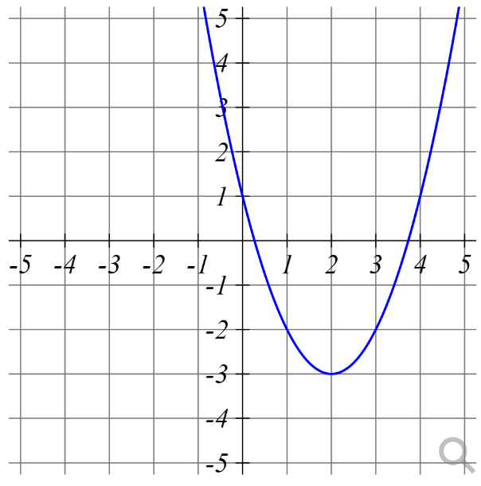
Graphs created this way will have automatically generated alt text added. The auto-generated alt-text is not descriptive, but simply states what the graph shows, like:
Graphs on the window x=-7.5 to 7.5 and y=-5 to 5: black graph of y=(x-2)^2-3.
Students unfamiliar with the shape of the graph could explore it using an accessible graph exploration tool like Desmos.

In Questions
When writing questions, if you need a static image (non-randomized) in your question, you can select Toggle Editor to turn on the text editor and use the process described above.
If you need randomized questions, or do not want the formula for the equation to be exposed to students, you can use the showplot function. For example, you could enter:
$g = showplot("(x-2)^2-3")
Then you would place the variable $g into the question text where you want the graph to show. See the question writing help for more details on the syntax options for showplot.

Graphs generated with showplot do not have alt text, but when a student has turned on the “text alternatives” system accessibility option, the graph will be replaced with a table of values for the function, like:
Graphs with window x: -5 to 5, y: -5 to 5. Start Graph, Color black
x | y
-5 | 46
-4 | 33
-3 | 22
-2 | 13
-1 | 6
0 | 1
1 | -2
2 | -3
3 | -2
4 | 1
5 | 6
The table of values is used to prevent the student from seeing the formula of the equation, as often the formula is the answer to the question. Of course, a table of values is not always useful or sufficient for answering the question. If needed, you can replace the textual description with something more appropriate for question, using the replacealttext function:
$g = showplot("(x-2)^2-3")
$g = replacealttext($g, "A U-shaped graph that decreases to the point (2,-3) then increases")
When writing custom alt text, think about what information about the graph is important to answering the question. Are the function values important, or just the shape? How can you describe it in a way that doesn't give away the answer?

Other Considerations
If you have multiple graphs and plan to refer to them, do not use color as the only way to distinguish them. For example, a matching question where you have students match equations to graphs based on the color the graph alone will be problematic for students without vision, with limited vision, or without perception of color. To address this, you can consider adding labels to the graphs using the addlabel function:
$g = showplot("(x-2)^2-3")
$g = addlabel($g, 1, 2, "A")

Charts and Diagrams
Like graphs, charts and diagrams are not accessible by someone without vision or with limited vision.
If the chart or diagram is added as a picture (jpg, png, gif, etc.), then you will need to create a text description that includes any information a student would need or be able to extract or infer from the picture.
Create the text description of the diagram. For example, the diagram below might be described as:
“Two radar dishes are shown located horizontally apart along the shore, labeled A and B. A boat is in the water, between the radar dishes horizontally and away from shore. Lines connecting the radar dishes and boat form a triangle. The angle of the triangle at radar dish A is labeled 70 degrees, and the angle at radar dish B is labeled 60 degrees.”
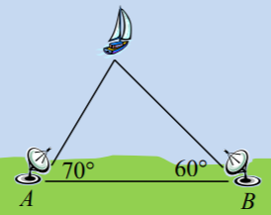
Since the text description is too long to be usable as alt text, include the text description as part of the question text. Alternatively, you could create a link to a separate page with the text description and include the link in the question text. Then for the alt text of the image, provide a brief description, such as “diagram of radar dishes and boat as described in the question text” instead of the entire description.
In some cases, you can duplicate the information from the chart or diagram in a text format elsewhere. For example, you could provide an accessible table that duplicates the data represented in a bar graph or provide all the relevant information for a problem in the text. As with diagrams, the alt text need only be brief, something like “a bar graph illustrating the data provided in the following table”.
When writing questions, most of the chart macros in the “stats” library, like fdbargraph, histogram, and boxplot, will automatically generate a table or textual description in place of the graphical chart when a student enables the textual alternative feature in MyOpenMath. For example, shown below is an automatically generated histogram and the textual alternative.
Graphical histogram:
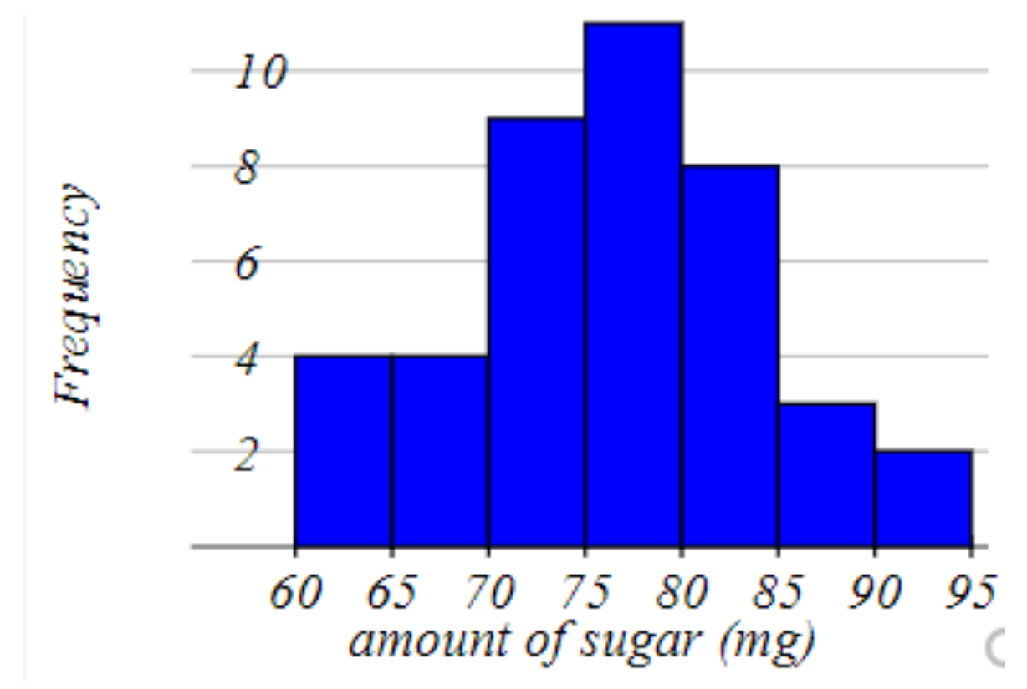

Text alternative:
Histogram for amount of sugar (mg)
Label on left of box | Frequency
60 | 4
65 | 4
70 | 9
75 | 11
80 | 8
85 | 3
90 | 2
As another caution, when writing questions avoid using the textonimage macro. This function does not produce an accessible output. It will result in something impossible for a student without vision or with limited vision to use, and something that may cause problems for students who enlarge the screen or are working on mobile devices.

Drawing and Graphing
Questions that ask students to draw a graph can cause accessibility issues for students without vision or with limited vision. It can also be challenging for students with limited manipulation, such as students who have difficulty moving the mouse precisely. To address this, MyOpenMath has an accessibility option for requesting a text-based entry alternative for drawing questions. When this mode is enabled, MyOpenMath replaces the default mouse-based graphical entry with a fully text-based entry option.
For example, in the standard mouse-based entry, a student might enter a parabola by clicking on the correct tool, clicking on the vertex, then clicking on a second point on the graph:
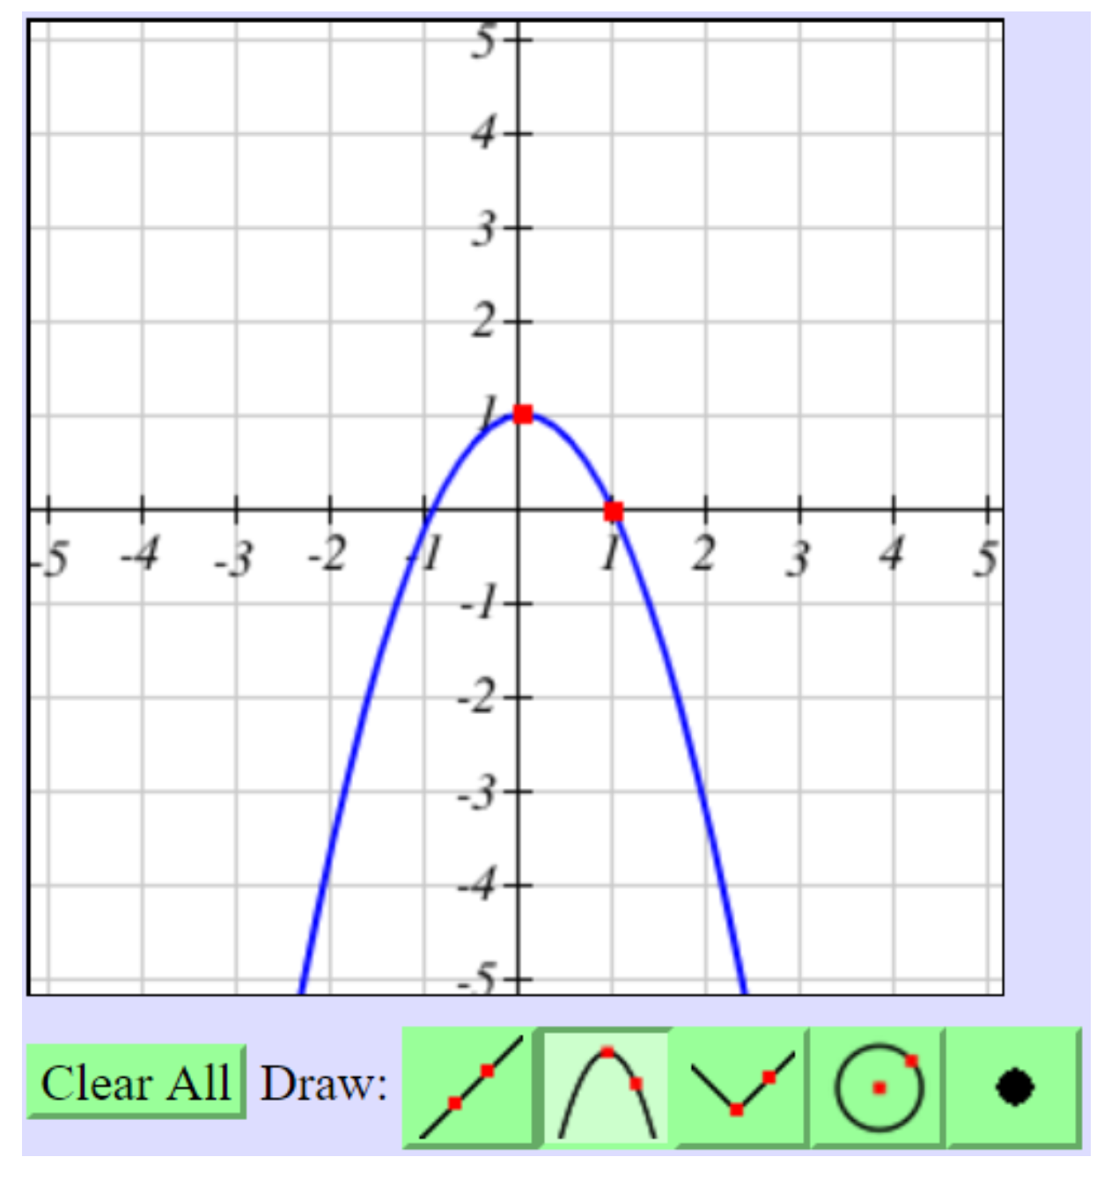
In the text-alternative mode, the student would choose the graph type from a list, then enter the vertex and other point in text format:
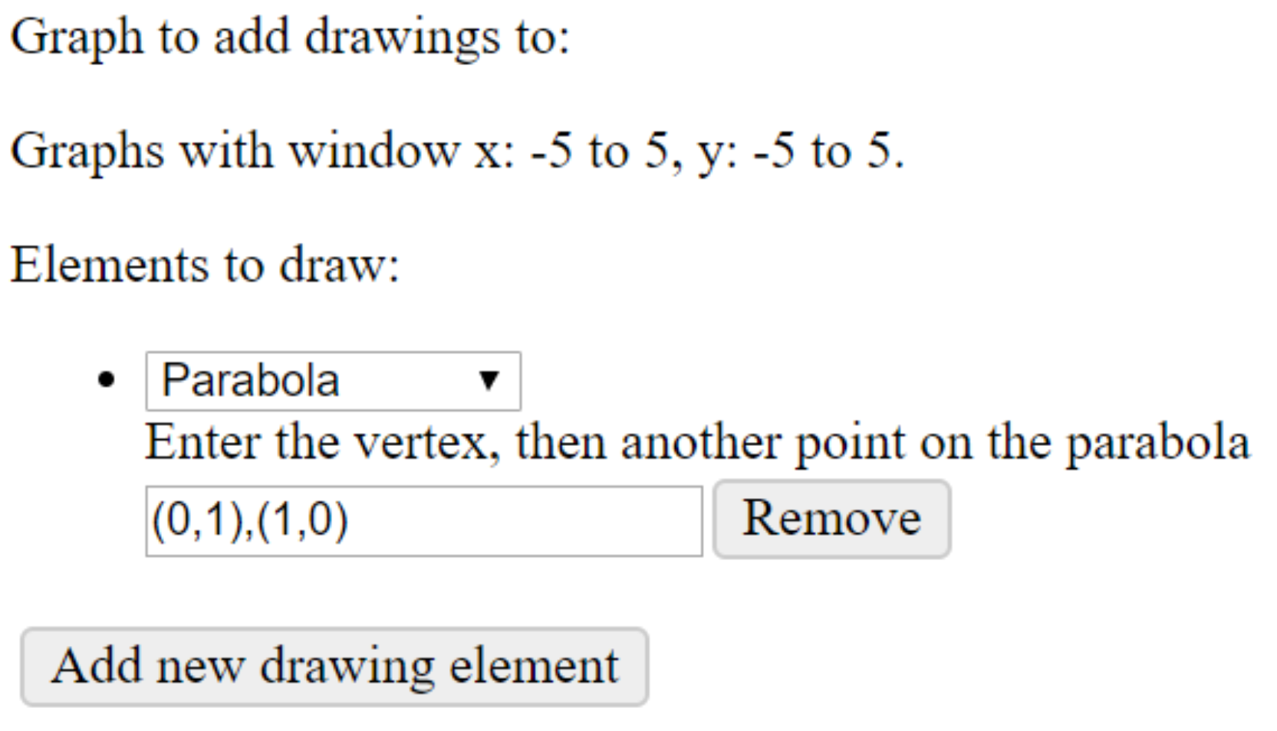
The text-alternative graphing option includes a list of graphing elements in a comb box. In this example, the graph type Parabola is selected. This triggers the text instruction, “Enter the vertex then another point on the parabola” and a text entry box. In this example, the text entry box contains (0,1),(1,0). Students also have the buttons Remove and Add new drawing element as options.
For most two-point graphing, this alternative will work well. There are some cases where this drawing entry may be difficult or impossible for a student to use:
- You are using “freehand” drawing, or the older line tool to have students draw complex graphs that could not easily be described by a list of points.
- You are having students draw lines or shapes through points on the background image where a textual alternative would not have sufficient detail to identify the needed coordinates, or if the background were generated using functions that do not produce useful alt text.

Input Boxes
In question writing, to help students understand what they should be entering into an answer box, it is important that the box be appropriately labeled. The system automatically provides some labels, but they are only numbered and do not include the question text.
First, use question writing options like $reqdecimals = 2 or $answerformat = “fraction” to specify the input requirements of the question. These automatically alter the question entry tips and become part of the input box label.
Next, write out instructions, like “Simplify your answer,” for an algebraic expression question. By including that text in the question text, it supports various types of learners. Be sure the instructions are located before the answer box so that a user of screen reading software will hear it before they read the input box.
For multipart questions, make sure that students can easily understand what each answer box is for without needing visual cues. For example, start by labeling each question part with a heading (correctly nested), such as Part 1, Part 2, etc. Then, make sure each answer box immediately follows the applicable question text. Keep in mind that using formatting options like columns, textonimage, or other HTML markup that alters the flow of the page can make the association between the question text and the answer box unclear, especially for users without vision, but also for users with limited vision or limited manipulation.
If needed, you can use the $readerlabel variable to define a visually-hidden input box label. Screen reading software can use this label to describe the purpose of the answer box to a student. For example, if using textonimage to place an input box on the leg of a triangle, you could define $readerlabel[0] = “The first leg of a right triangle”. In some cases, rather than providing alt text for the image, you may wish to build the image description into the reader label, like $readerlabel[0] = “The leg of a right triangle with hypotenuse $h and other leg $a”. Do not use the $readerlabel to provide entry tips like “Enter a fraction”; doing so would be redundant with the autogenerated tips and would be confusing.

Videos
When using videos in your course or questions, they must be captioned. Captioning is essential for students without hearing or with limited hearing. It is also very useful for students trying to watch videos in noisy environments, in places where they cannot play the audio, and for students learning English.
When searching for questions, you can identify questions with captioned videos associated by looking for the video icon with CC in the corner: . If the video does not have the CC badge, it is probably not captioned (though it is possible captions have been added since the video was originally added to the question).
When searching on YouTube for videos, check the video settings for captions. If you only see “English (auto-generated)”, those are auto-generated captions and are not considered good enough to meet accessibility requirements, especially in field like math with a lot of technical vocabulary. You want to verify there is a separate, manually created set of captions for the video.
A great resource for finding captioned videos is mathispower4u. You will likely recognize James Sousa's videos, as they are used extensively throughout MyOpenMath.

Making Videos
If you create your own videos, chunk the material into short segments rather than one long video. Most people tune out around the 5 to 10 minute mark.
If possible, work from a script. Using a script will help you talk more clearly and slowly. It will also help you stay on point. If you take the time to write a script, not only will your video sound better, but you can load the script into YouTube, where it will automatically be synced to the audio.
If you are doing a screencast or narrating a PowerPoint, keep in mind that captions display at the bottom of the screen. Try to keep the bottom of your screen or slides clear so that you are not covering important information with the captions.
When making a video, use descriptive language and do not rely on your viewers to read the screen; make sure you read everything to them. If a viewer is not able to see the video or has difficulty seeing parts of the video, then descriptive language will add more value to the video. Avoid statements like “so this and this are like terms.” Instead describe what is happening (e.g., “so 3x and 5x are like terms”).
If filming yourself, make sure you are in a quiet, clean, and simple environment without visual distractions.

Adding Captions in YouTube
Once you have made your video, it is time to add captions. You can do this a variety of ways – most depend on the type of video and whether you used a script. The easiest way to make captions requires either money or YouTube – you pick your approach.
Please note, many people will simply rely on YouTube's machine generated captions. These are not reliable and do not meet the needs of students with disabilities or meet accessibility standards. While they do improve when you speak clearly and slowly, they never contain punctuation, which makes it a confusing reading experience for the viewer.

If You Used a Script
If you have published your video to YouTube and used a script, creating captions will generally take less time than transcribing the entire video:
- Go to the Video manager, and in the edit dropdown menu next to your video, select “Subtitles and CC”.
- Select video language.
- Select “Add new subtitles or CC” (and select the video language again).
- Select “Transcribe and auto sync”.
- Paste your script into the box, then select “set timings”. Wait a few minutes while YouTube runs its magic!
- Once YouTube syncs the text, you will see two sets of captions when you look in the “Subtitles and CC” section of the video editor. Select on “English (Automatic)” again. In the “Actions” dropdown menu, select “Unpublish”.

If You Did Not Use a Script
One option is to follow the steps above, but for step #6, you will listen to your video and transcribe it yourself before selecting “set timings.” Plan for the transcription to take 3 to 5 times the length of the video.
The other option is to use YouTube's machine generated captions, then to go through and edit them. This takes less time than transcribing, but start with a script if you want to do this the quickest way.
- Upload your video to YouTube.
- Eventually, when you select “Subtitles and CC” from the edit menu, you will see “English (automatic)” next to your video. This sometimes takes a while and may not happen at all if there is a lot of silence at the start of the video.
- Select “English (Automatic)” to review the machine generated captions.
- To edit the captions, select the “Edit” link in the top right corner.
- Select the caption boxes to add punctuation (a must) and correct errors. While you type in your changes, the video will pause.
- Once you are done, select the “Publish edits” link in the top right corner.
- You will now see two sets of captions. Select “English (Automatic)” again. In the “Actions” dropdown menu, select “Unpublish”.

DECT Grant and 3C Media Solutions
California Community College faculty members have access to the Distance Education Captioning and Transcription grant (DECT). It provides CCCs with funding for live and synchronous captioning and transcription as a means of enhancing the access of all students to distance education courses.
DECT funding is available for:
- Distance Education (Online, Hybrid, Synchronous, Asynchronous)
- Credit and Non-Credit classes
- On-campus Classes utilizing distance methods of content delivery as they evolve (e.g., class capture, web conferencing, vodcasting, podcasting, content posted within a Learning Management System)
Another resource available to CCCs is 3C Media Solutions. In addition to providing options for uploading and storing videos, CCC faculty members can request captioning for videos through the DECT grant in a few short, simple steps. For more information, visit 3C Media Solutions Services.

Audio Description
While captions go a long way in making videos accessible to people who are deaf or hard of hearing, they do not fulfill the needs of people without vision or with limited vision who cannot make out the text or fine details in a video. Audio descriptions allow people without vision or with limited vision to hear what is happening or displayed on the screen that they cannot see. Audio descriptions are an additional audio file that can be played over a video.
If you are feeling overwhelmed by all this post-production work, remember that building accessibility into the process from the start will save you lots of time (and money).
First, remember, using a script will save you tons of time when creating captions. Look over your script. See if you can add in some language that describes the screen or identifies who is talking. Avoid phrases like “over here” or “when I do this” and replace them with more descriptive language (e.g., “when I select the grades tab in the course menu...”). Read your script and see if you can make sense of the language without visuals. If you can, maybe you do not need audio description.
If multiple people are talking in your video, ask them to identify themselves and their position or role. Again, try to represent any text that might be on the screen through audio. This will minimize the need for additional audio descriptions and can also be beneficial for people using captions, as often the captions may cover the portion of the screen that contains text.

Example Questions
The following are three examples of questions. These questions are formatted to be accessible using MyOpenMath options.
The text in brackets are labels that indicate formatting or accessibility tips. For example, “[general instructions identify that the answer is in two parts, use paragraph break].”

Example Assignment [heading 1]

Question 1 [heading 2]
Solve the inequality and write your answer as an inequality with reduced fractions. [use paragraph break]
17x−7 ≥ −16+9x [math content]
The solution for the above inequality is [answer field]
Question Help: Video for Question 1 [include the question number as part of the descriptive link text]
Submit Question [MyOpenMath button]

Example Assignment [heading 1]

Question 2 [heading 2]
Solve the inequality. Graph the solution on the number line and then give the answer in interval notation. [general instructions identify that the answer is in two parts, use paragraph break]
x−2 ≤ -4 [math content]

Part 1 [heading 3]
Graph the solution set for the above inequality on the given number line. [specific instructions for the first part of the answer, use paragraph break]
Choose the "Closed dot" or "Open dot" button to place the correct dot on the number line before you submit your answer. "Toggle the Line segments and rays" button to draw the correct line type. Select the Clear All button before you submit your answer to start over. [instructions for the use of MyOpenMath features, use paragraph break]
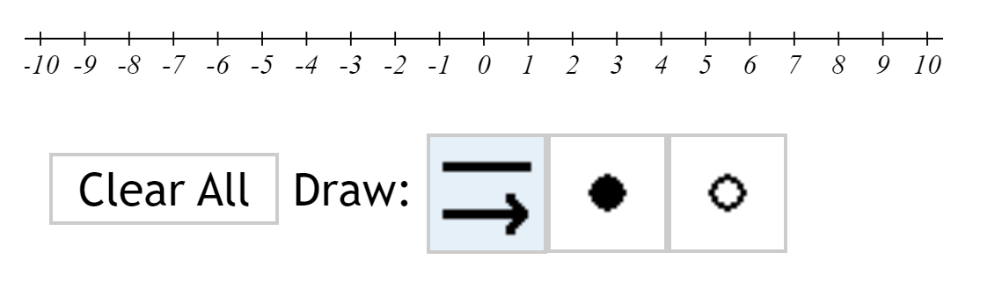[image of MyOpenMath interface]

Part 2 [heading 3]
Write the same solution set as an interval. Use "oo" (two lower case o's) for ∞ (infinity). [specific instructions for the second part of the answer, use paragraph break]
Interval notation for the above graph and inequality is [answer field]
Question Help: Video 1 for Question 2 Video 2 for Question 2 [label videos uniquely, include the question number as part of the descriptive link text]
Submit Question [MyOpenMath button]

Example Assignment [heading 1]

Question 3 [heading 2]
Solve the inequality. Identify the form of the answer then write the solution using interval notation. [general instructions identify that the answer is in two parts, use paragraph break]
Solve 2|x−6|+3 > 5 [math content]

Part 1
What is the form for the answer of the above inequality? [use list structure for the answers]
- (−∞,A)∪(B,∞) [math content]
- (A,B) [math content]

Part 2
State the solution using interval notation like the form for the answer above: [answer field]
Question Help: Video for Question 3 [include the question number as part of the descriptive link text]
Submit Question [MyOpenMath button]

Attributions
This document was created by the Academic Senate for California Community Colleges (ASCCC) and is licensed under the Creative Commons Attribution license.
Portions of this document are remixed from David Lippman’s Creating Accessible Pages and Questions and from STEM-centric Accessibility 101, offered by the Washington State Board for Community and Technical Colleges, licensed under the Creative Commons Attribution license.

