F-Distribution Table

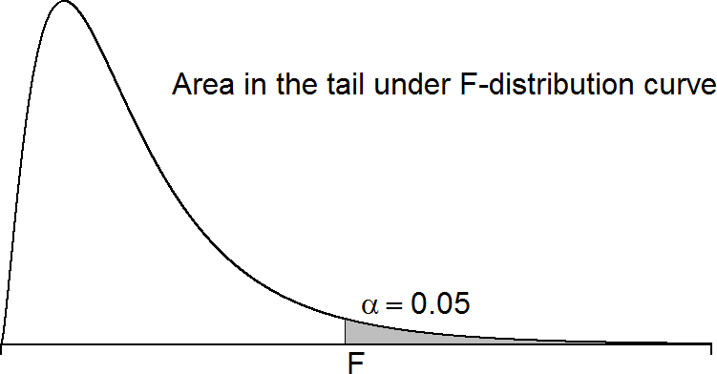
 | Degrees of Freedom: Numerator
df  denom. | 1 | 2 | 3 | 4 | 5 | 6 | 7 | 8 | 9 | 10
1 | 161.45 | 199.50 | 215.71 | 224.58 | 230.16 | 233.99 | 236.77 | 238.88 | 240.54 | 241.88
2 | 18.51 | 19.00 | 19.16 | 19.25 | 19.30 | 19.33 | 19.35 | 19.37 | 19.39 | 19.40
3 | 10.13 | 9.55 | 9.28 | 9.12 | 9.01 | 8.94 | 8.89 | 8.85 | 8.81 | 8.79
4 | 7.71 | 6.94 | 6.59 | 6.39 | 6.26 | 6.16 | 6.09 | 6.04 | 6.00 | 5.96
5 | 6.61 | 5.79 | 5.41 | 5.19 | 5.05 | 4.95 | 4.88 | 4.82 | 4.77 | 4.74
6 | 5.99 | 5.14 | 4.76 | 4.53 | 4.39 | 4.28 | 4.21 | 4.15 | 4.10 | 4.06
7 | 5.59 | 4.74 | 4.35 | 4.12 | 3.97 | 3.87 | 3.79 | 3.73 | 3.68 | 3.64
8 | 5.32 | 4.46 | 4.07 | 3.84 | 3.69 | 3.58 | 3.50 | 3.44 | 3.39 | 3.35
9 | 5.12 | 4.26 | 3.86 | 3.63 | 3.48 | 3.37 | 3.29 | 3.23 | 3.18 | 3.14
10 | 4.97 | 4.10 | 3.71 | 3.48 | 3.33 | 3.22 | 3.14 | 3.07 | 3.02 | 2.98
11 | 4.84 | 3.98 | 3.59 | 3.36 | 3.20 | 3.10 | 3.01 | 2.95 | 2.90 | 2.85
12 | 4.75 | 3.89 | 3.49 | 3.26 | 3.11 | 3.00 | 2.91 | 2.85 | 2.80 | 2.75
13 | 4.67 | 3.81 | 3.41 | 3.18 | 3.03 | 2.92 | 2.83 | 2.77 | 2.71 | 2.67
14 | 4.60 | 3.74 | 3.34 | 3.11 | 2.96 | 2.85 | 2.76 | 2.70 | 2.65 | 2.60
15 | 4.54 | 3.68 | 3.29 | 3.06 | 2.90 | 2.79 | 2.71 | 2.64 | 2.59 | 2.54
16 | 4.49 | 3.63 | 3.24 | 3.01 | 2.85 | 2.74 | 2.66 | 2.59 | 2.54 | 2.49
17 | 4.45 | 3.59 | 3.20 | 2.97 | 2.81 | 2.70 | 2.61 | 2.55 | 2.49 | 2.45
18 | 4.41 | 3.56 | 3.16 | 2.93 | 2.77 | 2.66 | 2.58 | 2.51 | 2.46 | 2.41
19 | 4.38 | 3.52 | 3.13 | 2.90 | 2.74 | 2.63 | 2.54 | 2.48 | 2.42 | 2.38
20 | 4.35 | 3.49 | 3.10 | 2.87 | 2.71 | 2.60 | 2.51 | 2.45 | 2.39 | 2.35
21 | 4.33 | 3.47 | 3.07 | 2.84 | 2.69 | 2.57 | 2.49 | 2.42 | 2.37 | 2.32
22 | 4.30 | 3.44 | 3.05 | 2.82 | 2.66 | 2.55 | 2.46 | 2.40 | 2.34 | 2.30
23 | 4.28 | 3.42 | 3.03 | 2.80 | 2.64 | 2.53 | 2.44 | 2.38 | 2.32 | 2.28
24 | 4.26 | 3.40 | 3.01 | 2.78 | 2.62 | 2.51 | 2.42 | 2.36 | 2.30 | 2.26
25 | 4.24 | 3.39 | 2.99 | 2.76 | 2.60 | 2.49 | 2.41 | 2.34 | 2.28 | 2.24
26 | 4.23 | 3.37 | 2.98 | 2.74 | 2.59 | 2.47 | 2.39 | 2.32 | 2.27 | 2.22
27 | 4.21 | 3.35 | 2.96 | 2.73 | 2.57 | 2.46 | 2.37 | 2.31 | 2.25 | 2.20
28 | 4.20 | 3.34 | 2.95 | 2.71 | 2.56 | 2.45 | 2.36 | 2.29 | 2.24 | 2.19
29 | 4.18 | 3.33 | 2.93 | 2.70 | 2.55 | 2.43 | 2.35 | 2.28 | 2.22 | 2.18
30 | 4.17 | 3.32 | 2.92 | 2.69 | 2.53 | 2.42 | 2.33 | 2.27 | 2.21 | 2.17
40 | 4.09 | 3.23 | 2.84 | 2.61 | 2.45 | 2.34 | 2.25 | 2.18 | 2.12 | 2.08
50 | 4.03 | 3.18 | 2.79 | 2.56 | 2.40 | 2.29 | 2.20 | 2.13 | 2.07 | 2.03
60 | 4.00 | 3.15 | 2.76 | 2.53 | 2.37 | 2.25 | 2.17 | 2.10 | 2.04 | 1.99
70 | 3.98 | 3.13 | 2.74 | 2.50 | 2.35 | 2.23 | 2.14 | 2.07 | 2.02 | 1.97
80 | 3.96 | 3.11 | 2.72 | 2.49 | 2.33 | 2.21 | 2.13 | 2.06 | 2.00 | 1.95
90 | 3.95 | 3.10 | 2.71 | 2.47 | 2.32 | 2.20 | 2.11 | 2.04 | 1.99 | 1.94
100 | 3.94 | 3.09 | 2.70 | 2.46 | 2.31 | 2.19 | 2.10 | 2.03 | 1.98 | 1.93

