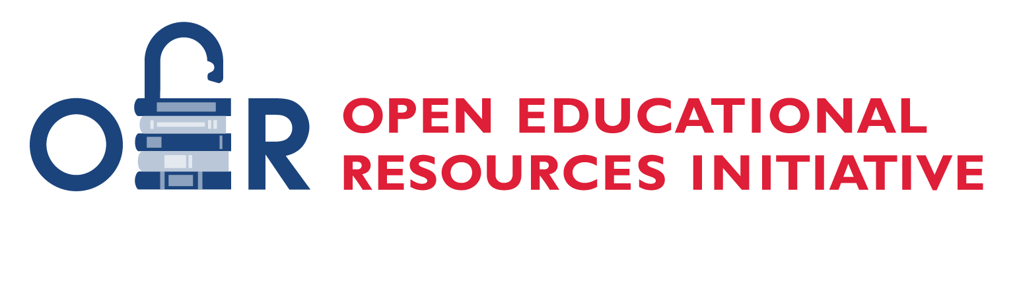

ASCCC OERI
Inclusion, Diversity, Equity, and Anti-Racism (IDEA) Framework and Implementation Guide
September 2023

This work is licensed under a Creative Commons Attribution 4.0 International License. Attribute this document as: “ASCCC OERI Inclusivity, Diversity, Equity, and Anti-Racism (IDEA) Framework Version 2 Draft, December 2022” by ASCCC Open Educational Resources Initiative is licensed under CC BY 4.0.

Table of Contents
Table of Contents 2
0.0 A Message for All Users 4
1.0 What is IDEA? 5
2.0 Background and Cultural Awareness - A Broad Overview of Why 5
3.0 Examining How We Know What We Know 7
4.0 ASCCC OERI Response and Resolutions 10
5.0 Guiding Principles for Improving Resources 11
6.0 Brief Introduction to the Framework 11
7.0 The IDEA Framework 13
7.1 Illustrations and Photos 13
Restorative Requirements 13
Elements for Consideration 13
7.2 Example Names 14
Restorative Requirements 14
Elements for Consideration 15
7.3 Gender-Inclusive Language and Use of Pronouns 15
Restorative Requirements 15
Elements for Consideration 15
7.4 Diverse Authors, Researchers, and Studies 16
Restorative Requirements 16
Elements for Consideration 16
7.5. Applications, Examples, and Problem Scenarios that Relate to Diverse Audiences 17
Restorative Requirements 17
Elements for Consideration 17
7.6 Appropriate Terminology 18
Restorative Requirements 18
Elements for Consideration 18
7.7 Keyword, Glossary, and Metadata Representation 19
Restorative Requirements 19
Elements for Consideration 19
7.8 Incorporating Diverse Perspectives on Issues, Events, and Concepts That Are Relevant to Underrepresented Groups 19
Restorative Requirements 19
Elements for Consideration 19
8.0 Deeper Dive Considerations and Additional Resources 20
Deeper Dive 20
Additional Resources 21
Illustrations and Photos (7.1) 21
Gender-Inclusive Language and Use of Pronouns (7.3) 21
Diverse Authors, Researchers, and Studies (7.4) 21
Open Access Journals (7.4) 21
Appropriate Terminology (7.6) 22
Other Helpful Resources 22
9.0 Implementation Guide & Goals 22
10.0 References 23
11.0 Attributions 23
Appendix A: Rubric 1 24
IDEA OER Assessment of Existing Materials 24
Appendix B: Rubric 2 27
IDEA OER Guide for New Materials 27

0.0 A Message for All Users
Thank you for your interest in the Academic Senate for California Community Colleges (ASCCC) Open Educational Resources Initiative (OERI) Inclusion, Diversity, Equity, and Anti-Racism (IDEA) Framework. We welcome your commitment to and engagement with this living document. If you’ve arrived at this document with the intent of using it and you do not need an overview of the reasons the IDEA Framework was created, please feel free to skip to page 13 to access the Framework. The Framework is preceded by a narrative that explains why it was developed, a preparation for the Framework which many users may not need.

This guide was created for faculty who want to ensure that their OER course materials reflect the IDEA principles. The purpose of this guide is to explains what the IDEA Framework is, why it’s important and how to use it to assess your openly-licensed materials. If you are using OER for your course, chances are you care about equity and access for students. That’s one important step but the work does not stop there. We also need to be critical of the materials we use and ensure that they reflect our equity and access goals.

It is important to note that accessibility is not identified as a distinct area of focus in the Framework as accessibility is a primary emphasis of the OERI. As a statewide initiative with a goal of interacting with faculty at all the California Community Colleges, we have made accessibility a priority, integrating it into all our professional development opportunities and striving to move accessibility forward across our system.

As this is a living document, we hope you will share any feedback you may have with us. We are interested in not only your responses related to the Framework, but also your experiences with using it and how we can make it better. To that end, we are exploring making it available in an interactive format. As we expand our applications and examples, it is likely that the utility of a static PDF will cease to serve our purposes.

A special thanks to the team that was convened in the summer of 2021 to create the IDEA Framework and the workgroup that was established in partnership with RIOS in the summer of 2022 to further refine the Framework and expand the availability of STEM-specific resources.
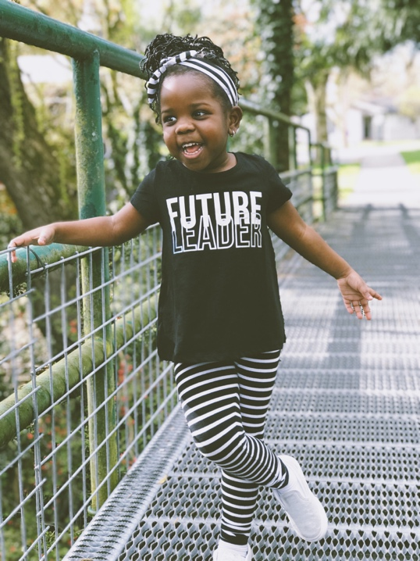
"International Business Day" by Kiana Bosman on Unsplash

1.0 What is IDEA?
This framework is shaped by the following principles: inclusion, diversity, equity, and anti-racism (IDEA). Here’s what we mean by these principles with regards to OER:

Inclusion: Intentional efforts to ensure students feel welcome, included, respected, and valued. Materials not only include the varied experiences of students but do so in a way that recognizes the value, legitimacy, and importance of those experiences.
Diversity: Materials are representative of the varied experiences of our diverse student body. This includes, but is not limited to, race and ethnicity, gender, class, ability, sexual orientation, country of origin and cultural affiliations.
Equity: A particular effort is made to address issues of access to and relevancy of course materials for historically marginalized groups.
Anti-racism: The materials do not attempt to be color-blind or culturally neutral since doing so perpetuates racial and ethnic inequities and white supremacy. These efforts reflect a focused effort on reducing racial and ethnic inequities and dismantling white supremacy.

2.0 Background and Cultural Awareness - A Broad Overview of Why
Teaching and learning are complicated endeavors, and many different theories can inform pedagogy. According to constructivism theory, students learn by constructing or building upon existing knowledge. Thus, prior knowledge influences how a student learns new information. In this approach, learning is active and recognizes that all knowledge is socially constructed. In addition, since learning occurs within the human mind, each student will have a distinct point of view based on the student’s own values and experiences. As a result, complex dynamics exist between culture, identity, context, and the learning experience.

For teaching to be effective and for learning to occur, faculty must be responsive to the experiences that students bring to the learning environment and adapt their pedagogy accordingly. Culturally responsive pedagogy acknowledges the cultural heritage of different ethnic and racial groups and bridges meaningfulness between the students’ lived experiences and the college classroom. It incorporates multicultural information and resources that are normative yet transformational. Culturally responsive pedagogy can not only teach students to know and praise their own cultural heritages and backgrounds but also to learn about, appreciate, and develop a respect for the heritages and backgrounds of others.

It is also important to provide socio-cultural context to material that may seem culturally neutral, especially if it is relevant to the experiences of marginalized communities. For example, a biology class may discuss the vast contributions of Dr. J. Marion Sims, known as the “father of gynecology”. What is often ignored is the methods used in his experiments to gain such knowledge. Sims performed his experiments on enslaved Black women, without their consent and without the use of anesthesia. To include the work of Dr. Sims without including how he was able to obtain such knowledge is to contribute to the erasure of black women and the long history of white supremacy that still lingers today.

According to Geneva Gay (2018), culturally responsive pedagogy, or culturally responsive teaching, has the following defining characteristics that support student learning and development (Figure 1).

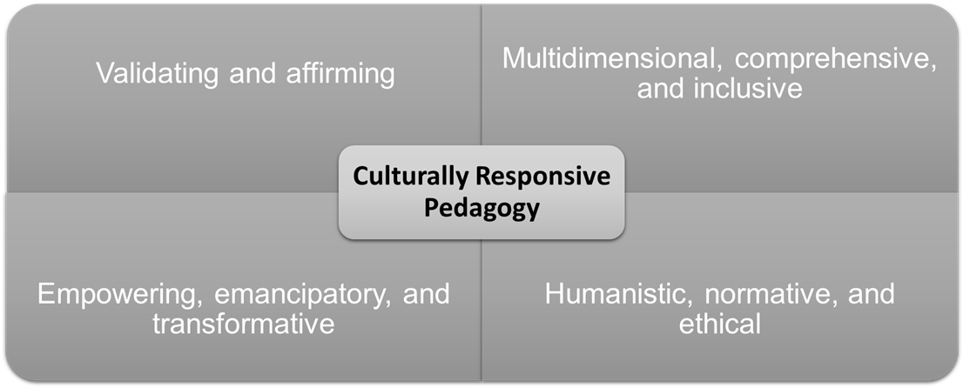
Figure 1. Characteristics of culturally responsive pedagogy.

According to Cohn and Mullenix (2007), the qualities of a diversity-rich curriculum can be further summarized into four areas:
- Includes other voices,
- Communicates interconnectedness,
- Values diversity and equity, and
- Promotes transformative thinking.
To support diversity and equity, faculty should include writings, speeches, dialogues, films, and other resources that originate from people of different social identities, cultural backgrounds, gender, and abilities in their curriculum. The inclusion of other voices has the power to not only validate and affirm students’ identities but also to expand students’ understanding of the lived experiences of others. By including diverse voices and perspectives, faculty help students understand and appreciate how they are connected to others although they may not share personal experiences, cultural, or geographic backgrounds. In addition, it signals that the students’ own diversity is welcomed in the learning environment.

When faculty incorporate diverse curriculum, they communicate to their students that equity, diversity, and inclusion are important values in a global society. As such, a diversity-rich curriculum has the power to support the critical thinking skills of students as they learn to question traditional views or assumptions. Furthermore, a diverse curriculum supports students as they develop new understandings and knowledge. These new perspectives can lead to transformational thinking, assisting students in becoming valued members of a diverse global society.

Of course, one must determine whether improving the qualitative experience of all students results in improvements in students’ learning. In a comprehensive analysis of the impact of ethnic studies curricula at all educational levels, Sleeter (2011) found that:
research on ethnic studies curricula designed for diverse student groups that include White students reports that just infusing representation of racially and ethnically diverse people into curriculum without doing anything else makes only a marginal impact on students’ attitudes, in contrast with curricula that teach directly about racism. The large body of research in higher education that examines the impact of various diversity experiences—particularly course-taking and interracial interaction—on “democracy outcomes” reports quite consistently that such courses have a positive impact, particularly when they include cross-group interaction and particularly on White students. Research on the academic impact of ethnic studies curricula designed for diverse student groups, while not voluminous, shows that such curricula, when designed to help students grapple with multiple perspectives, produces higher levels of thinking (19).

In sum, the transformative nature of a culturally responsive pedagogy not only improves learning, but it also creates an environment for all students to develop a wellspring of knowledge, an openness to diverse experiences, and the critical thinking skills so important for society and democracy.

3.0 Examining How We Know What We Know
Across time and space, our knowledges, lands, bodies, genders, sexualities, cultures and memories have been capitalized, appropriated and commodified by micro and macrosystems of power, regulating the very lives we live. What is claimed as “history” — in our everyday language and in institutions of power — is actually a mono-cultural, Western, “upper” Caste, white, male, straight and binary version of human experience. The tellers of history are those who have always had the powers to speak. (Aruna et al. 1:22)
Knowledge and information must have a source, and the recipient does not receive them passively; rather, recipients add new knowledge to what they already know, interpreting and determining its veracity and relevance based on its source. If academic knowledge is almost exclusively provided by authors who share an origin, perspective, or history, we must ask how we can be assured that our knowledge has not been filtered through a specific lens.

Malina Thiede, open educational resources (OER) librarian at State University of New York Plattsburgh, conducted an analysis of authors for commercial and OER textbooks. Just like commercial textbooks, OER are mostly written by faculty. Thiede’s research (2021) questions included the following:

- Does the population of textbook authors—commercial and OER—reflect the composition of the professoriate at large?
- At what point in a faculty’s career is that person most likely to be an author of a textbook?
- How does the population of textbook authors compare to the students who use them?
The questions posed are crucial when one is critically analyzing the authorial representations of openly-licensed resources. Using OASIS (Openly Available Sources Integrated Search; https://oasis.geneseo.edu/index.php), Thiede collected data on over 400 OER textbook authors and examined data from over 250 commercial textbook authors from four main publishers: Cengage, MacMillan, McGraw Hill, and Pearson. The study disaggregated the textbook author data by gender, race, and rank or role. In addition, the textbook authors’ institutions were categorized using the Carnegie Classification (https://carnegieclassifications.iu.edu/). It should be noted that race determinations were made using photos, surnames, and biographical data.

Thiede’s analysis revealed that most authors of commercial textbooks are white male professors from R1 and R2 research universities, or “Very High Research Activity” and “High Research Activity” respectively. Although an increase was shown in the percentage of women authors of OER textbooks (almost 50% of OER authors were female as compared to approximately 34% of commercial authors), the results obtained regarding race, rank or role, and Carnegie Classification were similar to commercial textbook authors. Thus, as is the case with commercial texts, most authors of OER textbooks are white professors from research universities. It should be noted, however, that OER authors are more likely to be from public institutions as compared to commercial authors.

Table 1: Who writes traditional textbooks? Who writes OERs? Data Summary (Thiede, 2021)
Author Characteristic (*percent of professorate) | Commercial Texts | OER Texts
Female (46) | 33.9% | 49.6%
White (~75) | 96.1% | 89.6%
Black (6) | 0% | 2.9%
Asian (12) | 2.2% | 5.8%
Latinx (6) | 1.1% | 0.6%
*The National Center for Educational Statistics (NCES) (2020)

Given the disparities in authorship and representation, faculty should consider how to contribute to the transformation and expansion of open access resources to truly address diversity, equity, and inclusion. Sarah Lambert (2018) ​​provides a framework for this transition. Lambert identifies and expands on three principles of social justice that may be applied to OER: redistributive justice, recognitive justice, and representational justices.

Lambert notes that providing free textbooks to learners of color in the American two-year college system is redistributive justice in action. It reduces the costs and increases the chances of success for learners who “by circumstance have less” (Lambert, 2018; p. 227)—i.e., they are marginalized in education, workplaces and more broadly in society. In her article, Lambert asks how “open” the textbook is for marginalized learners if indigenous, Hispanic, and learners of color are invisible inside the textbook and perhaps invisible in the whole curriculum. She notes that making edits to include images and cases featuring more diverse communities, businesses, and people will be an act of recognitive justice. Lambert goes on to ask additional questions, including what the implications are if the textbook features people of color, but does not value their perspectives, knowledge, or histories and what happens if the textbook takes a white colonial view of black lives or if black stories are told solely by white voices. Lambert argues that the development or selection of a new version of a textbook, or perhaps a new resource altogether, written by people of color where they are free to represent their own views, histories, and knowledges would be an act of representational justice, giving voice to those who are often not heard. The table below summarizes these three principles in the context of open education.

Table 2: Three Principles of Social Justice Applied to Open Education
Social Justice Principle | Open Education Example
Redistributive Justice | Free educational resources, textbooks, or courses to learners who by circumstance of socio-cultural position cannot afford them, particularly learners who could be excluded from education or be more likely to fail due to lack of access to learning materials.
Recognitive Justice | Socio-cultural diversity in the open curriculum. Inclusion of images, case studies, and knowledge of women, first nations people, and whomever is marginalized in any national, regional, or learning context. Recognition of diverse views and experiences as legitimate within open assignments and feedback.
Representational Justice | Self-determination of marginalized people and groups to speak for themselves and not have their stories told by others. Co-construction of OER texts and resources about learners of color by learners of color, about women’s experiences by women, about gay experiences by gay identifying people. Facilitation to ensure quiet and minority views have equal air-time in open online discussions.

Adapted from “Changing our (Dis)Course: A Distinctive Social Justice Aligned Definition of Open Education” by Sarah Roslyn Lambert under a Creative Commons Attribution-ShareAlike 4.0 International License (CC-BY-SA 4.0).

Using OER is an essential, important effort towards achieving social justice in education. However, our efforts cannot start and stop there. Faculty should consider the ways in which OER have or have not broken-down barriers and the existing power structures. As one reviews and adopts OER, one should consider whose voices are centered and whose knowledge is traditionally considered reliable. Providing faculty with the tools to do so is the central goal of this guide.

4.0 ASCCC OERI Response and Resolutions
To support faculty as they implement a culturally responsive and anti-racist pedagogy, the Academic Senate for California Community Colleges Open Educational Resources Initiative (ASCCC OERI), in response to Resolution 09.05 adopted in Spring 2021 (Developing an Anti-Racism, Diversity, Equity, and Inclusion Curriculum Audit Process; https://www.asccc.org/resolutions/developing-anti-racism-diversity-equity-and-inclusion-curriculum-audit-process), was tasked with the development of the following:
- an audit process and review framework to evaluate existing open educational resources to ensure that ASCCC OERI-supported open educational resources are inclusive, diverse, equitable, and anti-racist (IDEA).
- a curriculum audit process and review framework to assess instructional materials for equity, inclusiveness, diversity, and anti- racism and make the process and framework available for local consideration, modification, and implementation.
In the interest of addressing this resolution in a timely manner, the ASCCC OERI formed a work group in the summer of 2021 to develop a draft process that could inform new OER projects and address the other interests outlined in the resolution.
During its first meeting, the workgroup acknowledged that the proposed document would likely be one of many IDEA-related resources the ASCCC might pursue. Companion resources would likely include an IDEA framework for discipline texts, syllabi, student projects and assignments, and teaching practices. Additionally, the workgroup concluded that the Framework must be dynamic and, as such, recommended that an iterative process for review and improvement also be developed.
In the summer of 2022, a second workgroup was formed in partnership with the Institute for a Racially Just, Inclusive, and Open STEM Education (RIOS Institute), the ASCCC OERI recruited faculty, from the California Community Colleges and beyond, to participate in a short-term project to improve the IDEA Framework.

In the summer of 2023, an OERI IDEA faculty lead was hired to continue improving the IDEA Framework and take the next step towards implementation. The implementation guide was added to this document. The lead also created trainings for faculty members who are seeking additional assistance with application and assessment.
The Framework is intended to be applicable to all disciplines and accessible to all faculty. While the goal is to facilitate an in-depth and comprehensive analysis of resources, elements that are more superficial in nature were included to provide explicit approaches to improving resources. The ASCCC OERI hopes that the Framework will encourage faculty to not only address issues of inequity in academia but also promote a transformative reconsideration of how we know what we know and how education has been shaped by those who have been historically recognized as the experts.

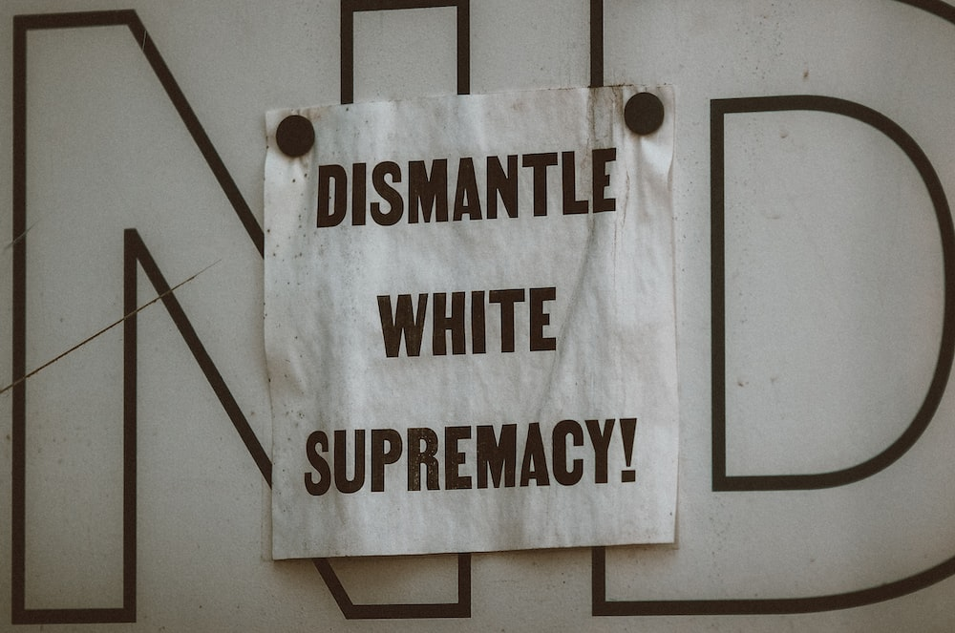
Photo by Jon Tyson on Unsplash

5.0 Guiding Principles for Improving Resources
The following are principles to guide the collective efforts of faculty to not only improve existing but also create new educational resources that reflect the diversity of student perspectives and experiences:
- Design and present resources always with students in mind.
- Ensure content supports students and provides space for, and valuing of, their contribution to collective learning and knowledge.
- Strive for meaningful inclusion of diverse populations to ensure that their perspectives and their experiences are reflected and valued.
- Develop resources that contribute to a learning environment that facilitates student learning and growth.
- Support students as they examine society as a system and the role that they play in perpetuating or changing the system.
- Facilitate students’ ability to challenge their own knowledge and opinions, process any discomfort, and, if warranted, choose to change.
- Assist students in understanding how information is created, validated, and disseminated, including their role in the process, and how to critically examine evidence and responsibly share information.

6.0 Brief Introduction to the Framework
The Framework is designed to be a practical starting point for creating new OER and assessing and editing existing OER for IDEA. However, before attempting a textbook revision through the lens of IDEA, one must have some understanding of what should be revised. Although the Framework will, to a certain extent, provide areas to consider and evaluate, one would ideally have a background in the concepts of IDEA. This document seeks to explain some of the background concepts, but additional participation in training on equity, cultural awareness, inclusion, and anti-racism is useful. As a place to start, or for further in-depth resources on various aspects of the Framework, the “Deeper Dive Considerations and Further Resources Section” at the end of this document should be helpful.

Each section of the Framework specifies a broad category to assess different elements, e.g., illustrations and photos, example names, appropriate terminology, etc. Each section is then broken into two components: “restorative requirements” and “elements for consideration.” Some sections cover sensitive content. Since the aim is to restore and include voices that have been excluded and marginalized, elements and explanations have been included to hopefully reduce misunderstandings and signal positive intent. For each section, the goal is to meet the “restorative requirements.” The “elements for consideration” component offers areas to assess, tips, and examples that will help meet the requirements.

It’s important to be cognizant of your own cultural assumptions when reviewing a resource. Consider how your age, upbringing, ethnicity, education, and experiences have shaped the way you view the world and how you think. Ensure examples do not presume knowledge that might be culture dependent. Specific sports, foods, and holidays, for example, might not be known to all students.

The following are a few ways to approach using the Framework:
- If addressing all the sections of the Framework seems overwhelming, start small. For example, a relatively easy and impactful way to change a resource is to review the images and, when appropriate, replace images with more inclusive images.
- Choose an OER commonly used for a specific course and work through the Framework to see what changes need to be made.
- Assess a resource by looking at it through a discipline-specific lens.
- Create a group of people from across your college or district with knowledge of IDEA to assess a work using the Framework.
As more people engage with the Framework, ideas and examples on how to use it will be added or linked to this document. Hopefully, familiarity with and use of the Framework will facilitate thoughtful reflections and, consequently, revisions.

Consider the excerpt below from a biology text and how it could be revised to be more consistent with IDEA principles.
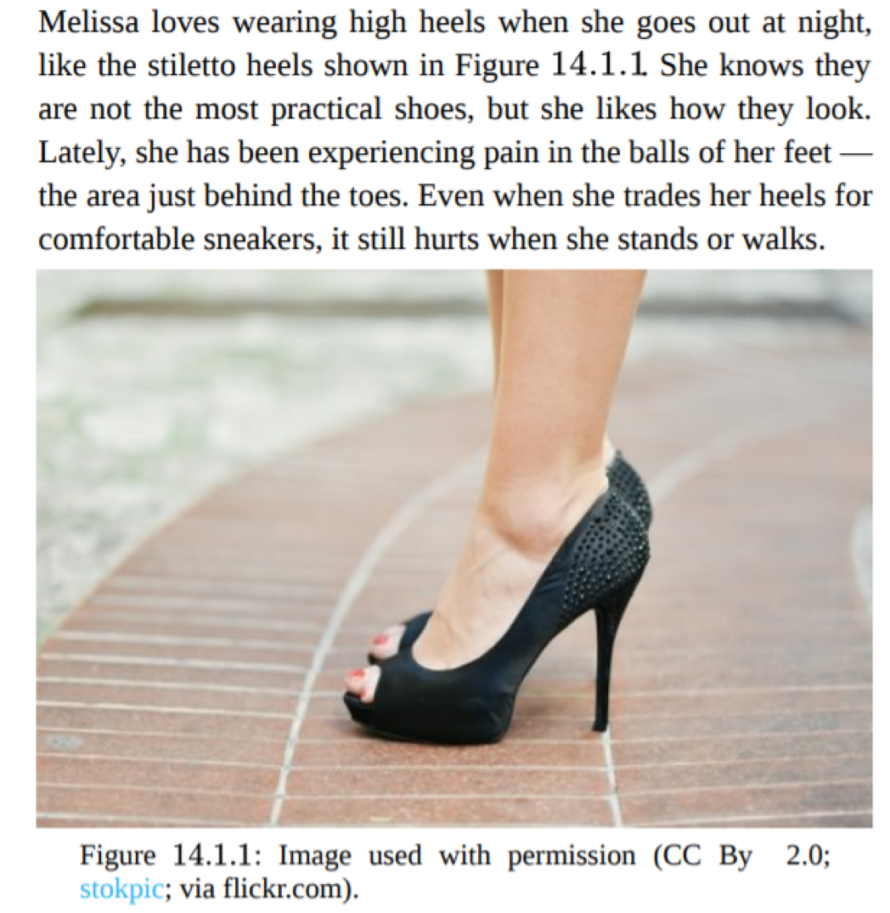

7.0 The IDEA Framework

7.1 Illustrations and Photos

Restorative Requirements
When illustrations and photos are reflective of diverse populations, students can see themselves, or people like them, in the learning materials. At the same time, visuals should not serve to perpetuate stereotypes. When images of people are not a typical element of the resources for a discipline (such as math or physics), consider incorporating images to humanize the content.

Elements for Consideration
- Examine the number of images and illustrations and the individuals and populations represented therein. Ensure that all populations are equitably represented throughout the resource.
- Analyze the role, depiction, connotation, expressions of authority, and purpose of the people represented in the image. Ensure that images do not perpetuate stereotypes. Examine the background or setting of the image to assess whether it depicts anything that may be perceived as negative.
- Consider diversity on a section or chapter level and in the work as a whole. Although it is impossible to represent every population in every illustration or photo, the resource should include a diversity of images and illustrations.
- Include images of people where the context of the image does not relate to their identity. For example, show differently abled people drinking beer in a section of a biology text discussing carbohydrates or an image of parents with their child who has Down syndrome in the context of a general discussion of parenting or family.

Photo by Elevate on Unsplash

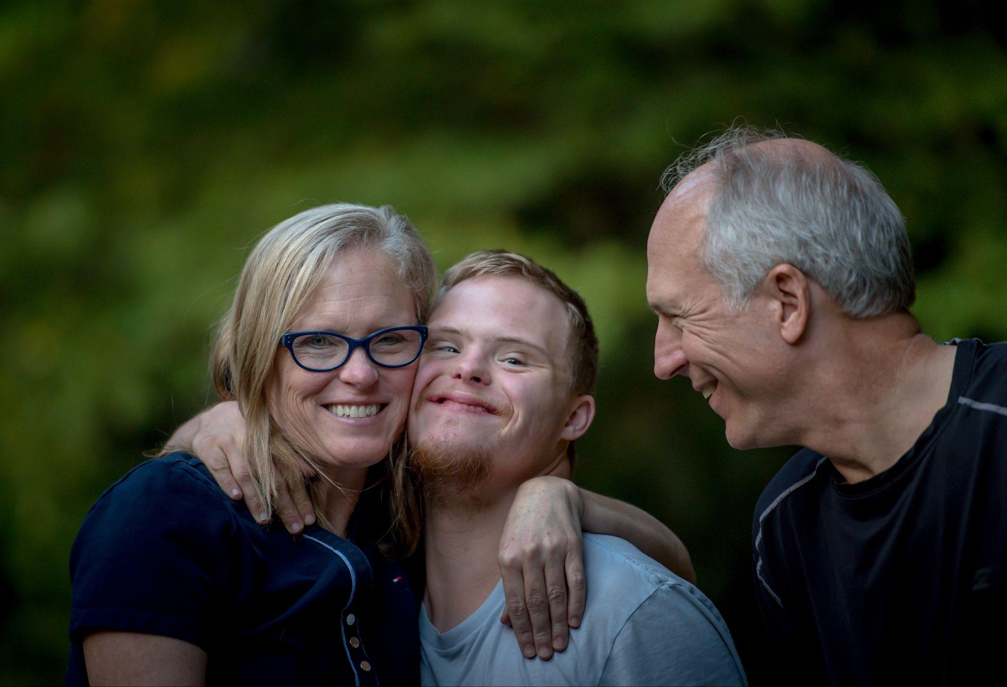
Photo by Nathan Anderson on Unsplash

7.2 Example Names

Restorative Requirements
Names of people are often needed for examples, exercises, and scenarios, and they should represent various countries of origin, ethnicities, genders, and races and be properly portrayed. At the same time, negative comparisons or stereotypes associated with particular names and national origins or ethnicities should be avoided.

Elements for Consideration
- Consider the diversity and overall representation on a quantitative and qualitative basis.
- Determine whether names indicative of a particular race, ethnicity, or national origin are associated with stereotypes or negative concepts.
- Seek other opinions, including those of students, when necessary.
- Seek out name pronunciations, if in doubt, when recording video presentations or lectures.
- Use a source such as Baby Name Finder that allows you to explore popular names from around the globe when looking for names to incorporate into your work.

7.3 Gender-Inclusive Language and Use of Pronouns

Restorative Requirements
Gender inclusivity is important because all students should be able to see themselves represented. Gender inclusive language can refer to the use of gender-neutral pronouns or language that intentionally dispels gender stereotypes.

Elements for Consideration
- Pay attention to connotations and make sure that gender stereotypes are not perpetuated. If in doubt, ask for another opinion.
- Use pronouns clearly. If using traditionally plural pronouns (such as them or they) confuses the context, change the wording to reflect the situation clearly.
- Explicitly state what pronouns an individual uses, if appropriate.
- Consider reducing the use of pronouns and rewriting sentences to eliminate pronouns.
- Avoid making assumptions about an individual’s gender.

Example for 7.1 - 7.3
The photo and description that follow are found in the textbook Human Biology. The modified image and description are the result of applying elements 6.1, 6.2, and 6.3 to the image introduced in section 5. The example uses different skin tones, them or their pronouns, and a name common in several different cultures. In addition, the earlier image linked the decision to wear impractical clothing to one gender. An alternative approach to modifying the narrative would be to remove pronouns entirely, avoiding the use of gendered pronouns. While the need to explain the pronouns employed adds a level of complexity to the narrative that may feel forced, it also demonstrates a respect and openness to the use of gender-neutral pronouns.

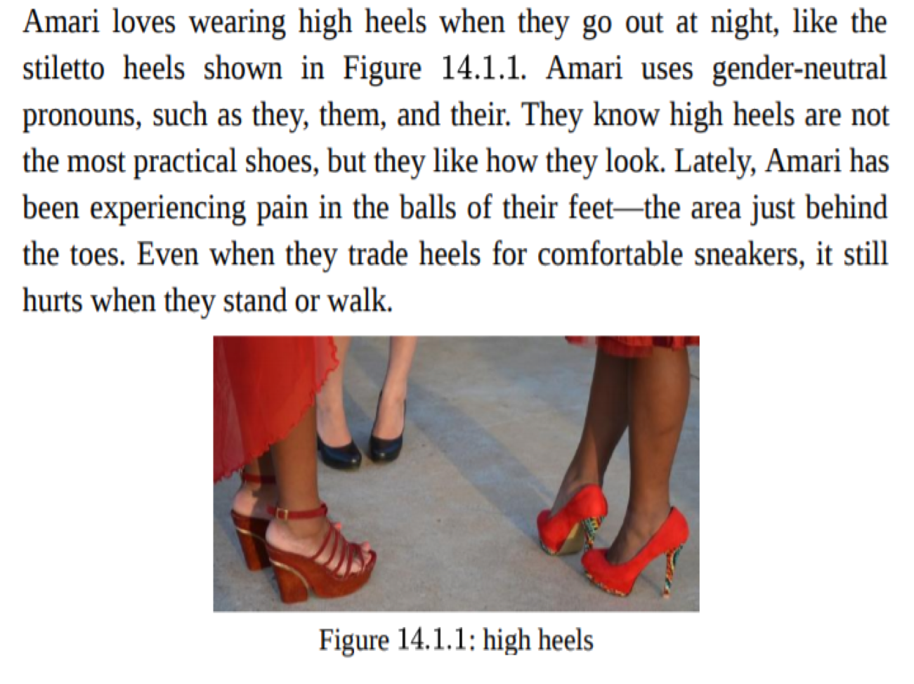
Heels by Agnali via Pixaby.com; pixabay license

7.4 Diverse Authors, Researchers, and Studies

Restorative Requirements
Referencing discipline contributors—e.g., researchers, scholars, academics—with backgrounds like those of students both validates and affirms the students as student-scholars and invites them into the academic conversation. Recognize that all people carry around biases that affect what they include and exclude. Counteract these biases by actively seeking out achievements and discipline contributions from all cultures and countries. Note that diversity may not be perceptible in some of the references. Consider the use of open-source articles and diversify research by using diverse resources.

Elements for Consideration
- Examine the diversity of included contributors in the discipline. If diversity is lacking, seek diversity in the contributions mentioned.
- If the contributions are dominated by cis-hetero white men, discuss this with the class and include some the historical and structural explanations for the lack of diversity.
- Include current, more diverse contributors when possible and relevant where historical contributors are not diverse. Keep in mind that your goal is to ensure the inclusion of forgotten perspectives.
- Avoid isolating diverse contributors to specific sections, e.g., “multicultural impacts on psychology.”
- Include examples of and references to historically underrepresented groups, such as Arabic contributors to mathematics and astronomy.
- Seek out specific efforts and programs to drive inclusive citation.
- If less formal, in-text mentions of specific researchers or studies are included, these references should be as diverse as possible.

7.5. Applications, Examples, and Problem Scenarios that Relate to Diverse Audiences

Restorative Requirements
When using real-world examples, one should include diverse and relatable examples for students and avoid stereotypes. This should be done on a chapter or section basis in the resource as well as holistically. Examples that rely on cultural knowledge will not be understandable by everyone and should be appropriately explained.

Elements for Consideration
- Review, and potentially have students review, problems and exercises, giving special consideration to their context and inclusivity.
- Analyze terminology, contexts, and situations presented in problems and applications to ensure that they are comprehensible by all populations.
- Write and use examples that include diverse people, organizations, geographies, and situations.
- Avoid negative stereotypes or sensitive subjects in problems and applications unless the subject matter demands it.
- For example, a section on mental health may require statistics on suicide rates, but a math textbook can likely employ an example that does not rely on such sensitive material.
- Be mindful when creating exercises that require specific knowledge, context, or frame of reference.
- Examine and adjust assumptions and expectations about prior knowledge, especially regarding knowledge from different subjects or cultural contexts. For example, in a history course, do not assume that everyone has read The Red Badge of Courage or has seen Saving Private Ryan; in an astronomy course, do not assume students have cooked when discussing heating or cooling. Even very common cultural elements such as Harry Potter, Disney, or popular game shows are not universal. An example that is inclusive and informative and requires no previous knowledge can be found in the open Human Biology textbook section on “Fighting Phytochemicals.”

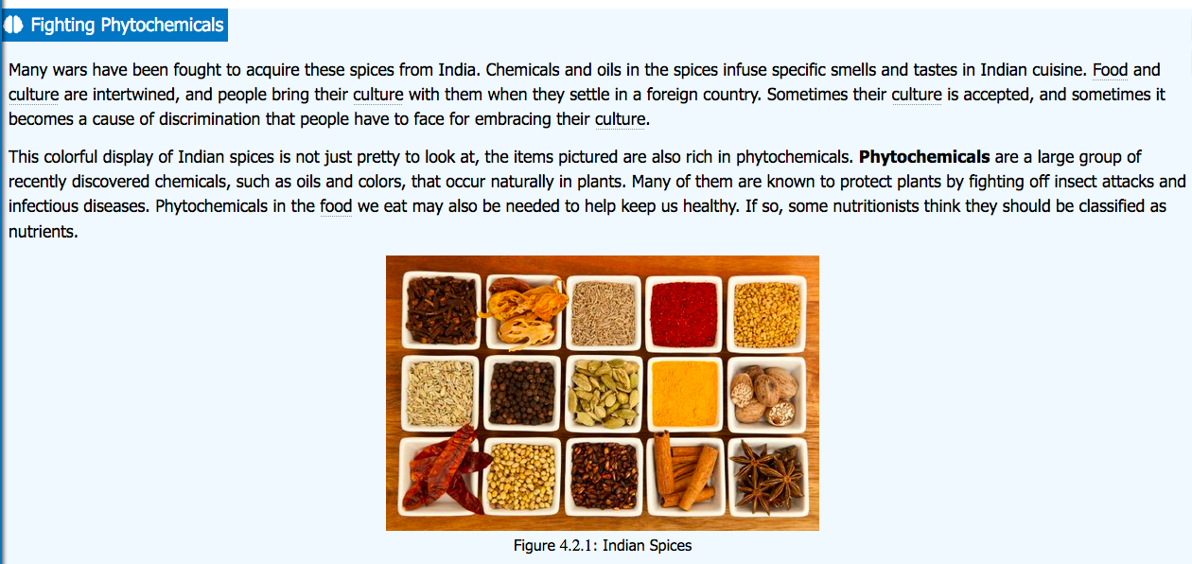

7.6 Appropriate Terminology

Restorative Requirements
References to people, groups, populations, categories, conditions, and disabilities should use appropriate verbiage and not contain derogatory, colloquial, inappropriate, or otherwise incorrect language. For historical uses that must remain in place, consider adding context, such as “a widely-used term at the time.” While “slave” was once commonly used to refer to African Americans who were enslaved and individuals who had schizophrenia were referred to as “schizophrenics”, today we strive to not use terminology that reduces a person to something that was done to them - and language that reflects their status as property - or a medical condition which they are living with. Ensure that quotations or paraphrases using outdated terms are attributed, contextualized, and limited. As language is not static, it is important to keep in mind that what terms are deemed “acceptable” is ever-changing. The need to begin referring to yesterday’s “master” bedroom” as today’s “primary” bedroom” or “foreign” languages as “world” languages may seem understandable and obvious today but was not commonly challenged historically.

Elements for Consideration
- Identify any outmoded or incorrect terminology and replace or reframe the terminology.
- Insert context, attribution, or quotations for historical references as needed.
- Identify and use the best terminology at the time. As noted, terminology changes regularly and acceptability is not universal. Consult style guides as necessary; note they may conflict. Do not feel obligated to use the latest term if it is not widely used or is controversial.
- Define outmoded terminology in historical situations—e.g., court cases, laws, or articles—using quotations or annotated with contextual information. For example, the use of “illegal alien” in a discussion of law can be framed as “as stated in the decision” or something similar.
- Avoid ableist language. Language that is offensive to people with disabilities is ableist. This includes using words like “psycho,” and “crazy” or phrases like “blind spot” or “falling on deaf ears”. This type of language is almost always expressing contempt for having a disability.
- Avoid idioms or colloquialisms that may lead to misconceptions among those who natively speak other languages or who may not have the educational or cultural context to understand them. While “hitting the books” and “break a leg” may have clear meanings to most speakers of English raised in the United States, those meanings are not universal and a literal interpretation of such phrases could create not only confusion, but fear of bodily harm. Clarify the context and use of common idioms or colloquialisms when they appear so that students may understand them better. Alternatively, consider limiting or eliminating the use of idioms.

7.7 Keyword, Glossary, and Metadata Representation

Restorative Requirements
Keywords and glossary terms signal high priority to students, and, as such, one should ensure that diverse topics and terms are appropriately represented in these sections.

Elements for Consideration
- Analyze keyword lists and glossaries and identify core terms that are not represented or highlighted.
- Assess whether software is negatively impacting the resource’s index. Book indexes are usually not fully representative of book content; they are often built by software, and search capabilities change their priority and comprehensiveness.
- Consider alternative phrasings and terminology to reduce misunderstanding.
- Add keywords that specifically highlight issues important to underrepresented group

7.8 Incorporating Diverse Perspectives on Issues, Events, and Concepts That Are Relevant to Underrepresented Groups

Restorative Requirements
Diverse populations experience issues such as social problems, health, politics, business practices, and economic conditions that may differ from the mainstream. Purposefully incorporating perspectives from populations that are commonly not included allows for how – and why – perspectives may vary to be examined.

Elements for Consideration
- Include diverse perspectives when presenting controversies, arguments, and opinions for each topic or concept covered. A variety of perspectives will expose students to different points of view and widen the context. Do not avoid the inclusion of a perspective due to the discomfort it might create.
- Do not stigmatize individuals having a specific condition, occupation, experience, or background.
- Be aware that certain controversial topics, when necessary to include, should be described in an academic manner that recognizes the existing controversy and provides an analysis of the relevant facts or data.
- If a discipline has accepted a specific position on a topic—e.g., climate change, sexual orientation being partially determined biologically—describe that position. Consider alternative points of view in relation to the discipline adopted position and explain rationale for the position.
- If a sociopolitical issue without a consensus must be described—e.g., campus carry, voting rights—include a balanced viewpoint by providing differing perspectives on the issue.
- Avoid characterizations that lead to generalization, such as “rural communities tend to support gun rights.” If a generalization must be stated, provide a reference to support that generalization and additional context for understanding. Also, include any counterpoints from within that generalization.

8.0 Deeper Dive Considerations and Additional Resources

Deeper Dive
As faculty continue to consider how to best improve their instructional resources, the following questions are designed to support their efforts. Discipline specific questions may arise as faculty continue to make improvements. The following list is a work in progress and will be expanded upon soon.

For all courses:
- Where can you include a more diverse and underrepresented voice in a meaningful way?
- Are the underrepresented groups from an intersectional lens or portrayed as a monolith?
- Who has a stake in the issues or content being discussed? Are they present?
- Are there other voices that have a place in the conversation beyond the usual?
- Will these new voices play a significant role in what will be included or assessed?
- Where are the biases and how do we counteract?
For humanities, literature, and world language courses:
- Are there other classics that have a place in your course alongside period pieces or perspectives?
- Is there a classic from a BIPOC (Black, Indigenous, and People of Color) voice that incorporates your learning goals?
- What essential context needs to be given to elements of the canon or must-covers?
For courses in the social sciences:
- Do histories include perspectives of multiple peoples?
- Are political perspectives and positions inclusive of multiple parties?
For science, technology, engineering, and mathematics courses:
- Referencing theory and concepts by the scientist’s or theorist’s name elevates the person over the concept. When appropriate, shift attention to the concept by using descriptions that signify the reason the concept is important. For example, Boyle’s Law for gases could be referred to as the Pressure-Volume Law.

Additional Resources
Because faculty may not be familiar with every aspect of IDEA or the Framework, a list of helpful resources has been included. Some resources offer a deeper dive into various aspects of IDEA. Many of the resources can help with specific sections of the Framework. The list below is curated and is not meant to be comprehensive.

Illustrations and Photos (7.1)
- Image Resources for Inclusive Representation
- Sources of stock photos featuring people of color
- Sources of free LGBTQ stock photos
- List of diverse and free stock photo sites

Gender-Inclusive Language and Use of Pronouns (7.3)
- GLSEN Pronoun Guide
- Alternatives to Gendered Nouns
- GLSEN Gender Terminology Guide
- Gender-Inclusive Biology - Curriculum Ideas

Diverse Authors, Researchers, and Studies (7.4)
- 500 Queer Scientists
- Cite Black Women
- Scientist Spotlights Initiative
- How To Infuse Diversity & Inclusion into Your Curriculum

Open Access Journals (7.4)
- Directory of Open Access Journals
- JSTOR Open Access Journals
- Oxford Academic Open Access Journals

Appropriate Terminology (7.6)
- Disability Language Style Guide
- Diversity/Inclusivity Style Guide (CSU)
- The Diversity Style Guide
- GLAAD Media Reference Guide
- Key Equity Terms and Concepts
- National Association of Black Journalists Style Guide
- Racial Equity Tools Glossary
- Religion Stylebook
- Style Guide: Reporting on Mental Health

Other Helpful Resources
- Introduction to Women’s Studies Textbook
- Introduction to Women, Gender, Sexuality Studies

9.0 Implementation Guide & Goals
So, what do we do with all the information you just learned? Implement it of course! In the appendix you will find two rubrics: Rubric 1 (Appendix A) is for assessing existing OER and Rubric 2 (Appendix B) is a tool you can use if you are creating your own OER. Each rubric includes the broad categories described in the framework (e.g., illustrations and photos, example names, and appropriate terminology) and three assessment categories: exclusive, emerging inclusive, and inclusive. Be sure to familiarize yourself with the broad categories before assessing your materials.

The assessment categories are based on one of the central principles of anti-racism which asserts that something/one is either racist or anti-racist, exclusive or inclusive. If the material is not explicitly inclusive, it is perpetuating racist ideology and contributing to racist outcomes. Some materials may be approaching inclusivity and so an “emerging inclusivity” category is also included.

The percentages you’ll find on both rubrics are based on data obtained from the California Community College Chancellor’s Office (Data Mart, Fall 2022). 77% of the students enrolled in a California Community are BIPOC and this is what informs the standards. Of course, faculty can adjust the standard to reflect BIPOC percentages by district or college. BIPOC is a term that refers to Black, Indigenous and People of Color. This term was created to promote the visibility of Black and Indigenous people, who often experience more extreme forms of oppression and the worst consequences of white supremacy and settler colonialism.

What’s the goal here? In a perfect world all textbooks would meet the inclusivity goal for all categories. But, alas, that is not the world we live in. It will be more difficult to achieve inclusivity for some categories compared to others. For example, there are many resources (also included in this guide) for inclusive illustrations and photos. However, if there are structural barriers that have restricted BIPOC from participating in a particular discipline, it will be more difficult to achieve inclusivity in terms of diverse authors and researchers. So, while “inclusivity” is the goal, sometimes “emerging inclusivity” is the obtainable goal.

Remember that you are not alone in these efforts! The ASCCC has workshops and an online community built around this work. Join the ASCCC OERI Canvas space to stay up to date on the OERI’s efforts and connect with colleagues. If you encounter issues with enrollment, please contact the OERI (oeri@asccc.org). There you’ll find a space to discuss and share your assessments as well as announcements about the latest trainings. Before you complete your own assessment, check our repository to see if your material has already been assessed. We welcome multiple assessments of the same materials, but you may find that unnecessary based on what’s already been done.

10.0 References
Aruna, Sanghapali, et al. Decolonizing Our Stories and Knowledges, part 1, 2018, https://whoseknowledge.org/new-resource-our-stories-our-knowledges/.
ASCCC. Anti-Racism Education in California Community Colleges. ASCCC, 2020.
Bouterse, Siko. “Whose Knowledge is Reliable?” OpenCon 2017. YouTube. Uploaded by The Right to Research Coalition, 29 November 2017, https://youtu.be/F0EU7YsibGI.

California Community Colleges Chancellor’s Office. (2022). Annual/Term Student Count Report Fall 2022. Data Mart. Retrieved September 15, 2023, from https://datamart.cccco.edu/Students/Student_Headcount_Term_Annual.aspx

Gay, Geneva. Culturally Responsive Teaching: Theory, Research, and Practice. 3rd ed. Multicultural Education Series, Teachers College Press, 2018.

Lambert, Sara Roslyn. “Changing Our (Dis)Course: A Distinctive Social Justice Aligned Definition of Open Education”. Journal of Learning for Development , Vol. 5, no. 3, Nov. 2018, pp. 225-244, https://jl4d.org/index.php/ejl4d/article/view/290.

Mullennix, John W., et al. Diversity Across the Curriculum: A Guide for Faculty in Higher Education. 1st ed., Anker Pub. Co., 2007.

Sleeter, Christine E. The Academic and Social Value of Ethnic Studies: A Research Review. National Education Association Research Department, 1 Jan. 2011.

Thiede, Malina. Who Writes Traditional Textbooks? Who Writes OERs? An examination. Vision for the Future: Open and Accessible, Eastern New York ACRL Chapter Conference, May 19, 2021. Virtual event. Poster presentation.

Tuck, Eve, and K. Wayne Yang. "Decolonization is not a metaphor." Decolonization: Indigeneity, Education & Society, vol. 1 no. 1. 2012, pp. 1-40, https://jps.library.utoronto.ca/index.php/des/article/view/18630.

11.0 Attributions
Section 6, is adapted from The Framework for Reviewing Equity, Diversity, and Inclusion in Open Educational Resources by Rachel Arteaga and Mandeep Grewal, licensed under a Creative Commons International Attribution 4.0 License. It is adapted from Improving Representation and Diversity in OER Materials (OpenStax, 2019), licensed under a Creative Commons International Attribution 4.0 License.

Appendix A: Rubric 1

IDEA OER Assessment of Existing Materials

Textbook/Publisher/Edition:
Chapter/Assignment:
Assessor Name/Title/School:

Use this rubric to assess existing openly-licensed materials . Refer to the IDEA Framework & Implementation Guide for further completion instructions and explanation of each category. Complete an assessment for each chapter, appendix, etc. of the textbook.

Category | Exclusive | Emerging Inclusive | Inclusive
Illustrations and Photos  ☐ Does not apply | ☐ Less than 30% of photos and illustrations include BIPOC | ☐ 30-70% of photos and illustrations include BIPOC | ☐ More than 70% of photos and illustrations include BIPOC
Example Names  ☐ Does not apply | ☐ Less than 30% of names reflect BIPOC culture | ☐ 30-70% of names reflect BIPOC culture | ☐ More than 70% of names reflect BIPOC culture
Gender Inclusive Language and Use of Pronouns  ☐ Does not apply | ☐ Many examples of language that is not gender inclusive and inappropriate use of pronouns. Include examples in notes | ☐ Some examples of language that is not gender inclusive and inappropriate use of pronouns. Include examples in notes | ☐ Very few to no examples of language that is not gender inclusive and inappropriate use of pronouns. Include examples in notes
Diverse Authors, Researchers, and Studies  ☐ Does not apply | ☐ Very few to no examples of diverse authors and researchers with few to no studies related to BIPOC | ☐ Some examples of diverse authors and researchers with some studies related to BIPOC | ☐ Many examples of diverse authors and researchers with many studies related to BIPOC
Applications, Examples, and Problem Scenarios  ☐ Does not apply | ☐ Very few to no examples of applications, examples and scenarios reflect BIPOC culture | ☐ Some examples of applications, examples and scenarios reflect BIPOC culture | ☐ Many examples of applications, examples and scenarios reflect BIPOC culture
Appropriate Terminology  ☐ Does not apply | ☐ Many examples of terminology that is derogatory/ inappropriate. Include examples in notes | ☐ Some examples of terminology that is derogatory/inappropriate. Include examples in notes | ☐ Very few to no examples of terminology that is derogatory/inappropriate. Include examples in notes
Keyword, Glossary and Metadata Representation  ☐ Does not apply | ☐ Very few to no examples of keywords or glossary terms reflect diverse topics and/or folks | ☐ Some examples of keywords or glossary terms reflect diverse topics and/or folks | ☐ Many examples of keywords or glossary terms reflect diverse topics and/or folks
Incorporating Diverse Perspectives  ☐ Does not apply | ☐ Use of 0 diverse perspectives relevant to underrepresented groups | ☐ Use of 1 diverse perspective relevant to underrepresented groups | ☐ Use of 2 or more diverse perspectives relevant to underrepresented groups

Use the sections below to keep notes on important pages or other observations throughout the textbook. For example, you can note where inappropriate terminology occurs, examples of non-inclusive gendered language or a good opportunity to incorporate a diverse perspective.

Illustrations and Photos:

Example Names:

Gender-Inclusive Language and Use of Pronouns:

Diverse Authors, Researchers, and Studies:

Applications, Examples, and Problem Scenarios that Relate to Diverse Audiences:

Appropriate Terminology:

Keyword, Glossary, and Metadata Representations:

Incorporating Diverse Perspectives:

Category Count:
Exclusive:
Emerging Inclusive:
Inclusive:

Notes:

Appendix B: Rubric 2

IDEA OER Guide for New Materials

Textbook:
Chapter:
Author Name/Title/School:

Use the rubric below as a guide to assess each chapter of your book. You can use this as a companion guide as you complete the textbook (recommended) or an assessment tool once it is completed.

Use the Chapter/Page Number box to list examples of fulfilling each category. Refer to the IDEA Framework & Implementation Guide for further completion instructions and explanation of each category. Assess whether you’ve reached the IDEA Goal for the category and once you have all the Goal Achieved boxes checked.

Category | Page Numbers | IDEA Goal | Goal Achieved
Illustrations and Photos |  | More than 70% of photos and illustrations include BIPOC | ☐ Yes  ☐ No  If no, explanation:
Example Names |  | More than 70% of names reflect BIPOC culture | ☐ Yes  ☐ No  If no, explanation:
Gender Inclusive Language & Use of Pronouns |  | Majority of the gendered language is inclusive and there is an appropriate use of pronouns | ☐ Yes  ☐ No  If no, explanation:
Diverse Authors, Researchers, and Studies |  | Many examples of diverse authors and researchers with many studies related to BIPOC | ☐ Yes  ☐ No  If no, explanation:
Applications, Examples, and Problem Scenarios |  | Many applications, examples and scenarios reflect BIPOC culture | ☐ Yes  ☐ No  If no, explanation:
Appropriate Terminology |  | References to people, groups, conditions, etc. do not contain derogatory or inappropriate language. | ☐ Yes  ☐ No  If no, explanation:
Keyword, Glossary and Metadata Representation |  | Many examples of keywords or glossary terms reflect diverse topics and/or folks | ☐ Yes  ☐ No  If no, explanation:
Incorporating Diverse Perspectives |  | Use of 2 or more diverse perspectives relevant to underrepresented groups per chapter | ☐ Yes  ☐ No  If no, explanation:

Use the sections below to keep notes on areas for improvement. Make a note of the specific pages/sections inappropriate terminology occurs, examples of non-inclusive gendered language or a good opportunity to incorporate a diverse perspective or include BIPOC photos or illustrations, etc.

Illustrations and Photos:
Example Names:
Gender-Inclusive Language and Use of Pronouns:
Diverse Authors, Researchers, and Studies:
Applications, Examples, and Problem Scenarios that Relate to Diverse Audiences:
Appropriate Terminology:
Keyword, Glossary, and Metadata Representations:
Incorporating Diverse Perspectives:

Other Notes:

