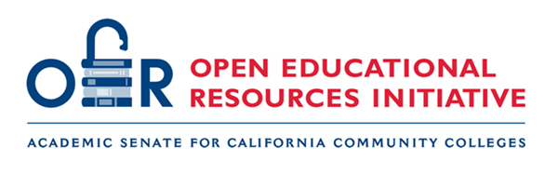

Resources from Chat Zoom: Exploring Open Educational Resources (OER) for ENGL C1000

Official Templates and Links
- CCN Template (Academic Reading and Writing)
- ASCCC OERI English and OER Discipline Collection

LibreTexts
- 88 Open Essays
- Rhetoric – What, Why, and How
- About Writing: Guide with Handbook (OpenStax)
- Writing, Reading, and College Success (Kashyap & Dyquisto)
- Let’s Get Writing
- Writing for Success
- Grammar Essentials (Excelsior OWL)
- Write What Matters

Pressbooks and OER Commons
- Open Oregon Poetry
- Writing Research & Design (WRD)
- Choosing and Using Sources
- Pressbooks: CSU English 100/101 Reader
- OER Commons Reader (Columbus State)

Canvas Commons Resources
- How Arguments Work: A Guide to Writing and Analyzing Texts in College
- Writing for Success

Additional OER Anthologies and Reading Banks
- My Slipper Floated Away: New American Memoirs (CUNY Manifold)
- Composition Reading Bank
- Humanities Commons (LibreTexts Book)

Library and Curated ZTC Collections
- Citrus College English OER Collection
- Citrus College “Master List” of ZTC English Options
- Curated eBook List (Google Sheets)

Other Documents (Lit2Go)
- “Ain’t I a Woman?” – Sojourner Truth
- Lit2Go Overview: Text/Audio Resource

