Fall 2025 ECE OER Update

Child Growth and Development
PSY 235 Child Psychology
by Bill Pelz; NOVA Online Psychology Faculty; and Courtney Gulbro
The purpose of the course is to provide the student with a comprehensive understanding of the methods, theories and main concepts related to child development. The course offers scientific and practical guidance to those who:1) work with, care for, or raise children, 2) design prevention and health promotion programs for children and 3) provide opportunities for children to thrive. There will be a special emphasis on the theories of development, offering descriptions and explanations of cognitive, motor, social, linguistic, emotional, personality, and moral development. The conditions and environments within which development takes place will be discussed, including an emphasis on those factors which promote positive development. A major goal of the course is for students to demonstrate an understanding of the interaction between the developing child and a continually changing world.
License: Creative Commons Attribution
PSY 235 Child Psychology – Simple Book Publishing
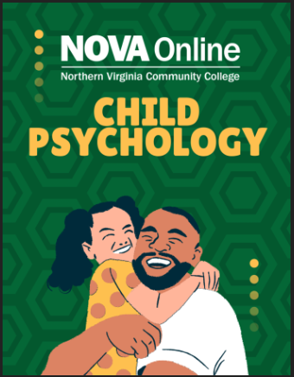
Middle Childhood and Adolescent Psychology
by Qiushan Liu

Child and Adolescent Development: A Topical Approach (2nd Edition)
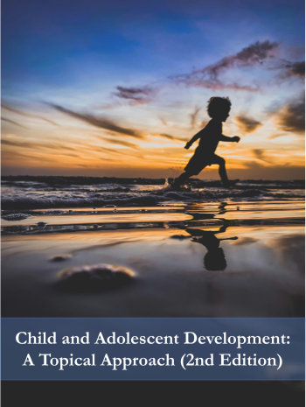
CC BY-NC-SA | 156 H5P activities | 150,870 words
Author(s): Krisztina V. Jakobsen, Paige Fischer
This topically organized textbook offers an overview of physical, cognitive, and socio-emotional development from conception through adolescence. This book is a work in progress. It was last updated in June 2025 and is currently under peer review.

Child Development
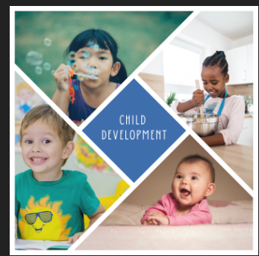
This textbook has been adapted for Child and Youth Care Practitioner (CYCP) students to understand various theories and approaches regarding child development, and how this knowledge can inform our practice with young people and their families. This textbook accompanies the course "Child Development" and explores the physical, cognitive, social, and emotional development from birth to middle childhood.
Creative Commons Attribution NonCommercial ShareAlike
Edited by Paola Ostinelli
Child Development – Simple Book Publishing

Infant and Child Development: From Conception Through Late Childhood
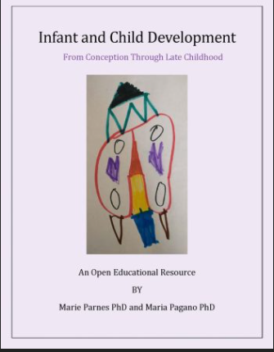
by Jay Brown and Marie Parnes PhD and Maria Pagano PhD
Infant and Child Development: From Conception Through Late Childhood
CC BY-NC-SA | 85 H5P activities | 139,060 words

Health, Safety and Nutrition
Health, Safety, and Nutrition for the Young Child
All Rights Reserved | 33 H5P activities | 137,081 words
Author(s): Julia Kroeker
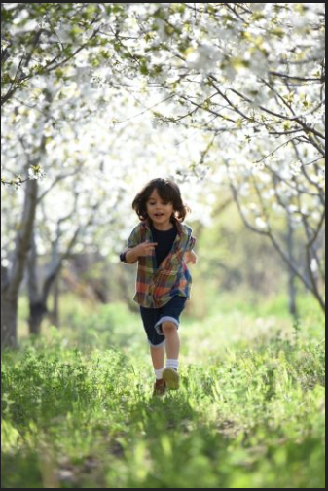

Last updated: 04-4-2025

Safety, Health and Nutrition in Early Childhood Education
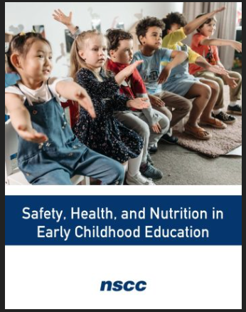
CC BY | 32 H5P activities | 115,732 words
Author(s): Jennifer Paris
Last updated: 03-18-2025
Early childhood is a critical time in development. Many outcomes, both positive and negative, have their beginnings in these years. It is vital that children’s health and safety be protected. High-quality early care and education programs can play a valuable role in improving outcomesfor children.
Health, Safety, Nutrition (Hale) (REMIX)

Principles and Practice
Intro to Early Childhood Education- ECED&105
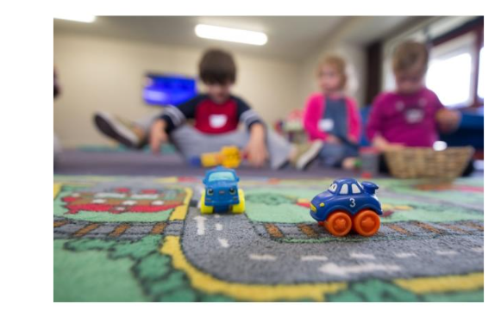
Overview
Introduction to Early Childhood Education Open Education Resources Textbook for common course ECED& 105 Introduction to Early Childhood Education was produced with support from funding secured through the Carl D. Perkins Act.
Download
Overview to this Textbook
Welcome to Introduction to Early Childhood Education. This textbook will cover the following topics:
- An overview of the field of early learning
- Historical roots of early learning
- Professionalism, values and ethics required for working in the field
- Philosophers and theorists that have contributed to early learning
- Brain development and the importance of executive function
- Developmentally appropriate practice
- Developmental theory: how children grow and develop
- The value of play for young children
- Environments both indoors and outdoors and the contribution both make to the developing child
- Family connections and support for all families
- Issues and trends within the field of early learning
- Beyond behaviors: guiding children’s behavior
- Adverse Childhood Trauma and building resiliency
- Diversity and equity within the field of early learning

Foundations of Early Childhood Education
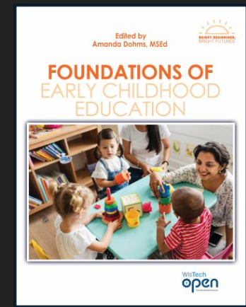
by Katie Steffes, MS, NBCT; Nora Ziburski, EdD; Amanda Dohms, MSEd; Mary Beth Boettcher, MSEd; Tracy Jacobson, MSEd; Christine Spang, MSEd; Sara Horstman, BS; and Vicki Tanck, MSEd
Foundations of Early Childhood Education – Simple Book Publishing
Discover the principles, practices, and strategies for teaching young children from birth to 8 years

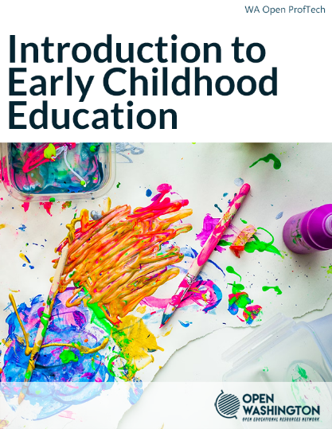
Download this book
openwa.pressbooks.pub | Open Washington Pressbooks
Introduction to Early Childhood Education
CC BY | 165 H5P activities | 111,175 words
Author(s): Gayle Julian, Brenda Boyd Brown, Ph.D., Angela Blums, Ph.D., Christine Moon, M.S., Jennifer Karshna, Ph.D., Ardene Niemer, M.Ed., Ninderjit Kaur Gill, Holly Lanoue, M.Ed.
Subject(s): The Arts
Last updated: 09-12-2025
Language: English
Introduction to Early Childhood Education is designed for ECED 105, one of the initial courses in the ECE Initial Certificate program in Washington State. This book serves as an essential guide, exploring the principles, practices, and foundational knowledge of early childhood education.
(REMIX & Revision) ECD Principles and Practices (Hale)
1.2: This text - Social Sci LibreTexts
- Chapter 2 The Early Childhood Teacher answers many initial questions students may ask about roles, responsibilities, and opportunities in the field of early childhood education.
- Chapter 3 The Field of Early Childhood Education discusses the different kinds of sites and programs in which you might work, and the way they are structured and regulated.
- Chapter 4 History of Early Childhood Education presents a little about the history of our field and encourages you to dig deeper as your interest dictates.
- Chapter 5 Theories introduces you to some of the major ideas and frameworks used to guide our practices with young children.
- Chapter 6 Early Childhood Philosophies discusses some of the important program philosophies that contribute to how we work today.
- Chapter 7 Developmental Ages and Stages describes the unique characteristics of children at various ages and stages of development.
- Chapter 8 Relationships and Guidance talks about the importance of relationships and the importance of understanding children's behavior.
- Chapter 9 Environments brings an awareness of the many aspects of planning physical spaces and routines that meet the needs of young children
- Chapter 10 Understanding Play defines and explains what play is and why it is so important.
- Chapter 11 Supporting Play discusses how teachers guide and support children in their play.
- Chapter 12 Observation and Assessment introduces you to the skills of gathering information about young children
- Chapter 13 Early Childhood Curriculum builds even further on observational skills and an understanding of developmental ages and stages to provide appropriate interactions and learning experiences for young children
- Chapter 14 Curriculum Planning discusses the process that teachers go through to play rich, intentional experiences and activities for children.
- Chapter 15 Partnering with Families: introduces the concept of valuing families as a child’s first teacher and the importance of partnering to provide positive collaboration between a child’s most important worlds, home and school.

Practicum/Field Experience
Field Experience Skill Evaluations
A set of rubrics used to evaluate students in early childhood education teacher preparation field experiences.
Field Experience Documents
A collection of field experience documents created to provide information and support to students, faculty, and community partners.
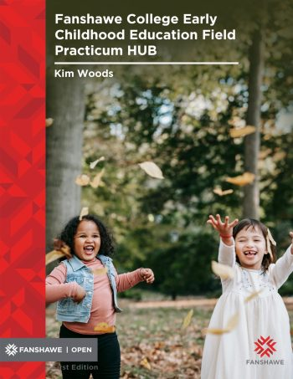
Network ecampusontario.pressbooks.pub | eCampusOntario Open Authoring Platform
Fanshawe College Early Childhood Education Field Practicum HUB
CC BY-NC-SA | 1 H5P activities | 17,707 words
Author(s): Kim Woods
Subject(s): Education, Early childhood care and education
Last updated: 12-18-2024
Institution(s): Fanshawe College
Publisher: Fanshawe College Pressbooks
Language: English (Canada)
Welcome to the ECE Field Practicum Hub. We have created this Open Education Resource to support Students, Community Partners, and ECE Faculty through the ECE Field Practicum Experience.

Introduction to Curriculum
Early Childhood Curriculum Models - Lesson

Overview
This lesson introduces students to different curriculum models, Montessori and HighScopes, used in early childhood settings. Students will identify important details to each model, then identify similarities and differences in curriculum as the child ages. Students will end the lesson by developing an opinion on which model they believe to be the best.
Download

Why play works
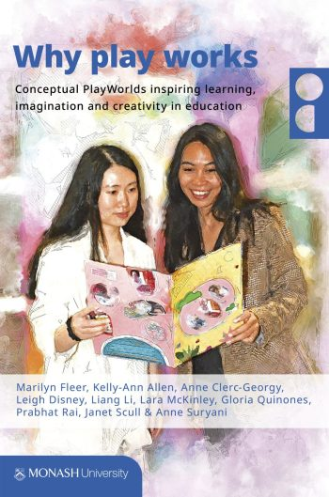
CC BY-NC | 0 H5P activities | 33,832 words
Author(s): Marilyn Fleer, Kelly-Ann Allen, Anne Clerc-Georgy, Leigh Disney, Liang Li, Lara McKinley, Gloria Quinones, Prabhat Rai, Janet Scull, Anne Suryani
Subject(s): Education / Educational sciences / Pedagogy, Early childhood care and education
Last updated: 10-22-2025
Institution(s): Monash University
Publisher: Monash University Library
Language: English (United Kingdom)
The focus of this textbook is on play and learning through a Conceptual PlayWorld. This evidence informed model helps teachers to plan innovative practices relevant for a range of discipline concepts. The teachers and children after reading/hearing a children’s book or nursery rhyme or fairytale jump into the story as characters from the book/story, go on adventures, meet challenges that they solve and return to the real world enriched, and excited to go back in for another adventure (potentially bringing with them things they have learned to enrich their play). The 5 characteristics of planning for a Conceptual PlayWorld are: 1) Selecting a story, 2) Designing an imaginary play space; 3) Planning an exciting entry and entry into that space; 4) Planning a problem that the characters of the story (children in role) will meet and need to solve using concepts; 5) Planning the role of the adults in the imaginary play.
This evidence-informed model forms the foundation of each chapter in the book. Students will learn:
● what is a Conceptual PlayWorld
● the research that underpins a Conceptual PlayWorld
● how to plan and implement a Conceptual PlayWorld
● how to contextualise a Conceptual PlayWorld for specific ages, contexts and discipline content
● how to assess and make learning visible in a Conceptual PlayWorld
● to be leaders and innovators by designing creative and imaginative programs using a Conceptual PlayWorld model of pedagogical practice
● the utility of Conceptual PlayWorlds for creativity, imagination, and wellbeing.

Parenting

Child Family Community
Family & Community Relationships
by Toshiba L. Adams, PhD; Sara Horstman; Tracy Jacobson, MSEd; Autumn Gill, MAEd; Mary Beth Boettcher, MSEd; Nora Ziburski, EdD; Katie Steffes, MSEd, NBCT; and Rachael Stilp, MSEd
Edited by Amanda Dohms, MSEd
Family & Community Relationships – Simple Book Publishing
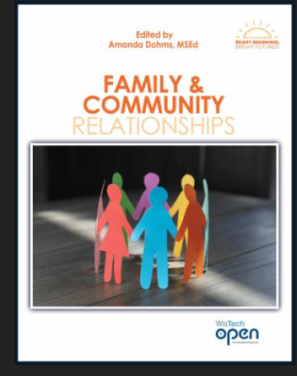

Families Across the Life Course -


Sociology of the Family - Social Sci LibreTexts


Child Guidance
Nurturing Potential: An Equity-Minded Approach to Functional Behavioral Assessment
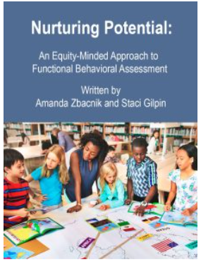

About the Book
As an educator, have you ever wondered about students, “Why can’t she just control her behaviour?” or “Why did he do that?” The demands of the classroom, and the scrutiny of teachers, often leave little time for teachers to consider the complex needs of children experiencing traumatic stress. Drawing on their lived experience and professional expertise, the conversations with trauma-informed education experts in this unique book offer educators an opportunity to develop a deeper understanding of the needs of students and strategies for responding with compassion and empathy. In a time of rapidly emerging scientific discovery, and social and political challenges, this book encourages educational leaders to question the fundamental assumptions of dominant pedagogical practices and sets the foundations for innovation in education.
Nurturing Potential: An Equity-Minded Approach to Functional Behavioral Assessment
CC BY-NC-SA (Attribution NonCommercial ShareAlike) English
Author(s): Amanda Zbacnik, Staci Gilpin
Last updated: 2025-09-08
In a society that is increasingly, beautifully diverse, educators need to ensure that data being collected about student(s) keeps the students’ perspectives and needs at the forefront of behavioral interventions. Zbacnik and Gilpin’s Open Educational Resource strategically guides readers through each step in the functional behavioral assessment and interventions process and continues to center and consider how student identity impacts educational journey.

From Compliance to Co-Regulation
From Compliance to Co-Regulation – Simple Book Publishing
Revisioning Guidance and Classroom Management Practices to Support Children’s Social and Emotional Development
by Sara E. Miller; Leslie La Croix; Kimberly Sanders Austin; Christine Pegorraro Schull; and Marianne Pegorraro Durocher
From Compliance to Co-Regulation: Revisioning Guidance and Behavior Management to Support Children’s Social and Emotional Development within Classroom Communities is an Open Educational Resource (OER) textbook that examines how to incorporate brain research and create supportive classroom communities for all children. The Community Model for Classroom Management, the approach shared in this textbook, shifts away from compliance-oriented management structures and instead advocates for using tiered systems of support to develop social and emotional skills using a problem-solving approach. Universal, strategic, and intensive supports are discussed and connected to the model. This textbook celebrates the unique strengths that children bring to early childhood spaces and shows how educators can work collaboratively to help all children successfully engage within these communities.

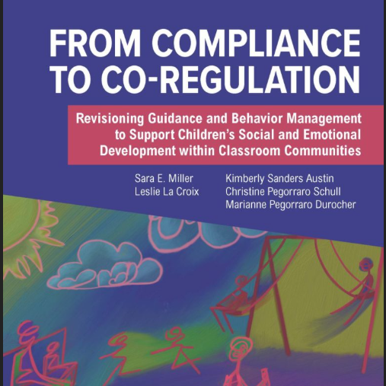

Child Abuse
Child Abuse and Neglect: Stopping the Maltreatment of Our Future Generations
Child Abuse and Neglect: Stopping the Maltreatment of Our Future Generations - Social Sci LibreTexts
Dana Rethwisch and Jennifer Marta
Coalinga College
An overview of child abuse and neglect, from historical and contemporary perspectives. Topics include: physical & emotional abuse & neglect, sexual abuse, reporting and investigation, case management & the legal response, treatment for survivors and perpetrators, and prevention of future child abuse & neglect. It is designed for use by adult students, and other individuals who work with children. Topics may be unsettling. Only through understanding can we stop the maltreatment of future generations.

Infant/Toddler

Diversity
Opening Eyes onto Inclusion and Diversity (Carter et al.)

CHD 216 Early Childhood Programs, Schools, and Social Change Course Materials
Remix of OER created for NOVA Online Students

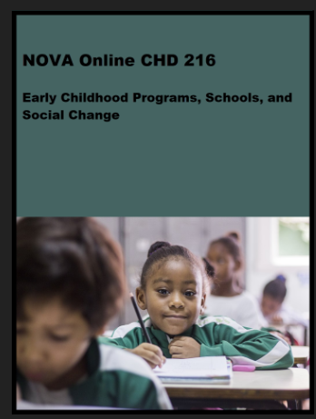

Copyright © by Remixed by NOVA Online is licensed under a Creative Commons Attribution 4.0 International License, except where otherwise noted.

Early Intervention

Administration
Sample Assignments Using AI - Child Care Administration Course
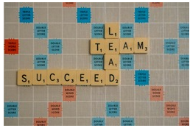
This resource was designed for instructors teaching Child Care Administration or Supervision courses for early childhood education students. It was created to support the integration of AI into the course content, with students using AI tools in several assignments and guiding students in the process of creating a Notebook LM.Supplemental resources are included in the file below that were used throughout the semester, and were availalble for students to use in creating their Notebook LM.
Activity/Lab, Homework/Assignment, Lesson Plan
Author:Rachel Oleaga, Nancy Pynchon, CA ROTEL Project
Date Added: 10/29/2025
License: Creative Commons Attribution

Administering Early Childhood Services in Nova Scotia
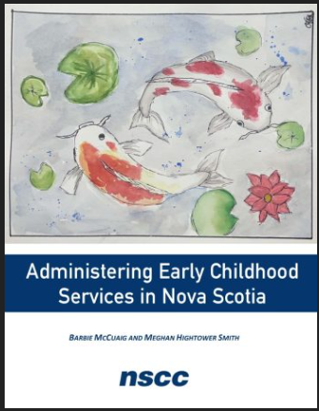
by Barbie McCuaig and Meghan Hightower Smith
Creative Commons Attribution NonCommercial ShareAlike
Administering Early Childhood Services in Nova Scotia – Simple Book Publishing

Exceptional Children/Special Needs


Attribution-NonCommercial-ShareAlike
CC BY-NC-SA
About the Book
This book is evolving into a book by and for teacher candidates pursuing licensing in Elementary, General Special Education, and Early Childhood Special Education in New Hampshire and surrounding New England states. These teacher candidates share their knowledge about teaching PreK-12 learners with disabilities and the many roles and responsibilities of the case manager/special educator.
The Roles and Responsibilities of the Special Educator - Open Textbook Library

Children’s Thinking and Learning
Author:Kathleen Peets

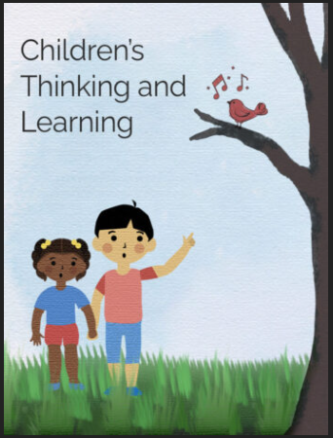

Miscellaneous
Reflective Practice in Early Years Education

Sheryl Third, Fanshawe College
Copyright Year: 2022
Publisher: Fanshawe College Pressboks
About the Book
This resource will provide a context that will allow the reader to consider their obligation to reflect from their own perspective and will explore how to create a practice that best suits their professional setting. This book will bring together in one place the history, the values, the skills and disposition required to be a reflective practitioner. It is a textbook with elements of a workbook, embedded are opportunities to watch, to think, to write, and to listen allowing the reader to become a purposeful and intentional reflective practitioner.
Link

Canvas Course Shells
Teaching & Learning Math in ECE Math in ECE.
Child, Family and Community OER Shell (COS) Child Family Community OER Shell
Introduction to Curriculum Introduction to Curriculum

CAP TPE
CAP TPE Aligned Methods of Evaluation
CAP CPL Child, Family and Community
CAP CPL Practicum
CAP CPL Teaching in a Diverse Society
CAP CPL Principles and Practices of Teaching Young
CAP CPL Health, Safety, and Nutrition
CAP CPL Introduction to Curriculum
CAP CPL Observation and Assessment
CAP CPL Child Growth and Development

CAP MOE
CAP MOEs for Infant and Toddler Courses
CAP MOEs for Administration and Supervision Courses

Places to Look
OER starting points - Early Childhood Education & Education - TCC OER Subject Guide - Tacoma Community College Library at Tacoma Community College

On the Horizon!
- Introduction to Children with Special Needs
- Curriculum and Strategies for Children with Special Needs.
Both books are slated to be completed by June, 2026. By Dana Rethwisch Palo Verde College

Guidance for Young Children
Ken Breeding: Palomar College

Scope
Table of Contents
1. Introduction and Historical Perspectives
2. Developmental Theories
3. Developmentally Appropriate Practice
4. Environmental Influences on Child Behavior
5. Observing Children & Understanding Bias
6. Analyzing Child Behavior
7. Diversity and Inclusion
8. Supporting Children with Special Needs
9. Communication I - Listening Effectively
10. Communication II - Assertive Communication
11. Purposes and Motivation for Behavior
12. Understanding The Role Emotions Play
13. Understanding and Using Conflict Productively
14. The ANSWER: An Overarching Principle for Effective Guidance
15. Implementation: Foundational Principles and Strategies
16. Mindfulness
From Todd LaMarr @ American River College lamarrt@arc.losrios.edu

Brain Coloring Book
I remember back in my graduate school days, many students taking neuroscience classes had these coloring books to learn about the brain. I have struggled to teach about the brain and so have tried to teach brain basics with coloring pages. Students seem to enjoy it, so I am planning to share it with the wider OER ECE world! Here is a short video of a few coloring pages and examples from students as we learned about the brain while coloring in class:
Brain Coloring Book video example

CDEV 1000 Audio Book
An audio reading of the Child Development OER book. More than just audio access, because the audio files are done via video format, the text is on the screen so students can read along and what I am super excited about is that the captions can be automatically translated into a student's native/preferred language. Students have shared that this audio approach also improves flexibility of access as they can listen to it while driving, cleaning, etc. Furthermore, I have chopped up the audio/videos into sections, so a teacher who adopts it can create their own playlists and remix with other videos to make it their own!
CDEV 1000 Audio Book video example

