Managing Hidden Ancillaries in LibreTexts (Conductor)

Ancillary materials (e.g., instructor resources, test banks) can be uploaded and managed within your Conductor project for the book.

Step 1: Navigate to Assets
- Open your Conductor project.
- Scroll to the bottom of the page to locate the Assets section.
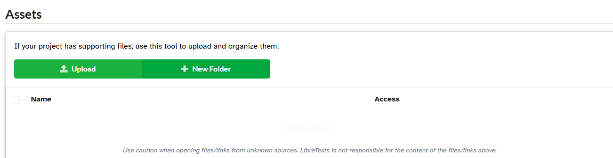

Step 2: Create a Folder
- Select add a new folder.
- Use clear, descriptive names to organize your ancillaries (e.g., Instructor Resources, Test Bank, Slides).

Step 3: Upload Files
- Upload your ancillary files into the appropriate folder.
- Files can be added at any time and reorganized as needed.

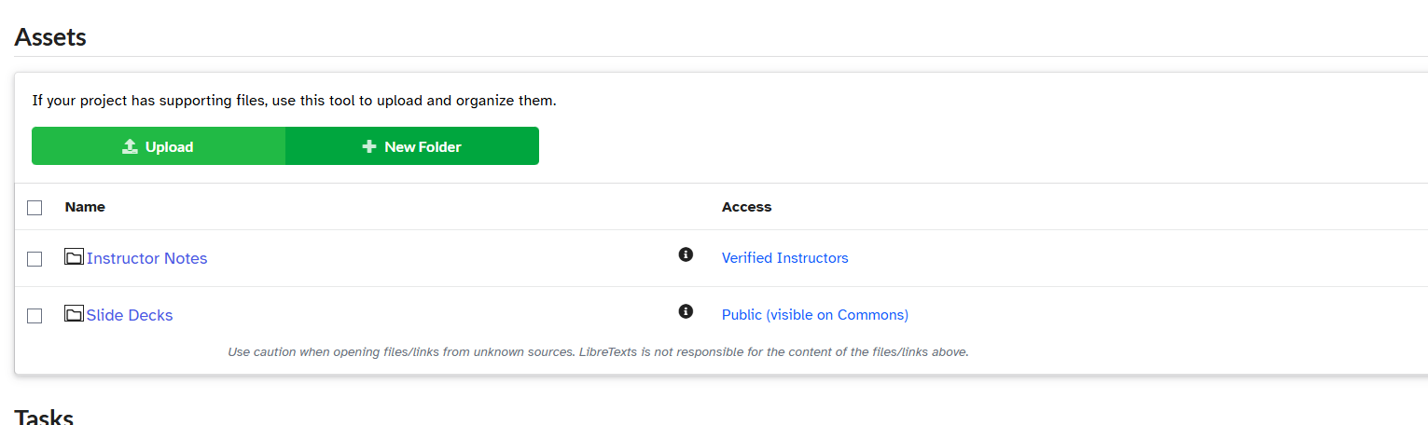

Step 4: Adjust Access Settings
- By default, all newly created folders and uploaded files are set to:
Public (visible on Commons)
- Click on the access setting to change visibility.
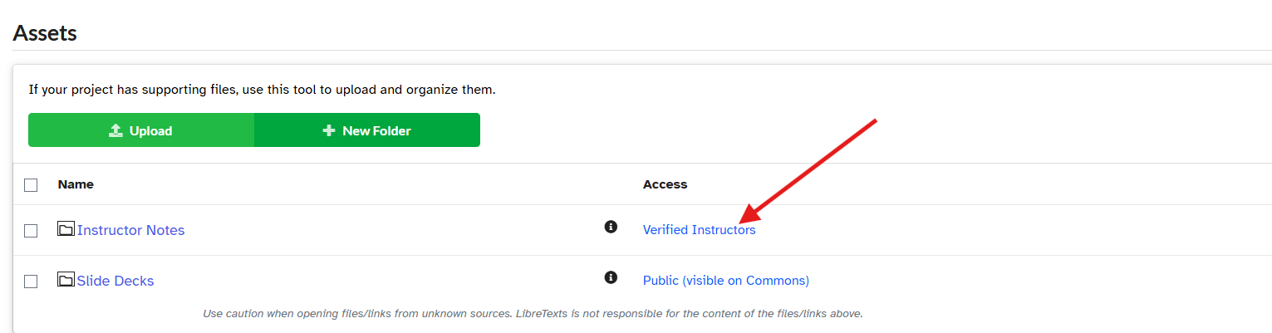

Access Options
- All Conductor Users
Visible to anyone with a Conductor account.
- Project Team Members
  - Only visible to collaborators on your project.
  - Best for materials still in development.
- Verified Instructors
  - Visible in Commons but only accessible to verified instructors.
  - Recommended for most ancillaries.(Often indicated by a graduation cap icon.)

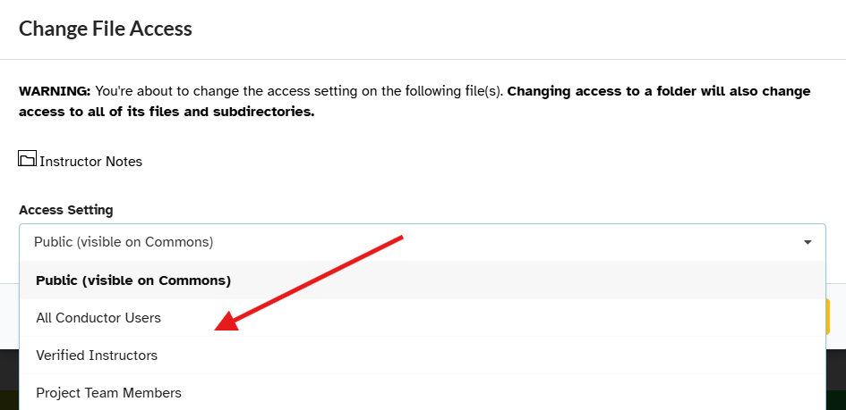

This structure allows you to keep materials organized while controlling who can access them at different stages of development and publication.

