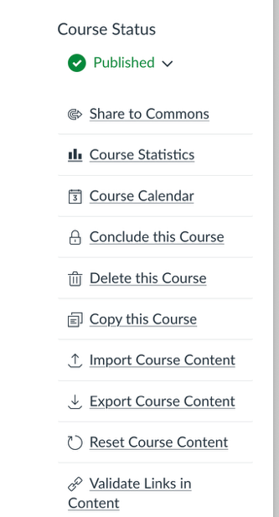
Sharing ZTC Resources to California Community Colleges Canvas Commons

- Log into the Canvas shell you wish to share.
- Go to Settings. Select “Share to Commons” from the menu on the right.
- After selecting Share to Commons, choose “Select Consortium(s)” in response to the question “Who can use this resource?” Please note that the available options vary. You may have more options or fewer options than are shown in the image below. Your consortium options will appear after you have indicated that your choice is Select Consortium(s). Select “California Community Colleges” to limit access to the resources to individuals with faculty permissions in the California Community Colleges.
